PhishSpot Manual
  - Administrator Guide
2026-06-02
Table of Contents

Introduction
Welcome to PhishSpot, a comprehensive phishing simulation and security awareness training platform. This manual covers all features available to account admins. It is designed for non-technical users and walks through every section of the platform step by step.
PhishSpot allows your organization to run realistic phishing campaigns, track employee responses, deliver security awareness training, and measure your team’s resilience to social engineering attacks over time.

1.1 What Is PhishSpot?
PhishSpot is a SaaS platform that helps organizations test and improve their employees’ ability to recognize phishing emails. As an admin, you can create simulated phishing campaigns that mimic real-world attacks, send them to your team, and then track who opened the email, who clicked the link, and who submitted sensitive information on a fake landing page. After a click, employees can be redirected to a training course to improve their awareness.

1.2 Who Is This Manual For?
This manual is written for account-level admins. If you have the Admin role on your team, you have full access to all features described in this guide: managing campaigns, contacts, templates, domains, courses, team members, reports, and account settings.

1.3 User Roles Overview
PhishSpot uses three user roles within each account. Your role determines what you can see and do:
Role | Access Level | Key Permissions
Admin | Full access | Everything: campaigns, contacts, templates, team management, account settings, domains, courses, media, webhooks, reports
Editor | Content access | Campaigns, contacts, courses, templates, media, reports. Cannot manage team members or account settings
Member | Read-only | Can view campaigns, contacts, and reports but cannot create or modify anything
This manual focuses exclusively on the Admin role. Editors and Members will see fewer menu items and action buttons.

Getting Started

2.1 Logging In
Navigate to your PhishSpot platform URL in your browser. Enter your email address and password on the login page and click the Sign In button.
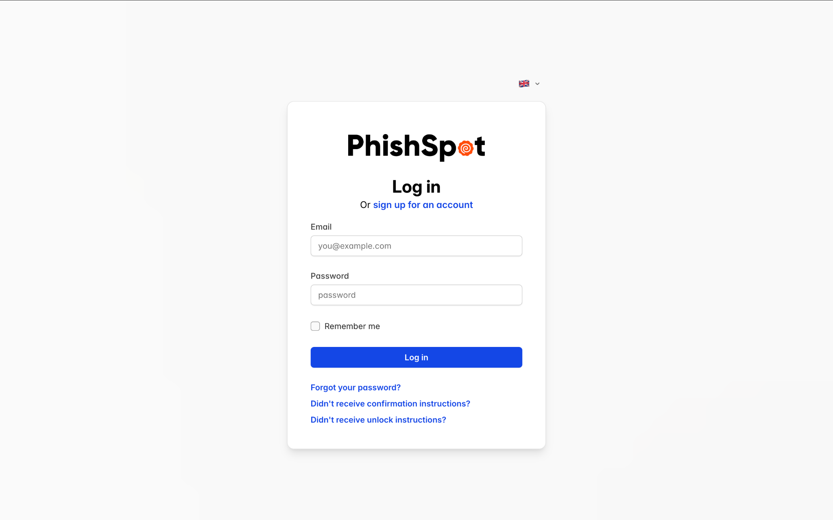
If your organization has enabled two-factor authentication (2FA), you will be prompted to enter a verification code from your authenticator app after entering your password.

2.2 Platform Navigation
After logging in, you will see the main dashboard. The platform uses a horizontal top navigation bar that appears on every page. The navigation bar contains:
- Left side — PhishSpot logo (links to homepage) and the account/team switcher (shows your current team name).
- Center — Main navigation links: Dashboard, Campaigns, Calendar, Trends, Templates, and Settings. The active page is highlighted with a blue underline.
- Right side — Language switcher (flag icon), theme toggle (light/dark mode), notification bell, and your user avatar/profile menu.
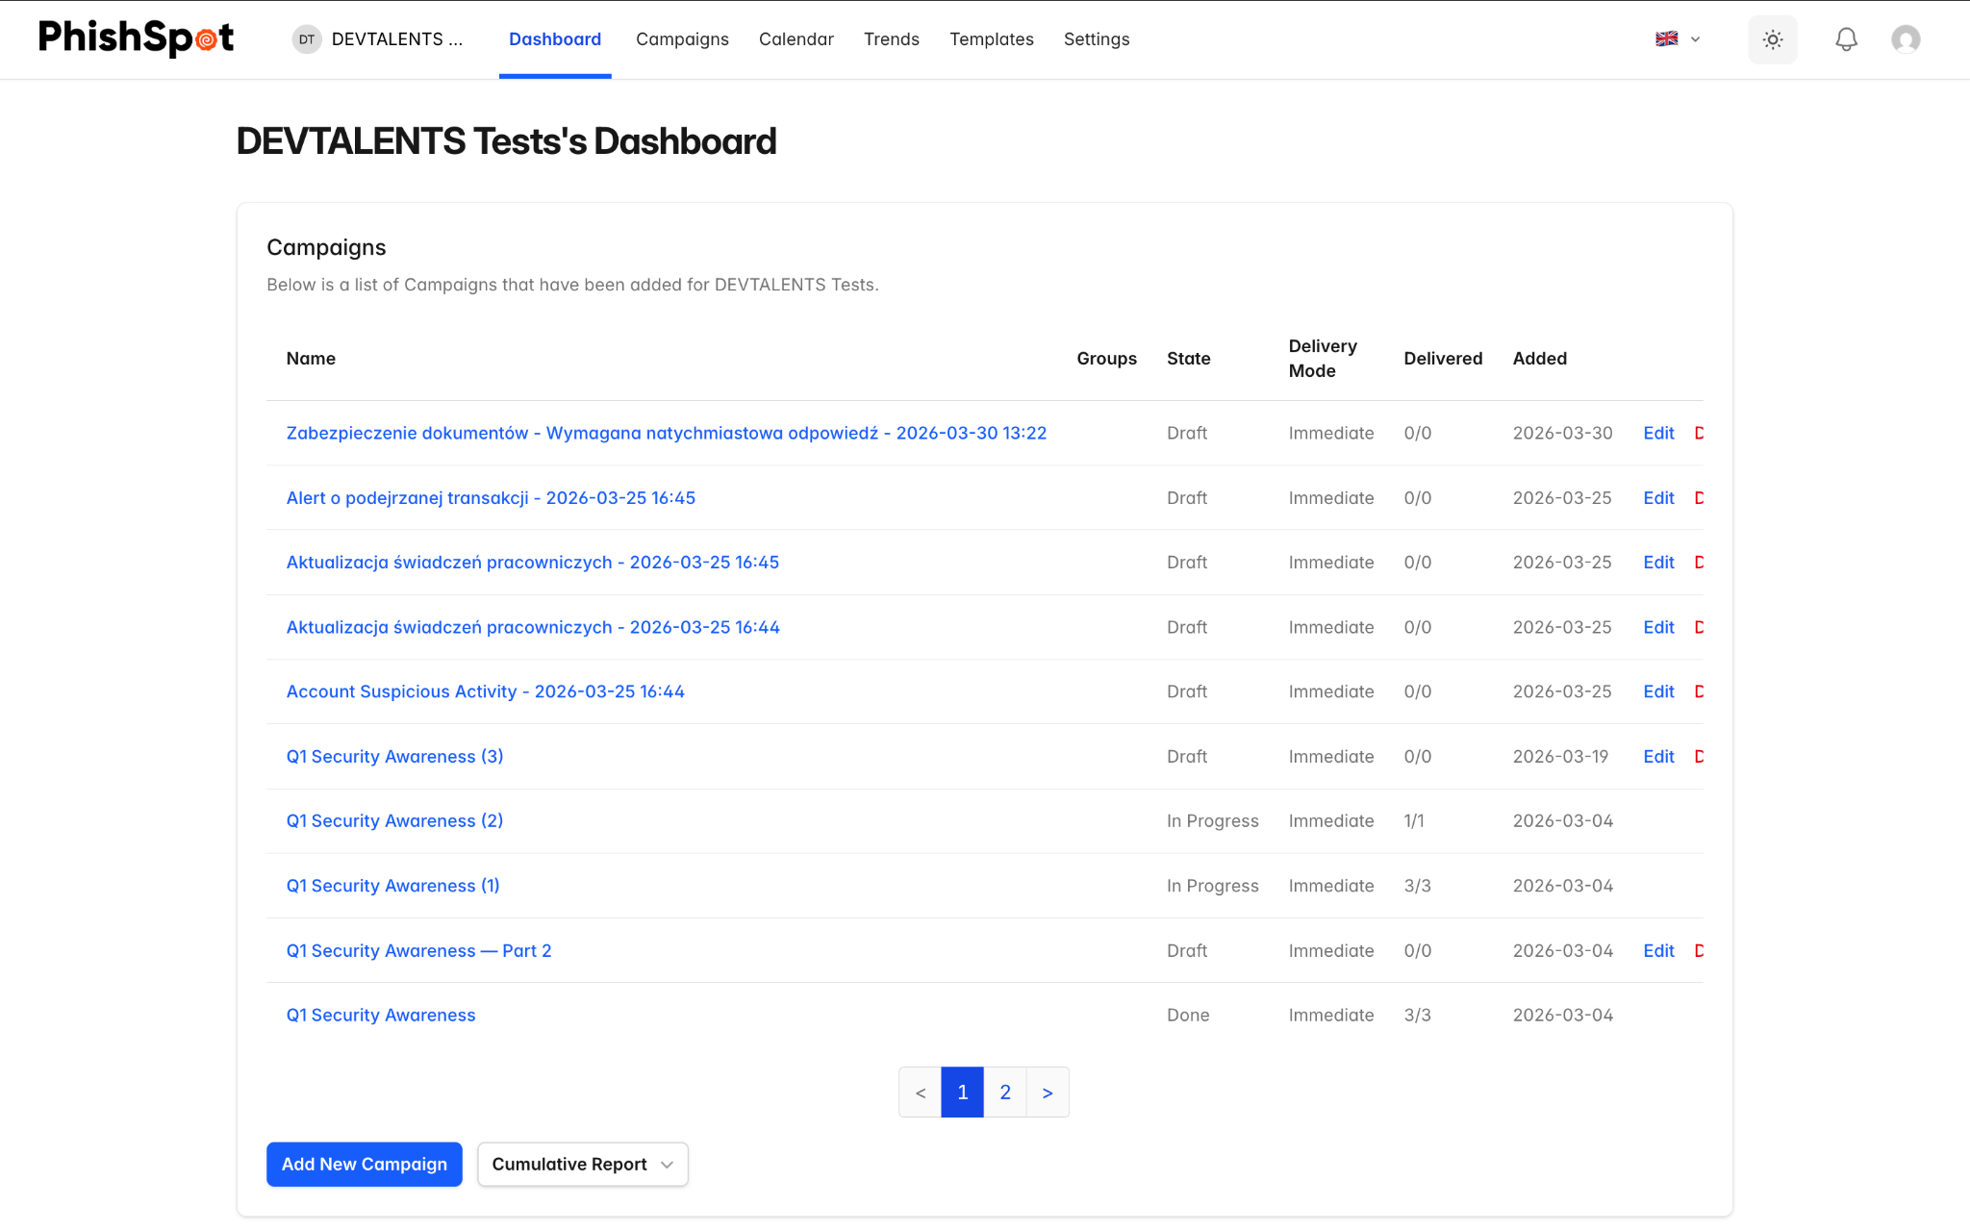

2.3 Navigation Menu Structure
The top navigation bar contains the following main sections:
Menu Item | Description
Dashboard | Overview of your account with recent campaigns and quick stats
Campaigns | Create, manage, and monitor phishing simulation campaigns
Campaign Calendar | Visual calendar view of scheduled and past campaigns
Trends | Historical trend data and analytics across all campaigns
Templates | Browse curated phishing templates and manage your custom templates
Settings | Expandable section containing: Contacts, Groups, Courses, Media, Domains, Platform Domains, Webhooks, Account Details, Team Members
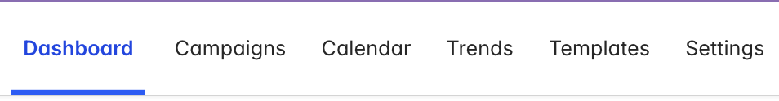

2.4 Switching Accounts
If you belong to multiple teams or accounts, you can switch between them using the account switcher at the top of the sidebar. Click your current account name to see a dropdown of all accounts you have access to, then select the one you want to work with.
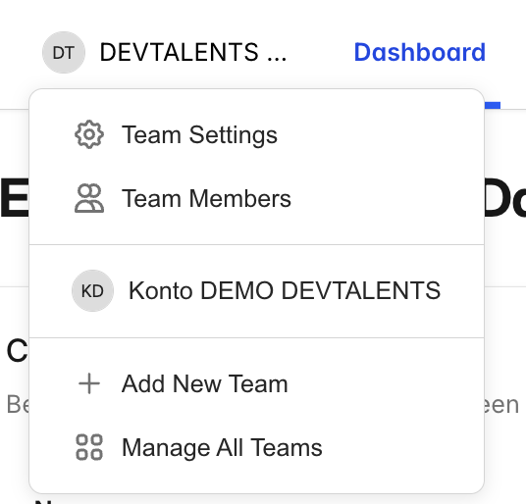

2.5 Notifications
The notification bell in the top-right corner shows a count of unread notifications. Click it to see a list of recent events such as campaign completions, new team member joins, or domain verification updates. Each notification links to the relevant item. You can mark all notifications as read using the link at the top of the notification panel.

Dashboard
The Dashboard is your home screen after logging in. It provides a high-level overview of your account activity.

3.1 Dashboard Components
The dashboard displays:
- A summary of your recent campaigns with their current status (Draft, Scheduled, Active, Paused, Done)
- Quick access to platform domains assigned to your account
- Your media library overview
From the dashboard, you can quickly navigate to any campaign by clicking its name, or create a new campaign using the button in the campaigns section.

Campaigns
Campaigns are the core of PhishSpot. A campaign is a simulated phishing exercise where you send a crafted email to a group of contacts, host a fake landing page to capture interactions, and optionally redirect users to a training course after they click.

4.1 Campaigns List
Navigate to Campaigns from the sidebar to see all campaigns in your account. The list displays:
Column | Description
Name | The campaign name (clickable to view details)
State | Current status: Draft, Scheduled, Active, Paused, or Done
Delivery Mode | How emails are sent: Immediate, Scheduled, or Staggered
Delivered | Number of emails sent out of total recipients
Created At | When the campaign was created
Actions | Buttons for Edit, Duplicate, and Delete
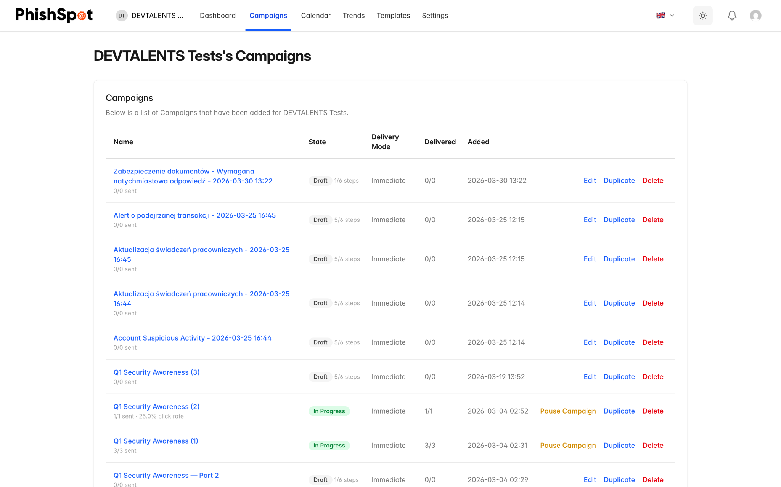
From this page you can also generate a Cumulative Report PDF that combines data from multiple campaigns.

4.2 Creating a New Campaign
Click the New Campaign button to start the campaign creation wizard. The wizard guides you through six steps:

Step 1: Settings
Configure the basic campaign parameters:
- Campaign Name — Give your campaign a descriptive name (e.g., “Zabezpieczenie dokumentów - Wymagana natychmiastowa odpowiedź”).
- Sender Identity — Provide Display Name and From Email
  - Display Name — Provide Display Name
  - From Email — Provide Email Username and Select Domain
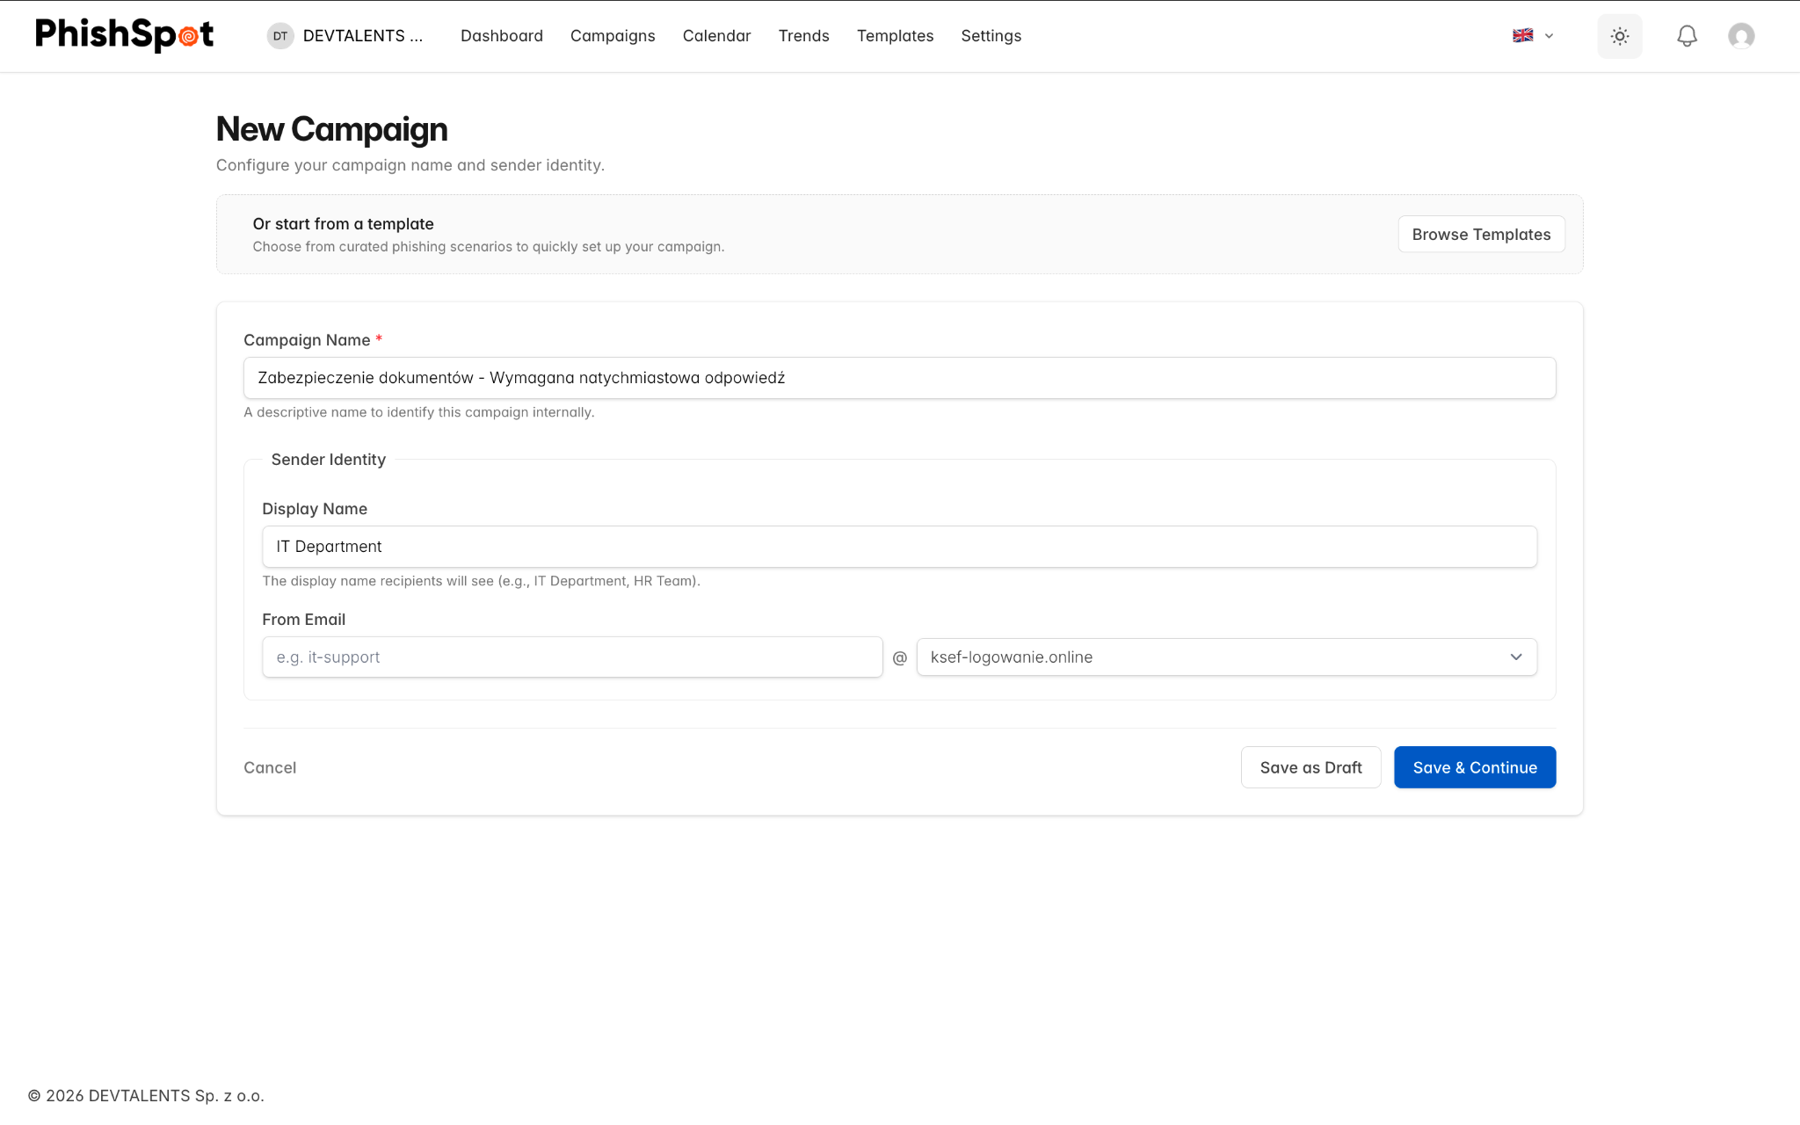

Step 2: Email Content
Design the phishing email your targets will receive:
- Email Subject — The subject line of the phishing email.
- Email Content — The HTML body of the email. Click the Edit Code button to open the Monaco code editor where you can write or paste HTML. The editor provides syntax highlighting and a live preview.
You can use template variables in both the subject and body to personalize emails. Common variables include the recipient’s first name, last name, and email.
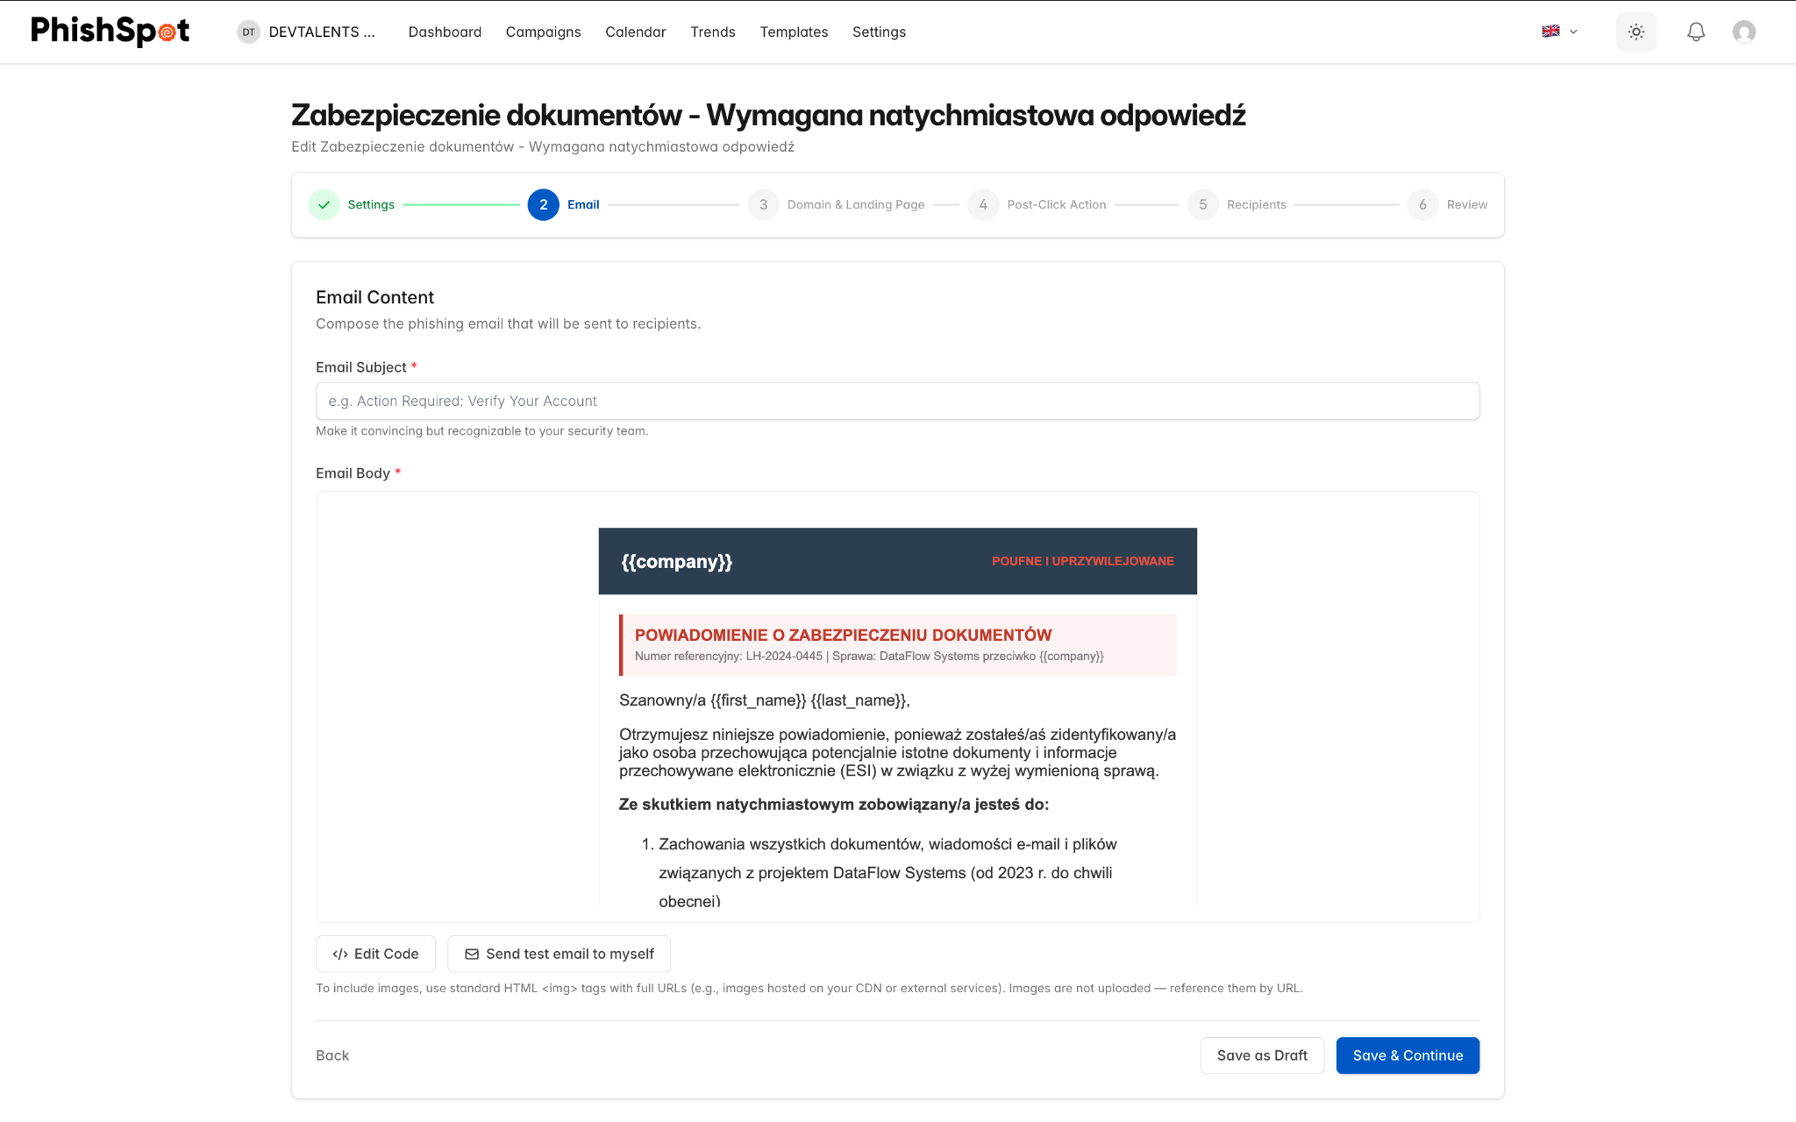
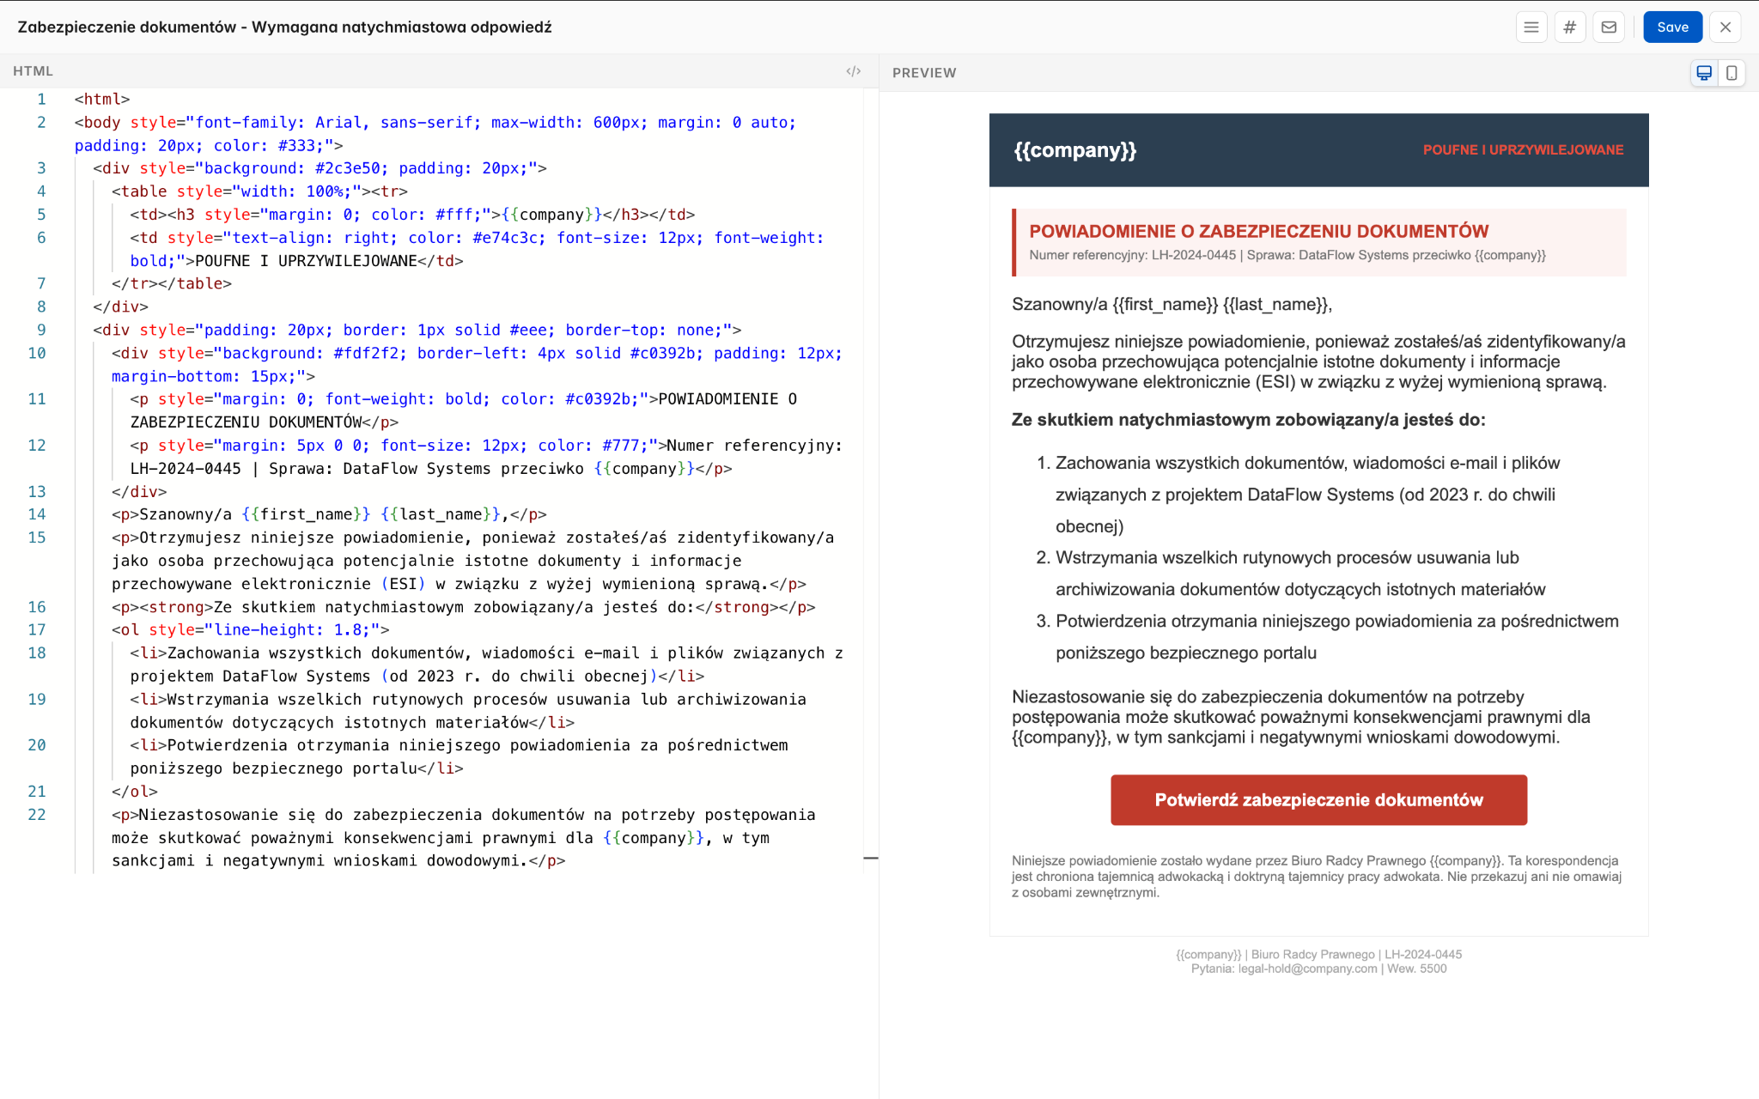
Always send a test email to yourself before launching a campaign to verify the formatting and links work correctly.

Step 3: Landing Page
Configure the fake landing page that recipients will see when they click the phishing link:
- Platform Domain — Select which domain to use for your landing page URL.
- Landing Page Content — Edit the HTML of the landing page using the visual editor. This is the page that mimics a legitimate login form or similar.
- Enable/Disable Landing Page — You can choose to track clicks only without hosting a landing page.
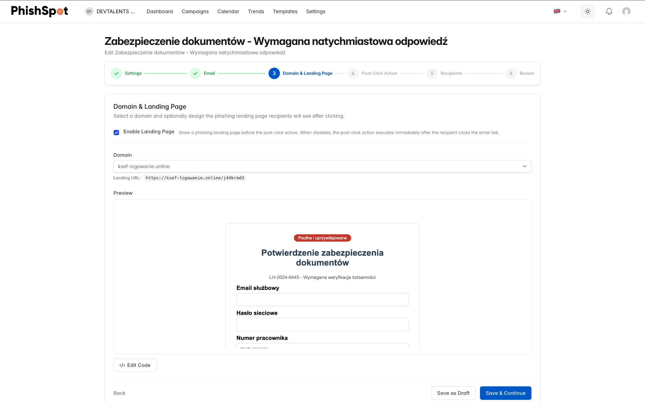
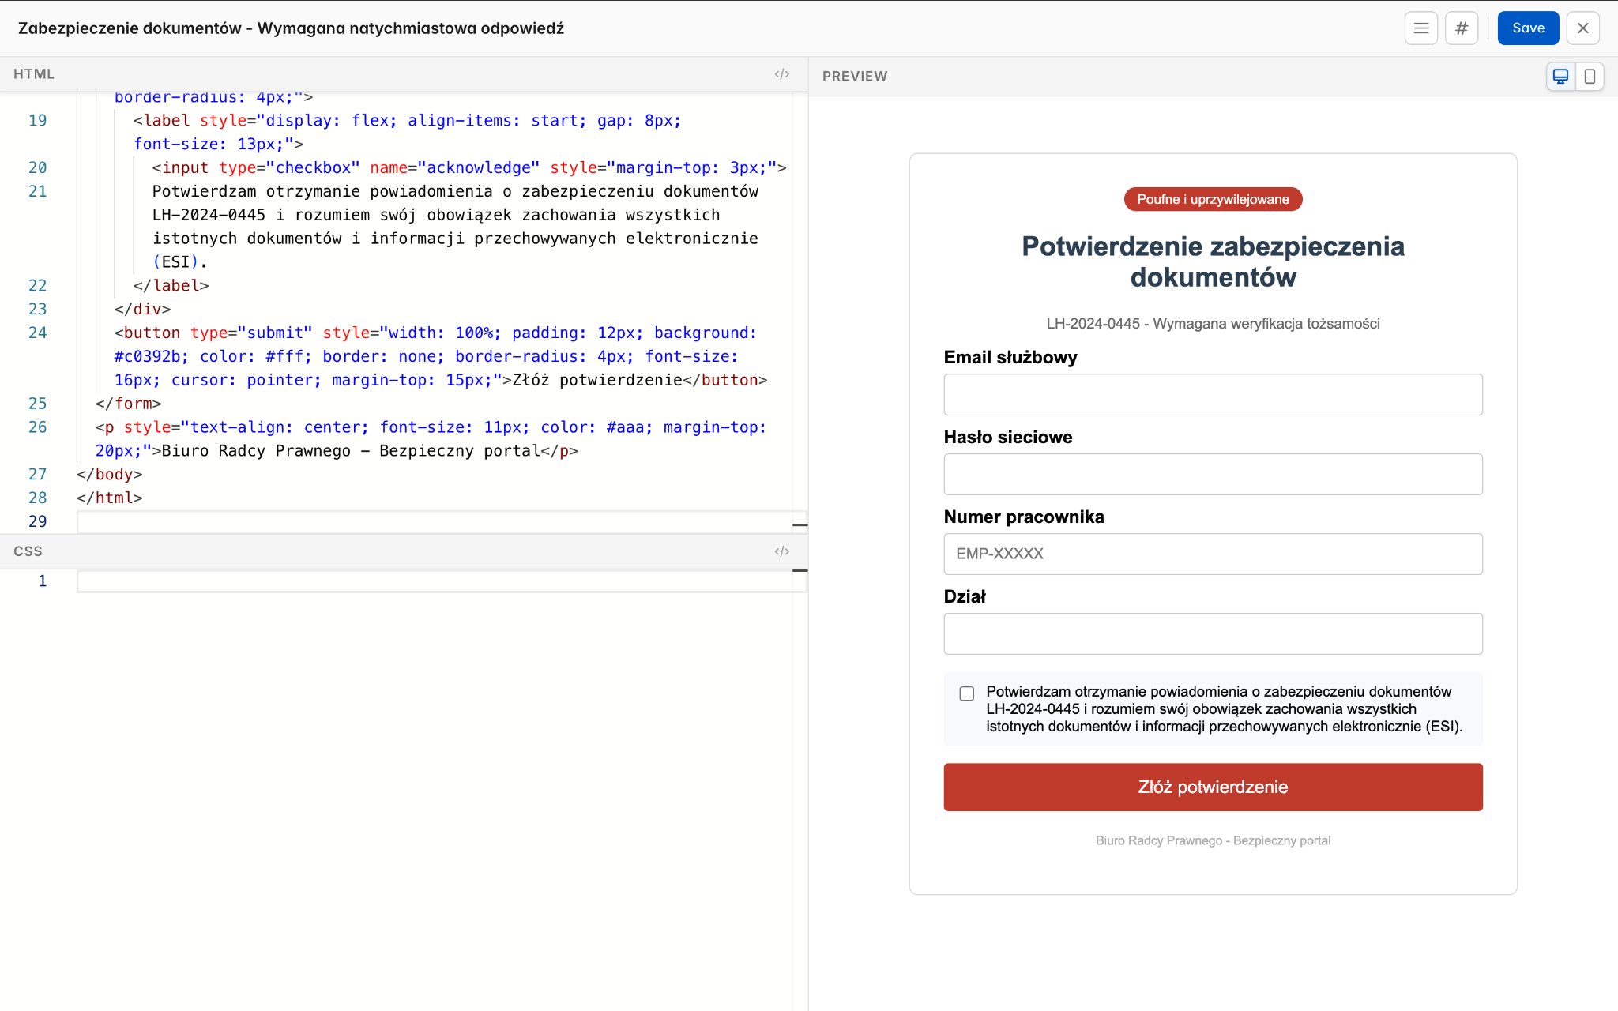

Step 4: Post-Click Action
Define what happens after a recipient interacts with the landing page:
- Training Course — Assign a security awareness course that the user is redirected to after clicking or submitting data.
- Custom Redirect URL — Redirect the user to a specific URL instead.
- Awareness Page — Display a built-in awareness message explaining that this was a simulation.
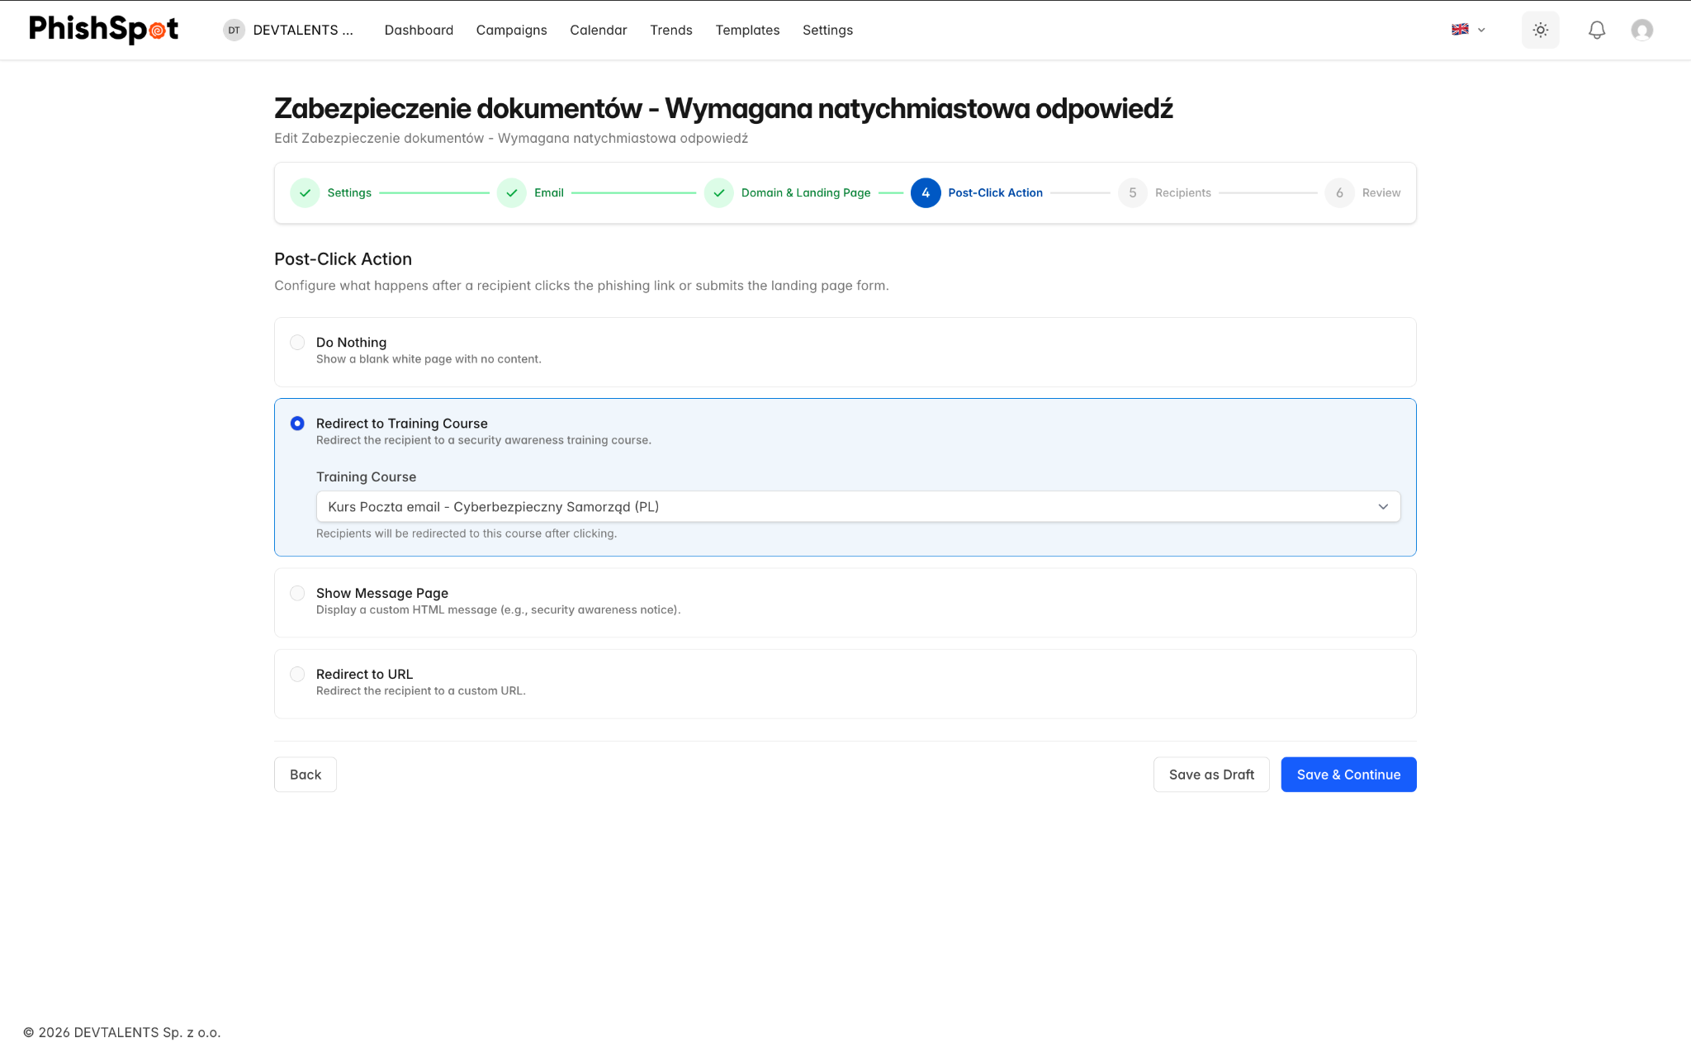

Step 5: Recipients
Select who receives the campaign emails:
- Browse your contacts and add individuals or entire groups
- Review the selected recipients list
- Remove specific contacts if needed
- The contact browser supports search and filtering by department, title, and location
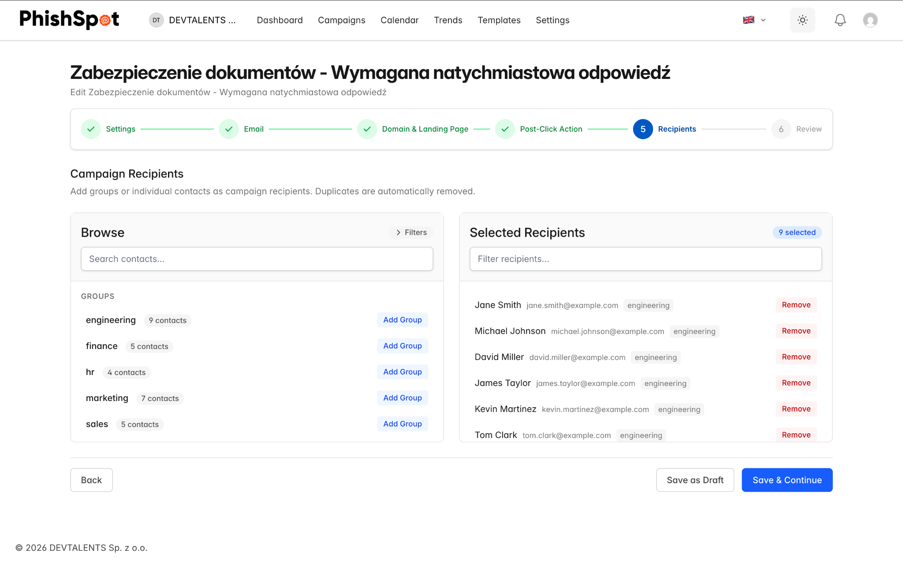

Step 6: Review & Launch
Review all campaign settings before launching:
- Summary of email content, landing page, recipients, and delivery settings
- Final confirmation before starting the campaign
- Option to save as draft and launch later
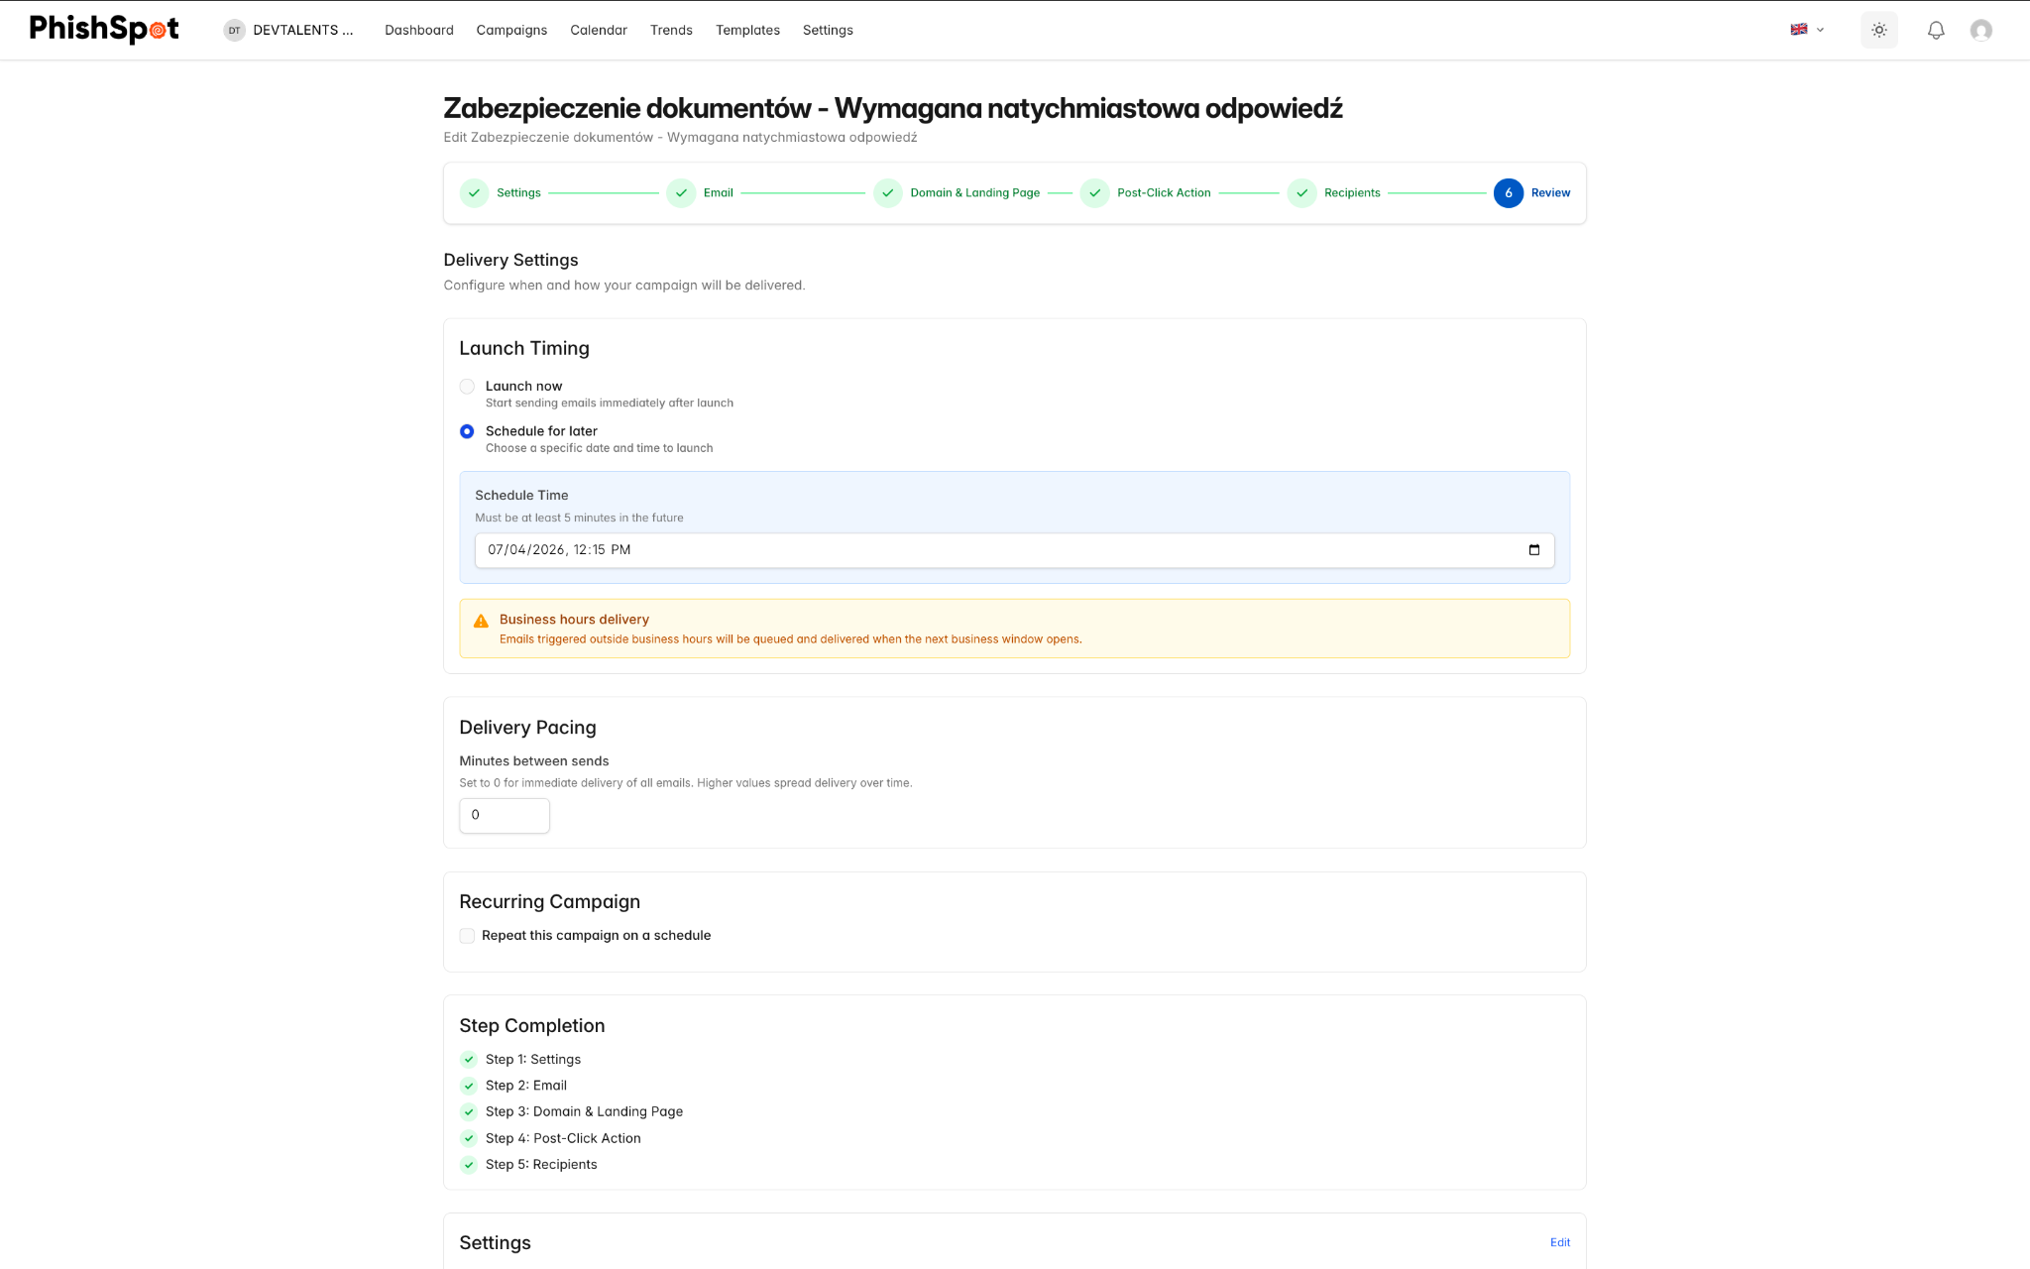
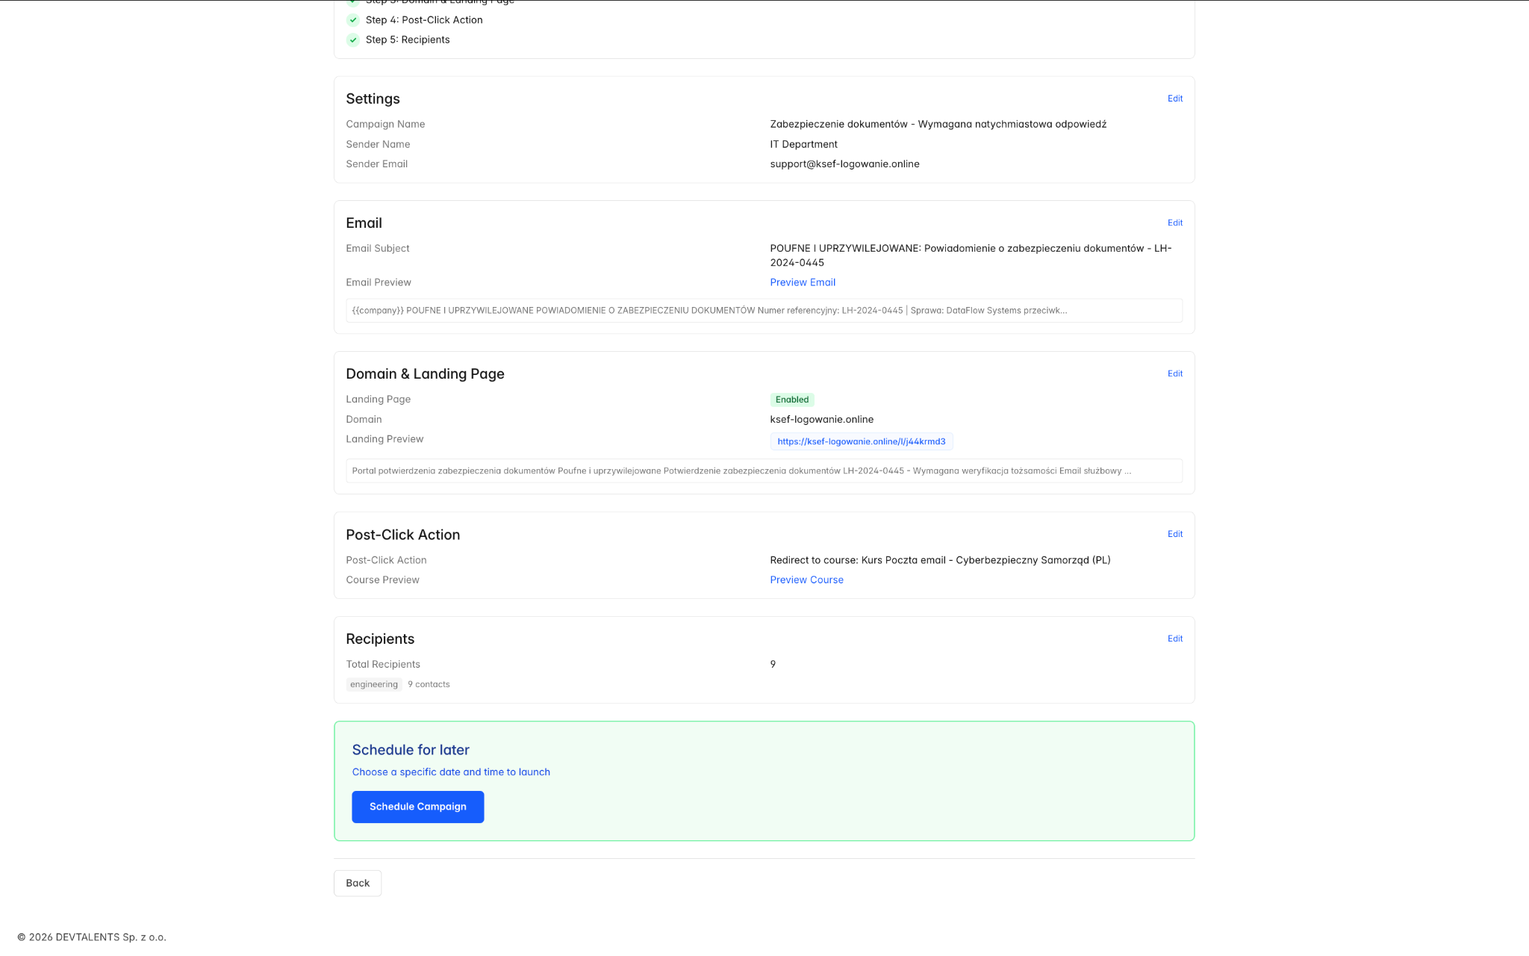

4.3 Campaign States
A campaign moves through these states during its lifecycle:
State | Meaning | Available Actions
Draft | Campaign is being configured and has not been sent | Edit, Start, Schedule, Delete
Scheduled | Campaign is set to launch at a future date/time | Edit, Reschedule, Cancel Schedule, Delete
Active | Campaign is currently sending or has sent emails | Pause, Stop, View Dashboard
Paused | Campaign sending is temporarily paused | Resume (Start), Stop
Done | All emails have been delivered and tracking is complete | View Dashboard, Export Reports, Duplicate

4.4 Campaign Actions
From a campaign’s detail page, you have access to several actions depending on its current state:
- Start — Begin sending the campaign immediately.
- Pause — Temporarily halt email delivery (can be resumed).
- Stop — Permanently stop the campaign. Remaining unsent emails will not be delivered.
- Schedule / Reschedule — Set or change the future delivery date.
- Duplicate — Create a copy of the campaign as a new draft.
- Save as Template — Save the current email content as a reusable phishing template.
- Send Test Email — Send a test version of the email to yourself to verify formatting.
- Export Report — Download campaign results as PDF or Excel.

4.5 Campaign Dashboard
Once a campaign is active or complete, you can access its dashboard for detailed analytics. The campaign dashboard includes:
- Funnel Chart — Visual funnel showing Sent → Delivered → Opened → Clicked → Submitted, with conversion percentages at each stage.
- Group Breakdown — Performance metrics broken down by contact group.
- Department Breakdown — Performance metrics broken down by department.
- Recipients Table — A list of every recipient with their individual status (sent, delivered, opened, clicked, submitted).
- Recipient Timeline — Click on any recipient to open a side panel showing their complete event timeline (when the email was sent, opened, link clicked, page visited, data submitted, course started/completed).
- Export CSV — Download the full recipient data as a CSV file for further analysis.
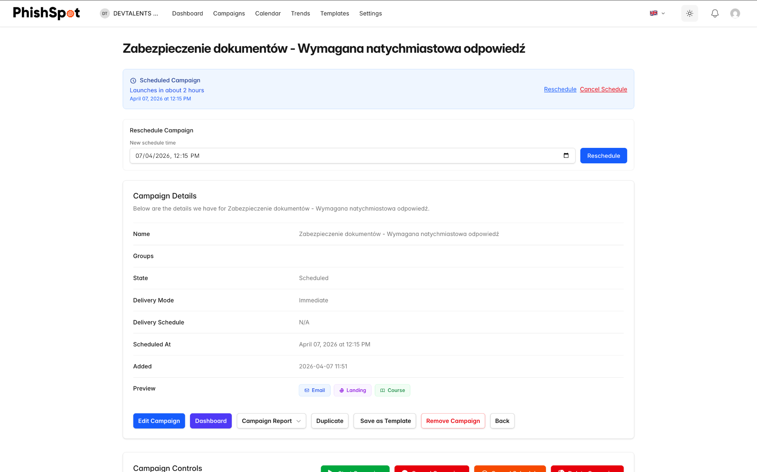
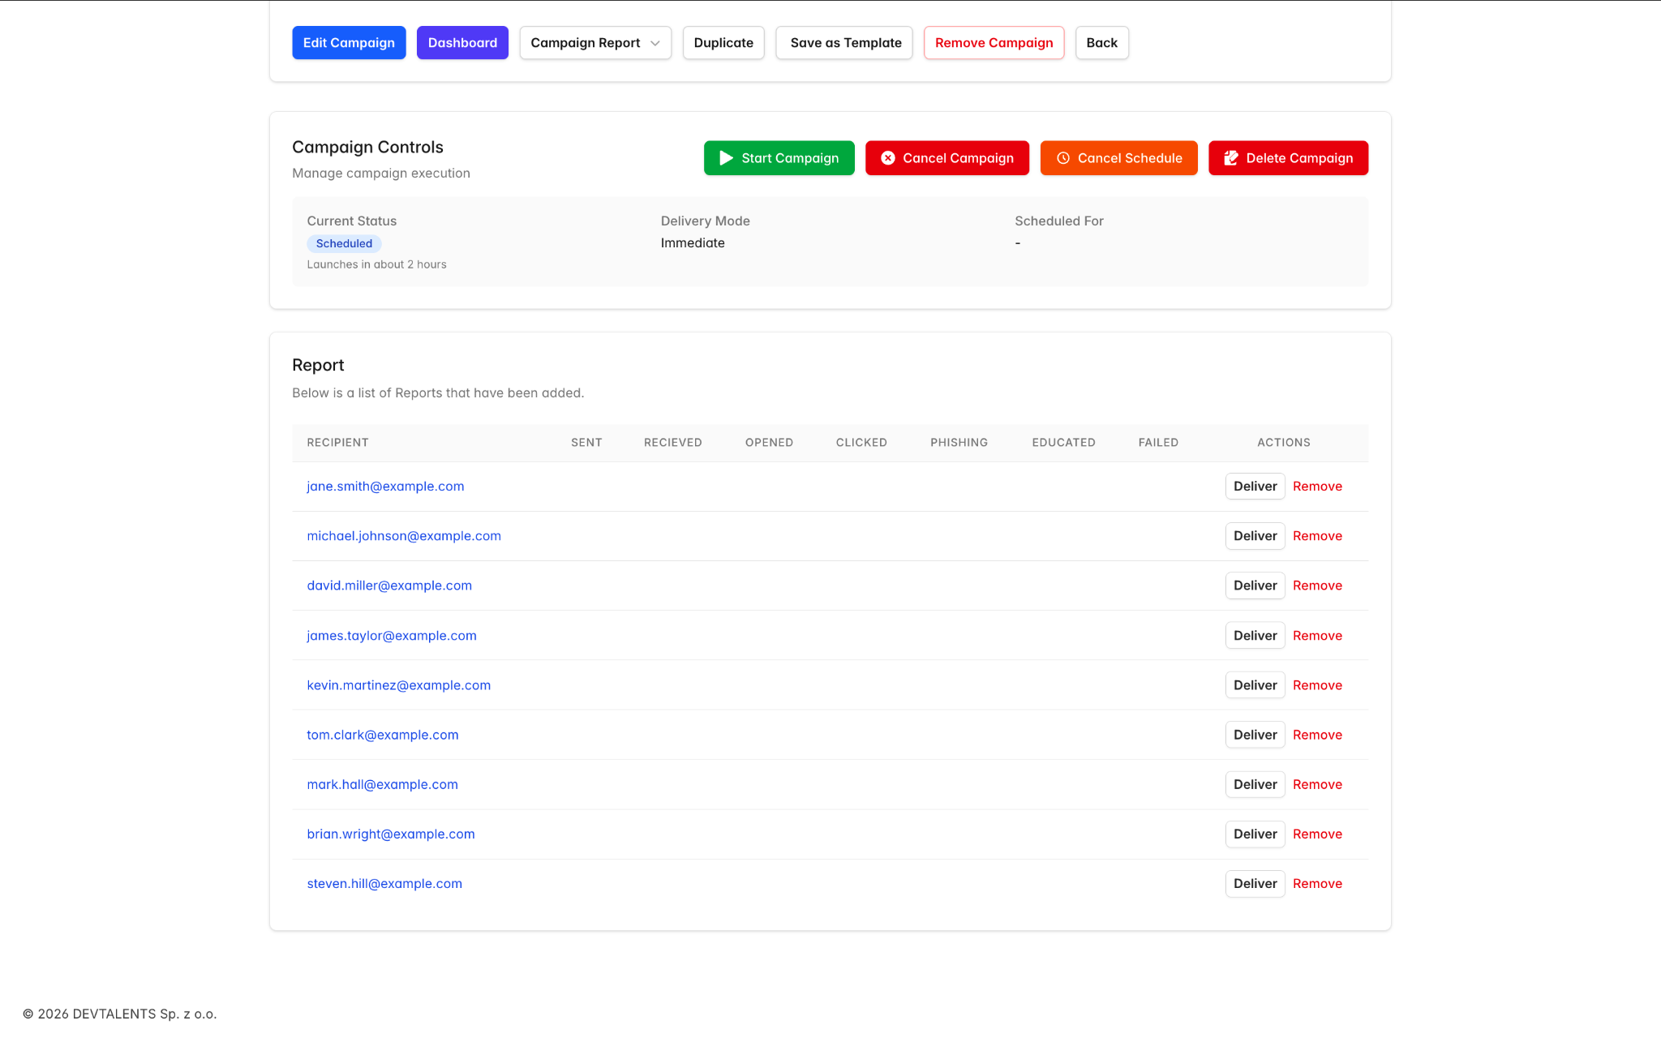

4.6 Recurring Campaigns
PhishSpot supports recurring campaigns that automatically repeat at set intervals. When configuring a scheduled campaign, enable the Recurring checkbox in the schedule step and set two values:
- Interval — a number (e.g., 1, 2, 4).
- Unit — days, weeks or months.
So 1 week runs the campaign every seven days; 2 months runs it every other month. Each recurrence creates a child campaign linked to the original parent — the parent stays as the canonical template (its content, recipients and post-click action are snapshotted into each child at launch time), and the children carry their own reports. Edits to the parent only affect future recurrences; in-flight children keep the configuration they were launched with.
To stop a recurring series, open the parent and cancel it — that prevents future children from being created. Children already launched continue to completion independently.
If your goal is a continuous awareness program rather than a tightly-scheduled recurring send, consider an autopilot instead — see Chapter 23 Autopilots. Autopilots adapt template selection per recipient and pick up new contacts automatically, which a recurring campaign doesn’t.

4.7 Campaign Calendar
The Campaign Calendar provides a visual calendar view of all scheduled and past campaigns. You can navigate between months and click on any campaign entry to go directly to its detail page. This is useful for planning your phishing program and avoiding schedule conflicts.
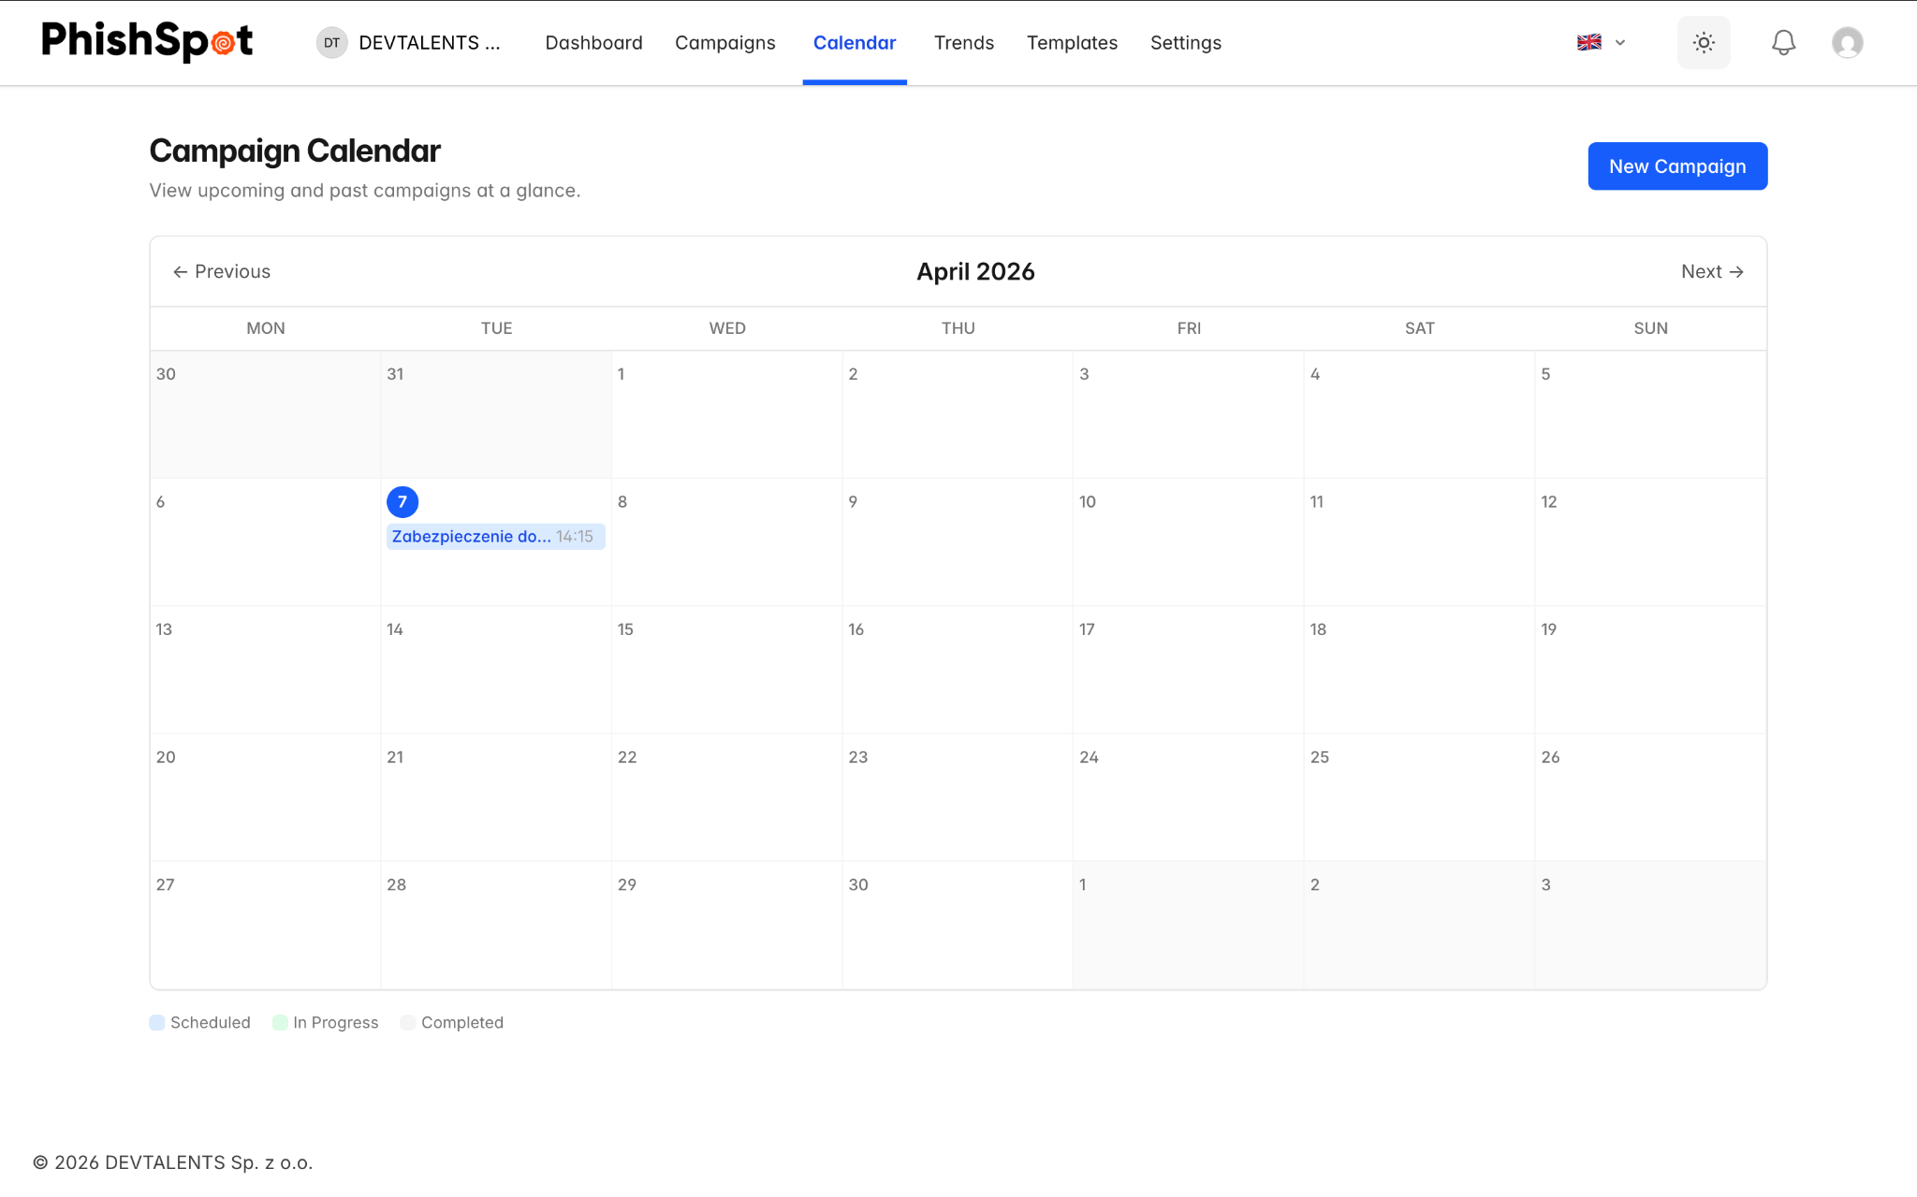

Contacts
Contacts are the people in your organization who receive phishing simulation emails. Managing your contacts accurately is essential for running effective campaigns.

5.1 Contacts List
Navigate to Settings → Contacts from the sidebar. The contacts list displays all contacts in your account with the following columns:
Column | Description
First Name | Contact’s first name (clickable to view details)
Last Name | Contact’s last name
Email | Email address (with a warning icon if the domain is unverified)
Telephone | Phone number (optional)
Department | Department the contact belongs to
Title | Job title
Location | Office or location
Groups | Number of groups the contact belongs to
Risk Score | Color-coded risk assessment (green = low, yellow = medium, orange = high, red = critical)
Performance | Click rate: how many campaigns they clicked vs. were targeted
Created At | When the contact was added
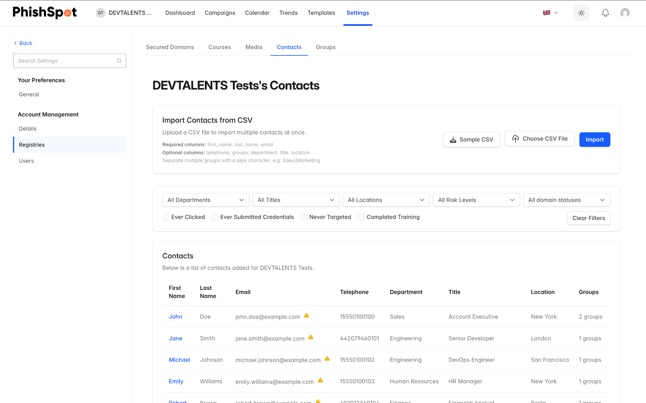

5.2 Filtering Contacts
The contacts list includes a filter bar at the top that lets you narrow down the list by:
- Department
- Title
- Location
- Special status filters such as: ever clicked a phishing link, ever submitted data, never targeted, or completed training

5.3 Adding a Single Contact
Click the New Contact button to add a contact manually. Fill in the following fields:
- First Name and Last Name — Required.
- Email — Required. Must be a valid email address.
- Telephone — Optional.
- Department, Title, Location — Optional fields for categorization and filtering.
- Groups — Assign the contact to one or more groups.
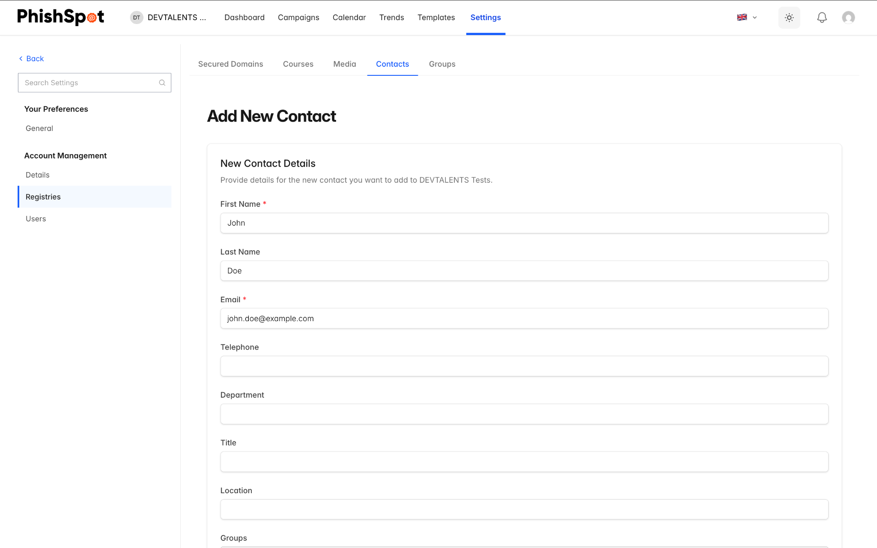

5.4 Importing Contacts via CSV
For bulk import, PhishSpot supports CSV file uploads. The process has three stages:
- Upload CSV — Click the Choose File button in the import section and select your CSV file. You can download a sample CSV first to see the expected format.
- Preview — Review the parsed data before importing. The preview shows which columns were detected and any errors found.
- Confirm — Click Confirm Import to create the contacts. If some rows fail, you can download a CSV of the failed rows to fix and re-import.
The required CSV columns are: first_name, last_name, email. Optional columns are: telephone, groups (comma-separated group names), department, title, location.
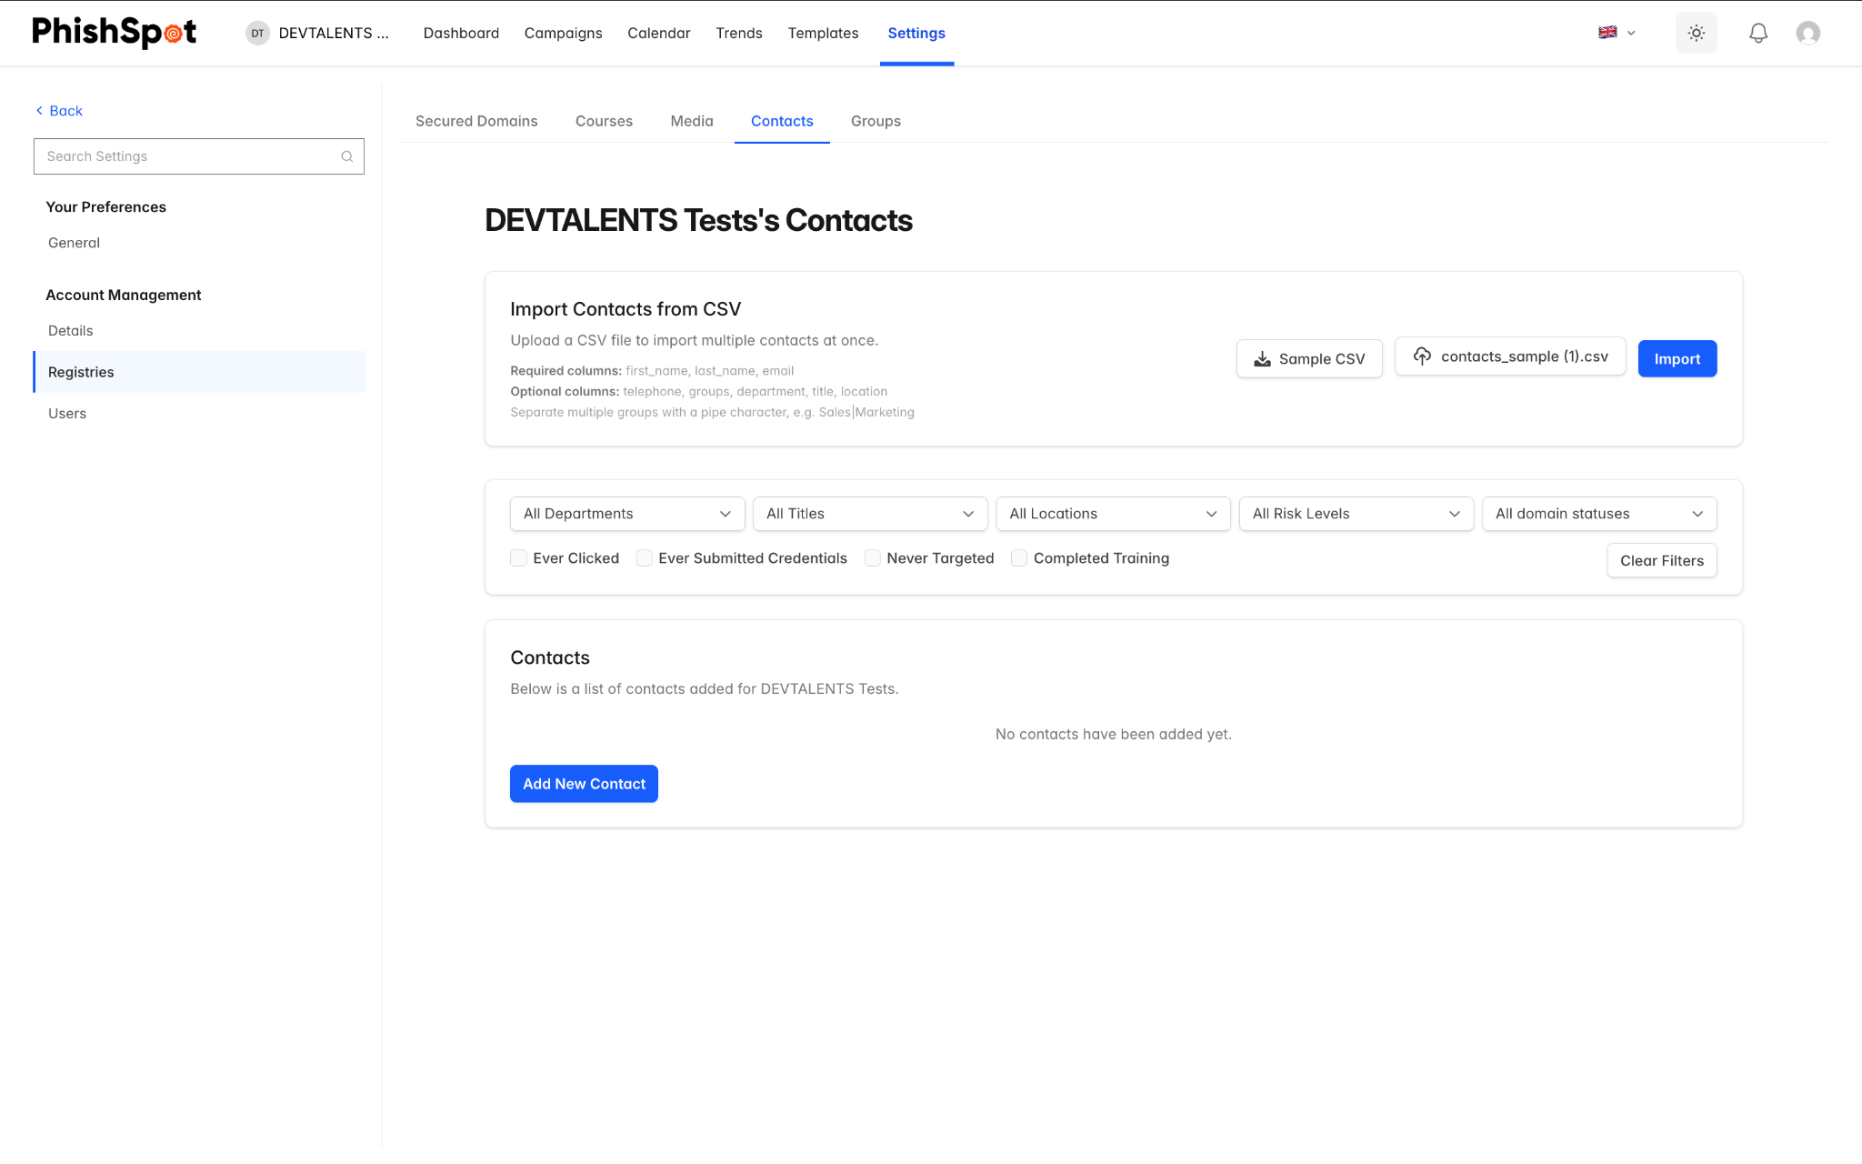
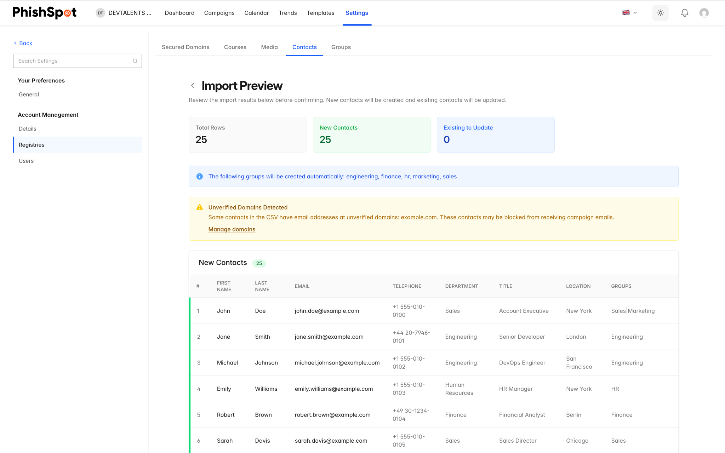

5.5 Contact Detail Page
Click on any contact’s name to see their detail page. This shows their complete profile information, risk score, campaign history, and performance metrics showing how they responded to past campaigns.
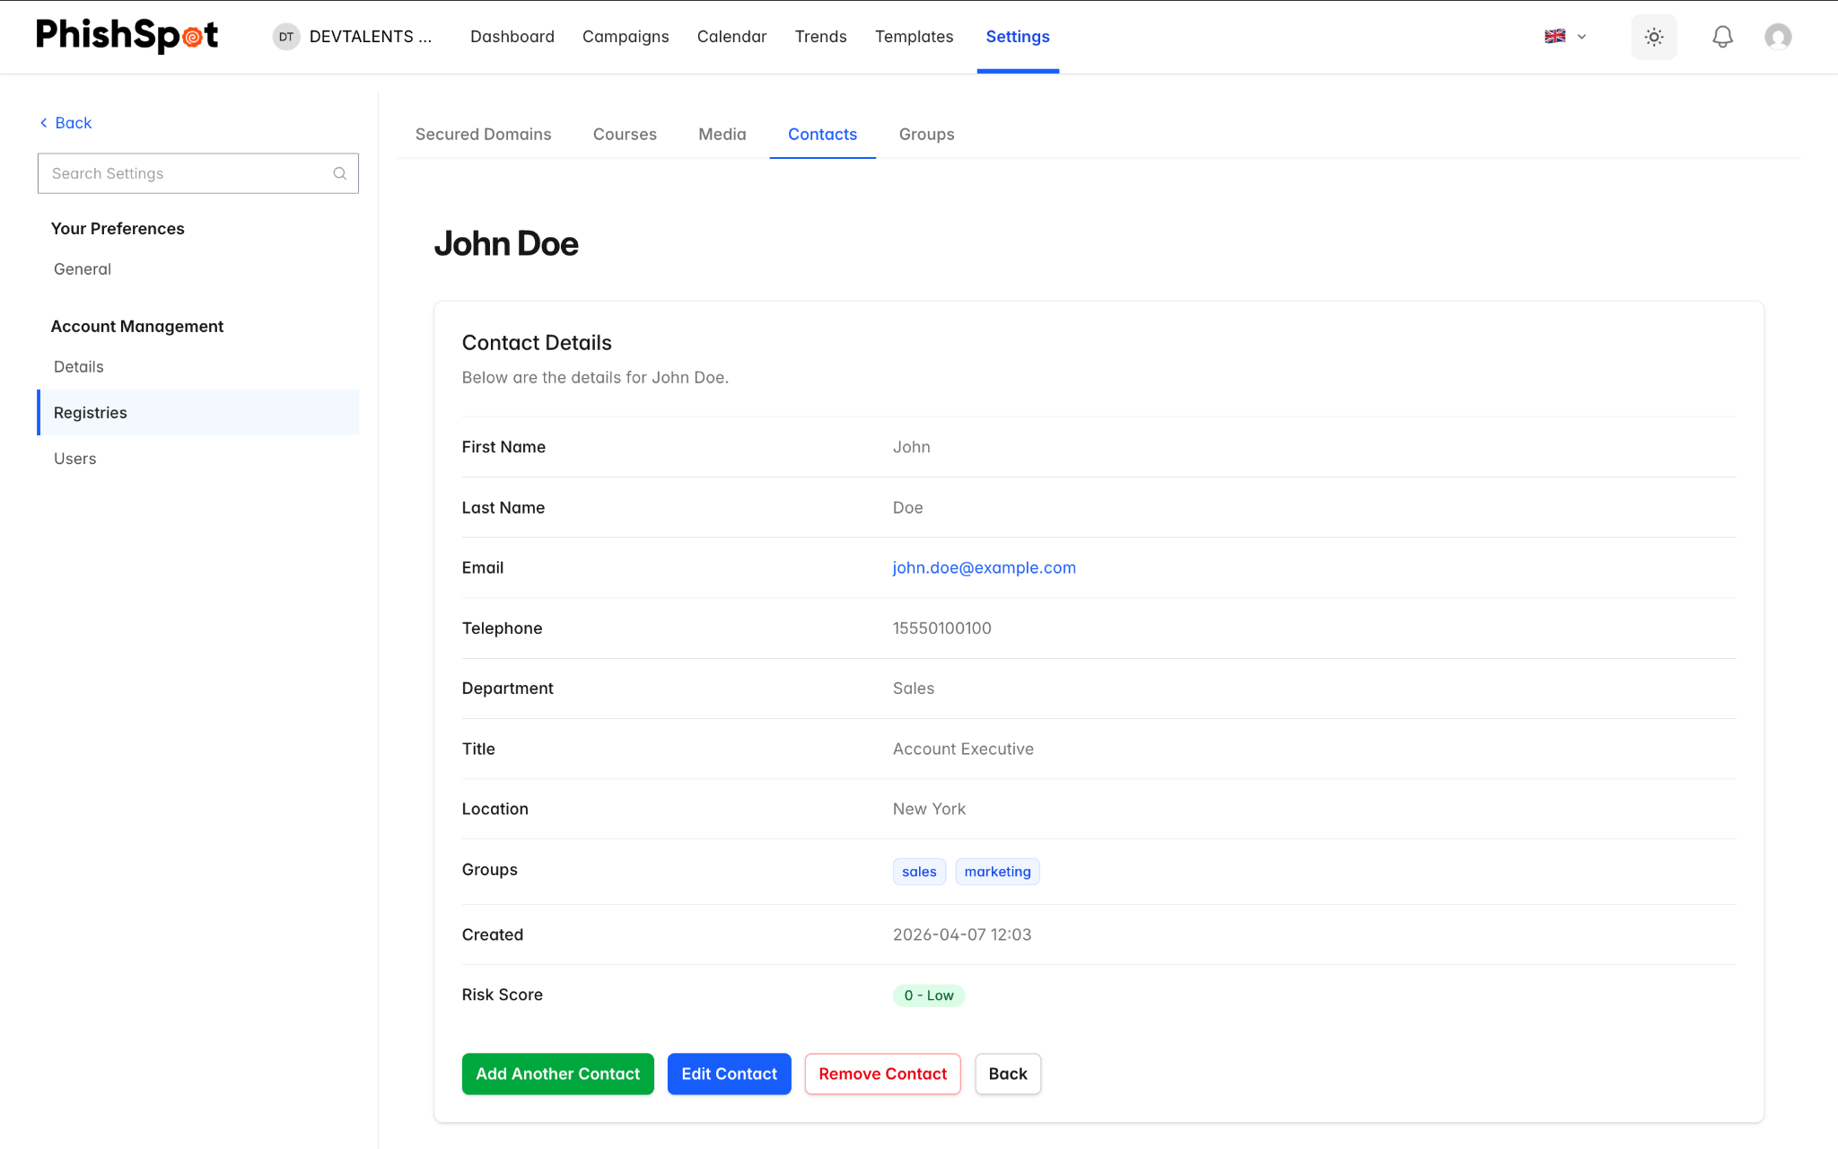

5.6 Bulk operations
Each row in the contacts list has a checkbox at the far left. Select two or more rows and a bulk action bar appears at the bottom of the page showing the selection count and the available actions. Today the only bulk action is Delete — useful for cleaning up a stale import, removing a department that has left the company, or pruning test contacts.
The bar’s Delete button asks for confirmation before removing anything; the confirmation dialog tells you exactly how many contacts will be removed. Deleted contacts disappear from the list and from any groups they belonged to; their deliverable history is preserved on the campaigns they participated in so reports stay intact.
Contacts imported from Entra AD (Chapter 25) will reappear on the next directory sync if they still exist (or are still enabled) in Entra. Bulk-delete is most useful for manually-imported contacts; for directory-managed ones, disable or remove them in Entra instead and let the next sync mirror the change.

Groups
Groups let you organize contacts into logical collections for targeted campaigns. For example, you might create groups for different departments, office locations, or risk levels.

6.1 Groups List
Navigate to Settings → Groups. The list shows:
Column | Description
Name | Group name (clickable to view members)
Contacts | Number of contacts in the group
Campaigns | Number of campaigns that have used this group
Created At | When the group was created
Actions | Edit and Delete buttons
Groups that are currently in use by active campaigns may be locked and cannot be edited or deleted until the campaign completes.

6.2 Creating a Group
Click New Group and enter a name and optional description. You can assign contacts to the group immediately using the multi-select contact picker, or add them later. Groups can also be created automatically during CSV import by including group names in the groups column.
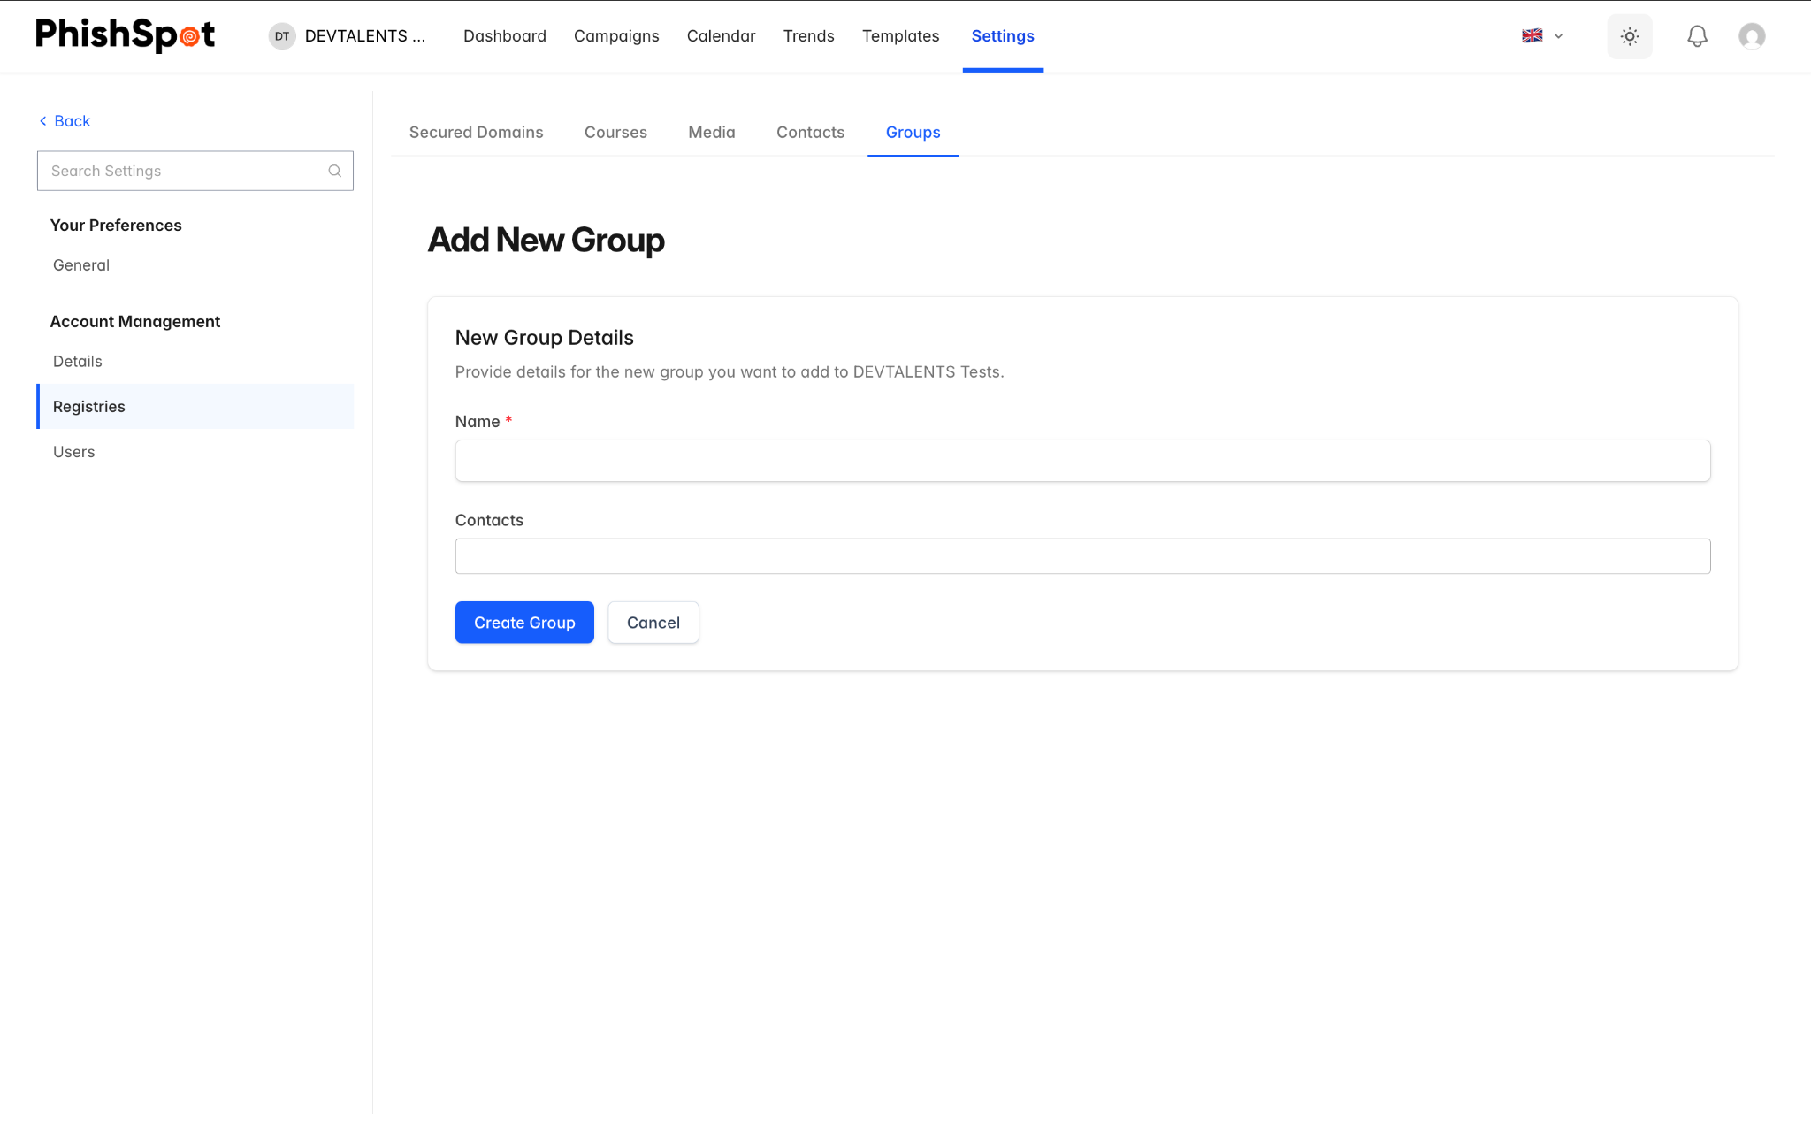

Phishing Templates
Templates save you time by providing pre-built phishing email designs that you can deploy directly into a campaign.

7.1 Template Library
Navigate to Templates from the sidebar. The template library has two tabs:
- Curated — Pre-built templates provided by PhishSpot, organized by category (e.g., credential harvesting, package delivery, IT alerts, HR notices). The curated library ships with 48 templates: 24 in English and 24 in Polish, all authored locally — the Polish set is written by a Polish-speaking team, not machine-translated, so the copy, sender names and pretexts land naturally for Polish recipients.
- My Templates — Custom templates you’ve created or saved from previous campaigns.
The left sidebar shows a category tree that lets you filter templates by type. Templates are displayed in a grid view with preview thumbnails.
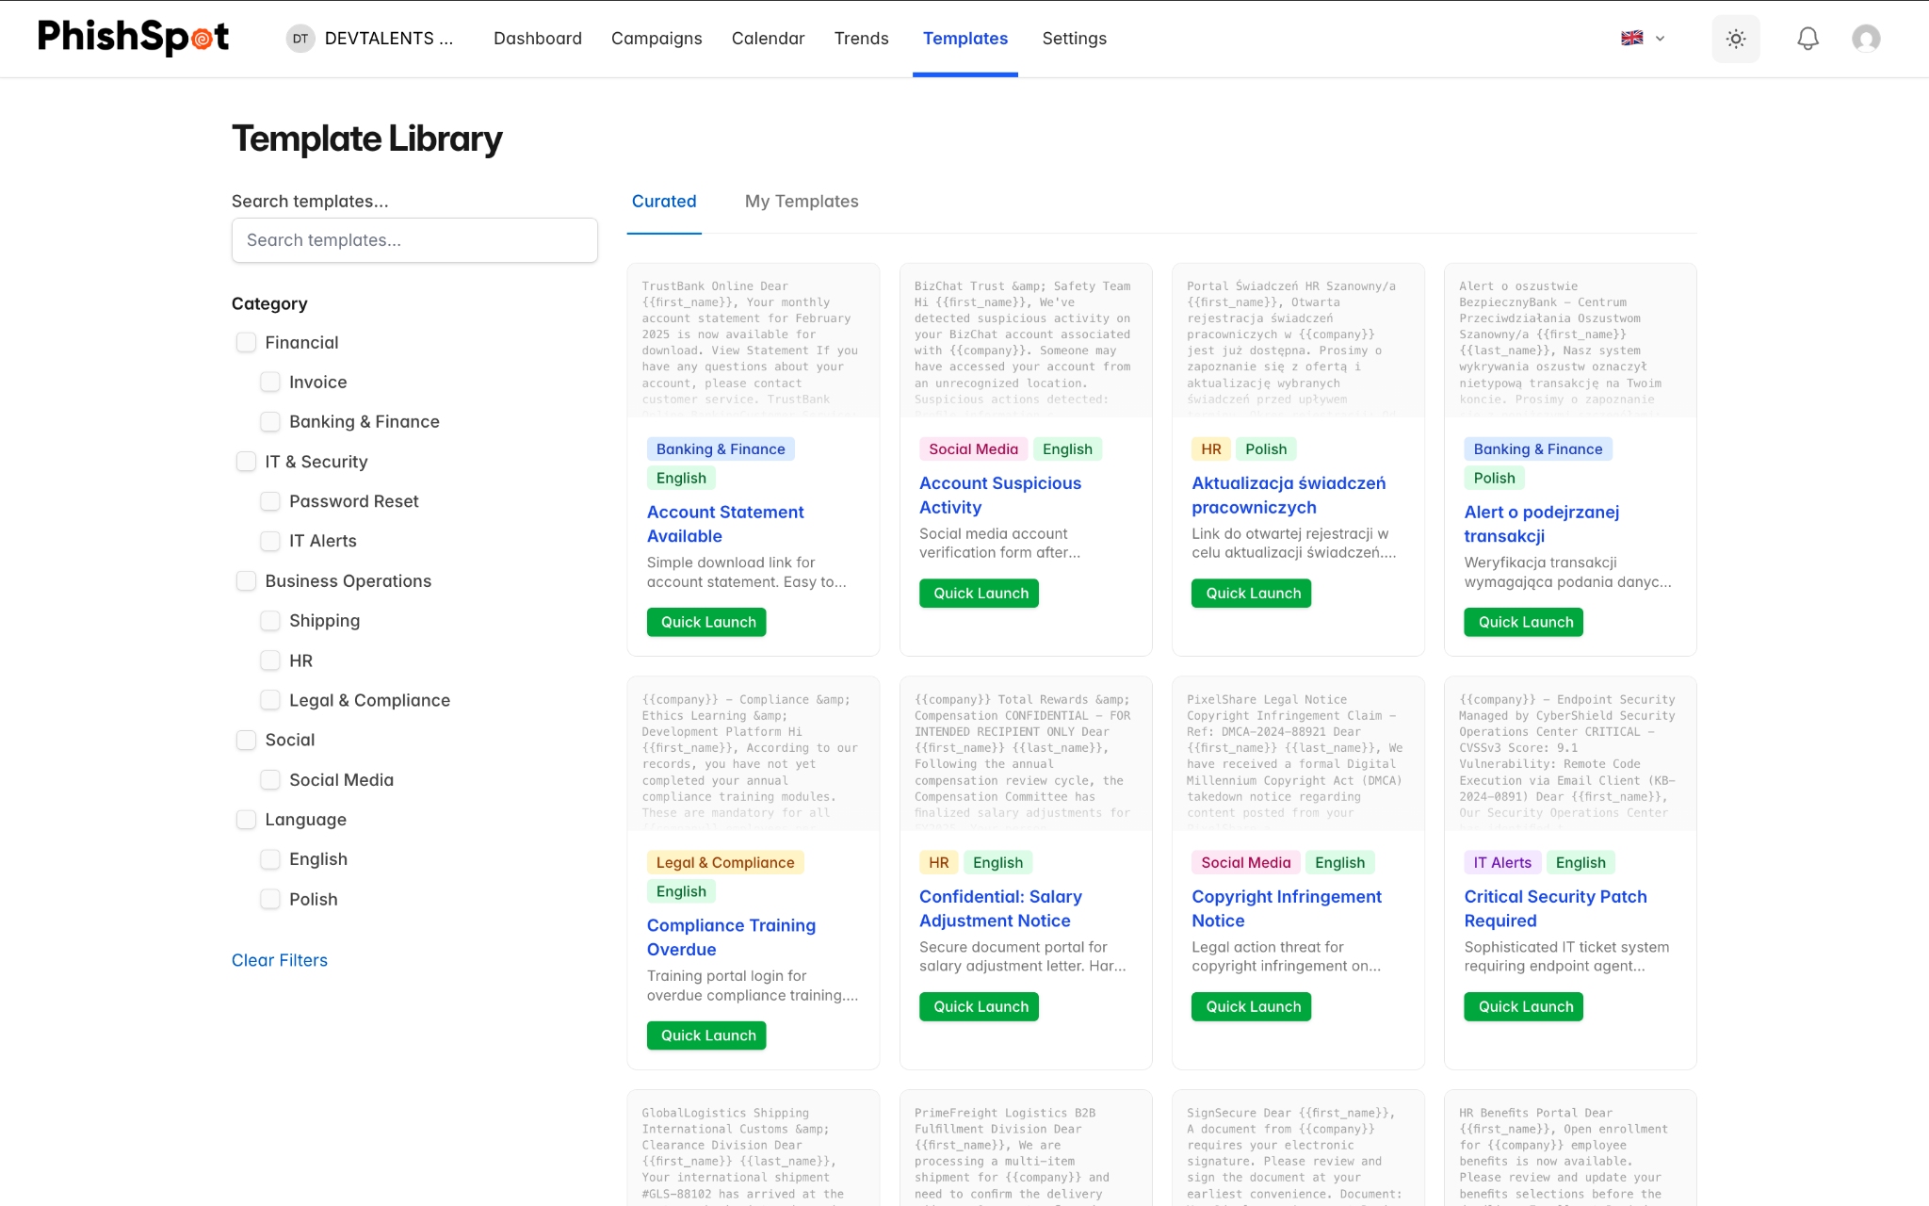

7.2 Using a Template
There are two ways to use a template:
- Deploy — Applies the template’s email content to an existing draft campaign.
- Quick Launch — Creates a new campaign pre-filled with the template’s email content, ready for you to configure recipients and delivery settings.

7.3 Creating Custom Templates
On the My Templates tab, click New Template to create your own. You can also save any campaign’s email as a template using the Save as Template button on the campaign detail page. Custom templates support the same email editor and template variables as campaigns.
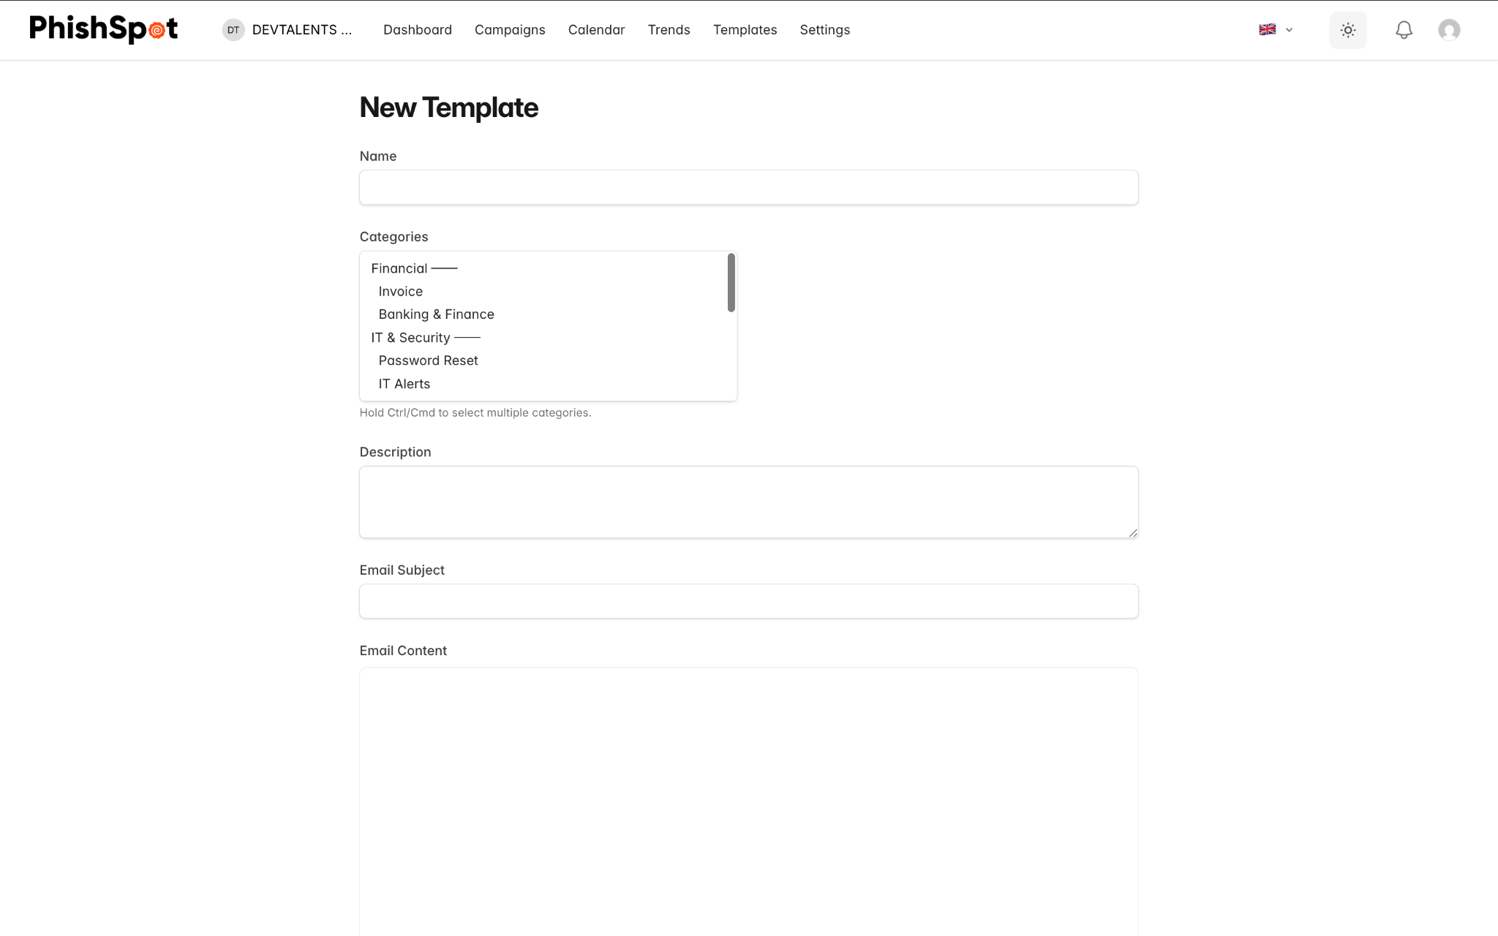
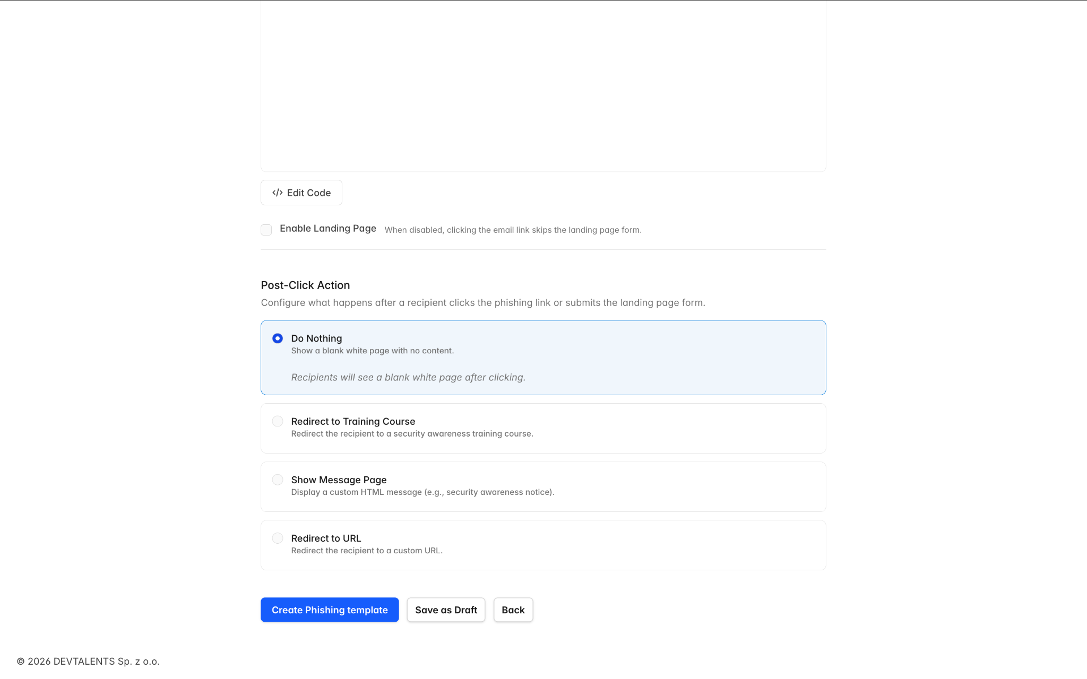

Courses (Security Awareness Training)
Courses are training modules that are shown to employees after they fall for a phishing simulation. They educate users on how to recognize phishing attempts and improve security behavior.

8.1 Course List
Navigate to Settings → Courses. The list shows all available courses with:
Column | Description
Name | Course title (with a purple “Global” badge if it’s a platform-provided course)
Blocks | Number of content blocks (lessons, quizzes) in the course
Created At | When the course was created
Actions | Preview, Edit, and Delete buttons
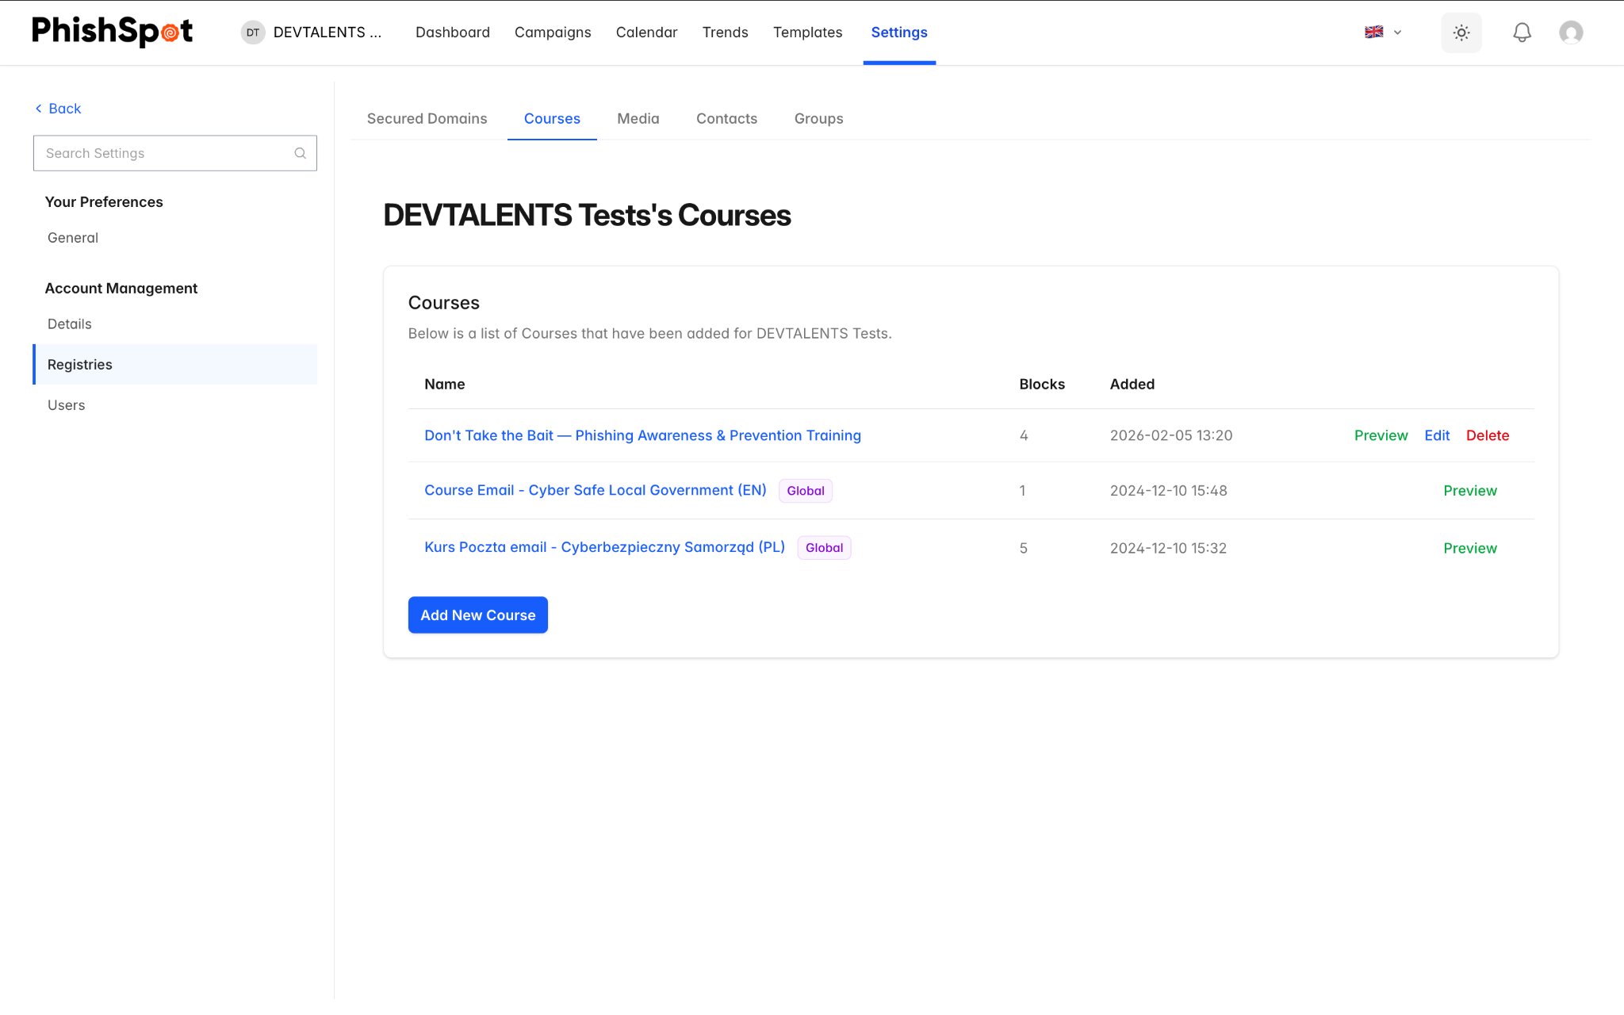

8.2 Creating a Course
Click New Course to create a custom training course. A course is made up of blocks, which are individual content sections:
- Lesson Blocks — Text, images, and educational content about phishing awareness.
- Quiz Blocks — Interactive quizzes to test the user’s understanding.
Blocks can be reordered by dragging them into the desired sequence. Use the Preview button to see how the course will appear to end users.
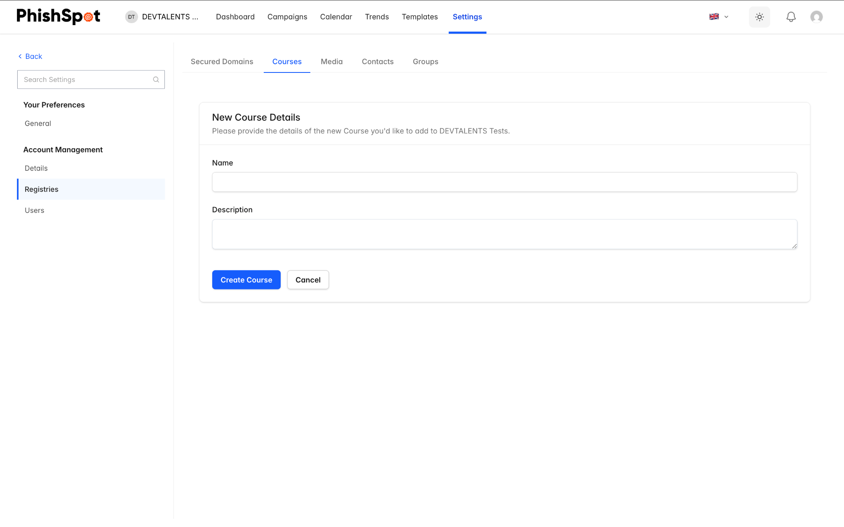

8.3 Assigning Courses to Campaigns
Courses are assigned during campaign creation in Step 4 (Post-Click Action). When a recipient clicks the phishing link or submits data on the landing page, they are redirected to the assigned course. Their progress and completion status are tracked in the campaign dashboard.

Domains
PhishSpot uses two types of domains: Secured Domains (for sending emails) and Platform Domains (for hosting landing pages).

9.1 Secured Domains (Sender Verification)
Secured domains verify that you own the email domains you send phishing simulations from. This ensures emails are delivered reliably and not flagged as spam.
Navigate to Settings → Secured Domains. The list shows each domain with its verification status:
Status | Meaning
Unverified | Domain has been added but verification has not been completed
Pending | Verification is in progress (DNS records added, awaiting propagation)
Verified | Domain ownership confirmed — ready for campaign use
Failed | Verification attempt failed — check your DNS records
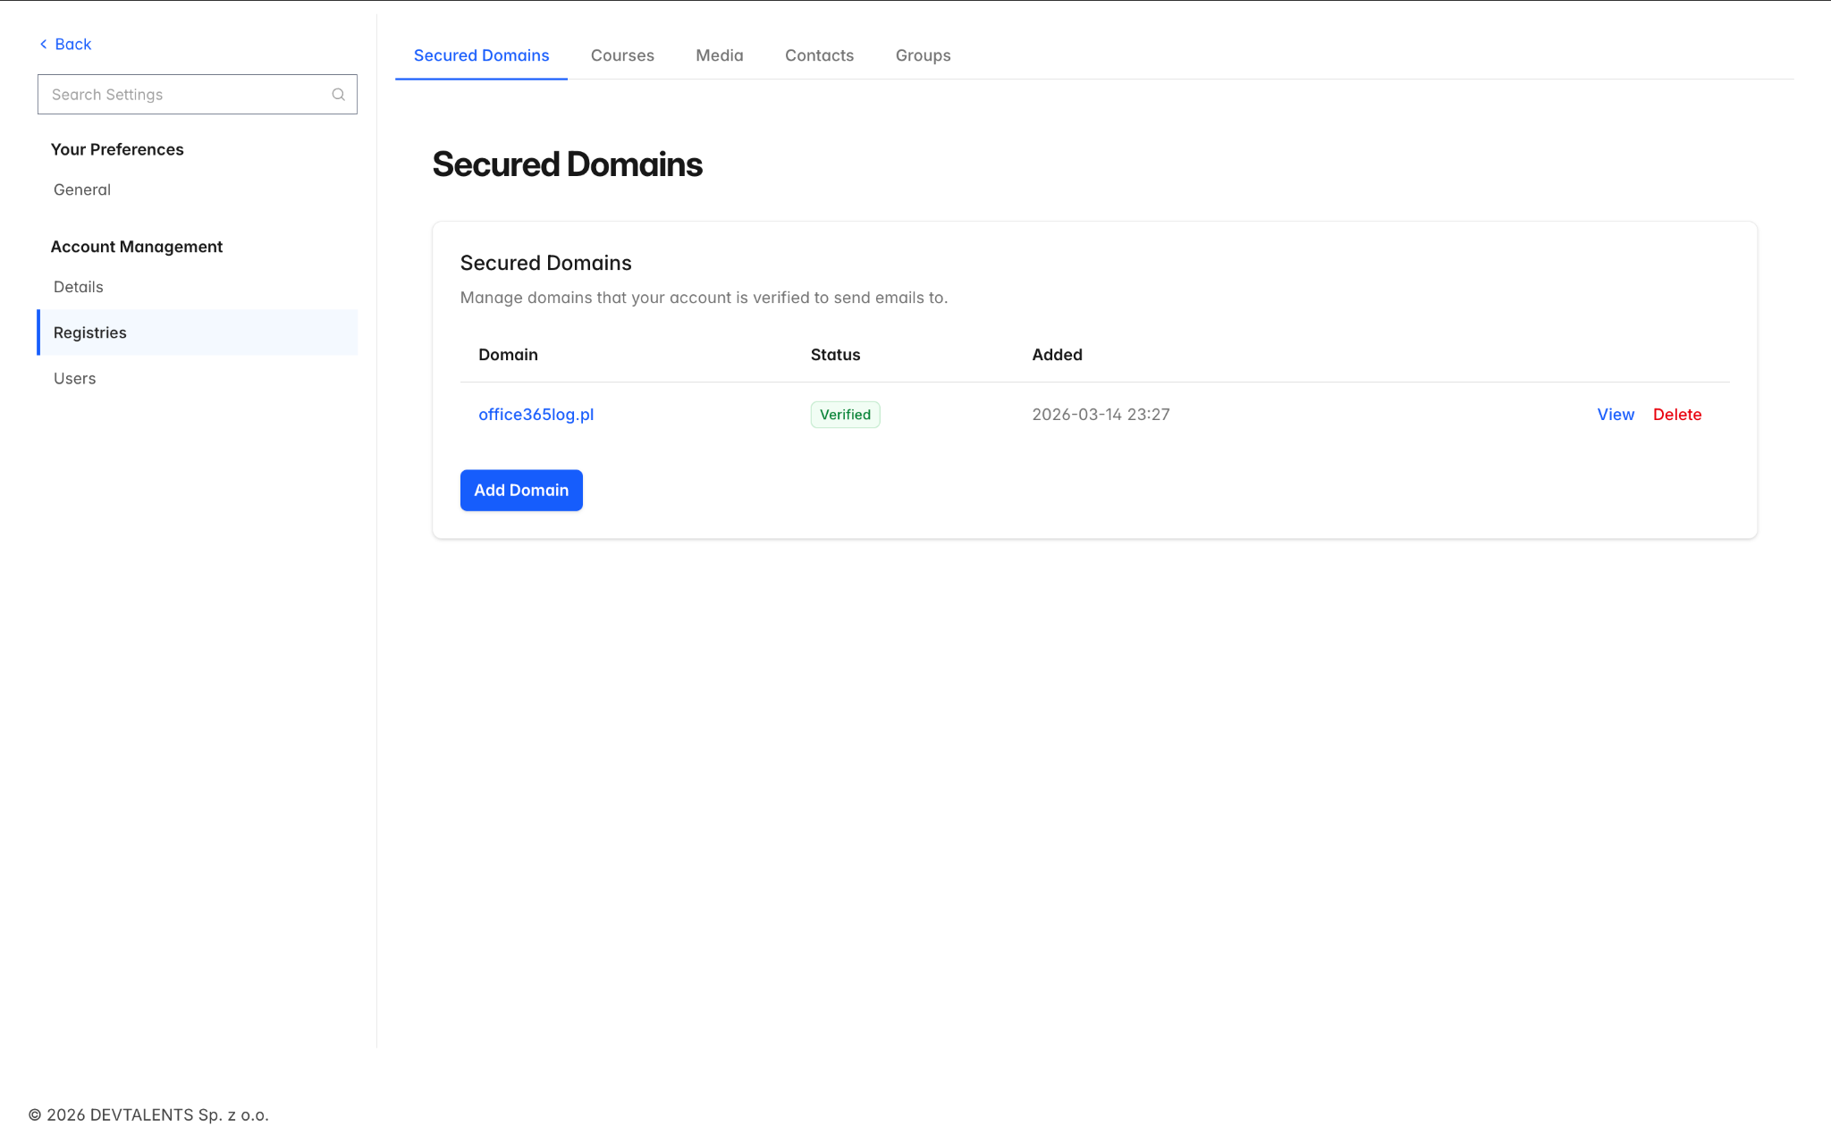

Verifying a Domain
To add and verify a new secured domain:
- Click New Domain and enter the domain name (e.g., yourcompany.com).
- PhishSpot will provide DNS records (CNAME or TXT) that you need to add to your domain’s DNS settings.
- After adding the DNS records, click Verify DNS to check if the records have propagated.
- Alternatively, you can verify via email — PhishSpot sends a verification code to a standard admin address on the domain.
DNS propagation can take up to 48 hours. If verification fails, wait and try again.

9.2 Platform Domains (Landing Page URLs)
Platform domains are the URLs used for your phishing landing pages. When a recipient clicks the link in a phishing email, they are taken to a page hosted on one of these domains.
Navigate to Settings → Platform Domains. The list shows:
Column | Description
Name | Domain display name
Public | Whether this domain is shared across accounts or private to yours
Mail | Whether the domain can also be used for sending emails
Expires On | Expiration date (or Never if permanent)
Campaigns | Number of campaigns currently using this domain
Platform domains are typically configured by your organization’s IT team or the platform admin. You select from available domains when creating campaigns.

9.3 Custom Sending Domains (Bring Your Own Domain)
Custom domains let you send campaigns from a domain you own, registered at any registrar. Unlike Secured Domains (which only verify that you own an address you send to) and Platform Domains (managed by the platform admin), a custom domain is fully managed for you once you delegate it: you point its nameservers to us, and we create every DNS record automatically.
Navigate to Settings → Custom Domains.

Buying a dedicated domain
Use a dedicated domain bought just for simulations — not a domain you use for your real website or email. Pointing the nameservers to us moves all DNS for that domain to us, so any existing website or mail on it would stop working.

Getting your nameservers
- Go to Settings → Custom Domains → Add domain and enter the domain you own.
- The setup page shows the two nameservers to use, each with a copy button.
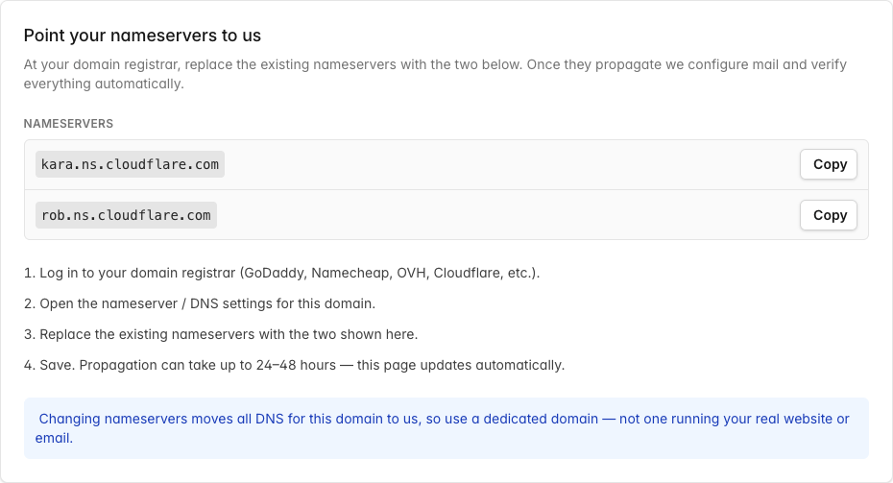

Setting nameservers at your registrar
- Log in to your domain registrar (GoDaddy, Namecheap, OVH, Cloudflare, etc.).
- Open the nameserver / DNS settings for the domain.
- Replace the existing nameservers with the two shown on the setup page.
- Save. Propagation can take up to 24–48 hours — the page updates itself as it progresses.


What we verify
A live progress bar walks through three stages — Delegation → Mail config → Sending-ready. You can also press Check status now at any time. The status badge means:
Status | Meaning
Waiting for nameservers | Delegation not detected yet
Configuring mail | Delegation found; we’re adding and verifying the sending records (SPF, DKIM, MX, Return-Path)
Sending-ready | Verified — the domain now appears in the sender list when you create a campaign
Needs attention | The domain was working but later broke; blocked for new campaigns
Setup failed | Setup couldn’t complete — re-check your nameservers and try again

Healthy vs. blocked
Because a custom domain isn’t under our control, we keep checking it. If the registration expires, the nameservers change away from us, or the mail records are removed, the domain is marked Needs attention and blocked from starting new campaigns. Campaigns already running on it keep delivering, and the account admins receive an email explaining what to fix.
Renew your domain on time. We email the account admins when a custom domain is approaching its expiry date so it never lapses mid-program.

Troubleshooting
- Stuck on “Waiting for nameservers” — confirm both nameservers are set exactly as shown at your registrar; propagation can take up to 48 hours.
- “Needs attention” after it was working — open the domain to see the specific reason (expired / nameservers changed / mail records missing), fix it, then click Check status now.
- Removing a domain — deleting a custom domain tears down its DNS and mail configuration. You can’t delete one while it has an active campaign; pause or finish those first.

Media Library
The media library stores files (images, documents, attachments) that you can use in your campaigns, courses, and landing pages.
Navigate to Settings → Media or find it on your Dashboard. The library shows a table of uploaded files with columns for Name, Content Type, a copyable URL link, creation date, and action buttons.

10.1 Uploading Media
Click New Media to upload a file. Enter a descriptive name and select the file from your computer. After upload, the file is assigned a permanent URL that you can copy and paste into email templates or landing page HTML.
[Screenshot: Media upload form]

Reports & Analytics
PhishSpot provides several ways to analyze your campaign results and track your organization’s security posture over time.

11.1 Campaign Reports
Each campaign has its own dashboard (see section 4.5) with detailed funnel charts, recipient tables, and group breakdowns. You can export individual campaign reports in two formats:
- PDF Report — A formatted document suitable for sharing with management.
- Excel Report — A spreadsheet with raw data for further analysis.

11.2 Cumulative Reports
From the campaigns list page, you can generate cumulative reports that aggregate data across all campaigns. This is useful for quarterly or annual security awareness reviews.

11.3 Trend Dashboard
Navigate to Trends from the sidebar to access the trend dashboard. This view shows historical performance data across all your campaigns with date range filtering options: 30 days, 90 days, 6 months, 1 year, all time, or a custom date range.
The trend dashboard helps you answer questions like: Are employees getting better at recognizing phishing emails over time? Which departments need additional training? Is the click rate decreasing campaign over campaign?
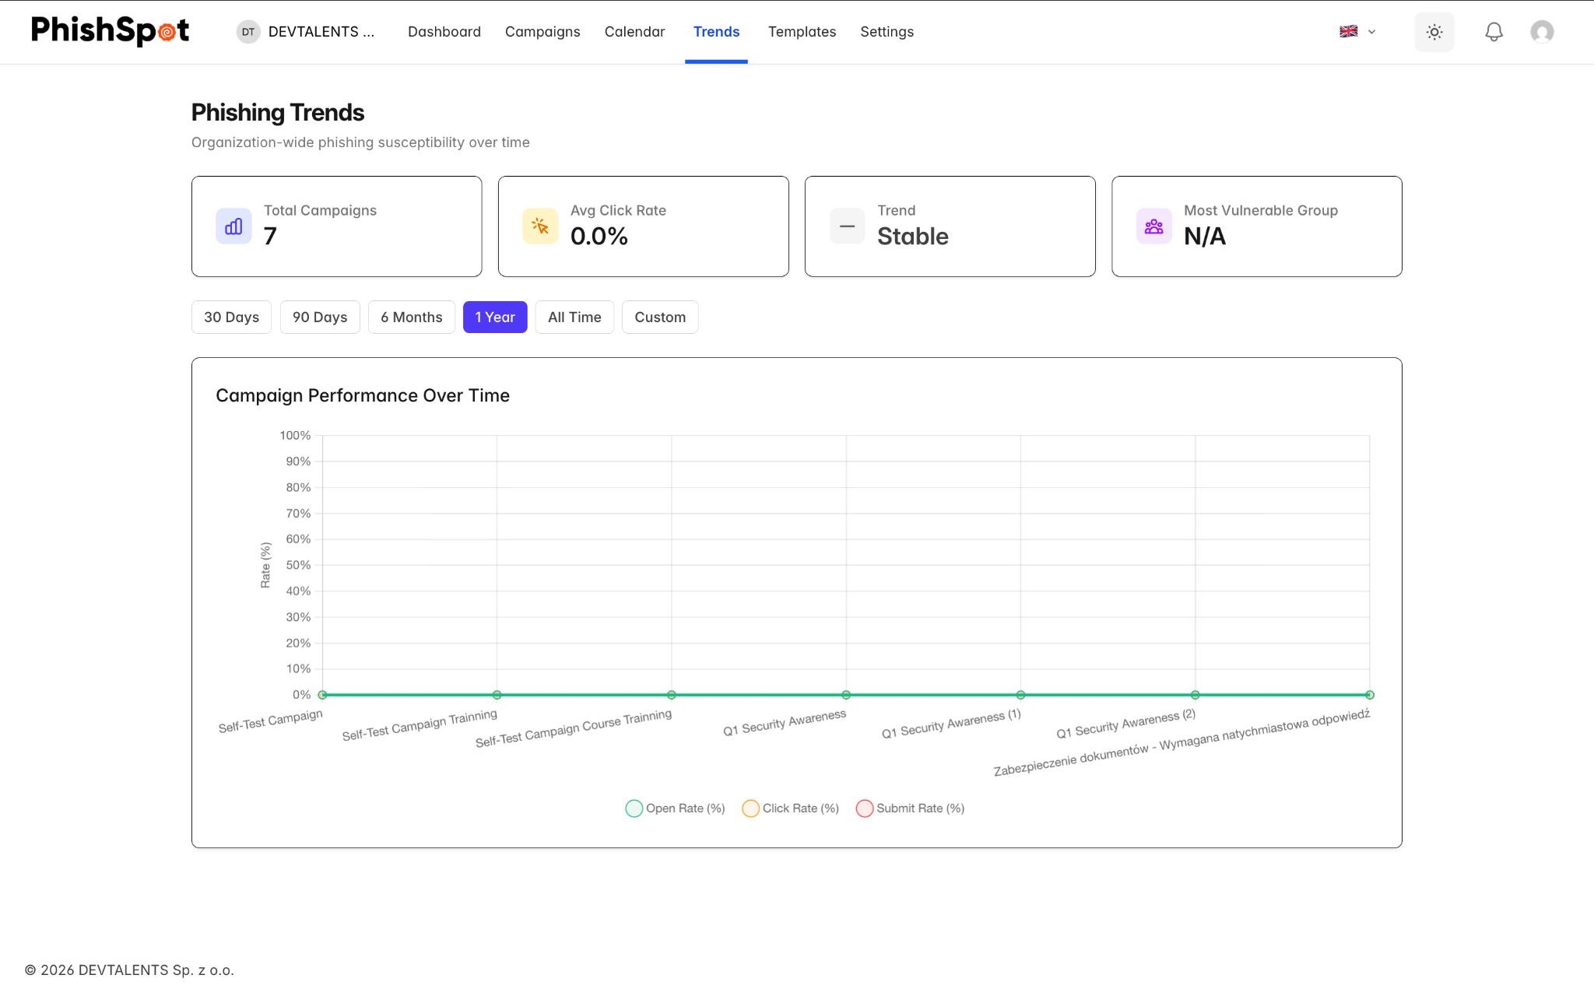

11.4 Recipient Timeline
Within any campaign dashboard, clicking on a recipient opens a detailed timeline panel showing every tracked event for that person: when the email was sent, when it was opened, when the link was clicked, when the landing page was viewed, whether data was submitted, and whether the training course was started or completed.

11.5 Previewing the email each recipient received
Every row in a campaign’s Recipients table has a small magnifier-on-envelope icon next to the recipient’s email address. Click it to open a modal showing the exact email that contact received — with every template variable ({{first_name}}, {{company}}, {{position}} …) substituted with that contact’s actual values, the actual landing-page URL embedded, the actual From: address used. Not a generic preview: the rendered mail for that specific recipient.
The modal has a desktop / mobile viewport toggle at the top — flip between the two to see how the email looked on a 1920px-wide Outlook client vs. an iPhone Mail rendering. Useful during stakeholder review of a finished campaign (“show me exactly what Anna saw on her phone”) and during incident investigations (“did the link in this specific delivery target the right domain?”).
The same preview is also available from a contact’s individual deliverables view — open any contact’s detail page and the deliverable rows have the same magnifier. Two perspectives on the same modal: per-campaign (every recipient on one campaign) and per-contact (every campaign one person received).

Team Management
As an Admin, you can manage who has access to your account and what they can do.

12.1 Viewing Team Members
Navigate to Settings → Team Members. This page shows two sections:
- Active Members — All users currently in your account, showing their name, email, role (Admin/Editor/Member), and join date. The account owner is marked with an Owner badge.
- Pending Invitations — Invitations that have been sent but not yet accepted.
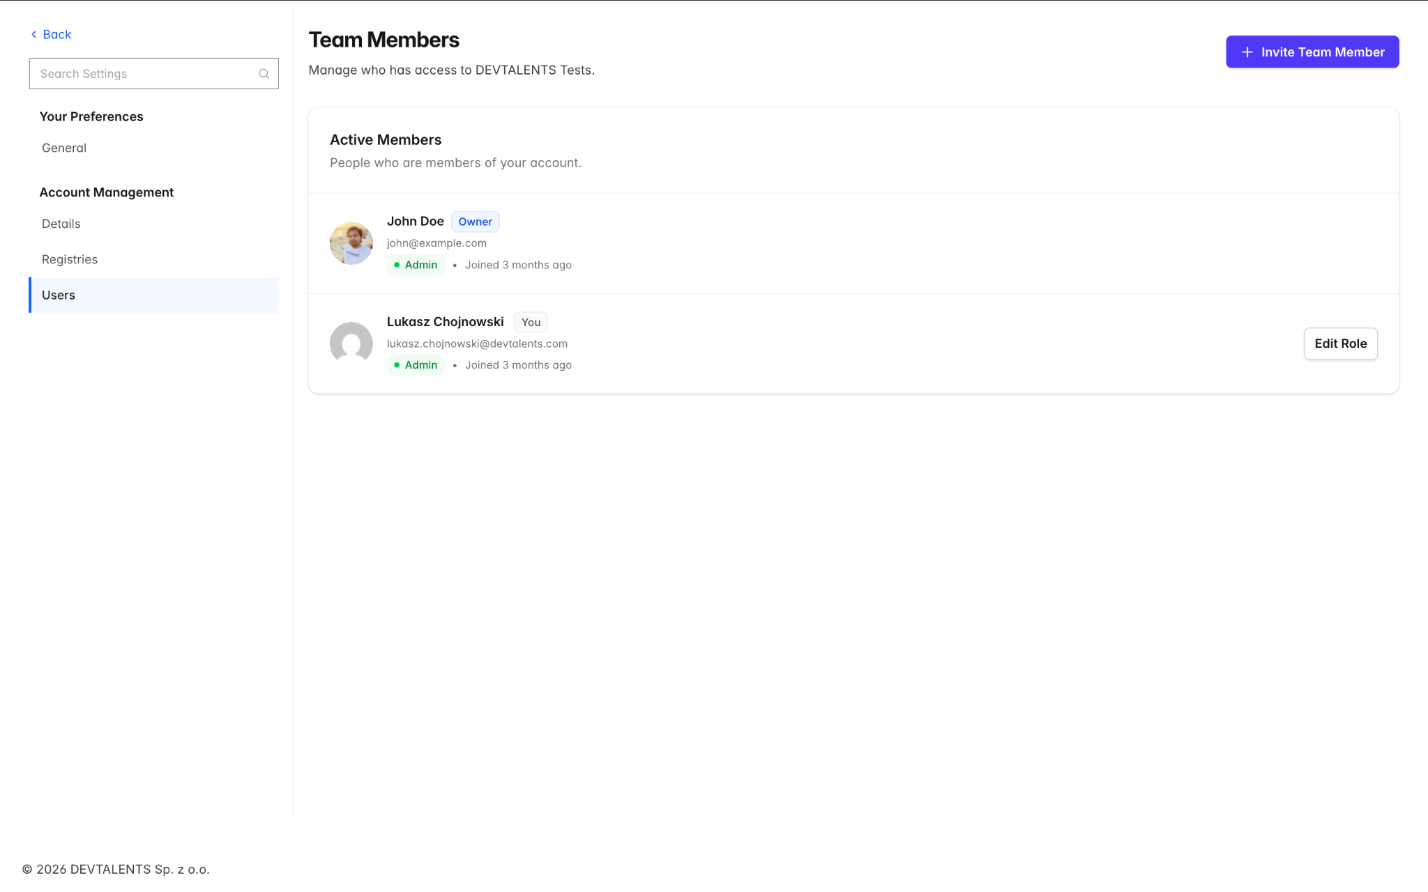

12.2 Inviting New Members
Click the Invite Member button to add someone to your team:
- Enter the person’s email address.
- Select their role: Admin, Editor, or Member.
- Click Send Invitation.
The invited person will receive an email with a link to accept the invitation. If they already have a PhishSpot account, they will see the new team appear in their account switcher. If they don’t have an account, they will be prompted to create one.
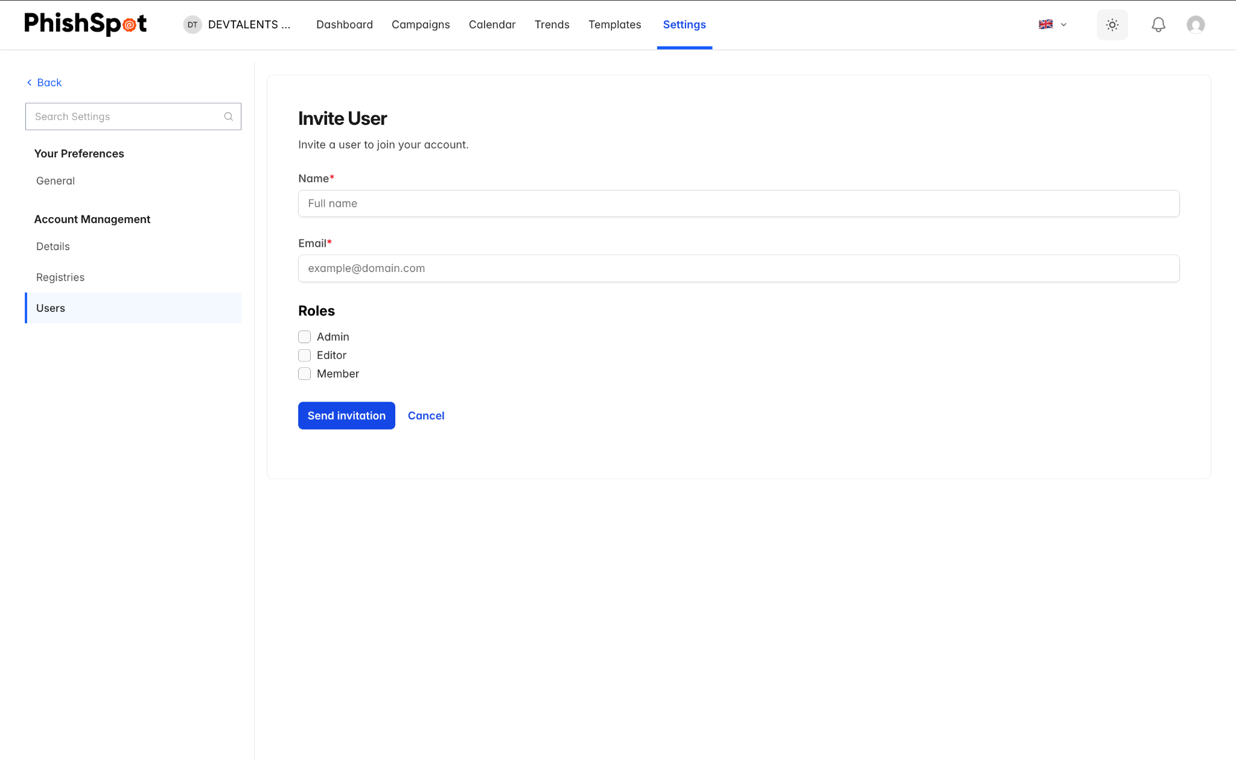
For pending invitations, you can resend the invitation email or cancel it entirely.

12.3 Changing Roles
To change a team member’s role, click the Edit button next to their name. Select the new role and save. Remember:
- Only Admins can change other members’ roles.
- The account owner’s role cannot be changed — they are always an Admin.
- You cannot change your own role.

12.4 Removing Members
To remove a team member, click the Remove button next to their name and confirm. The member will lose access to the account but their historical data (e.g., actions in campaign logs) is preserved. The account owner cannot be removed.

12.5 Transferring Ownership
If you are the account owner, you can transfer ownership to another Admin on the team. Navigate to Settings → Account Details and use the Transfer Ownership option. The target user must already be an Admin. After transfer, they become the new owner and you remain as an Admin.

Account Settings
Navigate to Settings → Account Details to configure your account preferences.

13.1 Basic Information
- Account Name — Your organization or team name.
- Time Zone — The default timezone used for campaign scheduling and report timestamps.
- Primary Language — The interface language (English or Polish).
- Avatar — An optional account image/logo.
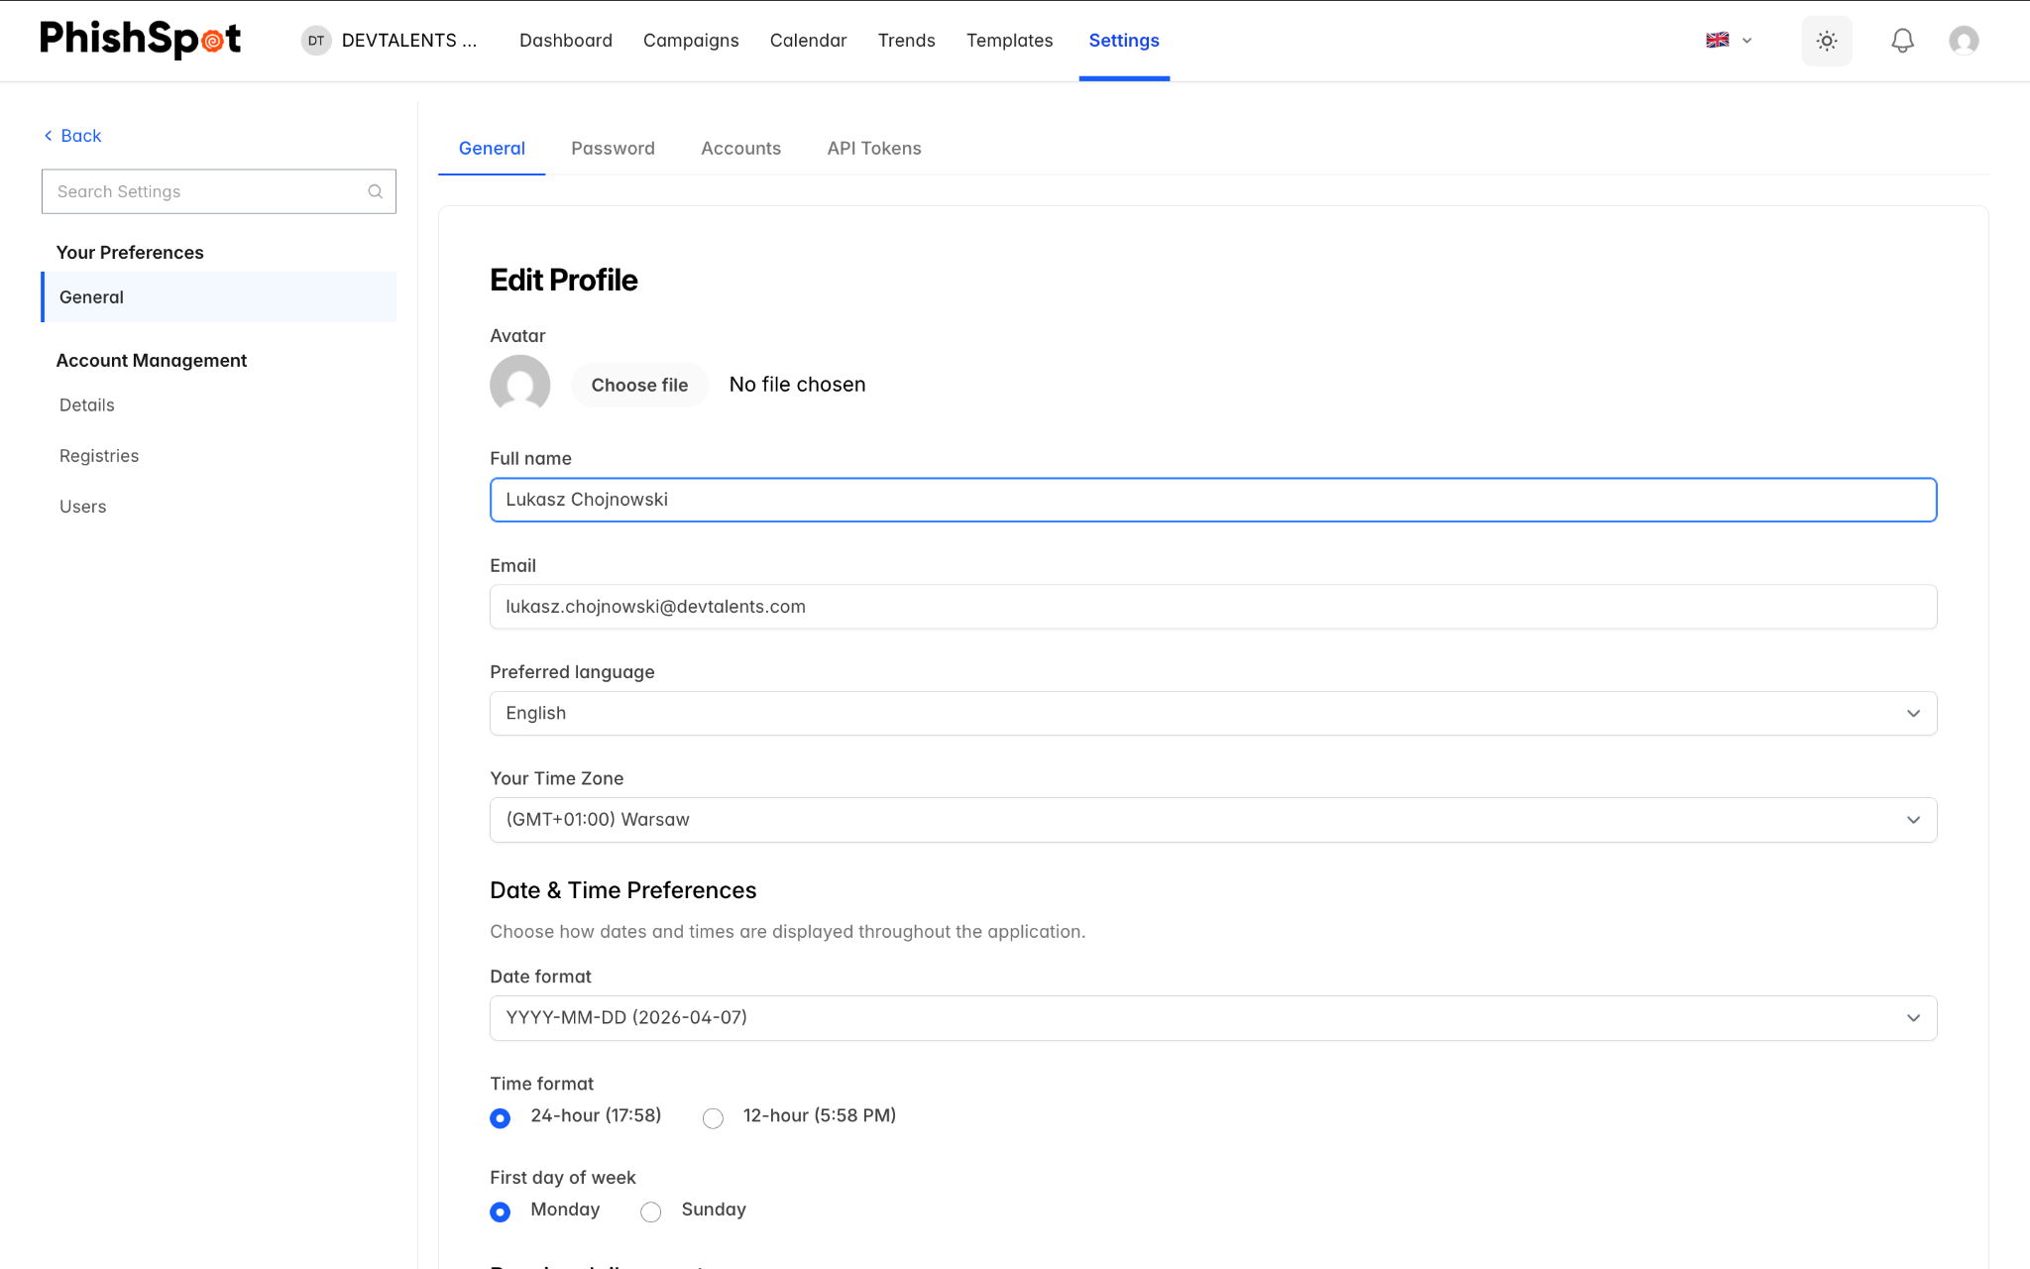

13.2 Business Hours
Enable business hours to restrict when campaign emails are delivered. When enabled, configure:
- Which days of the week emails can be sent (Monday through Sunday checkboxes)
- Start time and end time for the delivery window
Emails scheduled outside business hours will be queued and delivered during the next business window.

13.3 Default Awareness Page
Configure the default HTML page shown to users after they interact with a phishing simulation. This is the awareness/educational message that appears if no specific course is assigned to a campaign. You can edit the HTML using the built-in code editor and preview it in real time.

13.4 Deleting an Account
At the bottom of the Account Details page, there is a Delete Team button. This permanently deletes the account and all associated data including campaigns, contacts, templates, and results. This action cannot be undone. Only the account owner can delete the account.
Personal accounts cannot be deleted. Only team/organizational accounts have the delete option.

API Tokens
PhishSpot provides a REST API for programmatic access. To use the API, you need an API token.

14.1 Managing Tokens
Navigate to your user profile and select API Tokens. The token list shows all your tokens with their name, last used date, and creation date. Click New Token to create one. After creation, the token value is displayed once — make sure to copy it immediately as it cannot be viewed again.
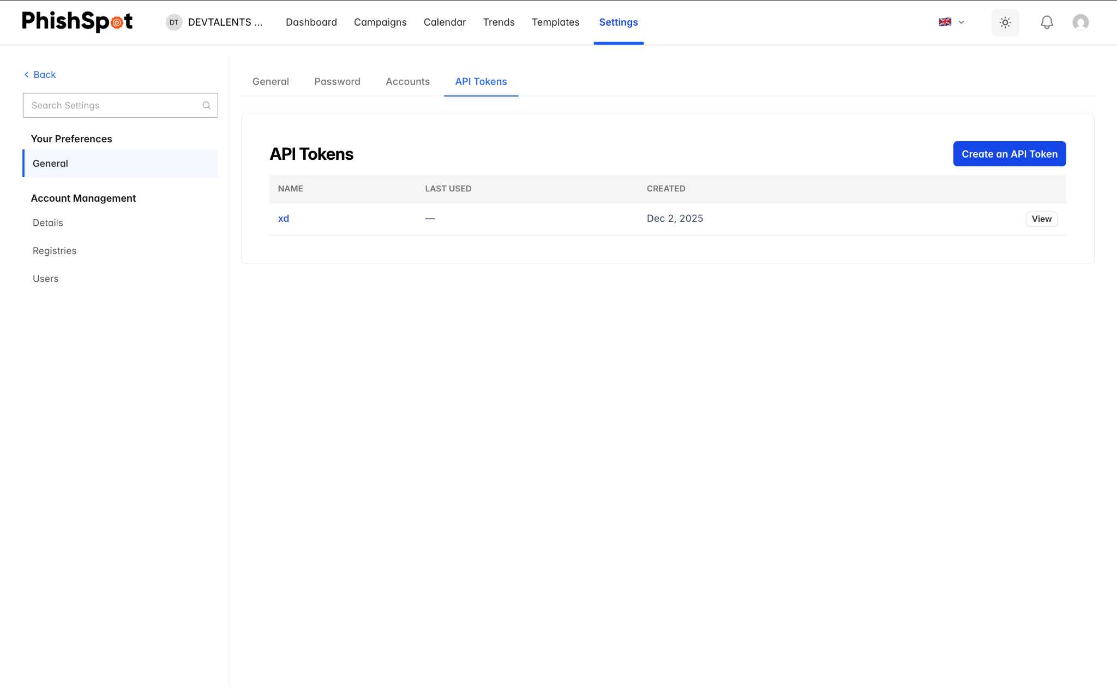
API tokens are tied to your user account, not to a specific team. Keep them secure and rotate them periodically.

User Profile & Preferences
Access your personal settings by clicking your name or avatar in the top-right corner and selecting your profile.

15.1 Profile Settings
- Name and Email — Update your display name and email address.
- Password — Change your login password.
- Two-Factor Authentication — Enable or manage 2FA for additional security.
- Theme — Switch between light and dark mode.

Common Workflows

16.1 Running Your First Campaign
Follow these steps to run your first phishing simulation:
- Add your contacts via CSV import (Settings → Contacts).
- Create at least one group and assign your contacts to it (Settings → Groups).
- Verify your sending domain (Settings → Secured Domains).
- Browse the template library and find a suitable phishing template (Templates).
- Click Quick Launch on the template, or create a new campaign manually (Campaigns → New Campaign).
- Walk through the 6-step wizard: configure settings, customize the email, set up the landing page, choose a post-click action, select recipients, and review.
- Send a test email to yourself and verify everything looks correct.
- Start or schedule the campaign.
- Monitor results on the campaign dashboard.

16.2 Ongoing Phishing Program
For a continuous security awareness program:
- Schedule recurring campaigns to automatically repeat at set intervals.
- Use different templates each time to test various attack vectors.
- Monitor the Trend Dashboard to track improvement over time.
- Focus additional training on departments or groups with higher click rates.
- Export cumulative reports for quarterly management reviews.
- Regularly update your contact list as employees join and leave.

16.3 Responding to High-Risk Users
When the platform identifies users with high risk scores (red badges):
- Review their profile to see which campaigns they fell for.
- Check if they completed the assigned training courses.
- Consider assigning them to a special group for additional targeted campaigns.
- Use the contact filters to find all high-risk users across the organization.

Template Variables
When writing email content or landing pages, you can use template variables — merge tags — to personalize the content for each recipient. Variables are replaced with each recipient’s actual values when the email is sent or the landing page is shown.
Wrap a variable in double curly braces: {{first_name}}. The available variables differ between the email (subject and body) and the landing page (and awareness message), because each is rendered in a different context. The editor validates this — you can’t save an email that references a landing-only variable.

Email variables (subject & body)
Variable | Description | Example output
{{first_name}} | Recipient’s first name | John
{{last_name}} | Recipient’s last name | Smith
{{full_name}} | Recipient’s full name | John Smith
{{email}} | Recipient’s email address | john.smith@company.com
{{position}} | Recipient’s job position | Senior Analyst
{{department}} | Recipient’s department | Finance
{{company}} | Your account (organization) name | Acme Inc.
{{campaign_name}} | The campaign’s name | Q2 Invoice Test
{{landing_url}} | The recipient’s tracked link | https://domain.com/l/abc123?d=…

Landing page & awareness message variables
Variable | Description
{{first_name}}, {{last_name}}, {{full_name}}, {{email}} | As above
{{company}} | Your account (organization) name
{{landing_url}} | The recipient’s tracked link
{{elearning_url}} | The recipient’s training link (for use on the awareness page)
Variable names are case-insensitive and tolerate surrounding spaces — {{First_Name}} and {{ first_name }} both work. If a variable has no value for a recipient, it is replaced with an empty string. A variable name that isn’t on the list above is left in the content literally, so watch for typos and always send a test email.
For guidance on using these variables effectively in a campaign, see Designing Effective Campaigns §30.1.

Troubleshooting

18.1 Emails Not Being Delivered
- Verify your sending domain is in Verified status (Settings → Secured Domains).
- Check that the from email address matches a verified domain.
- Ensure the campaign is in Active state and has not been paused or stopped.
- If using business hours, confirm the current time falls within the configured delivery window.

18.2 Landing Page Not Loading
- Verify that a platform domain is selected in the campaign settings.
- Check that the landing page is enabled (the toggle in Step 3 of the wizard).
- Ensure the platform domain has not expired.

18.3 Contacts Not Importing
- Download the sample CSV and verify your file matches the expected format.
- Ensure the email column contains valid email addresses.
- Check for duplicate emails — contacts with duplicate email addresses will be skipped.
- If rows fail, download the failed CSV to see specific error messages.

18.4 Cannot Edit a Campaign
- Only campaigns in Draft or Scheduled state can be edited.
- Active, Paused, and Done campaigns are read-only.
- If you need to modify an active campaign’s content, duplicate it, make changes, and start the new copy.

Reported Messages
Reported Messages is the inbox where your employees forward suspicious emails so your team can review them inside PhishSpot. Every account gets its own unique address. Reports show up in a dedicated section in the main navigation. The viewer keeps potentially dangerous content blocked by default — images, styling, links and attachments are all switched off until you decide otherwise.

19.1 The Phishing Report Inbox
Each account gets its own inbox address in the form <local>@platform.phishspot.com. The local part is filled in automatically when the account is created and can be edited from Settings → Account Details → Phishing Report Inbox.
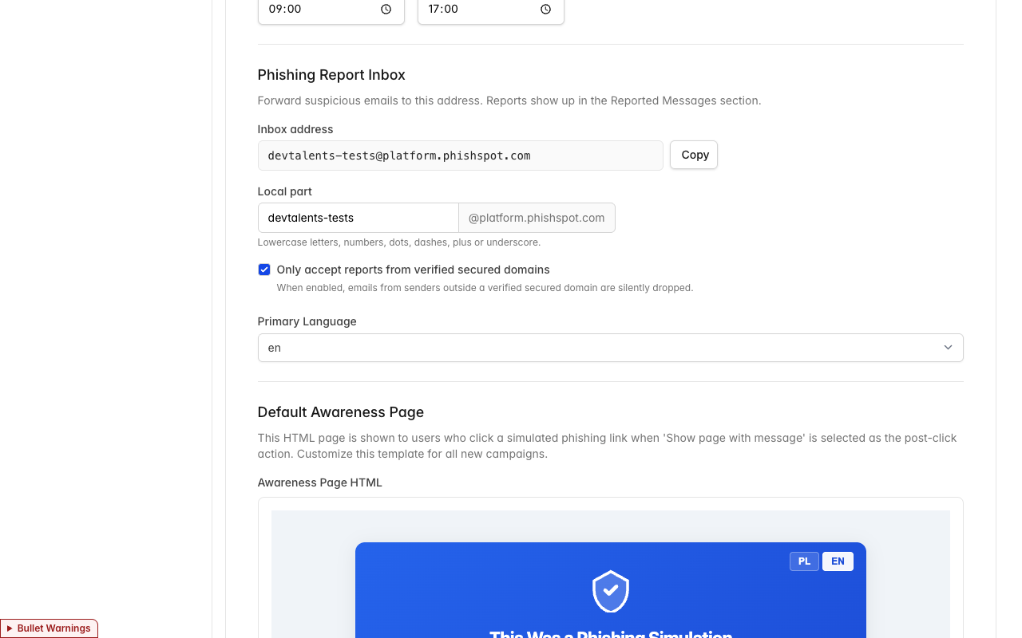
- Inbox address — the full address employees should forward to. The Copy button puts it on the clipboard so you can paste it into onboarding materials, signatures, or your help-desk knowledge base.
- Local part — the editable username part of the address. Use lowercase letters, numbers, dots, dashes, + or underscores.
- Only accept reports from verified secured domains — see 19.2.

19.2 Limit accepted senders
The Only accept reports from verified secured domains toggle (ON by default) limits who can submit a report:
- ON — only emails whose sender domain matches one of your verified Secured Domains are accepted. Everything else is discarded without notifying the sender.
- OFF — any sender is accepted.
Leave it ON in production. Switch it OFF temporarily during pilots when reporters might send from mailboxes you haven’t onboarded yet.
When a message is dropped, the sender is not notified — this is intentional, so that someone probing your inbox does not get a confirmation.

19.3 How a report arrives
The flow for your team:
- An employee receives a suspicious email.
- They forward it to the account’s Reported Messages inbox address.
- The report appears in Reported Messages in the main navigation, sorted with the newest first.
Promote the inbox address to your employees through onboarding, your help-desk knowledge base, or a signature footer.

19.4 The Reported Messages page
Open Reported Messages from the top navigation. The page is a two-pane list/detail view:
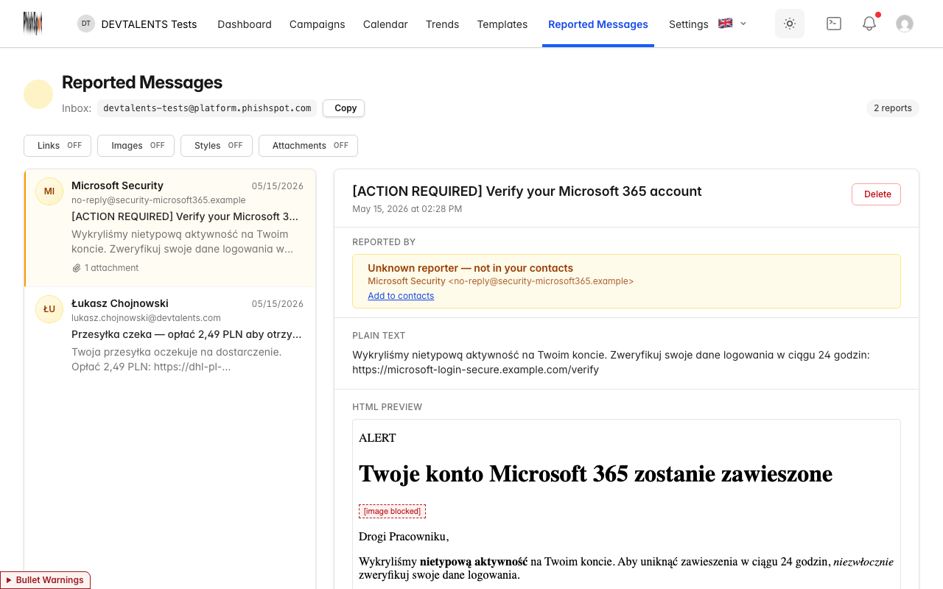
- Left — list of reports, newest first. Each item shows the reporter’s name (or email), the email’s subject and excerpt, an attachment count, and the receive date.
- Right — the detail panel for the selected report. Click a different item on the left and the right pane updates instantly.
- Counter — the pill in the top-right shows how many reports your account has.
- Inbox — the receiving address is repeated under the title with a Copy button.

19.5 Who reported it
Right under the subject, every report shows a Reported by panel that tells you whether the sender is known to your account.

Known reporter
If the sender’s email matches a Contact in your account, the panel is green and acts as a link to that contact’s profile:
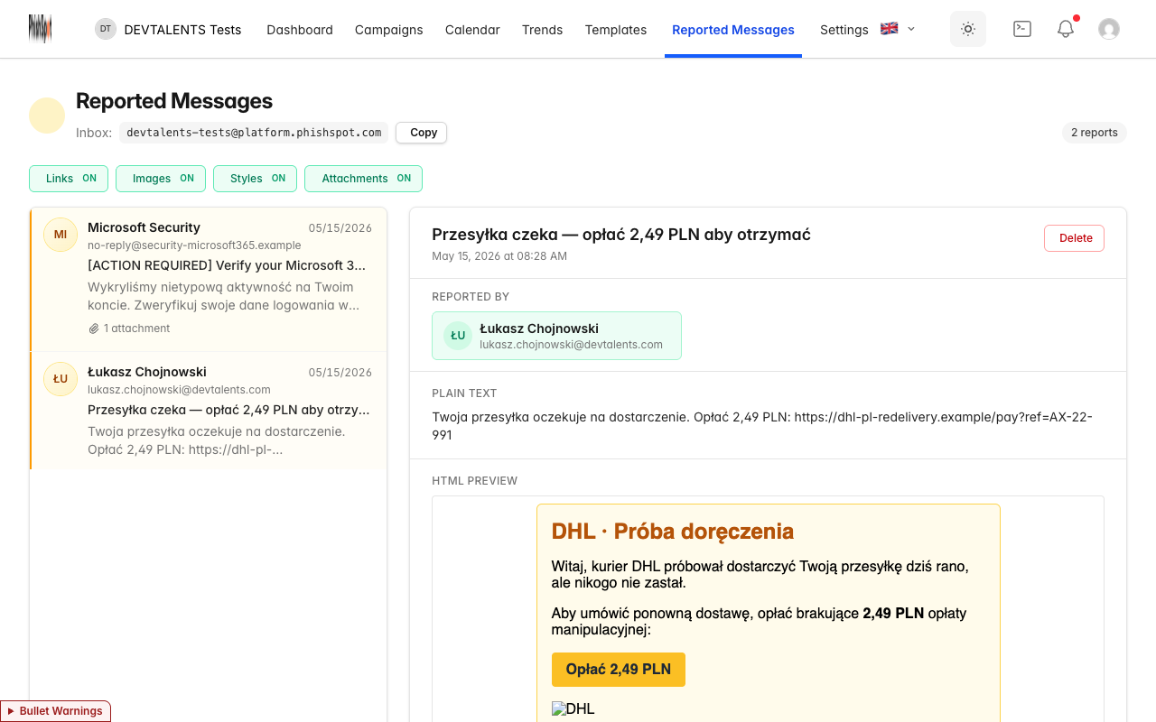
Clicking the panel takes you straight to the contact, where you can review their group memberships, prior campaign results, and contact history.

Unknown reporter
If no contact matches, the panel is amber and shows the sender details plus a quick-add link:
The Add to contacts link opens the new-contact form with the email already filled in — just add the first/last name and save.
A report from an address you have never onboarded deserves extra scrutiny. The amber warning is your first signal that something is off.

19.6 Safe-preview controls
Phishing emails are by definition untrusted. The detail view keeps potentially dangerous parts of the email switched OFF by default. Four controls let you progressively allow more of the original content:
Control | When OFF (default) | When ON
Links | Links are shown as red strike-through text. Hover to see the destination URL in a tooltip. Not clickable. | Links are clickable and open in a new browser tab (never inside PhishSpot).
Images | Each image is replaced with a [image blocked] placeholder. | Images load from their original sources.
Styles | All custom styling is removed — plain text only. | The email is rendered with its original styling.
Attachments | Filenames are listed, but no download buttons are shown. | Each attachment has a Download button.
Turning any control ON opens a confirmation dialog:
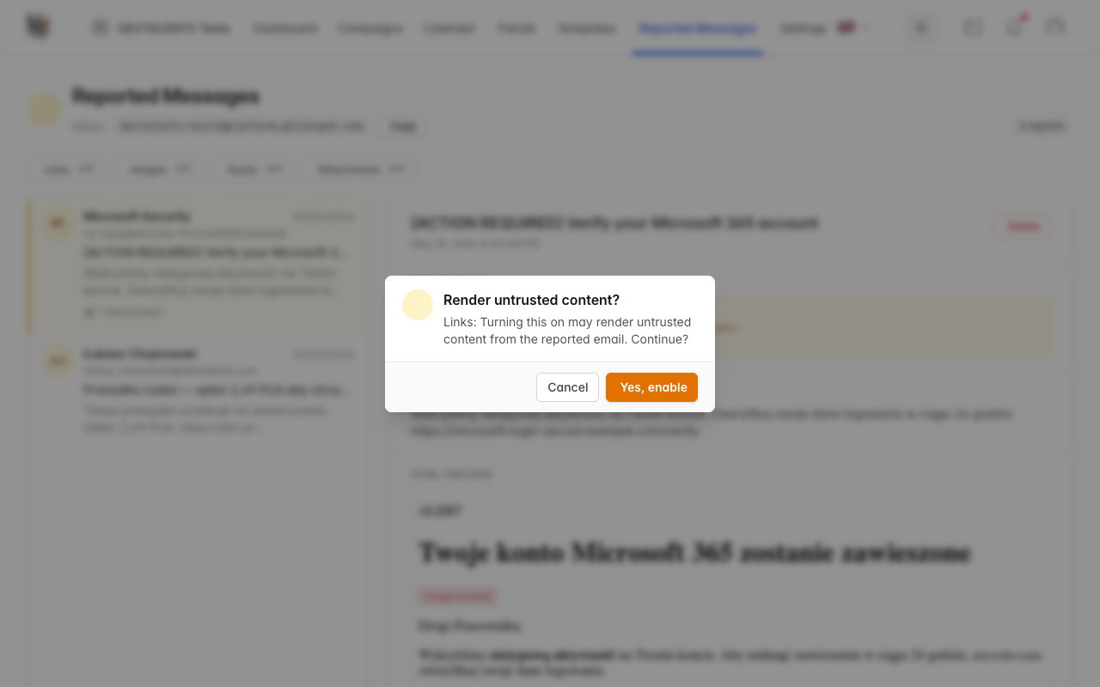
Turning a control OFF requires no confirmation.
Once styles and images are both enabled, the email renders the way the attacker designed it — useful when investigating a click-through campaign:
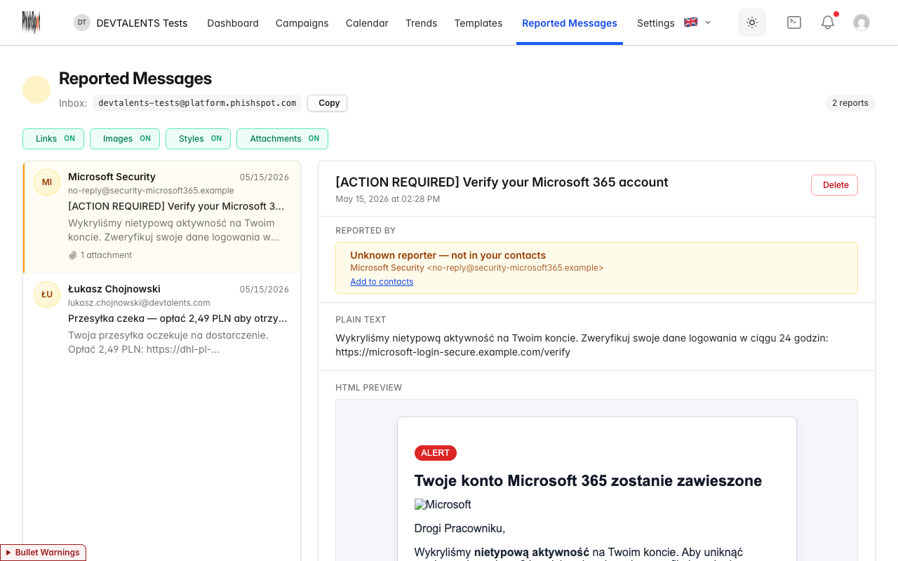
With Links ON, the buttons inside the email become clickable. They always open in a new browser tab, so you can inspect the destination URL without leaving PhishSpot:
Controls are account-level, not per-report. Flipping one affects every report in the inbox. The default is everything OFF so new accounts are safe from the start.

19.7 Deleting a report
The Delete button in the top-right of the detail panel removes the report (after a confirmation). Only admins and editors can delete; members can only view.

Outlook Add-in
The PhishSpot Outlook add-in puts a Report Phishing button on every email you read. One click sends the message (body, headers, attachments) to your PhishSpot account’s Reported Messages list. No forwarding to a special address, no manual copy-paste.
This page is for end users. If you’re an admin rolling the add-in out to a whole organisation, see Outlook Add-in: Central Deployment.

20.1 What you need
- Outlook on the web, Outlook for Windows or Mac, or the new Outlook for Windows.
- A PhishSpot Contact account at your organisation (your IT team can create one for you if you don’t have one).
- A few minutes to install the add-in and pair it.
The add-in does not work on Outlook for iOS / Android in v1.

20.2 Install the add-in
- Download the sideload package: phishspot-outlook-sideload-v1.1.0.zip.
- Unzip it. You’ll get a manifest.xml, a folder of icons, and a README.md with click-by-click instructions for each Outlook variant.
- In Outlook, open Get Add-ins → My add-ins → Add a custom add-in → Add from File… and pick manifest.xml.
- Confirm the install dialog. The Report Phishing button appears on the message-read ribbon.
If your IT team has already deployed the add-in centrally for everyone, skip the install — you’ll see the button automatically.

20.3 Pair the add-in (one-time)
The first time you click Report Phishing, the add-in shows a 6-digit code in the PhishSpot task pane on the right side of Outlook:
Outlook taskpane showing a 6-digit pairing code, copy button, and waiting-for-activation status
Outlook taskpane showing a 6-digit pairing code, copy button, and waiting-for-activation status
- Open https://platform.phishspot.com/guest/activation/new in a browser (the here link in the task pane will take you straight there). Once signed in, you’ll see the Connect your Outlook add-in page:
- 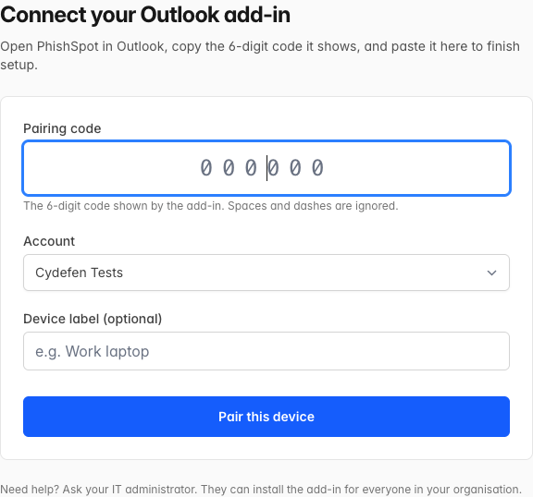
- Connect your Outlook add-in page in the browser, with the pairing-code input, account selector, optional device label, and Pair this device button
- Sign in with the same email your IT team registered for PhishSpot.
- Type or paste the 6-digit code shown in the task pane.
- Pick which account you’re pairing with (if you belong to more than one), optionally give the device a name, then click Pair this device.
The add-in detects the pairing within a few seconds and switches to its normal view, with a big Report suspicious message button and your organisation name underneath:
Outlook taskpane in the paired state — Report suspicious message button, organisation name, watermark logo, and theme/language controls at the bottom
Outlook taskpane in the paired state — Report suspicious message button, organisation name, watermark logo, and theme/language controls at the bottom
The pairing is per-device — if you have Outlook on two computers, you’ll pair each one separately. Optionally name the device (e.g. “Work laptop”, “Home iMac”) so admins can tell them apart on the API tokens screen.

20.4 Report a suspicious email
- Open the email you suspect is phishing.
- Click Report suspicious message in the task pane.
- The task pane briefly shows “Reporting…” while the message is sent.
- A thank-you screen confirms the report:
Outlook taskpane showing the green-check Thank you confirmation after a successful report
Outlook taskpane showing the green-check Thank you confirmation after a successful report
Click Close to dismiss the task pane.
The report appears in your organisation’s Reported Messages list. Your security team will review it.

20.5 What gets sent
- The sender’s email address and display name
- The subject and the message body (HTML + plain text)
- The full internet headers
- All file attachments
- A timestamp and the message’s Internet Message ID (for deduplication)
The bearer token the add-in uses is scoped to reported_messages:create only. The add-in cannot read, modify, or send any of your other mail.

20.6 The “Update available” banner
Each time you click the button the add-in checks its version against the server. Two outcomes:
- An update is available — soft banner; you can still report. Ask your IT team to push the new version when convenient.
- Update required — hard block; the button is hidden until the add-in is updated. This happens only when an old version is incompatible with a server change (rare).

20.7 Unpair / sign out
In the paired card, click Unpair this device. The token is removed from your Outlook. Your IT team can additionally revoke the token from the PhishSpot admin under API Tokens.

Outlook Add-in: Central Deployment
This page is for IT administrators who want the Report Phishing button to appear automatically for every user in their M365 tenant. For end-user install steps, see Outlook Add-in.

21.1 What gets installed
A small XML manifest (~5 KB). The manifest’s SourceLocation points at https://platform.phishspot.com/outlook/taskpane, which loads the live UI bundle. Result: shipping a new feature does not require re-distributing the add-in — the manifest itself only changes when the button label, permissions, or icons change.

21.2 Download the artifact
Download the manifest file for direct upload:
phishspot-outlook-manifest-v1.0.0.xml
Or the full sideload package (zip with icons + README):
phishspot-outlook-sideload-v1.0.0.zip

21.3 Deploy via Microsoft 365 Admin Center
PhishSpot uses the add-in only manifest format, so deploy it from the Integrated apps portal (Microsoft’s recommended path). The classic admin-center Add-ins portal works too but only supports this manifest type — the unified Microsoft 365 manifest is not used here, so either portal is fine.

Walk-through
- Sign in to admin.microsoft.com as a Global Admin.
- From the left navigation, expand … Show all, then choose Settings → Integrated apps.
- Click the Add-ins link near the top of the Integrated apps page, then Deploy Add-in.
- 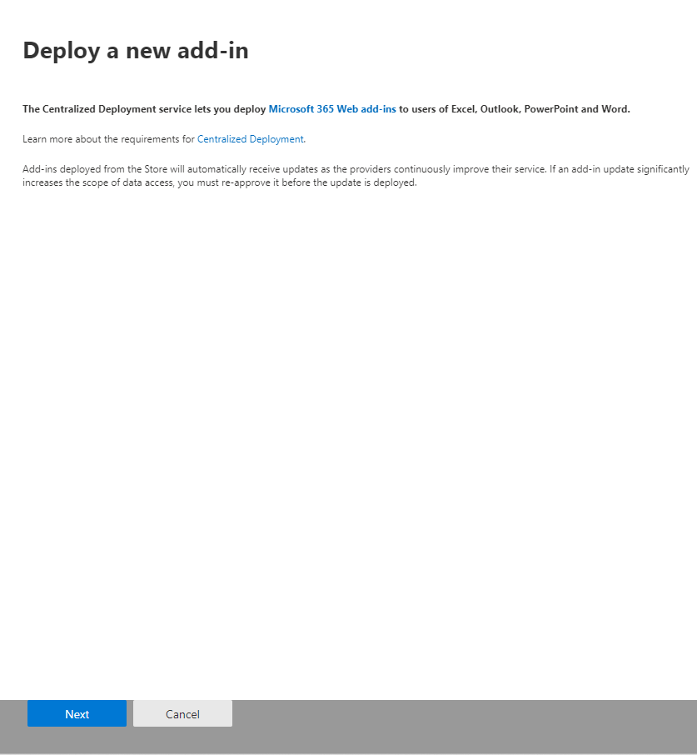
- Microsoft 365 admin center showing the Deploy Add-in button at the top of the Integrated apps page
- In the source picker, choose Upload custom apps → Upload manifest file (.xml) from device and pick phishspot-outlook-manifest-v1.0.0.xml.
- 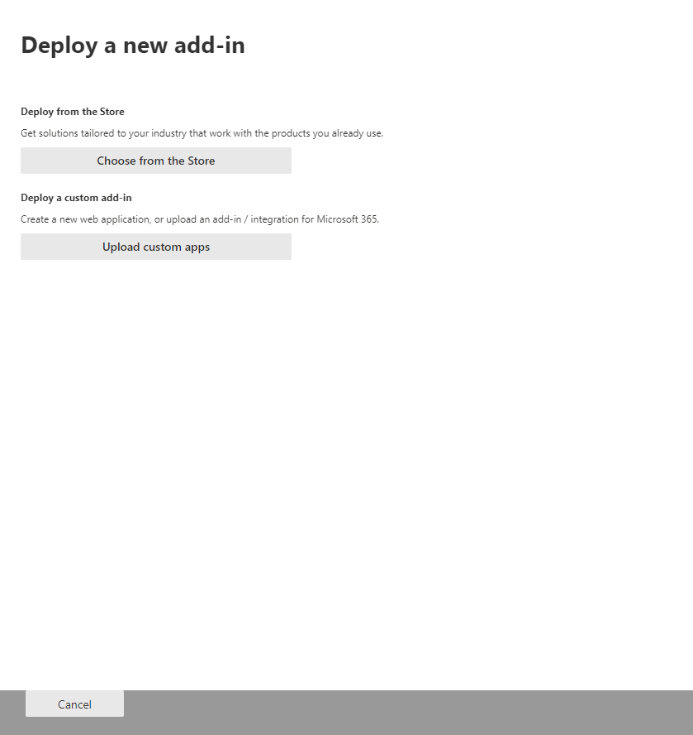
- Deploy wizard source picker offering Microsoft Marketplace or uploading a custom add-in by file or URL
- (The wizard also lists Microsoft Marketplace add-ins — those are unrelated, ignore them. PhishSpot is a line-of-business (LOB) add-in delivered by manifest file.)
- 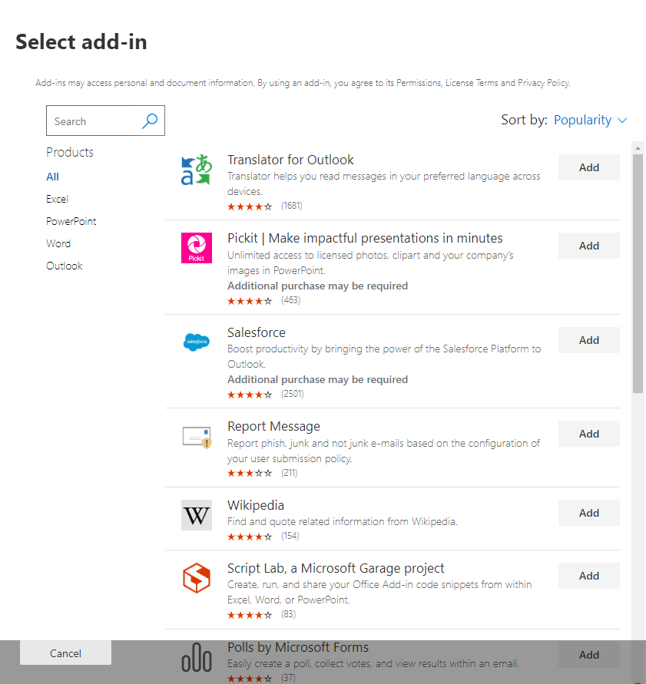
- Deploy wizard browsing Microsoft Marketplace add-ins by category
- On the Assign users step, pick the scope and click Deploy.
- 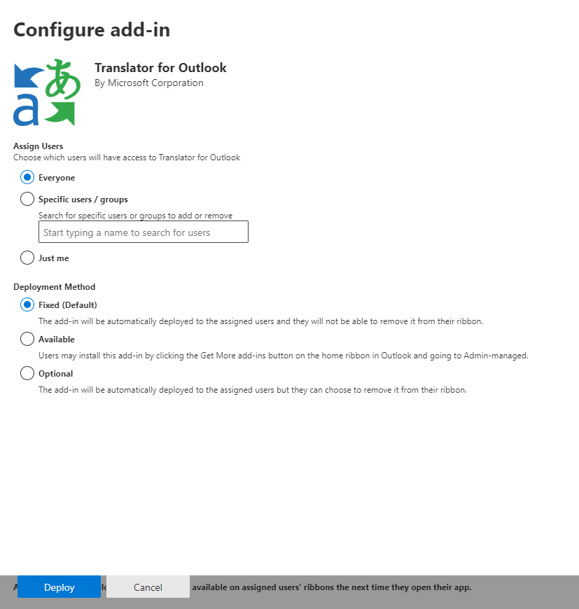
- Deploy wizard user/group assignment step with the Everyone, Specific users/groups, and Just me options
- Review permissions on the next pane — PhishSpot requests only the ReadItem scope. It cannot send mail, modify mail, or read folders other than the currently open message. These permissions are declared in the manifest and never change across manifest updates.
- Confirm. The wizard’s final step prompts you to announce the deployment to users — see Tips for getting users started below.

Assignment scope: pick groups, not individuals
Scope | When to use
Everyone | “Use sparingly — only for add-ins that are truly universal.” Reporting phishing is a good fit for everyone in most organisations, so this is usually correct.
Specific users / groups ⭐ | Recommended. Assigning by group means new joiners get the add-in automatically when they’re added to the group, and leavers lose it when removed. No admin action needed on either event. Assigning to individual users is fragile — every new hire requires a manual add.
Just me | Ideal for testing. After verifying the button works in your own mailbox, return to the deployed add-in and click Change who has access to add-in to widen the rollout.

Propagation timing
Microsoft’s documented expectation is that add-ins can take 24–72 hours to appear on the ribbon after deployment, though most users see it within 1–6 hours. Users may need to relaunch Outlook (close every window, then reopen) before the button shows up. Don’t escalate too eagerly — the propagation is normal.

21.4 Recommended rollout strategy
Microsoft’s published guidance is to roll out in waves:
- Wave 1 — IT + stakeholders. Deploy to your IT team and a handful of business stakeholders. Verify the Report Phishing button appears in their Outlook, that pairing works end-to-end, and that a reported test message lands in PhishSpot’s Reported Messages list under the right account. Resolve any tenant-specific surprises here (proxy / firewall / Contact provisioning gaps).
- Wave 2 — a department or two. Expand to one or two departments. Re-evaluate adoption and incident-response load. Tweak your user comms based on Wave 1 feedback.
- Wave 3 — full rollout. Once Wave 2 looks healthy, switch the assignment to the org-wide group (or Everyone) and announce broadly.
For a tenant with under ~50 mailboxes you can collapse Waves 1 and 2 into a single pilot. For tenants over a few thousand mailboxes, add a fourth wave that splits Wave 3 by region or job function.

21.5 Tips for getting users started
Microsoft explicitly calls this out as good practice, and it materially boosts reporting rates:
- Email everyone the day the add-in goes live. Include a one-paragraph explanation of what the button does, a screenshot of the ribbon, and a single sentence on what not to do (e.g. “if in doubt, click Report — false reports are fine; clicking the link inside the email is not.”).
- Link to your help-desk runbook. A short FAQ that covers: “I don’t see the button yet” (24–72 h propagation), “It asks for a 6-digit code” (pair-once flow), “I got a thank-you message — what happens next?” (security team triage SLA).
- Onboarding integration. Add a step to your new-hire IT onboarding that confirms the user can see the button and has paired their device.
- Reinforce on Phishing Awareness Month. Bump the comms in October — most orgs see a spike in reports during that month.

21.6 Provision your contacts in PhishSpot
The add-in pairs a user to a single PhishSpot Contact. Make sure every user who’ll use the add-in has a corresponding Contact in your PhishSpot account before they try to pair, otherwise pairing will fail with “We could not find an account for your sign-in.”
You can bulk-create contacts from:
- A CSV import (see Contacts)
- Microsoft Entra (Azure AD) directory sync — automatic
- Manual creation

21.7 First-pair user journey
Each user pairs once per device. Their journey:
- Outlook → click Report Phishing in any read message.
- The taskpane shows a 6-digit code.
- User opens https://platform.phishspot.com/guest/activation/new, signs in, pastes the code.
- The taskpane flips to the Paired state automatically.
Each successful pair creates an API token in PhishSpot, scoped to reported_messages:create for one specific account. You can list and revoke these tokens from Settings → API Tokens.

21.8 Rolling updates
We release new versions of the JS bundle every few weeks. You don’t need to re-upload the manifest for those releases — the version pointer at https://platform.phishspot.com/api/v1/outlook/version is the single source of truth, and every Outlook client picks up the new bundle on next open.
When the manifest itself changes (new permission, new button surface), you’ll get a release note that says “manifest update required” and a new phishspot-outlook-manifest-vX.Y.Z.xml. Upload that the same way you uploaded v1.0.0 — M365 Admin Center recognises it as an upgrade of the existing app (same Id GUID). To force an update from the LOB add-in’s pane, select the deployed add-in and click the Update Button at the bottom-right of its details panel; the change applies the next time each user launches Outlook.

21.9 Updates vs. blocked clients
The add-in’s bootstrap checks the version endpoint on every open. Two outcomes:
- latest > bundled — soft banner shown to the user. They can still report.
- min_supported > bundled — hard block. Reporting is disabled until the manifest is re-uploaded.
We only bump min_supported when an old version is incompatible with a security or data-model change. This is rare; expect one or two events per year at most.

21.10 Decommissioning
To remove the add-in:
- M365 Admin Center → Integrated apps → PhishSpot Report Phishing → Remove. This unlinks it from all user mailboxes within a few hours.
- PhishSpot → Settings → API Tokens — revoke all tokens with source = outlook_addin. Users who somehow still have an installed copy lose their ability to submit reports.

21.11 Troubleshooting
Symptom | Likely cause | Fix
Button doesn’t appear for any user | Propagation pending | Microsoft says 24–72 h is normal; force-restart Outlook to speed it up
Button appears, taskpane shows blank | Browser can’t reach platform.phishspot.com | Check corporate proxy / firewall
Pairing always says “no account” | User has no Contact record in PhishSpot | Provision the Contact, retry
Reports fail with 403 | Token’s pinned account doesn’t match | Unpair + re-pair the device
New Outlook for Windows: stuck on old version | M365 caches add-in metadata aggressively | Run outlook.exe /resetnavpane or clear the Wef folder

21.12 Compliance notes
- Reports are stored under your PhishSpot account, subject to your data residency settings.
- The bearer token never leaves the user’s mailbox (stored in Office.roamingSettings).
- The add-in’s source code lives in the same Git repo as the PhishSpot platform under plugins/office/. It’s reviewed under the same change-control as the rest of the product.

Spam Filter Whitelist
PhishSpot phishing simulations look like real attacks — that’s the point. Corporate spam filters (Microsoft 365, Google Workspace, Mimecast, Proofpoint, on-prem Postfix/SpamAssassin) will routinely block them unless they’re explicitly whitelisted. This chapter explains how to give your mail-server admin a single URL they can plug into their filter, and have it stay current automatically.

22.1 Why a whitelist?
SPF, DKIM and DMARC tell receiving servers “this email is genuinely from the domain it claims to be from.” For real phishing they often pass — that’s exactly why phishing is hard. But the same checks pass for our simulations too, and modern spam filters use much more than SPF/DKIM: they look at content patterns, link reputation, sender behaviour history, and dozens of other signals. Several of those signals will (correctly!) classify a phishing simulation as suspicious.
The right fix is for the receiving filter to bypass spam scanning for traffic that comes from PhishSpot. That requires the admin to tell their filter:
- which IP addresses we send from,
- which sending domains we use, and
- (optionally) which exact sender addresses appear on the From: header.
PhishSpot generates that list per account and exposes it at a stable URL. Configure your filter to pull it on a schedule (or react to our webhook when it changes) and you’re done.

22.2 Your whitelist URL
Open Account settings → Integrations → Spam Filter Whitelist. You’ll see a panel with:
- Your unique URL containing a 64-character secret token,
- A format picker (txt / json / csv / md / Microsoft 365 / Google Workspace / Mimecast / Proofpoint / Postfix / SpamAssassin),
- A status badge showing when the URL was last fetched and from which IP,
- A rotate button to invalidate the current URL,
- A disable toggle that returns 410 Gone until re-enabled,
- A live preview of what’s currently allowed,
- A download history of the last 50 fetches.
The URL is a single line you copy-paste into your spam filter or a small refresher script. There’s no API token, no Authorization header — the secret is in the path, and HTTPS encrypts it in transit. We rate-limit each token to 60 requests per minute, log every fetch (IP + UA) in the download history, and run on HTTPS only.
Treat the URL like a password. Anyone with it can read the full list of sending IPs and domains for your account. If you suspect a leak — rotate in the panel; the old URL keeps working for 24 hours so your spam filter has time to switch over.

22.3 Picking the right format
Format | When to use
txt | Plain text. Default. Easy to grep and pipe into scripts.
json | Structured payload. Best for custom integrations.
csv | Generic CSV — good as a fallback.
md | Human-readable Markdown — for documentation and review.
microsoft365 | PowerShell snippet + Tenant Allow/Block List commands for Exchange Online.
google-workspace | CSV laid out for the Google Admin email allowlist import.
mimecast | CSV in Mimecast’s Permitted Senders policy shape.
proofpoint | CSV in Proofpoint PPS Safelist shape.
postfix | access table snippet for on-prem Postfix.
spamassassin | whitelist_from lines for local.cf.
URL pattern: https://platform.phishspot.com/api/v1/integrations/spam/<TOKEN>/<format> — leave the format off and you get plain text.

22.4 Setup guides per provider

22.4.1 Microsoft 365 / Exchange Online
- In the PhishSpot panel, pick Microsoft 365 (PowerShell) and copy the URL.
- Save it to phishspot-whitelist.ps1 on a workstation that has Exchange Online PowerShell installed.
- Run Connect-ExchangeOnline (you’ll need Exchange Administrator rights).
- Execute the script. It does two things:
  - Adds each sending domain and address to the Tenant Allow/Block List with New-TenantAllowBlockListItems,
  - Merges the gateway IPs into the Hosted Connection Filter Policy via Set-HostedConnectionFilterPolicy.
- Optionally create a Mail Flow rule with “skip spam filtering” for senders matching @<your-phishspot-domain>. Re-pull the URL weekly to keep the list current.

22.4.2 Google Workspace
- Pick the Google Workspace (CSV) format and download the file.
- In Google Admin Console, go to Apps → Google Workspace → Gmail → Spam, phishing and malware.
- Open the Email allowlist for your top-level OU and paste the IP entries from the CSV (one per line).
- Open Inbound gateway (also in Spam settings) and add the same IPs. This is what makes Gmail bypass spam scoring for those connections.
- To allow by domain instead of IP, add the domain entries from the CSV to the Approved senders list (same section).

22.4.3 Mimecast
- Pick Mimecast (CSV) in the panel.
- In Mimecast Administration, go to Gateway → Policies → Permitted Senders.
- Click Import and upload the CSV. Mimecast picks up sender IPs from the Sender IP column and senders/domains from the Sender column.
- Either schedule a curl job (curl -fSL '<URL>' > whitelist.csv then re-import) or use the Mimecast API for automation.

22.4.4 Proofpoint Protection Server (PPS)
- Pick Proofpoint PPS (CSV).
- Either upload via System → User Management → Safelists → Import in the PPS UI, or push via the PPS REST API (/api/v1/safelist/import).
- PPS treats sender, domain and IP entries differently — the CSV’s type column tells PPS which list to put each row in.

22.4.5 Postfix (on-prem)
- Pick Postfix access table.
- Save to /etc/postfix/phishspot_whitelist, then run postmap /etc/postfix/phishspot_whitelist to compile the lookup table.
- Reference it from main.cf:
- smtpd_sender_restrictions =
check_sender_access hash:/etc/postfix/phishspot_whitelist,
...
- Run postfix reload.
- For IP-based bypass, copy the IPs into a separate CIDR file and add check_client_access cidr:/etc/postfix/phishspot_ips to smtpd_client_restrictions.

22.4.6 SpamAssassin
- Pick SpamAssassin local.cf.
- Append the snippet to /etc/spamassassin/local.cf.
- Validate with spamassassin -D --lint.
- Restart spamd.
- The snippet uses whitelist_from *@<domain> and trusted_networks <ips> — the latter raises the trust score for relayed mail.

22.5 Auto-refresh via webhook
The whitelist changes when you (or PhishSpot) add a sending domain, when a campaign uses a new From: address, or when our infrastructure team rotates gateway IPs. To keep the customer side current automatically:
- In Account settings → Webhooks → Endpoints, add a new endpoint pointing at a URL on your side.
- Subscribe to the event type spam_whitelist.updated.
- When the list changes we POST to that URL with a signed payload (HMAC-SHA256 in X-Webhook-Signature using the endpoint’s signing secret). The payload includes the new snapshot digest and the full set of whitelist URLs across formats.
- Your handler verifies the signature, then triggers your platform-specific import (the PowerShell job above, the Google Admin API call, Mimecast / Proofpoint API, etc.).
We retry failed deliveries 5 times with exponential backoff. After 5 consecutive failures we email account admins so the integration doesn’t silently rot.

22.6 Stale-fetch alerts
We track when each URL was last fetched. If 24 hours pass without a successful fetch — meaning your spam filter has stopped pulling the list — we email every admin on the account. The most common causes:
- The cron / scheduled task that pulls the URL stopped.
- Your firewall is now blocking outbound HTTPS to platform.phishspot.com.
- The URL was rotated and the old one expired before anyone updated the filter.
- The integration was removed from the spam filter accidentally.
To silence the warning, re-trigger the fetch from your side (one curl is enough — we reset the counter on every successful request).

22.7 Best practices
- Schedule the pull at least daily, ideally hourly. The endpoint is cheap to hit.
- Verify the snapshot digest (X-PhishSpot-Snapshot-Digest header) — if it matches what you have, skip the re-import to avoid noise in your downstream system.
- Rotate quarterly. Even with no leak, regular rotation limits blast radius if a script ever logs the URL.
- Monitor your side too. Alert if the cron job hasn’t run successfully in N hours. Don’t rely only on our stale-warning email.
- Use the webhook in addition to the cron, not instead of it. The cron is the safety net; the webhook is the fast path.
- Test your bypass with PhishSpot’s “Send test email” feature in a campaign before going live. If the test doesn’t land in the recipient inbox, your bypass isn’t working.

22.8 FAQ & troubleshooting
“Our phishing simulations still go to spam.” Confirm the spam filter is actually pulling the URL: check the download history in the PhishSpot panel — does the IP and timestamp match your filter’s egress IP and pull schedule? If yes, check the bypass rule is on the correct policy (often filters have separate inbound vs. transport policies). If no, the URL isn’t reaching the filter.
“The CSV format my filter expects is different.” Use the plain csv format as a template and transform it server-side. The json format is the most flexible source — easy to map to any target schema with jq or a 20-line script.
“Our webhook isn’t receiving deliveries.” Check the endpoint URL in Webhooks → Endpoints — make sure it’s HTTPS, publicly reachable, and not behind an authentication wall. Open the endpoint detail page in PhishSpot to see the delivery log with response codes and response bodies. Verify the HMAC signature handling on your side matches OpenSSL::HMAC.hexdigest("SHA256", signing_secret, raw_body).
“What if you change your gateway IPs?” You’ll get a spam_whitelist.updated event the moment we make the change, and the URL response includes the new IPs immediately. If your filter has a fresh pull within the change window, you’ll never notice.
“Can I have multiple URLs for different filters?” Not in the MVP — there’s one active URL per account. If you need separate URLs (e.g., for a phased rollout), use the rotation flow: rotate, wait 24h, rotate again. Each rotation gives you a fresh URL with a 24-hour grace period.

Autopilots
A campaign is a one-off send. An autopilot is the configuration that produces campaigns automatically, on a cadence you set, for as long as you want it to run. You define the audience, the intensity (how often), the post-click outcome and the targeting context (language, country, industry) — and PhishSpot launches simulations against the matching contacts until you pause or stop the autopilot.
The model is “set it once, then let it work.” If a new contact joins one of the autopilot’s groups (or arrives from a directory sync), they get picked up automatically on the next iteration. If you change the outcome or course mid-flight, the next launched campaign uses the new setting.

23.1 What an autopilot is — and isn’t
An autopilot is not a single long-running campaign. It’s a recipe. Each time the autopilot fires it creates a fresh Campaign record, picks a phishing template suited to the autopilot’s language and industry, snapshots recipients from the configured groups, and dispatches the send. Reports for those campaigns live in Reports & Analytics like any other.
Use autopilots when you want a continuous, low-touch awareness program. Use one-off campaigns (Chapter 4) when you want full control over timing, copy, and recipients for a single send.
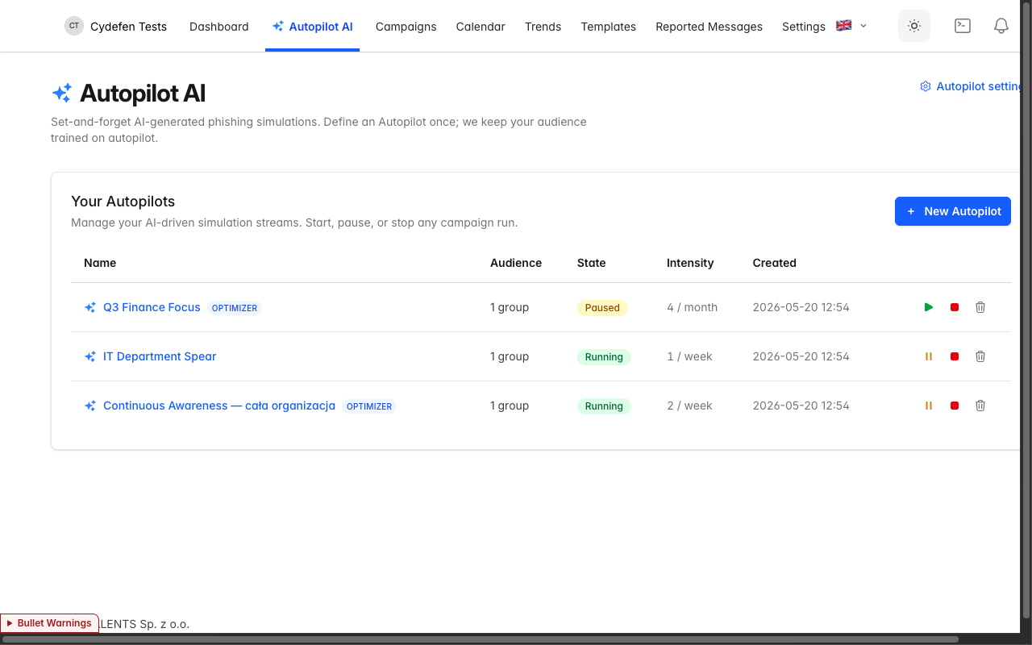
Autopilots index showing three configured autopilots

23.2 Creating an autopilot
Open Autopilots in the left sidebar and click New autopilot. The form has two visible sections:

23.2.1 Name and audience
- Name — what you’ll see in the autopilot list. Max 80 characters. Examples from a typical setup: “Continuous Awareness — cała organizacja”, “IT Department Spear”, “Q3 Finance Focus”.
- Audience — pick All contacts to target every contact on the account, or Selected groups to scope the autopilot to one or more groups. When the autopilot fires, recipients are sampled from the audience at that moment — so groups that grow over time grow the autopilot’s reach.

23.2.2 Advanced settings
This section is expanded by default when you’re editing an existing autopilot. It contains:
- AI Optimizer — when on, PhishSpot fine-tunes which templates are sent to whom based on past interactions. New autopilots default to ON.
- Duration — Continuous (runs until you stop it) or Until (stops automatically on the chosen day).
- Industry — the industry of the target organization (NAICS + LinkedIn taxonomy). Used to bias template selection toward themes that look plausible for that vertical. Leave blank to inherit from autopilot settings (§23.6).
- Language — the language the simulation copy will be authored in. Leave blank to inherit.
- Default outcome (after click) — what to show the recipient after they click the simulated phishing link:
  - Do nothing — no landing page; the click is just logged.
  - Redirect to training course — opens the course you select.
  - Show awareness page (recommended) — renders an in-context “this was a phishing simulation” page.
  - Redirect to URL — sends the user to an external URL of your choice.
- Automatically include new members of groups and contacts — when on, contacts added to the autopilot’s groups after the autopilot starts will be included from the next iteration onward. Default ON.
- Campaign intensity — see §23.3.
Save and the autopilot is created in Draft state. Click Start to begin.
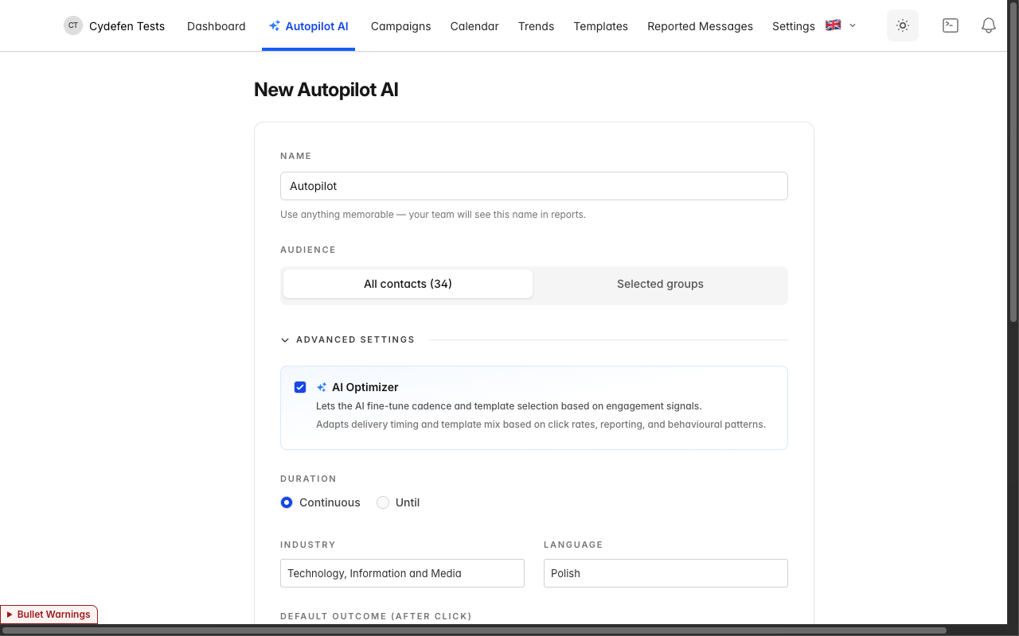
New autopilot form with the Advanced settings section expanded
The form below shows an existing autopilot in edit mode — every advanced setting is visible: AI Optimizer, duration, industry, language, outcome, auto-include new members, and intensity.
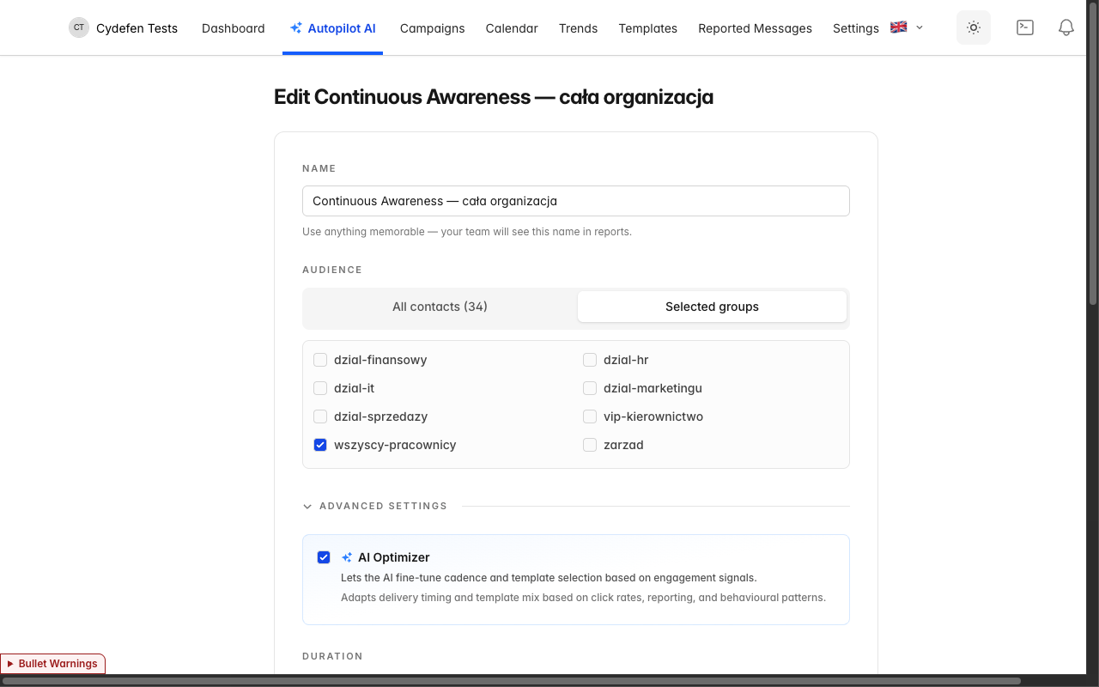
Editing a running autopilot — full settings panel

23.3 Intensity and the daily cap
Intensity is two values: a count and a period — 2 per week, 1 per month, 4 per year, etc. Periods are day, week, month, year.
PhishSpot enforces a hard ceiling: no single contact will be targeted by an autopilot more than twice per day, regardless of intensity setting. The intensity field in the form refuses values that would breach this:
- 1/day and 2/day are allowed.
- 3/day and above are rejected — the form shows an error.
- Weekly/monthly/yearly are converted internally to a per-day rate (PERIOD_DAILY_RATE of 1, 7, 30, 365 respectively) and checked against the same cap.
The cap is per-autopilot. If a contact sits in multiple autopilots, each autopilot honours its own limit independently — keep that in mind when running parallel programs against overlapping groups.

23.4 Lifecycle states
Every autopilot is in exactly one state:
State | Meaning | Editable?
Draft | Created but not yet launched. No campaigns fired. | Yes
Running | Active. Campaigns fire on the configured cadence. | Yes
Paused | Temporarily halted. No new campaigns until resumed. | Yes
Stopped | Permanently terminated. Read-only. Remove the autopilot to start fresh. | No
Transitions are explicit buttons on the autopilot row:
- Start — Draft or Paused → Running.
- Pause — Running → Paused.
- Stop — any state → Stopped. Cannot be undone; you’ll need to delete the autopilot and re-create it.
A Stopped autopilot is a tombstone — it retains its history (which campaigns it fired, when) but no fields can be changed. The intent is to give you an auditable trail of past programs without cluttering active ones.

23.5 The AI Optimizer
When enabled, the AI Optimizer adapts which templates the autopilot picks for each recipient based on past behaviour: people who consistently fall for invoice-themed lures see more of those (and the training that follows); people who never miss them get harder, less obvious variants. The optimizer is on by default for new autopilots and can be toggled per-autopilot in the Advanced settings section.
The optimizer’s adaptive logic ships in phases. The toggle and the per-template scoring are live today; the full multi-armed-bandit selection layer rolls out during the implementation engagement and is included in the SaaS subscription — no separate configuration is required when it lands.

23.6 Default settings
Click the gear icon → Autopilot settings on the autopilots list to open account-level defaults. Settings here pre-fill the new-autopilot form so you don’t repeat yourself across autopilots:
- Primary industry — your organization’s industry. Templates pick it up automatically.
- Default country — used to bias template selection (sender names, brand spoofing targets).
- Default language — language of simulation copy.
- Default outcome (after click) — same four options as on the autopilot form, used as the starting value.
- Default campaign intensity — count + period used as the starting value.
Changing settings here does not retroactively edit existing autopilots — it only changes the defaults for future ones. Per-autopilot fields override these defaults when set.
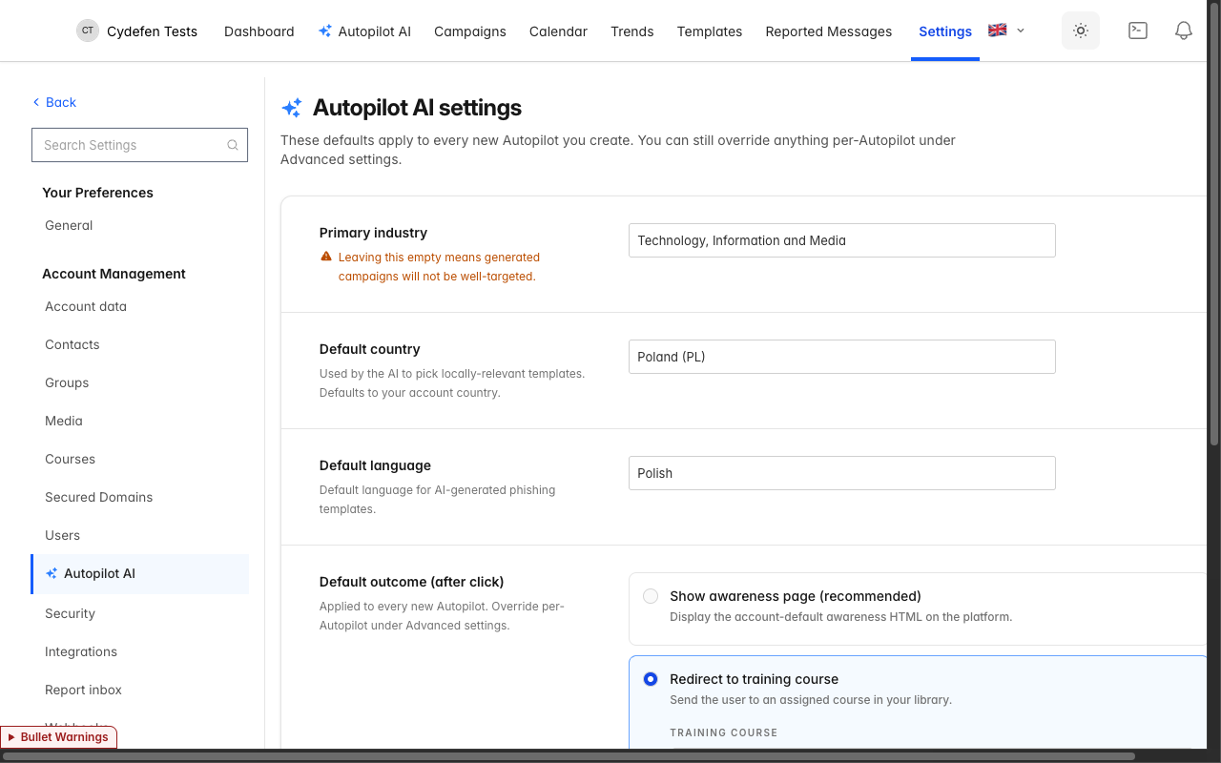
Autopilot settings — account-level defaults

23.7 Real-world examples
Below are three autopilot configurations from a working setup, illustrating the spread of typical use cases.

Continuous Awareness — full organisation
A baseline program for everyone on the account.
- Audience: the “Wszyscy pracownicy” group (all employees synced from Entra AD).
- Intensity: 2/week. With the daily cap that’s still no more than 2 emails on any single day per contact — but spread thinly across the week.
- AI Optimizer: ON.
- Language: pl. Industry: Technology, Information and Media.
- Outcome: Redirect to course “Świadomość phishingowa 101”.
- Auto-include new members: ON — directory sync changes flow straight through.

IT Department Spear
Higher-difficulty simulations aimed at the IT team — the group most likely to be targeted by real attackers.
- Audience: just the “Dział IT” group.
- Intensity: 1/week — lower than the org-wide program because the templates used are harder and the cohort is small.
- AI Optimizer: OFF — the admin wants deterministic, manually-curated targeting for this group during initial calibration.
- Outcome: Redirect to URL — a custom internal security wiki page.

Q3 Finance Focus (paused)
A time-boxed campaign for the finance team.
- Audience: “Dział Finansowy”.
- Intensity: 4/month.
- State: Paused — kept around between quarters; resumed when the next quarterly push starts.
Each of these is created once and then left alone. The reporting per autopilot shows up under the matching campaigns in Reports & Analytics.

23.8 Cross-references
- Account-level defaults: see §23.6 above.
- The contacts and groups autopilots target: Chapter 5 Contacts and Chapter 6 Groups.
- The directory sync that grows the audience automatically: Chapter 25 Directory Sync.
- Reporting for autopilot-fired campaigns: Chapter 11 Reports & Analytics.
- Course used as the post-click outcome: Chapter 8 Courses.

Sign-in with Microsoft 365
PhishSpot integrates with Microsoft 365 (Entra ID) for end-user sign-in. Employees imported from your directory log in with their corporate Microsoft account — no separate password to manage, no separate identity to onboard. The first time they sign in, PhishSpot links their authenticated user to the existing contact record imported from Entra, and lands them on their personal training portal at /guest/dashboard.
This chapter covers the sign-in flow as it appears to employees, the personal portal they reach after signing in, and the dual-role picker shown to admins who are also end users.

24.1 Why Microsoft 365 SSO?
Three reasons:
- No extra password to lose. Employees use the same Entra account they already use for Outlook, Teams, SharePoint and the rest of Microsoft 365. There’s nothing new to forget.
- Automatic onboarding. Once Entra directory sync (Chapter 25) imports an employee, their first Microsoft sign-in turns the contact into a fully-formed user account — no admin intervention required.
- Inherited security posture. Conditional access, MFA, device compliance — every Entra policy you have already applies. PhishSpot doesn’t run its own MFA in front of an Entra-authenticated session because Microsoft already enforces it upstream.

24.2 Admin setup
The platform-wide OAuth app is already registered in PhishSpot’s tenant. To enable end-user sign-in from your tenant you only need to grant admin consent for the PhishSpot enterprise application and (optionally) connect directory sync:
- Open Account settings → Integrations → Microsoft 365.
- Click Connect Microsoft 365. You’ll be redirected to the Microsoft admin consent screen.
- Grant the requested scopes (User.Read.All, Group.Read.All, Directory.Read.All for sync; openid, profile, email for sign-in).
- Microsoft redirects you back. PhishSpot stores your tenant ID and a tenant-scoped app token.
- (Optional but recommended) configure sync schedule — see Chapter 25 §25.3.
After admin consent, any user in your tenant whose email matches an imported Contact on your account can sign in. Users who don’t match a Contact (or whose tenant ID doesn’t match a configured integration) hit a friendly “no access” page — they cannot create accounts on the fly.

24.3 End-user sign-in flow
What an employee sees:
- They open https://platform.phishspot.com/users/sign_in.
- Below the email/password form, separated by an “OR” divider, they see a Continue with Microsoft button (with the Microsoft logo). Clicking it redirects to the Microsoft sign-in screen.
- Microsoft authenticates the user — including MFA if your tenant requires it. The user grants the PhishSpot app permission on first sign-in (a one-time consent per user, unless you’ve granted admin consent on their behalf, which suppresses the prompt entirely).
- Microsoft redirects back to PhishSpot. Behind the scenes:
  - If a User row exists with the same email, it’s reused.
  - If not, a new User row is created with that email, marked confirmed.
  - PhishSpot caches the user’s Entra tenant ID for fast lookups.
  - Any unlinked Contact row matching the email is bridged to this user — they become “your contact, your user”.
- The user lands on /guest/dashboard. No password was set. No invite email was sent. They’re in.
The first sign-in completes in one round-trip; subsequent sign-ins are even faster — Microsoft remembers consent, and the bridging step is a no-op after the first time.

24.4 The Guest Dashboard
/guest/dashboard is the employee-facing portal. It shows everything the employee is expected to engage with personally — and nothing else. They do not see other people’s results, the campaign list, account settings or any admin pages.
The dashboard has three sections:

24.4.1 Your training
The list of training assignments the employee has — typically one entry per phishing campaign that the employee clicked into and that has a course attached as the post-click outcome. Each row shows:
- The course name (e.g., “Świadomość phishingowa 101”).
- Completion status: not started / in progress (with % progress) / completed.
- A button to open the course player in the same tab.
Training assignments are derived from Deliverable records — when a contact reaches the clicked or later state on a campaign with a course, an obligation appears here.

24.4.2 Email history
The last 50 phishing simulation emails the user has interacted with. For each, the dashboard shows:
- The campaign name (the company-facing label, not the simulation-from address).
- Which actions the user took (opened / clicked / submitted form / reported).
- A timestamp.
This is the personal-history mirror of what admins see on the campaign dashboard. It’s deliberately short — long retention is an admin concern, not an end-user one.

24.4.3 Reported emails
If the user has reported phishing through the Outlook add-in (Chapter 20), each report appears here with subject, sender and the time it was reported. The section also displays the per-account reporting inbox address — useful for users on devices without the Outlook add-in installed, who can forward the suspicious mail manually instead.

24.5 The dual-role picker
Some users are both admins and employees: a security manager who runs phishing campaigns is also a phishing target themselves. PhishSpot handles this with an explicit picker.
When a user with both an account_user (admin role on at least one account) and a contact_membership (contact row on at least one account) signs in, the resolver routes them to /guest/role instead of straight to a dashboard. The picker shows two large card buttons:
- 🛡️ Admin panel — opens the account-scoped admin UI (/accounts/:account_id).
- 🎓 Training portal — opens /guest/dashboard.
The user picks once per session. The picker is also reachable from the user menu so admins can switch contexts mid-session.
A user with only an account_user (pure admin) skips the picker and lands directly on the admin dashboard. A user with only a contact_membership (pure employee) skips the picker and lands directly on /guest/dashboard. The picker only appears when both apply.

24.6 Security model
PhishSpot delegates authentication to Microsoft for SSO sessions. That means:
- MFA is enforced upstream. If your tenant requires MFA, every PhishSpot sign-in goes through it. If you don’t require MFA, PhishSpot does not silently re-impose it on the SSO path.
- Conditional access applies. Tenant policies (device compliance, geographic restrictions, app protection) gate the PhishSpot sign-in like any other Entra app.
- Tenant scoping (optional). PhishSpot can be configured to reject sign-in attempts whose Entra tenant ID doesn’t match any connected AccountOauthIntegration on the platform. This is recommended for tenants that don’t want any random Microsoft user to attempt sign-in.
- Local 2FA still available for non-SSO accounts. Admins who don’t sign in via Microsoft (e.g., service accounts) can still enable TOTP-based 2FA — see Chapter 15 User Profile & Preferences.

24.7 Troubleshooting
The Microsoft button takes me to “no access”. Either no Contact row matches your email on any account, or the tenant ID isn’t recognized. Ask your admin to confirm: (1) directory sync ran and your account was imported; (2) the integration is connected with admin consent (Chapter 25 §25.2).
I clicked Continue with Microsoft but Microsoft never asked me to consent. Admin consent is already granted in your tenant — that’s expected and faster.
I’m an admin and I keep landing on the role picker. That’s expected: you’re both an admin and a contact on the same account. Pick the role you want; the choice lasts for the current sign-in session.
I expected to see other employees’ results. You won’t — the Guest Dashboard only shows your own data. Aggregate dashboards are admin-only and live under the account admin UI.

24.8 Cross-references
- The directory sync that creates Contact rows from Entra: Chapter 25 Directory Sync.
- The Outlook add-in that feeds the “Reported emails” section: Chapter 20 Outlook Add-in.
- The campaign reports that admins use to monitor what employees see on this portal: Chapter 11 Reports & Analytics.
- Local TOTP-based 2FA for non-SSO accounts: Chapter 15 User Profile & Preferences.

Directory Sync with Entra AD
When a company runs phishing simulations against 50, 500 or 5,000 employees, keeping the contact list current by hand isn’t viable. PhishSpot connects to Microsoft Entra ID (formerly Azure AD) and pulls users and groups directly from your directory. New hires show up, leavers get disabled, group membership reflects today’s org chart — without anyone editing a spreadsheet.
This chapter covers the integration setup, the sync schedule, what gets imported and how, manual syncs, and the history log you check when something looks off.
Before you connect Entra ID, read Chapter 28 — Entra ID: tradeoffs to consider. For most organisations, PhishSpot recommends manual CSV imports over directory sync. This chapter is the technical reference for when you’ve decided to connect anyway.

25.1 Why directory sync?
The alternative is CSV imports (Chapter 5 Contacts covers the manual paths). Those are fine for proof-of-concept or one-shot pilots, but for production they get stale fast. Directory sync gives you:
- Authoritative source. Your IT team already maintains Entra. PhishSpot inherits that work — no parallel list to keep in sync.
- Automatic onboarding. A new hire whose Entra account is created today shows up in PhishSpot tomorrow morning (or sooner, depending on schedule), and immediately becomes a valid target for autopilot campaigns.
- Leavers handled cleanly. When IT disables an Entra account, the matching PhishSpot Contact is marked disabled — it stays in the database for historical reporting, but autopilots stop targeting it.
- Groups follow. Membership in “Engineering”, “Finance”, “Zarząd” — whatever you’ve defined in Entra — is mirrored into PhishSpot Groups, so autopilot audiences track org structure automatically.
If you also want users to sign in to their personal training portal with Microsoft, the same integration backs that flow — see Chapter 24 SSO with Microsoft 365.

25.2 Connecting Entra
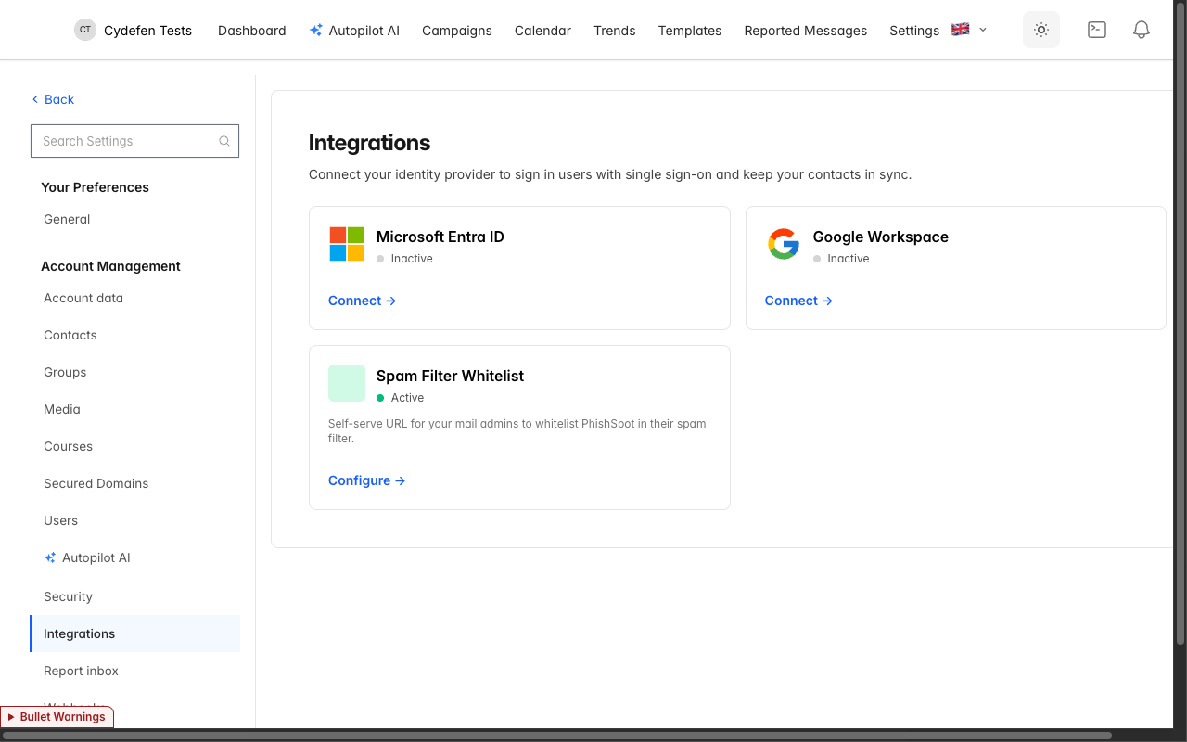
Integrations index showing the Microsoft Entra ID card alongside Google Workspace and the Spam Filter Whitelist
- Open Account settings → Integrations. You’ll see a grid of integration cards. Find the Microsoft Entra ID card; it shows a gray status dot (“inactive”) until connected.
- Click Connect to Microsoft. PhishSpot prompts you for your Entra tenant ID (a GUID, e.g., 1f3a8d2e-...). You can find this in the Entra admin centre under “Properties”.
- Submit. PhishSpot generates an HMAC-signed state token and redirects you to the Microsoft admin-consent screen at login.microsoftonline.com/<tenant>/v2.0/adminconsent. You must be signed in as a Global Administrator in the target tenant — admin consent grants the PhishSpot enterprise application directory-read scopes on behalf of all users.
- The consent screen lists the requested scopes:
  - User.Read.All — read user profiles (for the contact list).
  - Group.Read.All — read group definitions.
  - Directory.Read.All — read group memberships.
  - openid / profile / email — needed for the SSO sign-in flow.
- Grant. Microsoft redirects back to PhishSpot’s callback endpoint with admin_consent=True&tenant=<ID>&state=<HMAC>. PhishSpot verifies the HMAC, stores the tenant-scoped app token and turns the integration status to active.
You’re now connected. The Microsoft card shows an emerald status dot, the tenant ID in monospace, and the consent timestamp.

25.3 Sync schedule
Click Manage on the active Microsoft card to open the integration settings. Two checkboxes and one dropdown:
- Sync users to contacts — on by default. Pulls every Entra user (excluding guests and disabled accounts) and upserts them as PhishSpot Contact rows.
- Sync groups — on by default. Pulls every Entra group (security and Microsoft 365 groups) and upserts them as PhishSpot Group rows. Memberships are reconciled in the same pass.
- Schedule — one of:
  - Off — no automatic sync. You can still trigger sync manually (§25.5).
  - Hourly — runs every hour on the hour.
  - Daily — runs once a day at 02:00 UTC. Default for production tenants.
  - Weekly — runs once a week, on Mondays at 02:00 UTC.
Save settings. The platform’s scheduler (ScheduledDirectorySyncsJob) fan-outs at each interval, queuing one DirectorySyncJob per active integration matching that schedule.
The first sync after a fresh connection is usually the largest — it imports everything. Subsequent syncs only touch what changed (a handful of users updated, one group created, one membership removed), so they’re fast — typically under a minute even for thousands of users.

25.4 What gets imported
For each Entra user the importer creates or updates a Contact row keyed by the Entra object ID (oid). The mapping is:
PhishSpot Contact field | Entra source
email | userPrincipalName (falls back to mail)
first_name, last_name | givenName, surname
title | jobTitle
department | department
location | officeLocation (city + country fallback)
telephone | mobilePhone (falls back to businessPhones)
external_id | id (the Entra OID)
external_state | active if accountEnabled=true, else disabled
source | always :entra
synced_at | sync timestamp
For each Entra group the importer creates a Group row keyed by group OID:
PhishSpot Group field | Entra source
name | slugified displayName (e.g., “Dział IT” → dzial-it)
display_name | displayName (preserves casing and Polish characters)
external_id | group id
source | :entra
Membership is reconciled per sync: PhishSpot lists all current members of each Entra group, removes any local ContactGroup rows whose contacts are no longer in the Entra group, and creates new ones for additions.
Important: Contacts whose Entra account is deleted (not just disabled) are not removed from PhishSpot — they’re marked external_state: disabled so historical reports remain intact. To purge a contact entirely, delete it from the PhishSpot UI manually.

25.5 Manual sync (“Sync now”)
The integration management page has a Sync now button. Click it to enqueue a DirectorySyncJob immediately, regardless of the configured schedule. Use this for:
- Initial connection — most admins click Sync now once right after consent so the first import doesn’t wait for tomorrow’s 02:00 UTC cron.
- Onboarding push — after IT marks 20 new hires in Entra, you want them in PhishSpot before your next scheduled run.
- Troubleshooting — to retry after a transient Microsoft Graph error visible in the activity log.
A manual sync writes a DirectorySyncLog entry with trigger: manual — useful for distinguishing intentional admin actions from cron-driven runs when auditing.

25.6 Sync history
Below the settings, the activity table shows the last 50 sync runs. Columns:
Column | What it shows
Started | When the run kicked off
Trigger | Manual (admin clicked Sync now), Scheduled (cron), or OAuth callback (auto-sync right after admin consent)
Status | Running, Success, Failed, or Partial (with color-coded badge)
Changes | Users created / updated / disabled, groups created / updated, memberships changed
Duration | Wall-clock time for the run
A typical activity table for a small organisation looks like (real example from a working setup):
Started | Trigger | Status | Changes | Duration
6 hours ago | Scheduled | Success | 0c · 7u · 0d / 0c · 0u / 1m | 22 s
2 days ago | Scheduled | Success | 1c · 2u · 1d / 0c · 0u / 2m | 19 s
7 days ago | Manual | Success | 0c · 4u · 0d / 0c · 0u / 0m | 14 s
8 days ago | Scheduled | Failed | — | 1 s
10 days ago | Scheduled | Success | 1c · 3u · 0d / 0c · 0u / 1m | 16 s
Failed runs expand to show the Microsoft Graph error message — most are transient rate-limit responses (HTTP 429) that the next scheduled run absorbs cleanly.
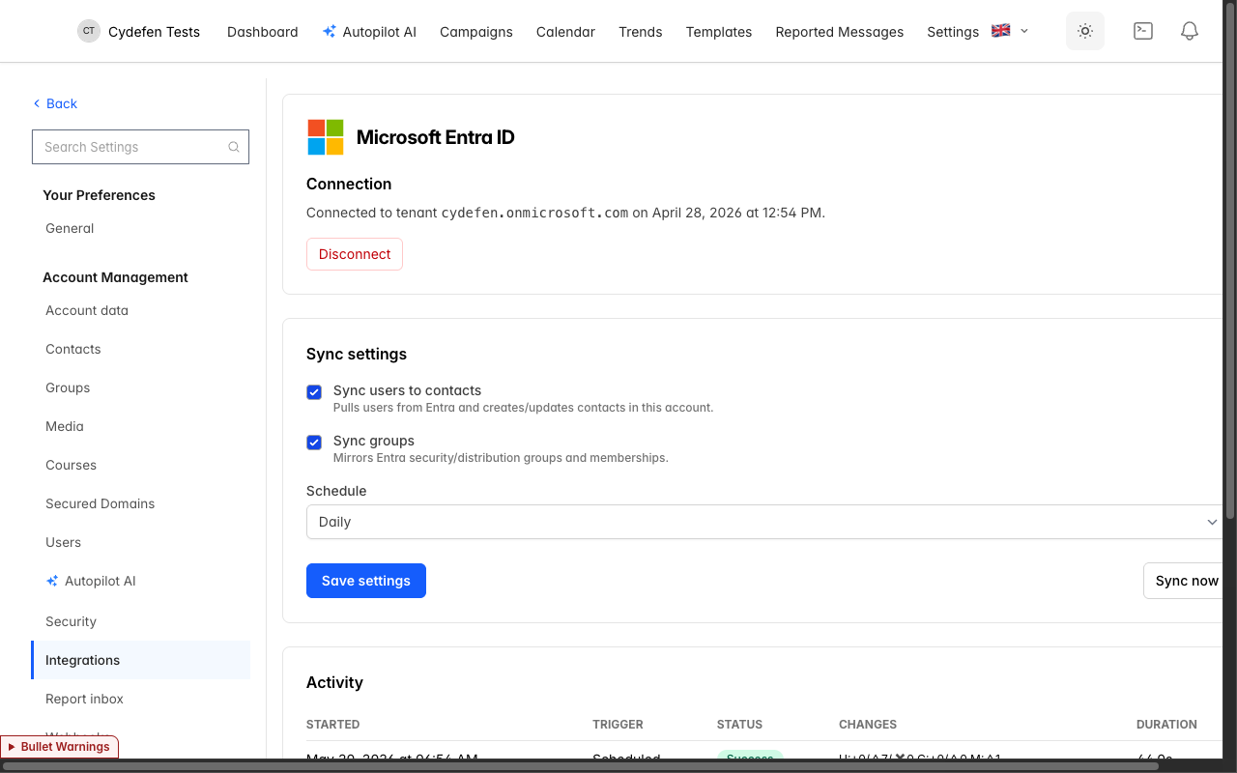
Entra integration management page — sync settings + activity history

25.7 Troubleshooting
Connect button takes me to a “consent denied” screen. You signed in as a non-admin user in your tenant. Sign out of all Microsoft accounts, sign in fresh as a Global Administrator, and retry.
Sync runs but no contacts appear. Open the activity log. If status is Success and changes are all zero, your Entra tenant has no users matching the filter (guests and disabled accounts are skipped). Verify in Entra that the users you expect have accountEnabled=true.
“Tenant mismatch” on callback. The Entra tenant ID you entered doesn’t match the tenant whose admin granted consent. Disconnect and reconnect with the correct tenant ID.
Partial syncs. If a sync finishes with status Partial, some upserts succeeded and others failed — usually because one user record violated a uniqueness constraint (e.g., two Entra users with the same email). Check the activity log entry; the error message includes the affected emails.
Schedule is “Off” but I expected Daily. Schedule defaults to the value you saved last — there’s no platform-wide default. New connections are created with Off so you can review settings before automation starts.

25.8 Cross-references
- The Microsoft SSO sign-in that uses the same integration: Chapter 24 SSO with Microsoft 365.
- The Contacts list that imported contacts join: Chapter 5 Contacts.
- The Groups feature mirroring Entra groups: Chapter 6 Groups.
- The autopilots that automatically include newly-synced contacts via the Auto-include new members flag: Chapter 23 Autopilots.
- The Webhooks that can notify external systems when contacts or groups change: Chapter 26 Webhooks.

Webhooks
The PhishSpot REST API (Chapter 27) lets you pull data on demand. Webhooks flip the direction: instead of you polling us, we POST to your URL the moment something happens. Wire a webhook into your SIEM and an opened campaign event becomes a security alert seconds after the user clicks. Wire one into your LMS and a finished course updates the learner record without you running a nightly sync.
This chapter covers what events are available, how to register an endpoint, what arrives on the wire, and how retries and signing work.

26.1 Why webhooks vs polling
Polling means asking “anything new?” on a timer and ignoring the answer most of the time. It wastes API calls, has built-in latency (you find out about events on your next poll, not when they happen), and gets clunky at scale (longer polls miss events, shorter polls hammer the API).
Webhooks invert it. You register a URL once; we deliver each event there exactly when it occurs. Same data, lower latency, fewer requests. The downside: you need a reachable HTTPS endpoint to receive deliveries — but for an integration target (SIEM, SOAR, LMS, chat bot, internal tool) that’s usually trivial.

26.2 Creating an endpoint
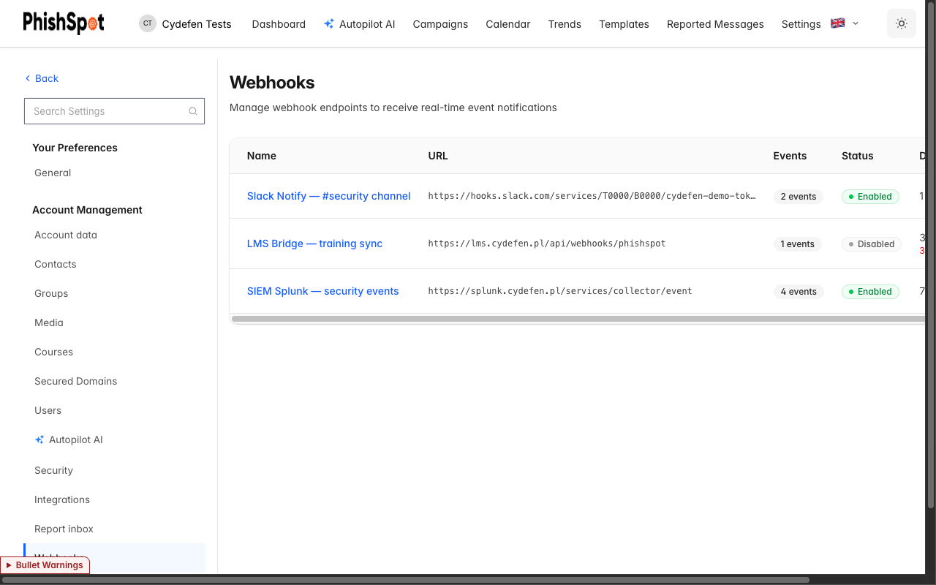
Webhooks endpoints index showing three configured webhooks
- Open Account settings → Webhooks. The endpoints page lists existing webhooks with columns for Name, URL, Events (count of subscribed types), Status (Enabled / Disabled), Deliveries (total + failed count), and Actions.
- Click New webhook. The form has four fields:
  - Name — a friendly label. Examples from a working setup: “SIEM Splunk — security events”, “LMS Bridge — training sync”, “Slack Notify — #security channel”.
  - Webhook URL — where deliveries POST. Must be HTTPS. The platform rejects URLs that resolve to localhost, link-local addresses (169.254/16), or any RFC1918 private range (10/8, 172.16/12, 192.168/16). It also blocks *.phishspot.com. The goal is to keep the webhook system from being used as an internal-network probe.
  - Subscribe to Events — checkboxes for each event type (see §26.3). Pick at least one.
  - Enable webhook endpoint — toggle. Off means we keep the record but don’t deliver anything.
- Save. PhishSpot generates a signing secret (64-char hex from SecureRandom.hex(32)) and displays it in full on the endpoint detail page with a copy-to-clipboard button. Store it somewhere safe; we never re-display it elsewhere.
The endpoint is live immediately. Any event you subscribed to that fires from now on will be POSTed to your URL.

26.3 Available event types
Nine event types are available today, grouped by subject:
Event type | When it fires
campaign.created | A new campaign is created (manual or from an autopilot iteration).
campaign.updated | A campaign’s state, recipients or content changes.
campaign.deleted | A campaign is deleted.
contact.created | A contact is added (CSV, manual, or directory sync).
contact.updated | A contact’s email, department, title, group membership or external state changes.
contact.deleted | A contact is removed from the account.
deliverable.created | A campaign send produces a deliverable row (one per recipient).
deliverable.updated | A recipient’s state changes (sent → opened → clicked → submitted → educated, or bounced).
spam_whitelist.updated | The sending-IP / sending-domain list for the account changes — see Chapter 22 §22.5.
An endpoint can subscribe to any combination. A typical SIEM subscribes to contact.* and deliverable.* so it sees both who’s targeted and how they react. A typical LMS bridge subscribes only to deliverable.updated because it only cares when someone progresses through a training assignment.

26.4 The delivery: payload + signature
Each delivery is an HTTP POST with a JSON body. The body is the event — the same record you can fetch via the API. Shape:
{
"id": "550e8400-e29b-41d4-a716-446655440000",
"type": "contact.created",
"created_at": "2026-05-20T14:22:33.000Z",
"api_version": 1,
"data": {
"id": 42,
"email": "anna.kowalska@cydefen.pl"
}
}
- id — UUID identifying this event; idempotency key. Replays of the same event use the same id.
- type — the event type name (one of the nine in §26.3).
- created_at — ISO-8601 UTC timestamp of when the event occurred.
- api_version — the integer schema version. 1 for the format above. Future-breaking shape changes will bump this and we’ll notify you in advance.
- data — subject-specific fields. For now data includes the subject’s id and key identifying attributes; expand the payload by fetching the full record via the REST API using the included id.
Signing. Every POST carries an X-Webhook-Signature header containing the HMAC-SHA256 of the JSON body, computed with the endpoint’s signing secret. Verification on your side:
expected = OpenSSL::HMAC.hexdigest("SHA256", signing_secret, request.raw_post)
signature = request.headers["X-Webhook-Signature"]
ActiveSupport::SecurityUtils.secure_compare(expected, signature) or render status: 401
import hmac, hashlib
expected = hmac.new(secret.encode(), request.body, hashlib.sha256).hexdigest()
if not hmac.compare_digest(expected, request.headers["X-Webhook-Signature"]):
abort(401)
Use the secret-protected POSTs only — never trust an unsigned request claiming to be from PhishSpot.

26.5 Retries
If your endpoint responds with anything other than HTTP 2xx, the delivery is queued for retry. Retries follow a fixed schedule:
Attempt | Delay from previous
1 | (immediate)
2 | +15 seconds
3 | +1 minute
4 | +5 minutes
5 | +15 minutes
6 | +1 hour
After 5 retries (6 total attempts) the delivery is marked Failed and not retried again. The endpoint’s consecutive_failures counter increments on each fully-failed delivery. After it crosses 5 consecutive failures the account admins are emailed once (with a 7-day cooldown to avoid spamming when an endpoint is misconfigured long-term). The endpoint itself stays enabled — we don’t auto-disable it, because most outages are transient and self-resolving deliveries should be allowed to succeed.
If you want to retry a single failed delivery manually after fixing your side, open the delivery detail page (§26.6) and click Retry. That creates a fresh delivery for the same event, with attempt counters reset.

26.6 Delivery history
The endpoint detail page (click any endpoint name in the index) shows everything we know about that endpoint:
- Endpoint Details — name, URL, API version, signing secret (with copy button), subscribed events.
- Status — Enabled / Disabled toggle.
- Recent Deliveries — table of the last 50 deliveries with columns:
  - Event Type (e.g., contact.created)
  - Status — Pending / Delivering / Delivered / Failed
  - Attempts — current attempt count / max (e.g., 1 / 5, 5 / 5)
  - Last Attempt — timestamp
  - Actions — View Details, Retry Delivery
Click View Details on any delivery row to open the delivery detail page. It shows the full payload (pretty-printed JSON), the destination URL we POSTed to, and a per-attempt log: attempt number, HTTP status code, response duration in ms, and response body (or the error message if the request didn’t complete). This is your primary debug surface when an integration breaks.
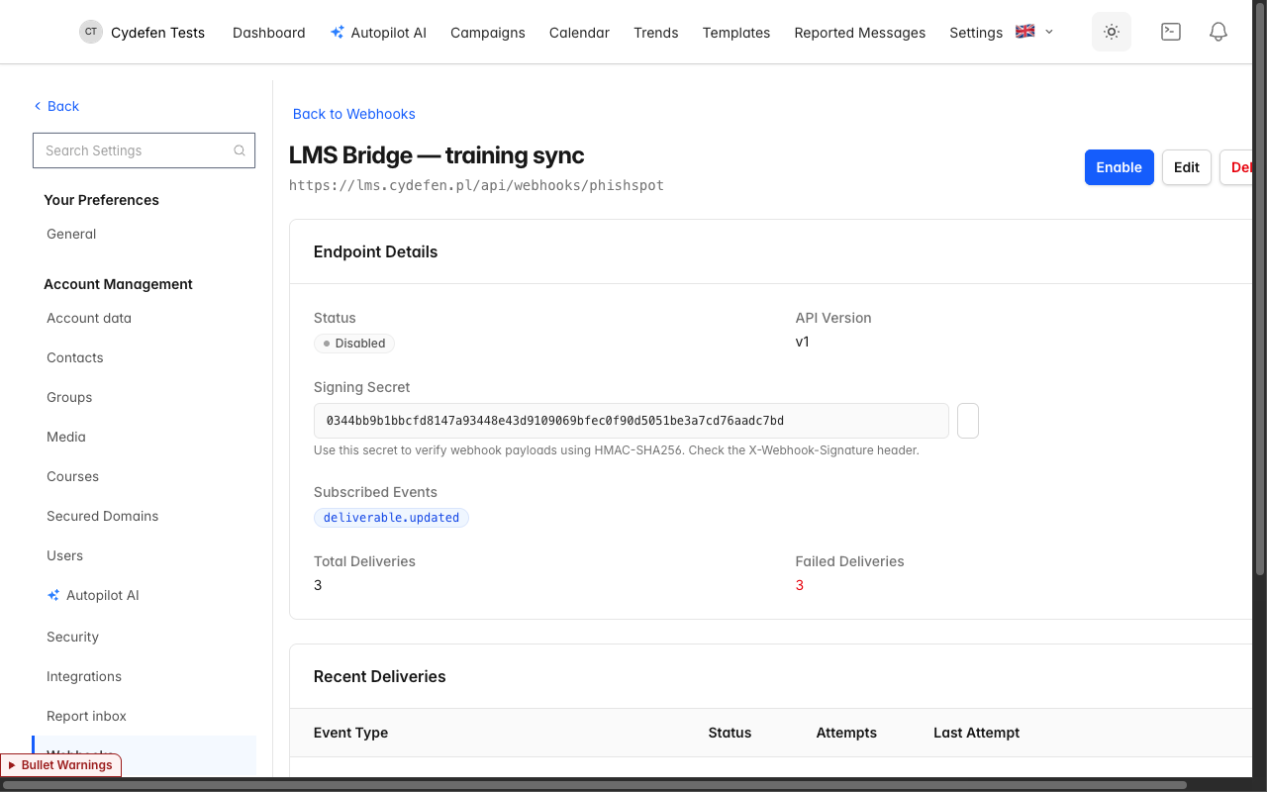
Webhook endpoint detail — signing secret, subscribed events, recent deliveries with attempt counts
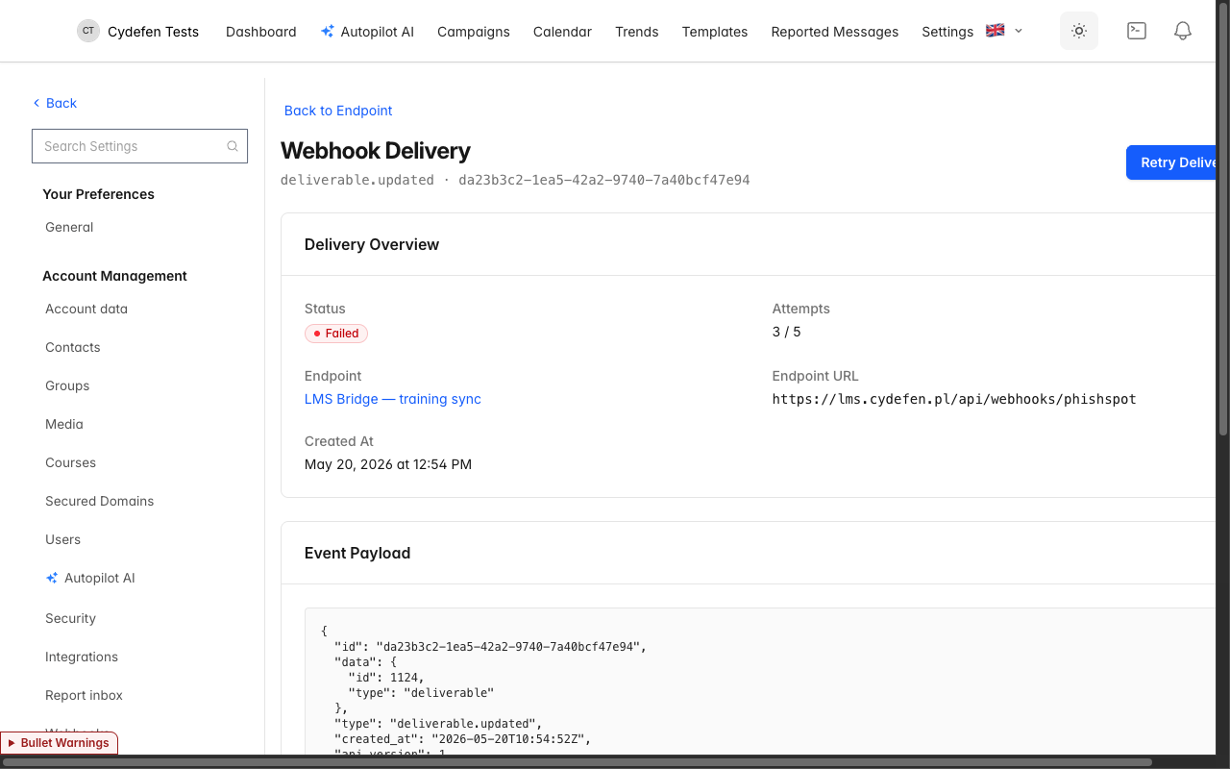
Webhook delivery detail — event payload + per-attempt HTTP log

26.7 Operational guidance
- Acknowledge fast. Your handler should accept the delivery (return 2xx) and process asynchronously. We give up on slow responders — and slow responders cascade into retries, which cascade into “consecutive failures” emails.
- Handle duplicates. Network issues can cause the same event to arrive twice. Dedupe on the id field — it’s stable across retries.
- Validate the signature. Don’t act on a webhook whose signature doesn’t match. The secret-protected POST is the only authentication; without it the integration is replayable by anyone who guesses the URL.
- Expect bursts. A campaign with 1,000 recipients produces 1,000 deliverable.created events in a short window. Make sure your handler scales.
- Rotate the secret if it leaks. Delete and recreate the endpoint — there’s no in-place rotation in the UI today.

26.8 Cross-references
- The REST API for pulling the same data on demand: Chapter 27 REST API Reference.
- The auto-whitelist refresh integration that uses the same delivery pipeline: Chapter 22 Spam Filter Whitelist.
- The Contacts the contact.* events refer to: Chapter 5 Contacts.
- The Campaigns the campaign.* events refer to: Chapter 4 Campaigns.
- Directory sync events that produce most contact.* traffic in production: Chapter 25 Directory Sync.

REST API Reference
PhishSpot exposes a REST API over JSON at https://platform.phishspot.com/api/v1. It covers essentially everything you can do in the admin app: build, schedule and analyze campaigns, manage contacts/groups/templates/courses/media/domains/autopilots, and stream results into your own tooling.
This chapter documents every endpoint in detail — parameters, request bodies, response fields and status codes — so you can integrate without reading the source. For a push-based event model see Chapter 26 Webhooks; for a natural-language AI interface over the same capabilities see Chapter 29 MCP Server.
:::tip[How to read this chapter] §27.1 and §27.2 describe authentication, ID formats, pagination and the error responses every endpoint shares — endpoint sections below only list their additional status codes. Each endpoint lists its parameters (path / query / body), a runnable curl example, the response fields, and a sample response. :::

27.1 Authentication
Every authenticated request must send an API token as a bearer header:
Authorization: Bearer <token>
Get a token one of two ways:
From the admin UI (recommended). Account settings → API Tokens → New token (see Chapter 14). Copy the value — it is shown once. Store it in a secrets manager.
From the API. POST email + password (plus otp_attempt if 2FA is on) to /auth:
curl -X POST https://platform.phishspot.com/api/v1/auth \
-H 'Content-Type: application/json' \
-d '{"email":"admin@example.com","password":"secret"}'
{ "token": "abc123…", "user": { "id": 2, "email": "admin@example.com" } }
Field | Type | Description
email | string | Required. The user’s email.
password | string | Required. The user’s password.
otp_attempt | string | Required only if the user has two-factor auth enabled.
A token belongs to a single user and inherits that user’s account memberships. Treat it like a password. All examples below assume $TOKEN holds a valid token.

27.2 Conventions
- Base URL: https://platform.phishspot.com/api/v1. All paths below are relative to it.
- Content type: send Content-Type: application/json; bodies and responses are JSON.
- Times: ISO-8601 (2026-05-20T14:22:33.000Z), UTC unless stated. The campaign scheduled_at input is interpreted in the account’s timezone.
- IDs in paths: wherever a path takes :id, you may pass either the integer primary key (/campaigns/42) or the record’s prefixed id (/campaigns/camp_0u1k…). Responses always expose the integer id; some also expose the prefixed id.
- account_id: nested routes take account_id in the path; it accepts the integer id or the acct_… prefixed id. Discover yours with GET /accounts.
- Account scoping: a token can act only on accounts its user belongs to. Requesting a record in another account returns 404 — the API never confirms another tenant’s data exists.
- Roles: read endpoints require any role (incl. member). Write endpoints (POST/PATCH/PUT/DELETE and state actions) require admin or editor; a member token gets 403. Team/billing and platform-domain admin actions require admin.
- Pagination: endpoints that paginate accept ?page=N (1-based) and sometimes ?per_page=M or ?limit=M; defaults are noted per endpoint. Non-paginated lists return the full ordered set.

Shared error responses
Unless an endpoint says otherwise, these apply to every call (only endpoint-specific codes are repeated below):
Code | Body | When
401 Unauthorized | (empty) | Missing or invalid Authorization token.
403 Forbidden | {"error":"You are not authorized to perform this action"} | Token valid but the user’s role is insufficient for this action.
404 Not Found | {"error":"Resource not found"} | No such record, or the record belongs to an account the token can’t access.
422 Unprocessable Content | {"errors":{"field":["message"]}} (or {"errors":["message"]} for action endpoints) | Validation failed; inspect errors.
429 Too Many Requests | (varies) | Rate limit exceeded; see §27.17. The Retry-After header says when to retry.

27.3 Identity & accounts

GET /me
Returns the user behind the token.
Parameters: none (bearer token only).
curl -H "Authorization: Bearer $TOKEN" \
https://platform.phishspot.com/api/v1/me
Response 200 OK
Field | Type | Description
id | integer | User id.
email | string | User email.
name | string | Display name.
locale | string | UI locale (en / pl).
accounts | array | Accounts the token can act on (see GET /accounts).

GET /accounts
Lists every account the token’s user can access. Use it to find the account_id for nested routes.
Parameters: none.
curl -H "Authorization: Bearer $TOKEN" \
https://platform.phishspot.com/api/v1/accounts
Response 200 OK — array of:
Field | Type | Description
id | integer | Account id (use in nested paths).
prefix_id | string | Prefixed id (acct_…).
name | string | Account name.
locale | string | Account default locale.
[{ "id": 11, "name": "Cydefen Tests", "locale": "pl", "prefix_id": "acct_3kf…" }]

27.4 Campaigns
Manage phishing-simulation campaigns: create and edit drafts, drive the campaign through its lifecycle (start, pause, stop, cancel), schedule a future send, duplicate, and read results, recipient progress, replies, and a per-contact event timeline.
Authorization is enforced per account: a campaign is only reachable if it belongs to one of the accounts the bearer token’s user is a member of (any membership role can read and write — there are no admin-only campaign actions). State-transition endpoints additionally require the campaign to be in a compatible state (e.g. you can only pause an in-progress campaign), returning 403 otherwise.
POST /campaigns/:id/start and POST /campaigns/:id/schedule send real phishing emails to the campaign’s recipients (immediately, or at the scheduled time). They are not dry-runs. Treat them as destructive, irreversible sends.
The campaign object emitted by show, create, update, and all state-transition endpoints is identical and described once under GET /campaigns/:id.

GET /accounts/:account_id/campaigns
Lists every campaign in the account, newest first. Use it to enumerate campaigns before drilling into one. Auth: Bearer; role: read (any role).
Parameters
Name | In | Type | Required | Description
account_id | path | string | yes | Account id (acct_… or integer). Must be an account the token’s user belongs to.
Request
curl -H "Authorization: Bearer $TOKEN" \
https://platform.phishspot.com/api/v1/accounts/11/campaigns
Response 200 OK — JSON array of campaign objects (see GET /campaigns/:id for the per-object field list), ordered by created_at descending.
[
{
"id": 42,
"account_id": 11,
"name": "Q2 Invoice Lure",
"state": "in_progress",
"delivery_mode": "immediate",
"delivery_schedule": null,
"created_at": "2026-05-01T09:00:00.000Z",
"updated_at": "2026-05-02T14:12:00.000Z",
"email_subject": "Your April invoice is ready",
"email_content": "<p>Hello {{first_name}}…</p>",
"landing_html": "<form>…</form>",
"domain": "officelogin.in",
"course_id": 7,
"groups": [{ "id": 3, "name": "Finance" }],
"statistics": {
"total_contacts": 120,
"total_deliverables": 120,
"completion_percentage": 100.0
},
"can_start": false,
"can_pause": true,
"can_cancel": true
}
]
Status codes
Code | When
200 | Campaigns listed (empty array if the account has none).
403 | Token’s user is not authorized to view the account.
404 | account_id is not an account the token’s user belongs to.

POST /accounts/:account_id/campaigns
Creates a new draft campaign in the account. All content fields are optional at creation — only name is required — so you can create a bare draft and fill it in with PATCH. Auth: Bearer; role: any role.
Parameters
All body params are wrapped in a campaign object.
Name | In | Type | Required | Description
account_id | path | string | yes | Account id (acct_… or integer).
campaign[name] | body | string | yes | Campaign name. Must be unique within the account (case-insensitive).
campaign[delivery_mode] | body | string | no | One of immediate, scheduled, staggered. Defaults to immediate.
campaign[delivery_schedule] | body | string | no | Free-form schedule string used only when delivery_mode is scheduled (ISO8601 datetime, or 5-field cron). Prefer the /schedule endpoint instead.
campaign[email_subject] | body | string | no | Subject line. May contain email merge tags (e.g. {{first_name}}); unknown tags fail validation.
campaign[email_content] | body | string | no | HTML email body. Must be well-formed HTML and use only allowed email merge tags.
campaign[landing_html] | body | string | no | Landing-page HTML. Must be well-formed HTML and use only allowed landing merge tags.
campaign[landing_css] | body | string | no | Landing-page CSS. Must be well-formed CSS.
campaign[landing_page_enabled] | body | boolean | no | Whether the landing page is served. Defaults to false.
campaign[platform_domain_id] | body | integer | no | Id of the PlatformDomain (attacker domain) used for sending and landing. Required before the campaign can start.
campaign[course_id] | body | integer | no | Id of the e-learning course to redirect victims to (used when end_action_type is redirect_to_course).
campaign[from_email] | body | string | no | Sender email address. Required before the campaign can start.
campaign[from_name] | body | string | no | Sender display name.
campaign[end_action_type] | body | string | no | What happens after a victim acts. One of nothing, redirect_to_course, message_page, redirect_to_url. Defaults to message_page.
campaign[end_action_url] | body | string | no | External URL to redirect to. Required (and must be http/https, not loop back to a platform domain) when end_action_type is redirect_to_url.
campaign[end_action_html] | body | string | no | Custom HTML message page. Required when end_action_type is message_page (auto-seeded with a default if omitted).
campaign[group_ids] | body | array of integer | no | Ids of contact groups to target.
Request
curl -X POST -H "Authorization: Bearer $TOKEN" -H "Content-Type: application/json" \
-d '{
"campaign": {
"name": "Q2 Invoice Lure",
"delivery_mode": "immediate",
"email_subject": "Your April invoice is ready",
"email_content": "<p>Hello {{first_name}}…</p>",
"from_email": "billing@officelogin.in",
"from_name": "Accounts Payable",
"platform_domain_id": 5,
"end_action_type": "redirect_to_course",
"course_id": 7,
"group_ids": [3]
}
}' \
https://platform.phishspot.com/api/v1/accounts/11/campaigns
Response 201 Created — the newly created campaign object (same shape as GET /campaigns/:id).
Status codes
Code | When
201 | Campaign created.
400 | The campaign object is missing from the body (ParameterMissing).
403 | Token’s user is not authorized to create campaigns in the account.
404 | account_id is not an account the token’s user belongs to.
422 | Validation failed — e.g. blank/duplicate name, invalid delivery_mode/end_action_type enum, malformed HTML/CSS, disallowed merge tag, or missing end_action_url/end_action_html for the chosen end_action_type. Body: { "errors": { "<field>": ["…"] } }.

GET /campaigns/:id
Fetches a single campaign by id (shallow route, not nested under account). Use it to read full campaign content and the action flags that tell you which transitions are currently allowed. Auth: Bearer; role: any role.
Parameters
Name | In | Type | Required | Description
id | path | string | yes | Campaign id (camp_… or integer). Must belong to an account the token’s user is a member of.
Request
curl -H "Authorization: Bearer $TOKEN" \
https://platform.phishspot.com/api/v1/campaigns/42
Response 200 OK — the campaign object.
Field | Type | Description
id | integer | Campaign id.
account_id | integer | Owning account id.
name | string | Campaign name.
state | string | Lifecycle state: draft, in_progress, paused, cancelled, done, or scheduled.
delivery_mode | string | immediate, scheduled, or staggered.
delivery_schedule | string | null | Raw delivery-schedule string (only meaningful for scheduled mode).
created_at | string | ISO8601 timestamp.
updated_at | string | ISO8601 timestamp.
email_subject | string | null | Email subject.
email_content | string | null | HTML email body.
landing_html | string | null | Landing-page HTML.
domain | string | null | Name of the associated PlatformDomain (e.g. officelogin.in), or null if none set.
course_id | integer | null | Associated course id, or null.
groups | array | Targeted groups, each { "id": integer, "name": string }.
statistics | object | Present only when state is in_progress, paused, or done. Object with total_contacts (integer), total_deliverables (integer), completion_percentage (float).
can_start | boolean | Whether start/schedule is allowed now (true for draft/scheduled).
can_pause | boolean | Whether pause is allowed now (true only when in_progress).
can_cancel | boolean | Whether cancel is allowed now (true for in_progress/paused/scheduled).
{
"id": 42,
"account_id": 11,
"name": "Q2 Invoice Lure",
"state": "draft",
"delivery_mode": "immediate",
"delivery_schedule": null,
"created_at": "2026-05-01T09:00:00.000Z",
"updated_at": "2026-05-01T09:00:00.000Z",
"email_subject": "Your April invoice is ready",
"email_content": "<p>Hello {{first_name}}…</p>",
"landing_html": "<form>…</form>",
"domain": "officelogin.in",
"course_id": 7,
"groups": [{ "id": 3, "name": "Finance" }],
"can_start": true,
"can_pause": false,
"can_cancel": false
}
Status codes
Code | When
200 | Campaign returned.
404 | No campaign with that id in any account the token’s user belongs to (includes cross-account access attempts).

PATCH /campaigns/:id
Updates an existing campaign. Editing is only permitted while the campaign is in draft or scheduled state (the authorization policy rejects edits to running/finished campaigns). Auth: Bearer; role: any role.
Parameters
Body params are wrapped in a campaign object; the same permitted keys as POST apply (all optional on update — send only the fields you want to change).
Name | In | Type | Required | Description
id | path | string | yes | Campaign id (camp_… or integer).
campaign[…] | body | — | no | Any subset of the keys listed under POST /accounts/:account_id/campaigns (name, delivery_mode, delivery_schedule, email_subject, email_content, landing_html, landing_css, landing_page_enabled, platform_domain_id, course_id, from_email, from_name, end_action_type, end_action_url, end_action_html, group_ids[]).
Request
curl -X PATCH -H "Authorization: Bearer $TOKEN" -H "Content-Type: application/json" \
-d '{ "campaign": { "email_subject": "Action required: invoice overdue" } }' \
https://platform.phishspot.com/api/v1/campaigns/42
Response 200 OK — the updated campaign object (same shape as GET /campaigns/:id).
Status codes
Code | When
200 | Campaign updated.
400 | The campaign object is missing from the body (ParameterMissing).
403 | Campaign is not in draft/scheduled state (editing locked), or user not authorized.
404 | Campaign not found in the user’s accounts.
422 | Validation failed (same validations as POST). Body: { "errors": { … } }.

DELETE /campaigns/:id
Permanently deletes a campaign and its dependent records (recipients, deliverables, events, replies). Allowed in any state. Auth: Bearer; role: any role.
No parameters beyond the bearer token and the path id.
Name | In | Type | Required | Description
id | path | string | yes | Campaign id (camp_… or integer).
Request
curl -X DELETE -H "Authorization: Bearer $TOKEN" \
https://platform.phishspot.com/api/v1/campaigns/42
Response 204 No Content — empty body.
Status codes
Code | When
204 | Campaign deleted.
403 | User not authorized to delete the campaign.
404 | Campaign not found in the user’s accounts.

POST /campaigns/:id/start
Starts the campaign and sends real phishing emails to all targeted recipients (in batches for immediate mode, or per the delivery schedule for other modes). This is irreversible — once started, emails go out.
Transitions a draft or scheduled campaign to in_progress and enqueues the send jobs. Before sending, the server runs a readiness preflight and rejects the request if the campaign is incomplete. Auth: Bearer; role: any role.
No parameters beyond the bearer token and the path id.
Name | In | Type | Required | Description
id | path | string | yes | Campaign id (camp_… or integer).
Request
curl -X POST -H "Authorization: Bearer $TOKEN" \
https://platform.phishspot.com/api/v1/campaigns/42/start
Response 200 OK — the campaign object with state: "in_progress".
Status codes
Code | When
200 | Campaign started; sends enqueued.
403 | Campaign is not in a startable state (draft/paused/scheduled).
404 | Campaign not found in the user’s accounts.
422 | Readiness preflight failed. Body: { "errors": ["…", "…"] } (a flat array of human-readable messages). Triggers include: missing email subject, missing email content, missing sender email, no platform domain set, platform domain not active or sending-blocked, no recipients targeted, and end-action gaps (missing course for redirect_to_course, missing URL for redirect_to_url, missing HTML for message_page).

POST /campaigns/:id/stop
Marks an in-progress campaign as done (completed). Use it to end a running campaign early; pending sends are not re-enqueued. Auth: Bearer; role: any role.
No parameters beyond the bearer token and the path id.
Name | In | Type | Required | Description
id | path | string | yes | Campaign id (camp_… or integer).
Request
curl -X POST -H "Authorization: Bearer $TOKEN" \
https://platform.phishspot.com/api/v1/campaigns/42/stop
Response 200 OK — the campaign object with state: "done".
Status codes
Code | When
200 | Campaign marked done.
403 | Campaign is not in_progress.
404 | Campaign not found in the user’s accounts.
422 | State transition rejected by the model. Body: { "errors": { … } }.

POST /campaigns/:id/pause
Pauses an in-progress campaign (state → paused), halting further scheduled sends. Resume by calling start again. Auth: Bearer; role: any role.
No parameters beyond the bearer token and the path id.
Name | In | Type | Required | Description
id | path | string | yes | Campaign id (camp_… or integer).
Request
curl -X POST -H "Authorization: Bearer $TOKEN" \
https://platform.phishspot.com/api/v1/campaigns/42/pause
Response 200 OK — the campaign object with state: "paused".
Status codes
Code | When
200 | Campaign paused.
403 | Campaign is not in_progress.
404 | Campaign not found in the user’s accounts.
422 | State transition rejected by the model. Body: { "errors": { … } }.

POST /campaigns/:id/cancel
Cancels a campaign (state → cancelled). Allowed from in_progress, paused, or scheduled (not from draft or already-finished campaigns). Auth: Bearer; role: any role.
No parameters beyond the bearer token and the path id.
Name | In | Type | Required | Description
id | path | string | yes | Campaign id (camp_… or integer).
Request
curl -X POST -H "Authorization: Bearer $TOKEN" \
https://platform.phishspot.com/api/v1/campaigns/42/cancel
Response 200 OK — the campaign object with state: "cancelled".
Status codes
Code | When
200 | Campaign cancelled.
403 | Campaign is not in a cancellable state (in_progress/paused/scheduled).
404 | Campaign not found in the user’s accounts.
422 | State transition rejected by the model. Body: { "errors": { … } }.

POST /campaigns/:id/duplicate
Clones the campaign into a fresh draft (with a numbered-suffix name like "Q2 Invoice Lure (1)"), copying content, targeted groups, and recipients but resetting state, schedule, and snapshot. Use it to re-run or branch a campaign. Auth: Bearer; role: any role.
No parameters beyond the bearer token and the path id.
Name | In | Type | Required | Description
id | path | string | yes | Campaign id (camp_… or integer) of the source campaign.
Request
curl -X POST -H "Authorization: Bearer $TOKEN" \
https://platform.phishspot.com/api/v1/campaigns/42/duplicate
Response 201 Created — the new draft campaign object (same shape as GET /campaigns/:id), with a new id and state: "draft".
Status codes
Code | When
201 | Duplicate created.
403 | User not authorized.
404 | Source campaign not found in the user’s accounts.
422 | The duplicate failed to save (validation). Body: { "errors": { … } }.

POST /campaigns/:id/schedule
Schedules the campaign to send real phishing emails at the given future time. When the scheduled time arrives, emails go out automatically.
Schedules a draft campaign for a future send (state → scheduled). Runs the same readiness preflight as start, plus time-validity checks. Auth: Bearer; role: any role.
Parameters
Name | In | Type | Required | Description
id | path | string | yes | Campaign id (camp_… or integer).
scheduled_at | body | string | yes | Target send time as a local (account-timezone) datetime, no offset — e.g. 2026-06-10T09:00 (the value a datetime-local input produces). It is interpreted in the account’s timezone (falling back to UTC if the account has none) and converted to UTC server-side. Must be in the future and at least 5 minutes from now. Not wrapped in a campaign object — sent as a top-level body key.
Request
curl -X POST -H "Authorization: Bearer $TOKEN" -H "Content-Type: application/json" \
-d '{ "scheduled_at": "2026-06-10T09:00" }' \
https://platform.phishspot.com/api/v1/campaigns/42/schedule
Response 200 OK — the campaign object with state: "scheduled".
Status codes
Code | When
200 | Campaign scheduled.
403 | Campaign is not in a startable state (must be draft).
404 | Campaign not found in the user’s accounts.
422 | Scheduling failed. Body: { "errors": ["…"] } (flat array). Triggers: scheduled_at blank, unparseable datetime, time in the past, time less than 5 minutes from now, or the start-readiness preflight failing (same content/sender/domain/recipient/end-action checks as start).

POST /campaigns/:id/cancel_schedule
Cancels a pending schedule, returning the campaign to draft and removing its queued send job. Only valid for a scheduled campaign. Auth: Bearer; role: any role.
No parameters beyond the bearer token and the path id.
Name | In | Type | Required | Description
id | path | string | yes | Campaign id (camp_… or integer).
Request
curl -X POST -H "Authorization: Bearer $TOKEN" \
https://platform.phishspot.com/api/v1/campaigns/42/cancel_schedule
Response 200 OK — the campaign object (state returned to draft).
Status codes
Code | When
200 | Schedule cancelled.
403 | User not authorized (policy requires scheduled state).
404 | Campaign not found in the user’s accounts.
422 | Campaign is not currently scheduled. Body: { "error": "Campaign is not scheduled (state: <state>); nothing to cancel." } (note the singular error key here).

GET /campaigns/:id/results
Returns aggregated campaign statistics: the overall engagement funnel plus per-group and per-department breakdowns. Use it to render dashboards and reports. Auth: Bearer; role: any role.
Parameters
Name | In | Type | Required | Description
id | path | string | yes | Campaign id (camp_… or integer).
Request
curl -H "Authorization: Bearer $TOKEN" \
https://platform.phishspot.com/api/v1/campaigns/42/results
Response 200 OK — statistics object.
Field | Type | Description
campaign_id | integer | Campaign id.
name | string | Campaign name.
funnel | object | Overall engagement funnel (counts + rates). See sub-fields below.
groups | array | Per-group breakdown. Empty array if the campaign targets no groups. See sub-fields below.
departments | array | Per-department breakdown (contacts grouped by their department). Empty if no departments. Same numeric sub-fields as a group entry, with name but no id.
funnel sub-fields:
Field | Type | Description
sent | integer | Distinct contacts the email was successfully sent to.
opened | integer | Distinct contacts who opened.
clicked | integer | Distinct contacts who clicked.
submitted | integer | Distinct contacts who submitted data on the landing page.
trained | integer | Deliverables that reached the educated (training-completed) state.
replied | integer | Distinct contacts who replied to the phishing email (side-channel signal, not part of the click/submit funnel).
open_rate | float | opened / sent as a percentage (1 decimal).
click_rate | float | clicked / sent percentage.
submit_rate | float | submitted / sent percentage.
train_rate | float | trained / sent percentage.
reply_rate | float | replied / sent percentage.
Each groups[] entry: name (string), id (integer), total_contacts (integer), sent, opened, clicked, submitted, trained (integers), and open_rate, click_rate, submit_rate, train_rate (floats).
{
"campaign_id": 42,
"name": "Q2 Invoice Lure",
"funnel": {
"sent": 120,
"opened": 84,
"clicked": 37,
"submitted": 12,
"trained": 9,
"replied": 3,
"open_rate": 70.0,
"click_rate": 30.8,
"submit_rate": 10.0,
"train_rate": 7.5,
"reply_rate": 2.5
},
"groups": [
{
"name": "Finance",
"id": 3,
"total_contacts": 60,
"sent": 60,
"opened": 45,
"clicked": 22,
"submitted": 8,
"trained": 6,
"open_rate": 75.0,
"click_rate": 36.7,
"submit_rate": 13.3,
"train_rate": 10.0
}
],
"departments": [
{
"name": "Accounting",
"total_contacts": 40,
"sent": 40,
"opened": 30,
"clicked": 15,
"submitted": 5,
"trained": 4,
"open_rate": 75.0,
"click_rate": 37.5,
"submit_rate": 12.5,
"train_rate": 10.0
}
]
}
Status codes
Code | When
200 | Statistics returned.
404 | Campaign not found in the user’s accounts.

GET /campaigns/:id/recipients
Returns a paginated, filterable list of campaign recipients with their per-contact delivery stage, training status, and reply flag. Recipients are ordered by contact last name then first name. Auth: Bearer; role: any role.
Parameters
Name | In | Type | Required | Description
id | path | string | yes | Campaign id (camp_… or integer).
page | query | integer | no | 1-based page number; values below 1 are clamped to 1. Defaults to 1. Page size is fixed at 25.
stage | query | string | no | Filter by funnel stage: sent, opened, clicked, submitted, or trained. all (or omitted) returns everyone. Filters are cumulative-by-stage (e.g. opened includes those who later clicked/submitted/were educated).
replied | query | boolean | no | When truthy (true/1), restrict to contacts who replied to the email.
group_id | query | integer | no | Restrict to contacts in this group (must belong to the campaign’s account).
department | query | string | no | Restrict to contacts whose department matches this exact value.
Request
curl -H "Authorization: Bearer $TOKEN" \
"https://platform.phishspot.com/api/v1/campaigns/42/recipients?stage=clicked&page=1"
Response 200 OK — paginated recipients.
Field | Type | Description
campaign_id | integer | Campaign id.
page | integer | Current page number.
per_page | integer | Page size (always 25).
total | integer | Total recipients matching the filters (across all pages).
recipients | array | Recipient rows (see sub-fields).
Each recipients[] entry:
Field | Type | Description
id | integer | Contact id.
contact_id | integer | Contact id (same value as id).
email | string | Contact email.
full_name | string | Contact full name.
status | string | Delivery state: pending, sent, delivered, bounced, opened, clicked, submitted, or educated.
stage | string | Same value as status (alias).
training_status | string | not_started, in_progress, or completed.
replied | boolean | Whether the contact replied to the phishing email.
{
"campaign_id": 42,
"page": 1,
"per_page": 25,
"total": 37,
"recipients": [
{
"id": 901,
"contact_id": 901,
"email": "jane.doe@victimco.com",
"full_name": "Jane Doe",
"status": "clicked",
"stage": "clicked",
"training_status": "in_progress",
"replied": false
}
]
}
Status codes
Code | When
200 | Recipients returned.
404 | Campaign not found in the user’s accounts, or a group_id/department lookup references a record outside the campaign’s account.

GET /campaigns/:id/replies
Returns a paginated list of inbound replies recipients sent back to the phishing email, newest first. Use it to surface engaged targets and review reply content. Auth: Bearer; role: any role.
Parameters
Name | In | Type | Required | Description
id | path | string | yes | Campaign id (camp_… or integer).
page | query | integer | no | 1-based page number; clamped to a minimum of 1. Defaults to 1. Page size is fixed at 25.
Request
curl -H "Authorization: Bearer $TOKEN" \
"https://platform.phishspot.com/api/v1/campaigns/42/replies?page=1"
Response 200 OK — paginated replies.
Field | Type | Description
campaign_id | integer | Campaign id.
page | integer | Current page number.
per_page | integer | Page size (always 25).
total | integer | Total replies for the campaign.
replies | array | Reply rows (see sub-fields).
Each replies[] entry:
Field | Type | Description
id | integer | Reply id.
from_email | string | Sender (recipient) email address.
received_at | string | ISO8601 timestamp of when the reply was received.
subject | string | Reply subject line.
excerpt | string | Plain-text excerpt of the reply body (truncated).
attachments_count | integer | Number of attachments on the reply.
{
"campaign_id": 42,
"page": 1,
"per_page": 25,
"total": 3,
"replies": [
{
"id": 5501,
"from_email": "jane.doe@victimco.com",
"received_at": "2026-05-02T11:24:00Z",
"subject": "Re: Your April invoice is ready",
"excerpt": "Is this really from accounting? I don't recognize…",
"attachments_count": 0
}
]
}
Status codes
Code | When
200 | Replies returned.
404 | Campaign not found in the user’s accounts.

GET /campaigns/:id/timeline
Returns the chronological event timeline for a single contact within the campaign (sent → opened → clicked → submitted → training, etc.). Use it to inspect one victim’s full interaction history. Auth: Bearer; role: any role.
Parameters
Name | In | Type | Required | Description
id | path | string | yes | Campaign id (camp_… or integer).
contact_id | query | integer | yes | Id of the contact whose timeline to return. Must belong to the campaign’s account.
Request
curl -H "Authorization: Bearer $TOKEN" \
"https://platform.phishspot.com/api/v1/campaigns/42/timeline?contact_id=901"
Response 200 OK — the contact’s event list, ordered oldest-first.
Field | Type | Description
campaign_id | integer | Campaign id.
contact_id | integer | Contact id.
events | array | Events for this contact (see sub-fields).
Each events[] entry:
Field | Type | Description
genre | string | Event type: sent, delivered, bounced, opened, clicked, submitted_data, started_training, completed_training, failed_quiz, passed_quiz, or replied.
created_at | string | ISO8601 timestamp of the event.
metadata | object | null | Arbitrary event metadata (e.g. user agent, IP, quiz details), as stored.
{
"campaign_id": 42,
"contact_id": 901,
"events": [
{ "genre": "sent", "created_at": "2026-05-01T09:05:00Z", "metadata": {} },
{ "genre": "opened", "created_at": "2026-05-01T09:41:00Z", "metadata": { "ua": "Mozilla/5.0" } },
{ "genre": "clicked", "created_at": "2026-05-01T09:42:00Z", "metadata": { "ip": "203.0.113.7" } }
]
}
Status codes
Code | When
200 | Timeline returned.
404 | Campaign not found in the user’s accounts, or contact_id does not reference a contact in the campaign’s account (a missing/invalid contact_id raises a not-found).

27.5 Phishing templates
The phishing-template library is the catalog of ready-made phishing scenarios (email + landing page + post-click action) that an account can deploy into a real campaign. Templates come in two flavors: curated (platform-provided, shared with every account, read-only) and custom (created by an account, visible only to that account). Templates are organized into a tree of categories (up to three levels deep). Deploying a template creates a new draft campaign pre-filled with the template’s content — it never sends any email.

GET /accounts/:account_id/phishing_templates
Lists templates visible to an account, paginated 12 per page. Use the tab parameter to switch between the shared curated library and the account’s own custom templates, and category/search to narrow the results. Returns metadata only (no HTML blobs) — call the show endpoint for full content. Auth: Bearer; role: read (any role).
Parameters
Name | In | Type | Required | Description
account_id | path | string | yes | Account id (acct_… or integer). Must be an account the token’s user belongs to.
tab | query | string | no | Which library to list. custom returns this account’s own templates; any other value (or omitted) returns the shared curated library. Default: curated.
category | query | string or array | no | One or more category ids (tcat_… prefix ids or integers) to filter by. Matches templates assigned to the given category or any of its descendants. Pass multiple as repeated category[] params. Unrecognized ids are ignored.
search | query | string | no | Case-insensitive substring match against template name and description.
page | query | integer | no | 1-based page number. Values below 1 are clamped to 1. Default: 1. Page size is fixed at 12.
Request
curl -H "Authorization: Bearer $TOKEN" \
"https://platform.phishspot.com/api/v1/accounts/11/phishing_templates?tab=curated&category=tcat_abc123&search=invoice&page=1"
Response 200 OK — pagination envelope plus a templates array of template metadata.
Field | Type | Description
tab | string | The resolved tab: "curated" or "custom".
page | integer | Current page number.
per_page | integer | Page size (always 12).
total | integer | Total number of templates matching the filters (across all pages).
templates | array | Array of template objects (see fields below).
templates[].id | integer | Raw numeric template id.
templates[].name | string | Template name.
templates[].description | string | null | Free-text description.
templates[].curated | boolean | true for platform-provided templates, false for account-owned.
templates[].draft | boolean | true if the template is an unpublished draft (missing required content). Drafts cannot be deployed.
templates[].email_subject | string | null | The phishing email subject line.
templates[].landing_page_enabled | boolean | Whether the template includes a hosted landing page.
templates[].created_at | string (ISO 8601) | Creation timestamp.
templates[].updated_at | string (ISO 8601) | Last-update timestamp.
templates[].template_id | string | Prefixed id (tmpl_…). Use this in the show/deploy paths.
templates[].categories | array | Categories this template is assigned to.
templates[].categories[].id | integer | Raw numeric category id.
templates[].categories[].category_id | string | Prefixed category id (tcat_…).
templates[].categories[].name | string | Localized category name (current request locale, falling back to English).
{
"tab": "curated",
"page": 1,
"per_page": 12,
"total": 37,
"templates": [
{
"id": 84,
"name": "Unpaid Invoice Reminder",
"description": "Spoofed accounts-payable invoice with a credential-harvesting login page.",
"curated": true,
"draft": false,
"email_subject": "Action required: invoice #44021 is overdue",
"landing_page_enabled": true,
"created_at": "2026-01-14T09:12:00.000Z",
"updated_at": "2026-03-02T16:40:11.000Z",
"template_id": "tmpl_8x2k9q",
"categories": [
{ "id": 5, "category_id": "tcat_abc123", "name": "Finance" }
]
}
]
}
Status codes
Code | When
200 | Templates listed (the array may be empty).
404 | account_id is not an account the token’s user belongs to. Body: {"error":"Account not found"}.

GET /accounts/:account_id/phishing_template_categories
Returns the full category tree (roots with nested children, up to three levels) for the template-library filter UI. Useful for building a category picker before calling the templates list with category=. Auth: Bearer; role: read (any role).
Parameters
Name | In | Type | Required | Description
account_id | path | string | yes | Account id (acct_… or integer). Must be an account the token’s user belongs to.
(Categories are global, not account-scoped — the account_id only gates access. No other parameters.)
Request
curl -H "Authorization: Bearer $TOKEN" \
https://platform.phishspot.com/api/v1/accounts/11/phishing_template_categories
Response 200 OK — a categories array of root categories, each recursively embedding its children.
Field | Type | Description
categories | array | Root categories, ordered by position.
categories[].id | integer | Raw numeric category id.
categories[].category_id | string | Prefixed category id (tcat_…).
categories[].name | string | Localized category name (request locale, falling back to English).
categories[].slug | string | URL-safe slug (unique, derived from the English name).
categories[].depth | integer | Tree depth: 0 for roots, 1 for children, 2 for grandchildren.
categories[].is_leaf | boolean | true when the category has no children.
categories[].children | array | Nested child categories with the same shape (empty array for leaves).
{
"categories": [
{
"id": 1,
"category_id": "tcat_root01",
"name": "Finance",
"slug": "finance",
"depth": 0,
"is_leaf": false,
"children": [
{
"id": 5,
"category_id": "tcat_abc123",
"name": "Invoices",
"slug": "invoices",
"depth": 1,
"is_leaf": true,
"children": []
}
]
}
]
}
Status codes
Code | When
200 | Category tree returned (may be an empty array).
404 | account_id is not an account the token’s user belongs to. Body: {"error":"Account not found"}.

GET /phishing_templates/:id
Returns a single template with its full content — email body, landing-page HTML/CSS, and post-click (end action) configuration. Use this to render a preview or to inspect what a deploy will copy into a campaign. This route is shallow (no account_id in the path); the token’s user must be able to see the template (their own custom templates plus all curated ones). Auth: Bearer; role: read (any role).
Parameters
Name | In | Type | Required | Description
id | path | string | yes | Template id (tmpl_… or integer).
No parameters beyond the bearer token.
Request
curl -H "Authorization: Bearer $TOKEN" \
https://platform.phishspot.com/api/v1/phishing_templates/tmpl_8x2k9q
Response 200 OK — the full template object.
Field | Type | Description
id | integer | Raw numeric template id.
name | string | Template name.
description | string | null | Free-text description.
curated | boolean | true for platform-provided templates, false for account-owned.
draft | boolean | true if unpublished. Drafts cannot be deployed.
email_subject | string | null | Phishing email subject line (may contain merge tags).
email_content | string | null | Full phishing email HTML body.
landing_html | string | null | Landing-page HTML.
landing_css | string | null | Landing-page CSS.
landing_page_enabled | boolean | Whether a hosted landing page is included.
end_action_type | string | What happens after a victim submits the landing page. One of nothing, redirect_to_course, message_page, redirect_to_url.
end_action_url | string | null | Target URL when end_action_type is redirect_to_url (must be http/https).
end_action_html | string | null | HTML shown when end_action_type is message_page (e.g. the awareness page).
created_at | string (ISO 8601) | Creation timestamp.
updated_at | string (ISO 8601) | Last-update timestamp.
template_id | string | Prefixed id (tmpl_…).
course_id | integer | null | Linked e-learning course id (used when end_action_type is redirect_to_course).
publishable | boolean | true when all required fields (name, subject, email body, landing HTML) are present.
categories | array | Assigned categories: each with id (integer), category_id (tcat_…), and name.
{
"id": 84,
"name": "Unpaid Invoice Reminder",
"description": "Spoofed accounts-payable invoice with a credential-harvesting login page.",
"curated": true,
"draft": false,
"email_subject": "Action required: invoice #44021 is overdue",
"email_content": "<html><body><p>Dear {{first_name}}, your invoice is overdue…</p></body></html>",
"landing_html": "<form action=\"#\">…</form>",
"landing_css": "body { font-family: sans-serif; }",
"landing_page_enabled": true,
"end_action_type": "message_page",
"end_action_url": null,
"end_action_html": "<h1>You've been phished by a simulation.</h1>",
"created_at": "2026-01-14T09:12:00.000Z",
"updated_at": "2026-03-02T16:40:11.000Z",
"template_id": "tmpl_8x2k9q",
"course_id": null,
"publishable": true,
"categories": [
{ "id": 5, "category_id": "tcat_abc123", "name": "Finance" }
]
}
Status codes
Code | When
200 | Template returned.
403 | The template is not visible to the token’s user (another account’s custom template). Body: {"error":"You are not authorized to perform this action"}.
404 | No template matches id. Body: {"error":"Resource not found"}.

POST /phishing_templates/:id/deploy
Creates a new draft campaign in the target account, pre-filled with the template’s content (email subject/body, landing HTML/CSS, end action, course). This route is shallow, so the deploying account is passed in the body as account_id. With quick_launch=true it additionally adds all of the account’s contacts as recipients and advances the campaign to the review step. This endpoint never sends any email — a human launches the campaign from the PhishSpot UI. Drafts cannot be deployed. Auth: Bearer; role: any member of the target account.
Parameters
Name | In | Type | Required | Description
id | path | string | yes | Template id to deploy (tmpl_… or integer). Must not be a draft template.
account_id | body | string | yes | Account to create the campaign in (acct_… or integer). Must be an account the token’s user belongs to.
quick_launch | body | boolean | no | When truthy (true, "1", etc.), bulk-adds every account contact as a recipient and marks wizard steps 1–5 complete so the campaign lands on the review step. Requires an active sending domain and at least one contact. Default: false.
Request
curl -X POST -H "Authorization: Bearer $TOKEN" -H "Content-Type: application/json" \
-d '{ "account_id": "acct_4f8a2c", "quick_launch": true }' \
https://platform.phishspot.com/api/v1/phishing_templates/tmpl_8x2k9q/deploy
Response 201 Created — the newly created campaign (same shape as the campaign show endpoint). A freshly deployed campaign is in the draft state, so the statistics block is omitted (it only appears once a campaign is in progress, paused, or done).
Field | Type | Description
id | integer | Raw numeric campaign id.
account_id | integer | Owning account id.
name | string | Auto-generated name: "<Template name> - YYYY-MM-DD HH:MM:SS" (with a numeric suffix on collision).
state | string | Lifecycle state — draft immediately after deploy. One of draft, in_progress, paused, cancelled, done, scheduled.
delivery_mode | string | null | immediate, scheduled, or staggered (not set by deploy).
delivery_schedule | object | null | Delivery schedule config (not set by deploy).
created_at | string (ISO 8601) | Creation timestamp.
updated_at | string (ISO 8601) | Last-update timestamp.
email_subject | string | null | Copied from the template.
email_content | string | null | Copied from the template.
landing_html | string | null | Copied from the template.
domain | string | null | Sending/landing platform domain name (auto-selected from the account’s available domains, may be null).
course_id | integer | null | Linked course id (template’s course, or the account default).
groups | array | Contact groups on the campaign — empty right after deploy. Each: id, name.
can_start | boolean | Whether the campaign can transition to start.
can_pause | boolean | Whether the campaign can be paused.
can_cancel | boolean | Whether the campaign can be cancelled.
{
"id": 512,
"account_id": 11,
"name": "Unpaid Invoice Reminder - 2026-06-02 14:30:07",
"state": "draft",
"delivery_mode": null,
"delivery_schedule": null,
"created_at": "2026-06-02T14:30:07.000Z",
"updated_at": "2026-06-02T14:30:07.000Z",
"email_subject": "Action required: invoice #44021 is overdue",
"email_content": "<html><body><p>Dear {{first_name}}…</p></body></html>",
"landing_html": "<form action=\"#\">…</form>",
"domain": "officelogin.in",
"course_id": null,
"groups": [],
"can_start": false,
"can_pause": false,
"can_cancel": false
}
Status codes
Code | When
201 | Campaign created from the template.
403 | The template is a draft (drafts cannot be deployed), or it is not visible to the token’s user. Body: {"error":"You are not authorized to perform this action"}.
404 | No template matches id, or the body account_id is not an account the token’s user belongs to. Body: {"error":"Resource not found"} (template) / {"error":"Account not found"} (account).
422 | quick_launch=true but the account has no active sending domain ("Quick launch needs an active sending domain for this account.") or no contacts ("Quick launch needs at least one contact in the account."). Body: {"error":"<message>"}.

27.6 Contacts & groups
Contacts are the employees you target with phishing simulations; groups are named collections used to scope campaigns. Both are account-scoped: collection actions are nested under /accounts/:account_id/…, while reads/writes on an individual record use the shallow /contacts/:id and /groups/:id routes. Membership in the account is required for every endpoint — all policy checks pass for any account member (read and write alike), so there is no admin/editor distinction here. The only write gate is that a group participating in an active campaign (in_progress or paused) is locked and cannot be updated, deleted, or have its membership changed.

GET /accounts/:account_id/contacts
Lists every contact in the account, ordered by last name then first name, with each contact’s groups inlined. Use it to page through or sync your roster. Auth: Bearer; role: read (any role).
Parameters
Name | In | Type | Required | Description
account_id | path | string | yes | Account id (acct_… or integer).
Request
curl -H "Authorization: Bearer $TOKEN" \
https://platform.phishspot.com/api/v1/accounts/11/contacts
Response 200 OK — a JSON array of contact objects (see the contact fields below).
Field | Type | Description
id | integer | Contact primary key.
account_id | integer | Owning account id.
first_name | string | Given name.
last_name | string|null | Surname.
email | string | Email address (unique per account).
telephone | string|null | Phone number.
created_at | string | ISO 8601 timestamp.
updated_at | string | ISO 8601 timestamp.
full_name | string | Convenience: "first_name last_name" trimmed.
groups | array | Groups this contact belongs to; each { id, name }.
groups[].id | integer | Group id.
groups[].name | string | Group name (normalized, snake_case for manual groups).
[
{
"id": 501,
"account_id": 11,
"first_name": "Ada",
"last_name": "Kowalska",
"email": "ada.kowalska@example.com",
"telephone": "+48 600 123 456",
"created_at": "2026-05-01T09:30:00.000Z",
"updated_at": "2026-05-12T14:02:11.000Z",
"full_name": "Ada Kowalska",
"groups": [
{ "id": 90, "name": "finance" }
]
}
]
Status codes
Code | When
200 | Contacts returned (possibly an empty array).
404 | account_id is not an account the token’s user belongs to.

POST /accounts/:account_id/contacts
Creates a single contact in the account. Use the import endpoint instead for bulk loads. Auth: Bearer; role: read (any role).
Parameters
Body params are wrapped in a contact object.
Name | In | Type | Required | Description
account_id | path | string | yes | Account id (acct_… or integer).
first_name | body | string | yes | Given name (max 255). Required by the model.
email | body | string | yes | Email address. Must match a standard email format and be unique within the account (case-insensitive). Max 255.
last_name | body | string | no | Surname (max 255).
telephone | body | string | no | Phone number (max 50). Must match +CC (NNN) NNN-NNNN-style formats; blank allowed.
group_ids | body | array | no | Array of group ids to attach the contact to on creation.
Request
curl -X POST -H "Authorization: Bearer $TOKEN" -H "Content-Type: application/json" \
-d '{ "contact": { "first_name": "Ada", "last_name": "Kowalska", "email": "ada.kowalska@example.com", "telephone": "+48 600 123 456", "group_ids": [90] } }' \
https://platform.phishspot.com/api/v1/accounts/11/contacts
Response 201 Created — the created contact, using the same fields as the list endpoint above.
{
"id": 501,
"account_id": 11,
"first_name": "Ada",
"last_name": "Kowalska",
"email": "ada.kowalska@example.com",
"telephone": "+48 600 123 456",
"created_at": "2026-05-01T09:30:00.000Z",
"updated_at": "2026-05-01T09:30:00.000Z",
"full_name": "Ada Kowalska",
"groups": [
{ "id": 90, "name": "finance" }
]
}
Status codes
Code | When
201 | Contact created.
400 | Body is missing the top-level contact key.
404 | account_id is not an account the token’s user belongs to.
422 | Validation failed (e.g. missing first_name, missing/malformed email, or duplicate email within the account). Body is { "errors": { … } }.

POST /accounts/:account_id/contacts/import
Bulk-imports contacts into the account from CSV. Existing contacts (matched by email) are updated with non-blank values; new ones are created; groups named in the data are created and associations are made. Provide either raw CSV text in csv or a JSON array in contacts — the array is converted to CSV server-side using the canonical header order. Auth: Bearer; role: read (any role).
The canonical CSV header order is: first_name, last_name, email, telephone, groups, department, title, location. In the groups column, multiple groups are separated by | (a pipe). When using the JSON contacts form, each row’s groups may be an array (e.g. ["finance","exec"]) which is joined with | automatically.
Parameters
Name | In | Type | Required | Description
account_id | path | string | yes | Account id (acct_… or integer).
csv | body | string | conditional | Raw CSV text with the canonical header row. Required if contacts is omitted. Takes precedence if both are given.
contacts | body | array | conditional | Array of row objects keyed by the canonical headers. Required if csv is omitted. Each row’s groups may be a string or an array of group names.
You must supply exactly one of csv or contacts. If both are blank/absent the request fails with 422.
Request
curl -X POST -H "Authorization: Bearer $TOKEN" -H "Content-Type: application/json" \
-d '{ "contacts": [
{ "first_name": "Ada", "last_name": "Kowalska", "email": "ada.kowalska@example.com", "telephone": "+48600123456", "groups": ["finance"], "department": "Finance", "title": "Analyst", "location": "Warsaw" },
{ "first_name": "Jan", "email": "jan.nowak@example.com", "groups": ["finance", "exec"] }
] }' \
https://platform.phishspot.com/api/v1/accounts/11/contacts/import
Response 200 OK — a summary of how the rows were processed.
Field | Type | Description
created | integer | Number of new contacts inserted.
updated | integer | Number of existing contacts (matched by email) updated with new non-blank values.
failed | integer | Number of rows rejected as invalid. (A downloadable failed-rows CSV report is attached to the account.)
{
"created": 1,
"updated": 1,
"failed": 0
}
Status codes
Code | When
200 | Import ran; returns the {created, updated, failed} summary.
404 | account_id is not an account the token’s user belongs to.
422 | Neither csv nor contacts was provided. Body is { "error": "Provide either csv or contacts." }.

GET /contacts/:id
Fetches a single contact by id, scoped to the token user’s accounts. Use it to read one contact without listing the whole account. Auth: Bearer; role: read (any role).
Parameters
Name | In | Type | Required | Description
id | path | string | yes | Contact id (cont_… or integer).
No parameters beyond the bearer token and path id.
Request
curl -H "Authorization: Bearer $TOKEN" \
https://platform.phishspot.com/api/v1/contacts/cont_abc123
Response 200 OK — the contact, using the same fields as the list endpoint.
{
"id": 501,
"account_id": 11,
"first_name": "Ada",
"last_name": "Kowalska",
"email": "ada.kowalska@example.com",
"telephone": "+48 600 123 456",
"created_at": "2026-05-01T09:30:00.000Z",
"updated_at": "2026-05-12T14:02:11.000Z",
"full_name": "Ada Kowalska",
"groups": [
{ "id": 90, "name": "finance" }
]
}
Status codes
Code | When
200 | Contact found.
404 | No contact with that id in any account the token’s user belongs to.

PATCH /contacts/:id
Updates a single contact. Send only the fields you want to change, wrapped in a contact object. Auth: Bearer; role: read (any role).
Parameters
Body params are wrapped in a contact object.
Name | In | Type | Required | Description
id | path | string | yes | Contact id (cont_… or integer).
first_name | body | string | no | Given name (max 255). Cannot be cleared to blank — it is required.
last_name | body | string | no | Surname (max 255).
email | body | string | no | Email address. Must stay valid and unique per account (case-insensitive). Max 255.
telephone | body | string | no | Phone number (max 50, format-validated; blank allowed).
group_ids | body | array | no | Replaces the contact’s group membership with this exact set of group ids.
Request
curl -X PATCH -H "Authorization: Bearer $TOKEN" -H "Content-Type: application/json" \
-d '{ "contact": { "title": "Senior Analyst", "group_ids": [90, 91] } }' \
https://platform.phishspot.com/api/v1/contacts/cont_abc123
title, department, and location exist on the model but are not in the API’s permitted params, so they are ignored on create/update via this endpoint — set them through CSV import instead. The example above shows group_ids, which is honored; title would be silently dropped.
Response 200 OK — the updated contact, using the same fields as the list endpoint.
{
"id": 501,
"account_id": 11,
"first_name": "Ada",
"last_name": "Kowalska",
"email": "ada.kowalska@example.com",
"telephone": "+48 600 123 456",
"created_at": "2026-05-01T09:30:00.000Z",
"updated_at": "2026-05-20T08:15:00.000Z",
"full_name": "Ada Kowalska",
"groups": [
{ "id": 90, "name": "finance" },
{ "id": 91, "name": "exec" }
]
}
Status codes
Code | When
200 | Contact updated.
400 | Body is missing the top-level contact key.
404 | No contact with that id in any account the token’s user belongs to.
422 | Validation failed (blank first_name, invalid/duplicate email, bad telephone format). Body is { "errors": { … } }.

DELETE /contacts/:id
Permanently deletes a contact and its group memberships, deliverables, events, and results. Auth: Bearer; role: read (any role).
Parameters
Name | In | Type | Required | Description
id | path | string | yes | Contact id (cont_… or integer).
No parameters beyond the bearer token and path id.
Request
curl -X DELETE -H "Authorization: Bearer $TOKEN" \
https://platform.phishspot.com/api/v1/contacts/cont_abc123
Response 204 No Content — empty body.
Status codes
Code | When
204 | Contact deleted.
404 | No contact with that id in any account the token’s user belongs to.

GET /accounts/:account_id/groups
Lists every group in the account, ordered by name, with each group’s contacts inlined. Auth: Bearer; role: read (any role).
Parameters
Name | In | Type | Required | Description
account_id | path | string | yes | Account id (acct_… or integer).
Response 200 OK — a JSON array of group objects (see the group fields below).
Field | Type | Description
id | integer | Group primary key.
account_id | integer | Owning account id.
name | string | Group name. For manual groups this is normalized to snake_case (spaces → underscores, non-alphanumerics stripped, lowercased).
contact_count | integer | Cached count of contacts in the group.
created_at | string | ISO 8601 timestamp.
updated_at | string | ISO 8601 timestamp.
contacts | array | Members of the group.
contacts[].id | integer | Contact id.
contacts[].email | string | Contact email.
contacts[].first_name | string | Contact given name.
contacts[].last_name | string|null | Contact surname.
contacts[].full_name | string | "first_name last_name" trimmed.
[
{
"id": 90,
"account_id": 11,
"name": "finance",
"contact_count": 2,
"created_at": "2026-04-10T11:00:00.000Z",
"updated_at": "2026-05-20T08:15:00.000Z",
"contacts": [
{ "id": 501, "email": "ada.kowalska@example.com", "first_name": "Ada", "last_name": "Kowalska", "full_name": "Ada Kowalska" }
]
}
]
Status codes
Code | When
200 | Groups returned (possibly an empty array).
404 | account_id is not an account the token’s user belongs to.

POST /accounts/:account_id/groups
Creates a group in the account. Manual group names are normalized to snake_case server-side. Auth: Bearer; role: read (any role).
Parameters
Body params are wrapped in a group object.
Name | In | Type | Required | Description
account_id | path | string | yes | Account id (acct_… or integer).
name | body | string | yes | Group name (max 255). Normalized to snake_case; must be unique within the account (case-insensitive, compared after normalization).
description | body | string | no | Free-text description. Permitted by the controller (the model has no description column, so it is accepted but not persisted/returned).
contact_ids | body | array | no | Array of contact ids to add as members on creation.
Request
curl -X POST -H "Authorization: Bearer $TOKEN" -H "Content-Type: application/json" \
-d '{ "group": { "name": "Finance Team", "contact_ids": [501, 502] } }' \
https://platform.phishspot.com/api/v1/accounts/11/groups
Response 201 Created — the created group, using the same fields as the list endpoint above. Note "Finance Team" is stored and returned as "finance_team".
{
"id": 90,
"account_id": 11,
"name": "finance_team",
"contact_count": 2,
"created_at": "2026-04-10T11:00:00.000Z",
"updated_at": "2026-04-10T11:00:00.000Z",
"contacts": [
{ "id": 501, "email": "ada.kowalska@example.com", "first_name": "Ada", "last_name": "Kowalska", "full_name": "Ada Kowalska" },
{ "id": 502, "email": "jan.nowak@example.com", "first_name": "Jan", "last_name": "Nowak", "full_name": "Jan Nowak" }
]
}
Status codes
Code | When
201 | Group created.
400 | Body is missing the top-level group key.
404 | account_id is not an account the token’s user belongs to.
422 | Validation failed (blank name, or a name that normalizes to a duplicate within the account). Body is { "errors": { … } }.

GET /groups/:id
Fetches a single group by id, scoped to the token user’s accounts. Auth: Bearer; role: read (any role).
Parameters
Name | In | Type | Required | Description
id | path | string | yes | Group id (grp_… or integer).
No parameters beyond the bearer token and path id.
Request
curl -H "Authorization: Bearer $TOKEN" \
https://platform.phishspot.com/api/v1/groups/grp_xyz789
Response 200 OK — the group, using the same fields as the list endpoint.
{
"id": 90,
"account_id": 11,
"name": "finance",
"contact_count": 1,
"created_at": "2026-04-10T11:00:00.000Z",
"updated_at": "2026-05-20T08:15:00.000Z",
"contacts": [
{ "id": 501, "email": "ada.kowalska@example.com", "first_name": "Ada", "last_name": "Kowalska", "full_name": "Ada Kowalska" }
]
}
Status codes
Code | When
200 | Group found.
404 | No group with that id in any account the token’s user belongs to.

PATCH /groups/:id
Updates a group’s name (and, optionally, replaces its membership). Blocked if the group is locked by an active campaign. Auth: Bearer; role: read (any role).
Parameters
Body params are wrapped in a group object.
Name | In | Type | Required | Description
id | path | string | yes | Group id (grp_… or integer).
name | body | string | no | New group name (max 255). Normalized to snake_case; must remain unique within the account.
description | body | string | no | Accepted but not persisted (no model column).
contact_ids | body | array | no | Replaces the group’s membership with this exact set of contact ids.
Request
curl -X PATCH -H "Authorization: Bearer $TOKEN" -H "Content-Type: application/json" \
-d '{ "group": { "name": "Finance and Ops", "contact_ids": [501, 503] } }' \
https://platform.phishspot.com/api/v1/groups/grp_xyz789
Response 200 OK — the updated group, using the same fields as the list endpoint.
{
"id": 90,
"account_id": 11,
"name": "finance_and_ops",
"contact_count": 2,
"created_at": "2026-04-10T11:00:00.000Z",
"updated_at": "2026-05-21T10:00:00.000Z",
"contacts": [
{ "id": 501, "email": "ada.kowalska@example.com", "first_name": "Ada", "last_name": "Kowalska", "full_name": "Ada Kowalska" },
{ "id": 503, "email": "ola.wisniewska@example.com", "first_name": "Ola", "last_name": "Wisniewska", "full_name": "Ola Wisniewska" }
]
}
Status codes
Code | When
200 | Group updated.
400 | Body is missing the top-level group key.
403 | The group is locked (used in an in_progress/paused campaign) so it cannot be modified.
404 | No group with that id in any account the token’s user belongs to.
422 | Validation failed (blank name or a name that normalizes to a duplicate). Body is { "errors": { … } }.

DELETE /groups/:id
Permanently deletes a group and its contact-group / campaign-group associations (the contacts themselves are not deleted). Blocked if the group is locked by an active campaign. Auth: Bearer; role: read (any role).
Parameters
Name | In | Type | Required | Description
id | path | string | yes | Group id (grp_… or integer).
No parameters beyond the bearer token and path id.
Request
curl -X DELETE -H "Authorization: Bearer $TOKEN" \
https://platform.phishspot.com/api/v1/groups/grp_xyz789
Response 204 No Content — empty body.
Status codes
Code | When
204 | Group deleted.
403 | The group is locked (used in an in_progress/paused campaign) so it cannot be deleted.
404 | No group with that id in any account the token’s user belongs to.

POST /groups/:id/add_contacts
Adds one or more contacts to a group. Contact ids are resolved against the group’s own account — ids that belong to another account, or that don’t exist, are silently dropped. Contacts already in the group are skipped. Blocked if the group is locked. Auth: Bearer; role: read (any role).
Parameters
Name | In | Type | Required | Description
id | path | string | yes | Group id (grp_… or integer).
contact_ids | body | array | yes | Contact ids (cont_… or integers) to add. Ids outside the group’s account or non-existent are ignored.
Request
curl -X POST -H "Authorization: Bearer $TOKEN" -H "Content-Type: application/json" \
-d '{ "contact_ids": [501, "cont_def456"] }' \
https://platform.phishspot.com/api/v1/groups/grp_xyz789/add_contacts
Response 200 OK — the updated group (after reload), using the same fields as the list endpoint. The response does not include a separate count of how many were added; compare contact_count / contacts before and after.
{
"id": 90,
"account_id": 11,
"name": "finance",
"contact_count": 2,
"created_at": "2026-04-10T11:00:00.000Z",
"updated_at": "2026-05-22T09:00:00.000Z",
"contacts": [
{ "id": 501, "email": "ada.kowalska@example.com", "first_name": "Ada", "last_name": "Kowalska", "full_name": "Ada Kowalska" },
{ "id": 540, "email": "marek.zielinski@example.com", "first_name": "Marek", "last_name": "Zielinski", "full_name": "Marek Zielinski" }
]
}
Status codes
Code | When
200 | Returns the updated group (even if every supplied id was dropped/already present — it just won’t change).
403 | The group is locked (used in an in_progress/paused campaign).
404 | No group with that id in any account the token’s user belongs to.

DELETE /groups/:id/remove_contacts
Removes one or more contacts from a group. Contact ids are resolved against the group’s account; ids not in the group (or outside the account) are ignored. Blocked if the group is locked. Auth: Bearer; role: read (any role).
Parameters
Name | In | Type | Required | Description
id | path | string | yes | Group id (grp_… or integer).
contact_ids | body | array | yes | Contact ids (cont_… or integers) to remove from the group.
Request
curl -X DELETE -H "Authorization: Bearer $TOKEN" -H "Content-Type: application/json" \
-d '{ "contact_ids": [540] }' \
https://platform.phishspot.com/api/v1/groups/grp_xyz789/remove_contacts
Response 200 OK — the updated group (after reload), using the same fields as the list endpoint.
{
"id": 90,
"account_id": 11,
"name": "finance",
"contact_count": 1,
"created_at": "2026-04-10T11:00:00.000Z",
"updated_at": "2026-05-22T09:10:00.000Z",
"contacts": [
{ "id": 501, "email": "ada.kowalska@example.com", "first_name": "Ada", "last_name": "Kowalska", "full_name": "Ada Kowalska" }
]
}
Status codes
Code | When
200 | Returns the updated group (ids not in the group are simply ignored).
403 | The group is locked (used in an in_progress/paused campaign).
404 | No group with that id in any account the token’s user belongs to.

27.7 Deliverables, events & results
These three resources record the per-recipient telemetry of a campaign. A deliverable is the join between a campaign and a contact (one row per recipient) and tracks its position in the engagement funnel via state. An event is an immutable-ish timeline entry (sent, opened, clicked, …) keyed by genre. A result stores a contact’s answer/score for a single e-learning block.
All endpoints in this section authorize with the resource’s Pundit policy, which permits any team member (any role) to read, create, update, and destroy. There is no admin/editor gate. Listing and creation are nested under an account (/accounts/:account_id/…); show/update/destroy are shallow (/deliverables/:id etc.) and are scoped to accounts the token’s user belongs to — requesting a record outside those accounts returns 404, never another tenant’s data.

GET /api/v1/accounts/:account_id/deliverables
Lists every deliverable for the account, newest first, optionally filtered to one campaign. Use it to pull the recipient roster and funnel state of a campaign. Auth: Bearer; role: read (any role).
Parameters
Name | In | Type | Required | Description
account_id | path | string | yes | Account id (acct_… or integer).
campaign_id | query | string | no | Restrict to one campaign (camp_… or integer). When omitted, all deliverables for the account are returned.
Request
curl -H "Authorization: Bearer $TOKEN" \
"https://platform.phishspot.com/api/v1/accounts/11/deliverables?campaign_id=42"
Response 200 OK — JSON array of deliverable objects.
Field | Type | Description
id | integer | Deliverable id.
campaign_id | integer | Owning campaign.
contact_id | integer | Targeted contact.
state | string | Funnel state (see enum below).
user_agent | string | null | User-agent captured on open/click, if any.
ip_address | string | null | IP captured on open/click, if any.
created_at | string | ISO 8601 timestamp.
updated_at | string | ISO 8601 timestamp.
campaign | object | null | Present when the campaign loads: { id, name, account_id }.
contact | object | null | Present when the contact loads: { id, email, first_name, last_name, full_name }.
events | array | Present only when the contact has events in this campaign; each item is { id, genre, created_at }.
state is one of: pending (not yet sent), sent, delivered, bounced, opened, clicked, submitted (data entered on landing page), educated (completed training).
[
{
"id": 5012,
"campaign_id": 42,
"contact_id": 880,
"state": "clicked",
"user_agent": "Mozilla/5.0 (Windows NT 10.0; Win64; x64)",
"ip_address": "203.0.113.7",
"created_at": "2026-05-30T09:12:44.000Z",
"updated_at": "2026-05-30T10:01:08.000Z",
"campaign": { "id": 42, "name": "Q2 Invoice Lure", "account_id": 11 },
"contact": { "id": 880, "email": "jan.kowalski@acme.test", "first_name": "Jan", "last_name": "Kowalski", "full_name": "Jan Kowalski" },
"events": [
{ "id": 9001, "genre": "sent", "created_at": "2026-05-30T09:12:44.000Z" },
{ "id": 9044, "genre": "opened", "created_at": "2026-05-30T09:58:21.000Z" },
{ "id": 9051, "genre": "clicked", "created_at": "2026-05-30T10:01:08.000Z" }
]
}
]
Status codes
Code | When
200 | Deliverables returned.
403 | Token user is not authorized to view the account (account.show? denied).
404 | account_id does not belong to the token user.

POST /api/v1/accounts/:account_id/deliverables
Creates a deliverable, linking a contact to a campaign. The account_id is derived from the campaign automatically (the supplied account_id path segment selects the account context). Auth: Bearer; role: read (any role).
Parameters
All body params are wrapped in a deliverable object.
Name | In | Type | Required | Description
account_id | path | string | yes | Account id (acct_… or integer).
deliverable.campaign_id | body | integer | yes | Campaign to attach to. Validated presence.
deliverable.contact_id | body | integer | yes | Contact being targeted. Validated presence.
deliverable.state | body | string | no | Funnel state; defaults to pending. One of the state enum values. Validated presence.
deliverable.name | body | string | no | Accepted by strong params but not persisted (no name column).
Request
curl -X POST -H "Authorization: Bearer $TOKEN" -H "Content-Type: application/json" \
-d '{ "deliverable": { "campaign_id": 42, "contact_id": 880, "state": "pending" } }' \
https://platform.phishspot.com/api/v1/accounts/11/deliverables
Response 201 Created — the created deliverable (same shape as the show/index object above).
{
"id": 5099,
"campaign_id": 42,
"contact_id": 880,
"state": "pending",
"user_agent": null,
"ip_address": null,
"created_at": "2026-06-02T08:00:00.000Z",
"updated_at": "2026-06-02T08:00:00.000Z",
"campaign": { "id": 42, "name": "Q2 Invoice Lure", "account_id": 11 },
"contact": { "id": 880, "email": "jan.kowalski@acme.test", "first_name": "Jan", "last_name": "Kowalski", "full_name": "Jan Kowalski" }
}
Status codes
Code | When
201 | Deliverable created.
404 | account_id does not belong to the token user.
422 | Validation failed (missing campaign_id/contact_id/state, or an invalid state value). Body: { "errors": { … } }.

GET /api/v1/deliverables/:id
Fetches a single deliverable, including its campaign, contact, and event timeline. Auth: Bearer; role: read (any role).
Parameters
Name | In | Type | Required | Description
id | path | string | yes | Deliverable id (delv_… or integer).
Request
curl -H "Authorization: Bearer $TOKEN" \
https://platform.phishspot.com/api/v1/deliverables/5012
Response 200 OK — single deliverable object (same fields as the index item above).
{
"id": 5012,
"campaign_id": 42,
"contact_id": 880,
"state": "clicked",
"user_agent": "Mozilla/5.0 (Windows NT 10.0; Win64; x64)",
"ip_address": "203.0.113.7",
"created_at": "2026-05-30T09:12:44.000Z",
"updated_at": "2026-05-30T10:01:08.000Z",
"campaign": { "id": 42, "name": "Q2 Invoice Lure", "account_id": 11 },
"contact": { "id": 880, "email": "jan.kowalski@acme.test", "first_name": "Jan", "last_name": "Kowalski", "full_name": "Jan Kowalski" },
"events": [
{ "id": 9001, "genre": "sent", "created_at": "2026-05-30T09:12:44.000Z" }
]
}
Status codes
Code | When
200 | Deliverable returned.
404 | No deliverable with that id in an account the token user belongs to.

PATCH /api/v1/deliverables/:id
Updates a deliverable — typically to advance its state or re-link campaign/contact. Auth: Bearer; role: read (any role).
Parameters
Body params are wrapped in a deliverable object; send only the fields you want to change.
Name | In | Type | Required | Description
id | path | string | yes | Deliverable id (delv_… or integer).
deliverable.state | body | string | no | New funnel state (one of the state enum values).
deliverable.campaign_id | body | integer | no | Reassign campaign (presence still enforced — cannot be blanked).
deliverable.contact_id | body | integer | no | Reassign contact (presence still enforced).
deliverable.name | body | string | no | Accepted but not persisted (no column).
Request
curl -X PATCH -H "Authorization: Bearer $TOKEN" -H "Content-Type: application/json" \
-d '{ "deliverable": { "state": "submitted" } }' \
https://platform.phishspot.com/api/v1/deliverables/5012
Response 200 OK — the updated deliverable object (same shape as show).
Status codes
Code | When
200 | Deliverable updated.
404 | No deliverable with that id in an account the token user belongs to.
422 | Validation failed (e.g. invalid state, or campaign_id/contact_id blanked). Body: { "errors": { … } }.

DELETE /api/v1/deliverables/:id
Permanently deletes a deliverable (and its dependent campaign_replies). Auth: Bearer; role: read (any role).
No parameters beyond the bearer token and the path id.
Request
curl -X DELETE -H "Authorization: Bearer $TOKEN" \
https://platform.phishspot.com/api/v1/deliverables/5012
Response 204 No Content — empty body on success.
Status codes
Code | When
204 | Deliverable deleted.
404 | No deliverable with that id in an account the token user belongs to.

GET /api/v1/accounts/:account_id/events
Lists the account’s events newest-first, with optional filtering by campaign, contact, and genre. Use it to reconstruct an engagement timeline. Auth: Bearer; role: read (any role).
Parameters
Name | In | Type | Required | Description
account_id | path | string | yes | Account id (acct_… or integer).
campaign_id | query | string | no | Restrict to one campaign (camp_… or integer).
contact_id | query | string | no | Restrict to one contact (cont_… or integer).
genre | query | string | no | Restrict to one genre (see enum below).
genre is one of: sent, delivered, bounced, opened, clicked, submitted_data (data submitted on landing page), started_training, completed_training, failed_quiz, passed_quiz, replied (recipient replied to the phishing email).
Request
curl -H "Authorization: Bearer $TOKEN" \
"https://platform.phishspot.com/api/v1/accounts/11/events?campaign_id=42&genre=clicked"
Response 200 OK — JSON array of event objects.
Field | Type | Description
id | integer | Event id.
account_id | integer | Owning account.
campaign_id | integer | Campaign the event belongs to.
contact_id | integer | Contact the event belongs to.
genre | string | Event genre (see enum above).
metadata | object | Free-form JSON (e.g. ip_address, user_agent, submitted fields, quiz data). Defaults to {}.
created_at | string | ISO 8601 timestamp.
updated_at | string | ISO 8601 timestamp.
genre_display_name | string | Humanized genre (e.g. "Submitted data"); present only when genre is set.
ip_address | string | Convenience copy of metadata.ip_address; present only when set.
user_agent | string | Convenience copy of metadata.user_agent; present only when set.
[
{
"id": 9051,
"account_id": 11,
"campaign_id": 42,
"contact_id": 880,
"genre": "clicked",
"metadata": { "ip_address": "203.0.113.7", "user_agent": "Mozilla/5.0" },
"created_at": "2026-05-30T10:01:08.000Z",
"updated_at": "2026-05-30T10:01:08.000Z",
"genre_display_name": "Clicked",
"ip_address": "203.0.113.7",
"user_agent": "Mozilla/5.0"
}
]
Status codes
Code | When
200 | Events returned.
404 | account_id does not belong to the token user.

POST /api/v1/accounts/:account_id/events
Records a new event. The event’s account is set from the path account, and on save the model overrides it to match the campaign’s account. Auth: Bearer; role: read (any role).
Parameters
Body params are wrapped in an event object.
Name | In | Type | Required | Description
account_id | path | string | yes | Account id (acct_… or integer).
event.campaign_id | body | integer | yes | Campaign for this event. Validated presence.
event.contact_id | body | integer | yes | Contact for this event. Validated presence.
event.genre | body | string | no | Event genre; defaults to sent. One of the genre enum values. Validated presence.
event.metadata | body | object | no | Arbitrary JSON hash (permitted as metadata: {}). Defaults to {}.
event.name | body | string | no | Accepted by strong params but not persisted (no name column).
Request
curl -X POST -H "Authorization: Bearer $TOKEN" -H "Content-Type: application/json" \
-d '{ "event": { "campaign_id": 42, "contact_id": 880, "genre": "opened", "metadata": { "ip_address": "203.0.113.7", "user_agent": "Mozilla/5.0" } } }' \
https://platform.phishspot.com/api/v1/accounts/11/events
Response 201 Created — the created event object (same shape as the index item above).
{
"id": 9044,
"account_id": 11,
"campaign_id": 42,
"contact_id": 880,
"genre": "opened",
"metadata": { "ip_address": "203.0.113.7", "user_agent": "Mozilla/5.0" },
"created_at": "2026-05-30T09:58:21.000Z",
"updated_at": "2026-05-30T09:58:21.000Z",
"genre_display_name": "Opened",
"ip_address": "203.0.113.7",
"user_agent": "Mozilla/5.0"
}
Status codes
Code | When
201 | Event created.
404 | account_id does not belong to the token user.
422 | Validation failed (missing campaign_id/contact_id/genre, or an invalid genre). Body: { "errors": { … } }.

GET /api/v1/events/:id
Fetches a single event. Auth: Bearer; role: read (any role).
Parameters
Name | In | Type | Required | Description
id | path | string | yes | Event id (evt_… or integer).
Request
curl -H "Authorization: Bearer $TOKEN" \
https://platform.phishspot.com/api/v1/events/9044
Response 200 OK — single event object (same fields as the index item above).
{
"id": 9044,
"account_id": 11,
"campaign_id": 42,
"contact_id": 880,
"genre": "opened",
"metadata": { "ip_address": "203.0.113.7" },
"created_at": "2026-05-30T09:58:21.000Z",
"updated_at": "2026-05-30T09:58:21.000Z",
"genre_display_name": "Opened",
"ip_address": "203.0.113.7"
}
Status codes
Code | When
200 | Event returned.
404 | No event with that id in an account the token user belongs to. Body: { "error": "Event not found" }.

PATCH /api/v1/events/:id
Updates an event’s genre or metadata. Auth: Bearer; role: read (any role).
Parameters
Body params are wrapped in an event object; send only the fields you want to change.
Name | In | Type | Required | Description
id | path | string | yes | Event id (evt_… or integer).
event.genre | body | string | no | New genre (one of the genre enum values; presence still enforced).
event.metadata | body | object | no | Replacement metadata hash.
event.campaign_id | body | integer | no | Reassign campaign (presence enforced).
event.contact_id | body | integer | no | Reassign contact (presence enforced).
event.name | body | string | no | Accepted but not persisted.
Request
curl -X PATCH -H "Authorization: Bearer $TOKEN" -H "Content-Type: application/json" \
-d '{ "event": { "metadata": { "note": "manual correction" } } }' \
https://platform.phishspot.com/api/v1/events/9044
Response 200 OK — the updated event object (same shape as show).
Status codes
Code | When
200 | Event updated.
404 | No event with that id in an account the token user belongs to. Body: { "error": "Event not found" }.
422 | Validation failed (e.g. invalid/blank genre). Body: { "errors": { … } }.

DELETE /api/v1/events/:id
Permanently deletes an event. Auth: Bearer; role: read (any role).
No parameters beyond the bearer token and the path id.
Request
curl -X DELETE -H "Authorization: Bearer $TOKEN" \
https://platform.phishspot.com/api/v1/events/9044
Response 204 No Content — empty body on success.
Status codes
Code | When
204 | Event deleted.
404 | No event with that id in an account the token user belongs to. Body: { "error": "Event not found" }.

GET /api/v1/accounts/:account_id/results
Lists the account’s e-learning results newest-first. There are no query filters on this endpoint. Auth: Bearer; role: read (any role).
Parameters
Name | In | Type | Required | Description
account_id | path | string | yes | Account id (acct_… or integer).
Request
curl -H "Authorization: Bearer $TOKEN" \
https://platform.phishspot.com/api/v1/accounts/11/results
Response 200 OK — JSON array of result objects.
Field | Type | Description
id | integer | Result id.
block_id | integer | Course block this result is for.
contact_id | integer | Contact who produced the result.
account_id | integer | Owning account.
metadata | object | Free-form JSON (e.g. answer, correct, score, time_spent, completed). Defaults to {}.
created_at | string | ISO 8601 timestamp.
updated_at | string | ISO 8601 timestamp.
block | object | null | Present when the block loads: { id, name }.
contact | object | null | Present when the contact loads: { id, email, first_name, last_name, full_name }.
[
{
"id": 7100,
"block_id": 320,
"contact_id": 880,
"account_id": 11,
"metadata": { "answer": "B", "correct": true, "score": 100, "completed": true },
"created_at": "2026-05-31T14:20:00.000Z",
"updated_at": "2026-05-31T14:20:00.000Z",
"block": { "id": 320, "name": "Spot the Lookalike Domain" },
"contact": { "id": 880, "email": "jan.kowalski@acme.test", "first_name": "Jan", "last_name": "Kowalski", "full_name": "Jan Kowalski" }
}
]
Status codes
Code | When
200 | Results returned.
403 | Token user is not authorized to view the account (account.show? denied).
404 | account_id does not belong to the token user.

POST /api/v1/accounts/:account_id/results
Records a contact’s result for a course block. The account is derived from the block automatically. Auth: Bearer; role: read (any role).
Parameters
Body params are wrapped in a result object.
Name | In | Type | Required | Description
account_id | path | string | yes | Account id (acct_… or integer).
result.block_id | body | integer | yes | Course block this result is for. Validated presence.
result.contact_id | body | integer | yes | Contact producing the result. Validated presence.
result.metadata | body | object | no | JSON hash of answer/score/completion data. Defaults to {}. Permitted as a scalar param (:metadata), so send it as a JSON object value.
result.name | body | string | no | Accepted by strong params but not persisted (no name column).
result.state | body | string | no | Accepted by strong params but not persisted (Result has no state column/enum).
Request
curl -X POST -H "Authorization: Bearer $TOKEN" -H "Content-Type: application/json" \
-d '{ "result": { "block_id": 320, "contact_id": 880, "metadata": { "answer": "B", "correct": true, "score": 100, "completed": true } } }' \
https://platform.phishspot.com/api/v1/accounts/11/results
Response 201 Created — the created result object (same shape as the index item above).
{
"id": 7150,
"block_id": 320,
"contact_id": 880,
"account_id": 11,
"metadata": { "answer": "B", "correct": true, "score": 100, "completed": true },
"created_at": "2026-06-02T08:30:00.000Z",
"updated_at": "2026-06-02T08:30:00.000Z",
"block": { "id": 320, "name": "Spot the Lookalike Domain" },
"contact": { "id": 880, "email": "jan.kowalski@acme.test", "first_name": "Jan", "last_name": "Kowalski", "full_name": "Jan Kowalski" }
}
Status codes
Code | When
201 | Result created.
404 | account_id does not belong to the token user.
422 | Validation failed (missing block_id/contact_id). Body: { "errors": { … } }.

GET /api/v1/results/:id
Fetches a single result. Auth: Bearer; role: read (any role).
Parameters
Name | In | Type | Required | Description
id | path | string | yes | Result id (res_… or integer).
Request
curl -H "Authorization: Bearer $TOKEN" \
https://platform.phishspot.com/api/v1/results/7100
Response 200 OK — single result object (same fields as the index item above).
{
"id": 7100,
"block_id": 320,
"contact_id": 880,
"account_id": 11,
"metadata": { "answer": "B", "correct": true, "score": 100 },
"created_at": "2026-05-31T14:20:00.000Z",
"updated_at": "2026-05-31T14:20:00.000Z",
"block": { "id": 320, "name": "Spot the Lookalike Domain" },
"contact": { "id": 880, "email": "jan.kowalski@acme.test", "first_name": "Jan", "last_name": "Kowalski", "full_name": "Jan Kowalski" }
}
Status codes
Code | When
200 | Result returned.
404 | No result with that id in an account the token user belongs to.

PATCH /api/v1/results/:id
Updates a result, typically to revise its metadata (answer, score, completion). Auth: Bearer; role: read (any role).
Parameters
Body params are wrapped in a result object; send only the fields you want to change.
Name | In | Type | Required | Description
id | path | string | yes | Result id (res_… or integer).
result.metadata | body | object | no | Replacement metadata hash.
result.block_id | body | integer | no | Reassign block (presence enforced).
result.contact_id | body | integer | no | Reassign contact (presence enforced).
result.name | body | string | no | Accepted but not persisted.
result.state | body | string | no | Accepted but not persisted.
Request
curl -X PATCH -H "Authorization: Bearer $TOKEN" -H "Content-Type: application/json" \
-d '{ "result": { "metadata": { "answer": "C", "correct": false, "score": 0 } } }' \
https://platform.phishspot.com/api/v1/results/7100
Response 200 OK — the updated result object (same shape as show).
Status codes
Code | When
200 | Result updated.
404 | No result with that id in an account the token user belongs to.
422 | Validation failed (e.g. block_id/contact_id blanked). Body: { "errors": { … } }.

DELETE /api/v1/results/:id
Permanently deletes a result. Auth: Bearer; role: read (any role).
No parameters beyond the bearer token and the path id.
Request
curl -X DELETE -H "Authorization: Bearer $TOKEN" \
https://platform.phishspot.com/api/v1/results/7100
Response 204 No Content — empty body on success.
Status codes
Code | When
204 | Result deleted.
404 | No result with that id in an account the token user belongs to.

27.8 Account trends
Aggregated phishing-susceptibility analytics for an account: one data point per delivered campaign over a date range, plus a roll-up summary. Backed by Campaigns::TrendService, which only counts campaigns whose state is in_progress or done (the delivered scope) created within the selected range.

GET /accounts/:account_id/trends
Returns susceptibility metrics for an account’s delivered campaigns, ordered oldest-first, together with a summary (campaign count, average click rate, trend direction, and the most-clicked recipient group). Use it to power a trend dashboard or to track whether employees are getting better or worse at spotting phishing over time. Auth: Bearer; role: read (any role — any member of the account).
Parameters
Name | In | Type | Required | Description
account_id | path | string | yes | Account id (acct_… or integer). Must be an account the token’s user belongs to.
start_date | query | string | no | Start of a custom range, YYYY-MM-DD. Parsed to the beginning of that day. If present (with or without end_date), the custom range takes precedence over range. When omitted but end_date is given, defaults to 1 year ago.
end_date | query | string | no | End of a custom range, YYYY-MM-DD. Parsed to the end of that day. When omitted but start_date is given, defaults to now.
range | query | string | no | Preset range, used only when neither start_date nor end_date is present. One of 30d, 90d, 6m, all. Any other/absent value (including the default) yields the last 1 year. all spans from the Unix epoch to now.
start_date/end_date form a custom range that overrides range. Dates are inclusive (start = beginning of day, end = end of day). Invalid dates return 422 (see below).
Request
curl -X GET -H "Authorization: Bearer $TOKEN" -H "Content-Type: application/json" \
"https://platform.phishspot.com/api/v1/accounts/11/trends?start_date=2026-01-01&end_date=2026-06-01"
Response 200 OK — an object with a campaigns array (one entry per delivered campaign in range) and a summary object.
Field | Type | Description
campaigns | array | Delivered campaigns in the range, ordered by created_at ascending. Each element is a data point (fields below). Empty array if none.
campaigns[].id | integer | Campaign id (raw integer).
campaigns[].name | string | Campaign name.
campaigns[].date | string | Date the campaign ran, YYYY-MM-DD (ISO 8601 date). Uses scheduled_at if set, otherwise created_at.
campaigns[].open_rate | number (float) | Percent of recipients who opened the email (0.0 when no data).
campaigns[].click_rate | number (float) | Percent of recipients who clicked a link (0.0 when no data).
campaigns[].submit_rate | number (float) | Percent of recipients who submitted data on the landing page (0.0 when no data).
campaigns[].total_sent | integer | Number of recipients the campaign was sent to.
summary | object | Roll-up across the campaigns above (fields below).
summary.total_campaigns | integer | Count of delivered campaigns in the range (0 when none).
summary.avg_click_rate | number (float) | Mean of the per-campaign click_rate values, rounded to 1 decimal (0.0 when none).
summary.trend_direction | string | One of improving, worsening, stable, or neutral. Compares the average click rate of the most recent up-to-3 campaigns against the earliest up-to-3; neutral when fewer than 2 campaigns, stable when the change is within ±1.0 percentage point.
summary.most_vulnerable_group | string | null | Name of the recipient group with the highest click-to-sent ratio across the range; null when no group data is available.
{
"campaigns": [
{
"id": 42,
"name": "Q1 Invoice Lure",
"date": "2026-01-14",
"open_rate": 61.5,
"click_rate": 23.1,
"submit_rate": 7.7,
"total_sent": 130
},
{
"id": 57,
"name": "Password Expiry Notice",
"date": "2026-04-02",
"open_rate": 54.0,
"click_rate": 12.0,
"submit_rate": 4.0,
"total_sent": 150
}
],
"summary": {
"total_campaigns": 2,
"avg_click_rate": 17.6,
"trend_direction": "improving",
"most_vulnerable_group": "Finance"
}
}
Status codes
Code | When
200 | Trend data returned (the campaigns array and summary are present even when there are no matching campaigns).
404 | account_id does not belong to the token’s user ({"error":"Account not found"}).
422 | start_date or end_date is not a parseable YYYY-MM-DD date ({"error":"Invalid date; use YYYY-MM-DD."}).

27.9 Courses & blocks
E-learning courses delivered to employees who fall for a phishing simulation. A course is an ordered collection of blocks (text, HTML, video, quiz, etc.). Courses are either owned by your account or global (curated, shared library). Blocks are nested under a course for listing/creation but addressable by their own shallow id for show/update/destroy.
All endpoints in this section authorize through the per-record policy, which grants read and write to any account role (member, editor, admin). The only write restrictions are: you cannot modify a global course/block that your account does not own (403), and you cannot update/delete a course or block that is locked by an in-progress or paused campaign.

GET /api/v1/accounts/:account_id/courses
Lists every course available to the account — courses your account owns plus all global: true courses — ordered by name, with a lightweight block summary inlined. Auth: Bearer; role: read (any role).
Parameters
Name | In | Type | Required | Description
account_id | path | string | yes | Account id (acct_… or integer). Must be an account the token user belongs to.
Request
curl -H "Authorization: Bearer $TOKEN" \
https://platform.phishspot.com/api/v1/accounts/11/courses
Response 200 OK — JSON array of course objects (see the course fields below).
Field | Type | Description
id | integer | Course id.
account_id | integer | Owning account id.
name | string | Course name.
description | string | Course description.
global | boolean | true for shared/curated library courses, false for account-owned.
created_at | string | ISO 8601 timestamp.
updated_at | string | ISO 8601 timestamp.
blocks | array | Inlined block summaries (see fields below). Ordered as stored on the association.
blocks[].id | integer | Block id.
blocks[].name | string | Block name.
blocks[].order | integer | Zero-based position within the course.
blocks[].genre | string | Block genre (see enum under block endpoints).
[
{
"id": 7,
"account_id": 11,
"name": "Spotting Spoofed Senders",
"description": "A short course on recognising display-name and domain spoofing.",
"global": false,
"created_at": "2026-05-01T09:12:00.000Z",
"updated_at": "2026-05-14T16:40:11.000Z",
"blocks": [
{ "id": 31, "name": "Intro", "order": 0, "genre": "html" },
{ "id": 32, "name": "Quick check", "order": 1, "genre": "quiz" }
]
}
]
Status codes
Code | When
200 | Courses returned.
404 | account_id is not an account the token user belongs to.

POST /api/v1/accounts/:account_id/courses
Creates a new account-owned course. The course is always created under the path account (global cannot be set — new courses are private). Both name and description are required by the model. Auth: Bearer; role: read (any role — all team members can create courses).
Parameters
Body params are wrapped in a course object.
Name | In | Type | Required | Description
account_id | path | string | yes | Account id (acct_… or integer).
course | body | object | yes | Wrapper object holding the fields below.
course.name | body | string | yes | Course name. Presence-validated.
course.description | body | string | yes | Course description. Presence-validated.
Request
curl -X POST -H "Authorization: Bearer $TOKEN" -H "Content-Type: application/json" \
-d '{ "course": { "name": "Invoice Fraud 101", "description": "Recognising fake supplier invoices." } }' \
https://platform.phishspot.com/api/v1/accounts/11/courses
Response 201 Created — the created course, same shape as a list item (with an empty blocks array).
Field | Type | Description
id | integer | New course id.
account_id | integer | Owning account id (the path account).
name | string | Course name.
description | string | Course description.
global | boolean | Always false for newly created courses.
created_at | string | ISO 8601 timestamp.
updated_at | string | ISO 8601 timestamp.
blocks | array | Empty on creation.
{
"id": 19,
"account_id": 11,
"name": "Invoice Fraud 101",
"description": "Recognising fake supplier invoices.",
"global": false,
"created_at": "2026-06-02T10:00:00.000Z",
"updated_at": "2026-06-02T10:00:00.000Z",
"blocks": []
}
Status codes
Code | When
201 | Course created.
404 | account_id is not an account the token user belongs to.
422 | Validation failed — e.g. name or description blank. Body: {"errors": {"name": ["can't be blank"]}}.

GET /api/v1/courses/:id
Fetches a single course by its shallow id. Resolvable for courses your account owns or any global course; a course belonging to another tenant returns 404. Auth: Bearer; role: read (any role).
Parameters
Name | In | Type | Required | Description
id | path | string | yes | Course id (course_… or integer).
Request
curl -H "Authorization: Bearer $TOKEN" \
https://platform.phishspot.com/api/v1/courses/7
Response 200 OK — one course object, same fields as a list item (including the inlined blocks summary).
Field | Type | Description
id | integer | Course id.
account_id | integer | Owning account id.
name | string | Course name.
description | string | Course description.
global | boolean | Whether the course is from the shared library.
created_at | string | ISO 8601 timestamp.
updated_at | string | ISO 8601 timestamp.
blocks | array | Inlined block summaries: id, name, order, genre.
{
"id": 7,
"account_id": 11,
"name": "Spotting Spoofed Senders",
"description": "A short course on recognising display-name and domain spoofing.",
"global": false,
"created_at": "2026-05-01T09:12:00.000Z",
"updated_at": "2026-05-14T16:40:11.000Z",
"blocks": [
{ "id": 31, "name": "Intro", "order": 0, "genre": "html" },
{ "id": 32, "name": "Quick check", "order": 1, "genre": "quiz" }
]
}
Status codes
Code | When
200 | Course returned.
404 | No course with that id is owned by your account and it is not global.

PATCH /api/v1/courses/:id
Updates a course’s name and/or description. Auth: Bearer; role: read (any role), subject to the global-ownership and lock checks below.
Parameters
Body params are wrapped in a course object. Only name and description are permitted.
Name | In | Type | Required | Description
id | path | string | yes | Course id (course_… or integer).
course | body | object | yes | Wrapper object holding the fields below.
course.name | body | string | no | New name. Cannot be blank if supplied (presence-validated).
course.description | body | string | no | New description. Cannot be blank if supplied (presence-validated).
Request
curl -X PATCH -H "Authorization: Bearer $TOKEN" -H "Content-Type: application/json" \
-d '{ "course": { "description": "Updated for the 2026 supplier-fraud wave." } }' \
https://platform.phishspot.com/api/v1/courses/7
Response 200 OK — the updated course (same shape as GET /courses/:id).
{
"id": 7,
"account_id": 11,
"name": "Spotting Spoofed Senders",
"description": "Updated for the 2026 supplier-fraud wave.",
"global": false,
"created_at": "2026-05-01T09:12:00.000Z",
"updated_at": "2026-06-02T10:05:00.000Z",
"blocks": [
{ "id": 31, "name": "Intro", "order": 0, "genre": "html" }
]
}
Status codes
Code | When
200 | Course updated.
403 | The course is global and not owned by your account, or it is locked by an in-progress/paused campaign.
404 | Course not reachable by your account (not owned and not global).
422 | Validation failed — e.g. name/description set to blank. Body: {"errors": {...}}.

DELETE /api/v1/courses/:id
Deletes a course and (via dependent: :destroy) all of its blocks. Auth: Bearer; role: read (any role), subject to the global-ownership and lock checks below.
Parameters
No parameters beyond the bearer token and the path id.
Name | In | Type | Required | Description
id | path | string | yes | Course id (course_… or integer).
Request
curl -X DELETE -H "Authorization: Bearer $TOKEN" \
https://platform.phishspot.com/api/v1/courses/19
Response 204 No Content — empty body on success.
Status codes
Code | When
204 | Course deleted.
403 | The course is global and not owned by your account, or it is locked by an in-progress/paused campaign.
404 | Course not reachable by your account.

GET /api/v1/courses/:course_id/blocks
Lists the blocks of a course, ordered by order (ascending), scoped through Pundit to blocks of accessible (owned or global) courses. Auth: Bearer; role: read (any role).
Parameters
Name | In | Type | Required | Description
course_id | path | string | yes | Course id (course_… or integer). Must be owned by your account or global.
Request
curl -H "Authorization: Bearer $TOKEN" \
https://platform.phishspot.com/api/v1/courses/7/blocks
Response 200 OK — JSON array of full block objects (fields below).
Field | Type | Description
id | integer | Block id.
name | string | Block name.
course_id | integer | Parent course id.
order | integer | Zero-based position within the course.
genre | string | One of: text, html, image, video, quiz, interactive, code, file_download.
metadata | object | Free-form JSON. For quiz blocks this holds the question/answers payload.
created_at | string | ISO 8601 timestamp.
updated_at | string | ISO 8601 timestamp.
html_data | string | Rendered rich-text HTML. Present only when the block has ActionText content.
locked | boolean | true when an associated campaign is in progress (block cannot be updated/deleted).
quiz_question | string | Quiz blocks only. The parsed question text.
quiz_answers | array | Quiz blocks only. Array of answer hashes parsed from metadata.
url | string | Canonical API URL for this block (/api/v1/blocks/:id).
[
{
"id": 31,
"name": "Intro",
"course_id": 7,
"order": 0,
"genre": "html",
"metadata": {},
"created_at": "2026-05-01T09:12:00.000Z",
"updated_at": "2026-05-01T09:12:00.000Z",
"html_data": "<div>Welcome to the course.</div>",
"locked": false,
"url": "https://platform.phishspot.com/api/v1/blocks/31"
},
{
"id": 32,
"name": "Quick check",
"course_id": 7,
"order": 1,
"genre": "quiz",
"metadata": [
{ "question_text": "Which sender is spoofed?" },
{ "answer_text": "no-reply@paypa1.com", "right_answer": "on" },
{ "answer_text": "no-reply@paypal.com" }
],
"created_at": "2026-05-01T09:13:00.000Z",
"updated_at": "2026-05-01T09:13:00.000Z",
"locked": false,
"quiz_question": "Which sender is spoofed?",
"quiz_answers": [
{ "answer_text": "no-reply@paypa1.com", "right_answer": "on" },
{ "answer_text": "no-reply@paypal.com" }
],
"url": "https://platform.phishspot.com/api/v1/blocks/32"
}
]
Status codes
Code | When
200 | Blocks returned (empty array if the course has none).
404 | course_id not reachable by your account (not owned and not global).

POST /api/v1/courses/:course_id/blocks
Adds a block to a course. The block’s account is set automatically from the course; if order is omitted it is auto-assigned to the end of the course. Content requirements vary by genre (see below). Auth: Bearer; role: read (any role), but you cannot add blocks to a global course you don’t own (403).
Parameters
Body params are wrapped in a block object.
Name | In | Type | Required | Description
course_id | path | string | yes | Course id (course_… or integer).
block | body | object | yes | Wrapper object holding the fields below.
block.name | body | string | yes | Block name. Presence-validated.
block.genre | body | string | yes | One of text, html, image, video, quiz, interactive, code, file_download. Defaults to text if omitted.
block.body | body | string | conditional | Plain-text/markdown body. Required unless genre is quiz, html, video, or file_download. For video/file_download it serves as an optional description.
block.html_data | body | string | conditional | Rich HTML content (ActionText). For html/text blocks, supply either body or html_data.
block.metadata | body | object/array | conditional | Free-form JSON. Required for quiz blocks, where it carries the question and answers (see quiz constraints).
block.order | body | integer | no | Position within the course (integer ≥ 0). Auto-assigned to the end if omitted.
block.course_id | body | integer | no | Permitted but normally redundant with the path course_id.
block.video_file | body | file | conditional | Video attachment. Required for video blocks. Must be video/mp4 or video/webm, ≤ 300 MB, ≤ 1920×1080, ≤ 600 s, video codec h264/vp8/vp9, audio codec aac/opus. Blank string values are ignored.
block.document_file | body | file | conditional | Document attachment. Required for file_download blocks. Any format, ≤ 100 MB. Blank string values are ignored.
quiz blocks must have between 2 and 6 answers in metadata, and at least one answer must be marked correct (an answer is correct when its right_answer/correct value is true, "on", "true", "1", or "yes"). Otherwise the create fails with 422.
Request
curl -X POST -H "Authorization: Bearer $TOKEN" -H "Content-Type: application/json" \
-d '{
"block": {
"name": "Identify the phish",
"genre": "quiz",
"metadata": [
{ "question_text": "Which sender is spoofed?" },
{ "answer_text": "no-reply@paypa1.com", "right_answer": "on" },
{ "answer_text": "no-reply@paypal.com" }
]
}
}' \
https://platform.phishspot.com/api/v1/courses/7/blocks
Response 201 Created — the created block (same shape as a list item).
{
"id": 33,
"name": "Identify the phish",
"course_id": 7,
"order": 2,
"genre": "quiz",
"metadata": [
{ "question_text": "Which sender is spoofed?" },
{ "answer_text": "no-reply@paypa1.com", "right_answer": "on" },
{ "answer_text": "no-reply@paypal.com" }
],
"created_at": "2026-06-02T10:10:00.000Z",
"updated_at": "2026-06-02T10:10:00.000Z",
"locked": false,
"quiz_question": "Which sender is spoofed?",
"quiz_answers": [
{ "answer_text": "no-reply@paypa1.com", "right_answer": "on" },
{ "answer_text": "no-reply@paypal.com" }
],
"url": "https://platform.phishspot.com/api/v1/blocks/33"
}
Status codes
Code | When
201 | Block created.
403 | The parent course is global and not owned by your account.
404 | course_id not reachable by your account.
422 | Validation failed — missing name/genre, missing required content for the genre (body, html_data, metadata, video_file, or document_file), too few/too many quiz answers, no correct quiz answer, or an unacceptable video/document file. Body: {"errors": {...}}.

GET /api/v1/blocks/:id
Fetches a single block by its shallow id, scoped to blocks of courses your account can reach (owned or global). Auth: Bearer; role: read (any role).
Parameters
Name | In | Type | Required | Description
id | path | string | yes | Block id (blk_… or integer).
Request
curl -H "Authorization: Bearer $TOKEN" \
https://platform.phishspot.com/api/v1/blocks/32
Response 200 OK — one block object (full fields as in the blocks list).
Field | Type | Description
id | integer | Block id.
name | string | Block name.
course_id | integer | Parent course id.
order | integer | Zero-based position.
genre | string | Block genre (see enum above).
metadata | object/array | Free-form JSON; quiz payload for quiz blocks.
created_at | string | ISO 8601 timestamp.
updated_at | string | ISO 8601 timestamp.
html_data | string | Rendered rich text. Present only when set.
locked | boolean | true when an associated campaign is in progress.
quiz_question | string | Quiz blocks only.
quiz_answers | array | Quiz blocks only.
url | string | Canonical API URL for this block.
{
"id": 32,
"name": "Quick check",
"course_id": 7,
"order": 1,
"genre": "quiz",
"metadata": [
{ "question_text": "Which sender is spoofed?" },
{ "answer_text": "no-reply@paypa1.com", "right_answer": "on" },
{ "answer_text": "no-reply@paypal.com" }
],
"created_at": "2026-05-01T09:13:00.000Z",
"updated_at": "2026-05-01T09:13:00.000Z",
"locked": false,
"quiz_question": "Which sender is spoofed?",
"quiz_answers": [
{ "answer_text": "no-reply@paypa1.com", "right_answer": "on" },
{ "answer_text": "no-reply@paypal.com" }
],
"url": "https://platform.phishspot.com/api/v1/blocks/32"
}
Status codes
Code | When
200 | Block returned.
404 | Block not reachable by your account (its course is neither owned nor global).

PATCH /api/v1/blocks/:id
Updates a block. Same permitted fields and genre-specific content rules as create. Auth: Bearer; role: read (any role), but you cannot edit a block on a global course you don’t own (403), and a locked? block (campaign in progress) raises a not-destroyed error during the update.
Parameters
Body params are wrapped in a block object. Permitted keys: name, body, course_id, order, genre, metadata, html_data, video_file, document_file.
Name | In | Type | Required | Description
id | path | string | yes | Block id (blk_… or integer).
block | body | object | yes | Wrapper object holding any of the permitted fields.
block.name | body | string | no | New name (presence-validated if supplied).
block.genre | body | string | no | Change genre; same enum as create. Changing genre may make other fields required.
block.body | body | string | no | Body text. Required unless genre is quiz/html/video/file_download.
block.html_data | body | string | no | Rich HTML content.
block.metadata | body | object/array | no | Free-form JSON; quiz payload (2–6 answers, ≥1 correct).
block.order | body | integer | no | New position (integer ≥ 0).
block.video_file | body | file | no | Replacement video (same constraints as create). Blank strings ignored.
block.document_file | body | file | no | Replacement document (≤ 100 MB). Blank strings ignored.
Request
curl -X PATCH -H "Authorization: Bearer $TOKEN" -H "Content-Type: application/json" \
-d '{ "block": { "name": "Identify the phishing sender", "order": 1 } }' \
https://platform.phishspot.com/api/v1/blocks/32
Response 200 OK — the updated block (same shape as GET /blocks/:id).
{
"id": 32,
"name": "Identify the phishing sender",
"course_id": 7,
"order": 1,
"genre": "quiz",
"metadata": [
{ "question_text": "Which sender is spoofed?" },
{ "answer_text": "no-reply@paypa1.com", "right_answer": "on" },
{ "answer_text": "no-reply@paypal.com" }
],
"created_at": "2026-05-01T09:13:00.000Z",
"updated_at": "2026-06-02T10:15:00.000Z",
"locked": false,
"quiz_question": "Which sender is spoofed?",
"quiz_answers": [
{ "answer_text": "no-reply@paypa1.com", "right_answer": "on" },
{ "answer_text": "no-reply@paypal.com" }
],
"url": "https://platform.phishspot.com/api/v1/blocks/32"
}
Status codes
Code | When
200 | Block updated.
403 | The block’s course is global and not owned by your account.
404 | Block not reachable by your account.
422 | Validation failed — blank name, missing genre-required content, invalid quiz answers, unacceptable file, or the block is locked by a campaign in progress. Body: {"errors": {...}}.

DELETE /api/v1/blocks/:id
Deletes a block. The controller first checks whether the block is locked by an in-progress campaign and refuses with 422 if so. Auth: Bearer; role: read (any role), but you cannot delete a block on a global course you don’t own (403).
Parameters
No parameters beyond the bearer token and the path id.
Name | In | Type | Required | Description
id | path | string | yes | Block id (blk_… or integer).
Request
curl -X DELETE -H "Authorization: Bearer $TOKEN" \
https://platform.phishspot.com/api/v1/blocks/33
Response 204 No Content — empty body on success.
Status codes
Code | When
204 | Block deleted.
403 | The block’s course is global and not owned by your account.
404 | Block not reachable by your account.
422 | The block is locked (a connected campaign is in progress). Body: {"errors": ["Cannot delete block because connected campaign is in progress"]}.

27.10 Autopilots
Autopilots are recurring, hands-off phishing programs: you describe an audience and a cadence, and the platform keeps generating and delivering campaigns automatically until you stop it. An autopilot is created as a draft, then driven through a small lifecycle (draft → running ⇄ paused → stopped) via the dedicated member actions below.
Starting an autopilot activates a live, sending program — the platform will begin generating and delivering real phishing campaigns to the targeted members at the configured cadence. Treat POST /autopilots/:id/start as a go-live action, not a dry run.
A few model facts referenced throughout this section:
- State (state): one of draft, running, paused, stopped.
- Intensity period (intensity_period): one of day, week, month, year.
- Duration kind (duration_kind): continuous (runs forever) or until_date (stops on ends_on).
- End action type (end_action_type): one of nothing, redirect_to_course, message_page, redirect_to_url — controls what a target sees after the simulation.
- Daily-rate cap: the effective send rate is intensity_count / period_in_days and must not exceed 2 campaigns/day (day=1, week=7, month=30, year=365 days per period). Exceeding it fails validation on intensity_count.
- Editable: an autopilot is editable unless it is stopped. Once stopped, only read and delete remain available.

GET /accounts/:account_id/autopilots
Lists every autopilot belonging to an account, newest first. Use it to render an autopilot dashboard or to find an autopilot’s id before acting on it. Auth: Bearer; role: read (any role — member, editor, or admin).
Parameters
Name | In | Type | Required | Description
account_id | path | string | yes | Account id (acct_… or integer).
state | query | string | no | Filter to a single state. One of draft, running, paused, stopped. Any other value returns 422.
Request
curl -H "Authorization: Bearer $TOKEN" \
"https://platform.phishspot.com/api/v1/accounts/11/autopilots?state=running"
Response 200 OK — a JSON array of autopilot objects (each identical to the single-autopilot response below).
Field | Type | Description
id | integer | Autopilot id.
account_id | integer | Owning account id.
name | string | Display name.
state | string | draft | running | paused | stopped.
all_groups | boolean | Whether the autopilot targets all groups (vs. the listed groups).
intensity_count | integer | Campaigns per intensity_period.
intensity_period | string | day | week | month | year.
duration_kind | string | continuous | until_date.
ai_optimizer_enabled | boolean | Whether AI optimization is on.
auto_include_new_members | boolean | Whether new members are auto-enrolled.
language | string | Target language code (e.g. en, pl).
end_action_type | string | nothing | redirect_to_course | message_page | redirect_to_url.
end_action_url | string | null | Redirect URL (used when end_action_type is redirect_to_url).
created_at | string | ISO-8601 timestamp.
updated_at | string | ISO-8601 timestamp.
ends_on | string | null | ISO-8601 date the program stops (when duration_kind is until_date), else null.
started_at | string | null | ISO-8601 timestamp of first start, else null.
daily_rate | number | Effective campaigns/day, rounded to 2 decimals.
progress_percentage | integer | null | Integer % of expected campaigns delivered this period; null for draft/stopped.
course_id | integer | null | Linked e-learning course id, else null.
editable | boolean | false only when state is stopped.
groups | array | Targeted groups. Each: { "id": integer, "name": string }.
recent_campaigns | array | Up to 10 most recent generated campaigns, newest first. Each: { "id": integer, "name": string, "state": string }.
[
{
"id": 7,
"account_id": 11,
"name": "Finance team — quarterly drip",
"state": "running",
"all_groups": false,
"intensity_count": 2,
"intensity_period": "month",
"duration_kind": "continuous",
"ai_optimizer_enabled": true,
"auto_include_new_members": true,
"language": "en",
"end_action_type": "redirect_to_course",
"end_action_url": null,
"created_at": "2026-05-01T09:00:00Z",
"updated_at": "2026-06-01T12:30:00Z",
"ends_on": null,
"started_at": "2026-05-02T08:00:00Z",
"daily_rate": 0.07,
"progress_percentage": 88,
"course_id": 14,
"editable": true,
"groups": [
{ "id": 3, "name": "Finance" }
],
"recent_campaigns": [
{ "id": 102, "name": "Invoice approval — May", "state": "completed" }
]
}
]
Status codes
Code | When
200 | List returned (possibly empty).
404 | The account_id does not exist or the token’s user is not a member of it.
422 | state query param is present but not one of draft, running, paused, stopped.

POST /accounts/:account_id/autopilots
Creates a new autopilot in the draft state. Blank fields are prefilled from the account’s autopilot settings and account defaults (industry, language, end-action URL/HTML, default course), so a minimal body still produces a usable draft. The autopilot is not started — call start afterward to go live. Auth: Bearer; role: admin/editor.
The body is wrapped in an autopilot object.
Parameters
Name | In | Type | Required | Description
account_id | path | string | yes | Account id (acct_… or integer).
name | body | string | yes | Display name. Max 80 chars; must be unique within the account (case-insensitive).
all_groups | body | boolean | no | Target all groups. Defaults to true.
group_ids | body | array | no | Prefixed group ids (grp_…) to target. Unknown/foreign id → 422. Used when all_groups is false.
intensity_count | body | integer | no | Campaigns per period. Must be ≥ 1. Defaults to 1. The resulting daily rate (intensity_count / period_days) must be ≤ 2/day.
intensity_period | body | string | no | day | week | month | year. Defaults to month.
duration_kind | body | string | no | continuous | until_date. Defaults to continuous.
ends_on | body | string (date) | conditional | Required (and must be a future date) when duration_kind is until_date.
ai_optimizer_enabled | body | boolean | no | Defaults to true.
auto_include_new_members | body | boolean | no | Defaults to true.
language | body | string | no | Target language code (e.g. en, pl). Prefilled from account settings/locale if blank.
industry_code_id | body | integer | no | Industry code id. Prefilled from account settings if blank.
end_action_type | body | string | no | nothing | redirect_to_course | message_page | redirect_to_url. Defaults to message_page.
end_action_url | body | string | conditional | Required and must be http/https when end_action_type is redirect_to_url.
end_action_html | body | string | conditional | Required when end_action_type is message_page (prefilled from account defaults if blank).
course_id | body | string | conditional | Prefixed course id (course_…); must belong to the account or be a global course (else 422). Required when end_action_type is redirect_to_course.
Request
curl -X POST -H "Authorization: Bearer $TOKEN" -H "Content-Type: application/json" \
-d '{
"autopilot": {
"name": "Finance team — quarterly drip",
"all_groups": false,
"group_ids": ["grp_3a9k"],
"intensity_count": 2,
"intensity_period": "month",
"duration_kind": "continuous",
"end_action_type": "redirect_to_course",
"course_id": "course_8h2d"
}
}' \
https://platform.phishspot.com/api/v1/accounts/11/autopilots
Response 201 Created — the newly created autopilot, in the same shape as the list item above (state will be draft, started_at and progress_percentage null).
{
"id": 9,
"account_id": 11,
"name": "Finance team — quarterly drip",
"state": "draft",
"all_groups": false,
"intensity_count": 2,
"intensity_period": "month",
"duration_kind": "continuous",
"ai_optimizer_enabled": true,
"auto_include_new_members": true,
"language": "en",
"end_action_type": "redirect_to_course",
"end_action_url": null,
"created_at": "2026-06-02T10:15:00Z",
"updated_at": "2026-06-02T10:15:00Z",
"ends_on": null,
"started_at": null,
"daily_rate": 0.07,
"progress_percentage": null,
"course_id": 14,
"editable": true,
"groups": [
{ "id": 3, "name": "Finance" }
],
"recent_campaigns": []
}
Status codes
Code | When
201 | Autopilot created.
400 | The autopilot body wrapper is missing entirely.
403 | Token’s user is a member (read-only) on the account — only admins/editors may create.
404 | The account_id does not exist or the token’s user is not a member of it.
422 | Validation failed — e.g. blank/duplicate/too-long name, daily rate above the 2/day cap, missing ends_on for until_date, missing end_action_url/end_action_html/course_id for the chosen end_action_type, or an unknown group_ids / course_id.

GET /autopilots/:id
Fetches a single autopilot by its id. This is a shallow (non-nested) route — no account_id in the path; the account is inferred from the autopilot and the token’s membership is verified. Auth: Bearer; role: admin/editor.
No parameters beyond the bearer token.
Name | In | Type | Required | Description
id | path | string | yes | Autopilot id (auto_… or integer).
Request
curl -H "Authorization: Bearer $TOKEN" \
https://platform.phishspot.com/api/v1/autopilots/9
Response 200 OK — a single autopilot object (identical field set to the list item documented under GET …/autopilots).
{
"id": 9,
"account_id": 11,
"name": "Finance team — quarterly drip",
"state": "running",
"all_groups": false,
"intensity_count": 2,
"intensity_period": "month",
"duration_kind": "continuous",
"ai_optimizer_enabled": true,
"auto_include_new_members": true,
"language": "en",
"end_action_type": "redirect_to_course",
"end_action_url": null,
"created_at": "2026-06-02T10:15:00Z",
"updated_at": "2026-06-02T10:16:00Z",
"ends_on": null,
"started_at": "2026-06-02T10:16:00Z",
"daily_rate": 0.07,
"progress_percentage": 100,
"course_id": 14,
"editable": true,
"groups": [
{ "id": 3, "name": "Finance" }
],
"recent_campaigns": []
}
Status codes
Code | When
200 | Autopilot returned.
403 | Token’s user is a member (read-only) on the autopilot’s account — single-autopilot reads require admin/editor.
404 | No autopilot with that id, or the token’s user has no active membership in its account.

PATCH /autopilots/:id
Updates an autopilot’s configuration. The body is wrapped in an autopilot object and accepts the same fields as create. Passing group_ids replaces the full set of targeted groups. Auth: Bearer; role: admin/editor — and the autopilot must be editable (not stopped). Shallow route (no account_id).
Parameters
Name | In | Type | Required | Description
id | path | string | yes | Autopilot id (auto_… or integer).
name | body | string | no | Display name. Max 80 chars; unique per account (case-insensitive).
all_groups | body | boolean | no | Target all groups.
group_ids | body | array | no | Prefixed group ids (grp_…). When present, replaces the current group set; unknown/foreign id → 422.
intensity_count | body | integer | no | Campaigns per period (≥ 1; daily rate must stay ≤ 2/day).
intensity_period | body | string | no | day | week | month | year.
duration_kind | body | string | no | continuous | until_date.
ends_on | body | string (date) | conditional | Required future date when duration_kind is until_date.
ai_optimizer_enabled | body | boolean | no | Toggle AI optimization.
auto_include_new_members | body | boolean | no | Toggle auto-enrollment.
language | body | string | no | Target language code.
industry_code_id | body | integer | no | Industry code id.
end_action_type | body | string | no | nothing | redirect_to_course | message_page | redirect_to_url.
end_action_url | body | string | conditional | Required http/https URL when end_action_type is redirect_to_url.
end_action_html | body | string | conditional | Required when end_action_type is message_page.
course_id | body | string | conditional | Prefixed course id (course_…); must belong to the account or be global. Required when end_action_type is redirect_to_course.
Request
curl -X PATCH -H "Authorization: Bearer $TOKEN" -H "Content-Type: application/json" \
-d '{ "autopilot": { "intensity_count": 1, "intensity_period": "week" } }' \
https://platform.phishspot.com/api/v1/autopilots/9
Response 200 OK — the updated autopilot object (same shape as GET /autopilots/:id).
{
"id": 9,
"account_id": 11,
"name": "Finance team — quarterly drip",
"state": "running",
"all_groups": false,
"intensity_count": 1,
"intensity_period": "week",
"duration_kind": "continuous",
"ai_optimizer_enabled": true,
"auto_include_new_members": true,
"language": "en",
"end_action_type": "redirect_to_course",
"end_action_url": null,
"created_at": "2026-06-02T10:15:00Z",
"updated_at": "2026-06-02T11:00:00Z",
"ends_on": null,
"started_at": "2026-06-02T10:16:00Z",
"daily_rate": 0.14,
"progress_percentage": 100,
"course_id": 14,
"editable": true,
"groups": [
{ "id": 3, "name": "Finance" }
],
"recent_campaigns": []
}
Status codes
Code | When
200 | Autopilot updated.
400 | The autopilot body wrapper is missing entirely.
403 | Token’s user is a member (read-only), or the autopilot is stopped (stopped autopilots are read-only — delete only).
404 | No autopilot with that id, or the token’s user has no active membership in its account.
422 | Validation failed — same triggers as create (name, daily-rate cap, ends_on, end-action requirements, unknown group_ids/course_id).

DELETE /autopilots/:id
Permanently deletes an autopilot and its group links; generated campaigns are detached (not deleted). A running autopilot cannot be deleted — stop it first. Auth: Bearer; role: admin/editor. Shallow route (no account_id).
No parameters beyond the bearer token.
Name | In | Type | Required | Description
id | path | string | yes | Autopilot id (auto_… or integer).
Request
curl -X DELETE -H "Authorization: Bearer $TOKEN" \
https://platform.phishspot.com/api/v1/autopilots/9
Response 204 No Content — empty body on success.
Status codes
Code | When
204 | Autopilot deleted.
403 | Token’s user is a member (read-only) on the autopilot’s account.
404 | No autopilot with that id, or the token’s user has no active membership in its account.
422 | The autopilot is running — stop it before deleting. (A paused or draft autopilot can be deleted directly.)

POST /autopilots/:id/start
Activates the autopilot: sets state to running (stamping started_at on first start) so the platform begins generating and delivering campaigns at the configured cadence. Use to go live, or to resume a paused autopilot. Auth: Bearer; role: admin/editor — and the autopilot must be editable (not stopped). Shallow route.
This is a live action: a successful call begins sending real simulated phishing email to targeted members.
No parameters beyond the bearer token.
Name | In | Type | Required | Description
id | path | string | yes | Autopilot id (auto_… or integer).
Request
curl -X POST -H "Authorization: Bearer $TOKEN" \
https://platform.phishspot.com/api/v1/autopilots/9/start
Response 200 OK — the autopilot object with state: "running" (same shape as GET /autopilots/:id).
{
"id": 9,
"name": "Finance team — quarterly drip",
"state": "running",
"started_at": "2026-06-02T10:16:00Z",
"editable": true,
"progress_percentage": 100,
"daily_rate": 0.07
}
Status codes
Code | When
200 | Autopilot started/resumed; now running.
403 | Token’s user is a member (read-only), or the autopilot is stopped (a stopped autopilot cannot be restarted).
404 | No autopilot with that id, or the token’s user has no active membership in its account.

POST /autopilots/:id/pause
Pauses a running autopilot: sets state to paused so no new campaigns are generated. Resume later with start. Auth: Bearer; role: admin/editor — and the autopilot must be editable (not stopped). Shallow route.
No parameters beyond the bearer token.
Name | In | Type | Required | Description
id | path | string | yes | Autopilot id (auto_… or integer).
Request
curl -X POST -H "Authorization: Bearer $TOKEN" \
https://platform.phishspot.com/api/v1/autopilots/9/pause
Response 200 OK — the autopilot object with state: "paused" (same shape as GET /autopilots/:id).
{
"id": 9,
"name": "Finance team — quarterly drip",
"state": "paused",
"started_at": "2026-06-02T10:16:00Z",
"editable": true,
"progress_percentage": 92
}
Status codes
Code | When
200 | Autopilot paused.
403 | Token’s user is a member (read-only), or the autopilot is stopped.
404 | No autopilot with that id, or the token’s user has no active membership in its account.

POST /autopilots/:id/stop
Stops the autopilot permanently: sets state to stopped. A stopped autopilot becomes read-only — it can no longer be updated, started, paused, or stopped again, only viewed or deleted. Auth: Bearer; role: admin/editor — and the autopilot must still be editable (not already stopped). Shallow route.
No parameters beyond the bearer token.
Name | In | Type | Required | Description
id | path | string | yes | Autopilot id (auto_… or integer).
Request
curl -X POST -H "Authorization: Bearer $TOKEN" \
https://platform.phishspot.com/api/v1/autopilots/9/stop
Response 200 OK — the autopilot object with state: "stopped" and editable: false (same shape as GET /autopilots/:id).
{
"id": 9,
"name": "Finance team — quarterly drip",
"state": "stopped",
"started_at": "2026-06-02T10:16:00Z",
"editable": false,
"progress_percentage": null
}
Status codes
Code | When
200 | Autopilot stopped.
403 | Token’s user is a member (read-only), or the autopilot is already stopped.
404 | No autopilot with that id, or the token’s user has no active membership in its account.

27.11 Sending domains
Two related resources control which domains a campaign can send from:
- Platform domains (pdm_…) are the attacker/landing domains PhishSpot operates. Most are platform-owned (“public” or assigned “private” domains); customers can also bring their own (BYOD) via provision_byod. Writing platform-domain records directly (POST/PATCH/DELETE /platform_domains) is reserved for admin users; provisioning a BYOD domain is open to any account member.
- Secured domains (sdm_…) are DNS-ownership proofs. A customer adds a domain they control, drops a TXT record, and verifies it — this is how PhishSpot confirms a sender is allowed to send “from” that domain.

GET /api/v1/platform_domains
Lists every platform domain visible to the calling token’s account — all operational public domains plus any operational private domains assigned to the account. Results are ordered by name. Auth: Bearer; role: read (any role).
No parameters beyond the bearer token.
Request
curl -H "Authorization: Bearer $TOKEN" \
https://platform.phishspot.com/api/v1/platform_domains
Response 200 OK — a JSON array of platform-domain objects (each object uses the same fields as the show endpoint below).
Field | Type | Description
id | integer | Numeric id. (Use the pdm_… prefixed id in URLs.)
name | string | Domain name (e.g. officelogin.in).
public | boolean | Legacy public flag from the column.
mail | boolean | Whether this is the platform’s mail domain.
state | string | Lifecycle state. One of pending, checking, confirmed, purchasing, purchased, configuring_dns, dns_pending, configuring_postal, active, failed.
expires_on | string|null | ISO8601 registration expiry, or null.
metadata | object | Free-form JSON (Cloudflare/Postal provisioning details, diagnostics, etc.).
created_at | string | ISO8601 timestamp.
updated_at | string | ISO8601 timestamp.
active | boolean | True when state == "active".
byod | boolean | True for customer “bring your own domain” records.
sending_blocked | boolean | True when the domain is active but blocked from starting new sends.
nameservers | array | Cloudflare nameservers assigned to this domain’s zone (empty unless captured).
cloudflare_error | string|null | Set if the Cloudflare zone could not be created/read.
[
{
"id": 42,
"name": "officelogin.in",
"public": true,
"mail": false,
"state": "active",
"expires_on": "2027-03-01T00:00:00.000Z",
"metadata": {},
"created_at": "2026-01-10T09:00:00.000Z",
"updated_at": "2026-05-30T14:22:00.000Z",
"active": true,
"byod": false,
"sending_blocked": false,
"nameservers": [],
"cloudflare_error": null
}
]
Status codes
Code | When
200 | Domains returned (possibly an empty array).

GET /api/v1/platform_domains/:id
Fetches a single platform domain by id. Useful for inspecting state, BYOD nameservers, and sending_blocked before selecting it for a campaign. Auth: Bearer; role: read (any role).
Parameters
Name | In | Type | Required | Description
id | path | string | yes | Platform-domain id (pdm_… or integer).
Request
curl -H "Authorization: Bearer $TOKEN" \
https://platform.phishspot.com/api/v1/platform_domains/pdm_42
Response 200 OK — a single platform-domain object (same fields as the list endpoint above).
{
"id": 42,
"name": "officelogin.in",
"public": true,
"mail": false,
"state": "active",
"expires_on": "2027-03-01T00:00:00.000Z",
"metadata": {},
"created_at": "2026-01-10T09:00:00.000Z",
"updated_at": "2026-05-30T14:22:00.000Z",
"active": true,
"byod": false,
"sending_blocked": false,
"nameservers": [],
"cloudflare_error": null
}
Status codes
Code | When
200 | Domain found.
404 | No platform domain with that id.

POST /api/v1/platform_domains
Creates a platform-owned domain record directly. This is an administrative operation for managing the platform’s own domain pool — customers should use provision_byod instead. Auth: Bearer; role: admin.
Parameters — wrapped in a platform_domain object.
Name | In | Type | Required | Description
platform_domain.name | body | string | yes | Domain name. Lowercased/trimmed; must be a valid domain (3–253 chars, at least one dot, only a-z 0-9 . -, no leading/trailing dot or hyphen, no consecutive ../--, labels ≤63 chars). Must be globally unique (case-insensitive).
platform_domain.public | body | boolean | no | Legacy public flag.
platform_domain.metadata | body | object | no | Free-form JSON metadata.
platform_domain.expires_on | body | string | no | ISO8601 registration expiry.
`state`, `genre`, and `source` are not settable through the API; a record created here defaults to `state: "active"`, `genre: "public"`, `source: "manual"`.
Request
curl -X POST -H "Authorization: Bearer $TOKEN" -H "Content-Type: application/json" \
-d '{ "platform_domain": { "name": "secure-portal.co", "public": true } }' \
https://platform.phishspot.com/api/v1/platform_domains
Response 201 Created — the created platform-domain object (same fields as the show endpoint).
{
"id": 77,
"name": "secure-portal.co",
"public": true,
"mail": false,
"state": "active",
"expires_on": null,
"metadata": {},
"created_at": "2026-06-02T10:00:00.000Z",
"updated_at": "2026-06-02T10:00:00.000Z",
"active": true,
"byod": false,
"sending_blocked": false,
"nameservers": [],
"cloudflare_error": null
}
Status codes
Code | When
201 | Domain created.
403 | Caller is not an admin.
422 | Validation failed (e.g. blank/duplicate/invalid name). Body: { "errors": { "name": ["..."] } }.

PATCH /api/v1/platform_domains/:id
Updates a platform-owned domain record. Auth: Bearer; role: admin.
Parameters — same wrapped platform_domain body as create; all fields optional.
Name | In | Type | Required | Description
id | path | string | yes | Platform-domain id (pdm_… or integer).
platform_domain.name | body | string | no | New domain name (same validation rules as create).
platform_domain.public | body | boolean | no | Legacy public flag.
platform_domain.metadata | body | object | no | Free-form JSON metadata.
platform_domain.expires_on | body | string | no | ISO8601 registration expiry.
Renaming or otherwise updating a domain that has an in-progress (locked) campaign is rejected at the model level (`ActiveRecord::RecordNotDestroyed`), which surfaces as a 500-level error rather than 422. Avoid editing domains attached to running campaigns.
Request
curl -X PATCH -H "Authorization: Bearer $TOKEN" -H "Content-Type: application/json" \
-d '{ "platform_domain": { "expires_on": "2028-01-01T00:00:00Z" } }' \
https://platform.phishspot.com/api/v1/platform_domains/pdm_42
Response 200 OK — the updated platform-domain object (same fields as the show endpoint).
Status codes
Code | When
200 | Domain updated.
403 | Caller is not an admin.
404 | No platform domain with that id.
422 | Validation failed. Body: { "errors": { ... } }.

DELETE /api/v1/platform_domains/:id
Deletes a platform-owned domain. A domain can only be deleted if it has no blocking associations: platform-owned domains must have no campaigns and no assigned accounts; BYOD domains must have no active (in-progress/paused) campaigns. Auth: Bearer; role: admin.
Parameters
Name | In | Type | Required | Description
id | path | string | yes | Platform-domain id (pdm_… or integer).
Request
curl -X DELETE -H "Authorization: Bearer $TOKEN" \
https://platform.phishspot.com/api/v1/platform_domains/pdm_42
Response 204 No Content — empty body on success.
Status codes
Code | When
204 | Domain deleted.
403 | Caller is not an admin.
404 | No platform domain with that id.
422 | Domain still has active campaigns (or other blocking associations). Body: { "error": "Cannot delete platform domain with active campaigns" }.

POST /api/v1/platform_domains/:id/check
Re-checks the BYOD provisioning/health status of a domain the calling account owns, then returns the (reloaded) domain. Use this to poll a BYOD domain after delegating nameservers: an active domain runs a health check, a still-provisioning domain refreshes its setup status. Transient refresh failures are swallowed so polling never errors — you just get the last persisted state. Auth: Bearer; role: read (any role), but the token’s user must belong to the domain’s owner account.
Parameters
Name | In | Type | Required | Description
id | path | string | yes | Platform-domain id (pdm_… or integer). Must be a BYOD domain owned by an account the caller belongs to.
Request
curl -X POST -H "Authorization: Bearer $TOKEN" \
https://platform.phishspot.com/api/v1/platform_domains/pdm_88/check
Response 200 OK — the refreshed platform-domain object (same fields as the show endpoint). Watch state, active, nameservers, sending_blocked, and cloudflare_error to track progress.
{
"id": 88,
"name": "mail.acme-customer.com",
"public": false,
"mail": false,
"state": "dns_pending",
"expires_on": null,
"metadata": { "cloudflare_nameservers": ["kara.ns.cloudflare.com", "rob.ns.cloudflare.com"] },
"created_at": "2026-06-01T08:00:00.000Z",
"updated_at": "2026-06-02T09:30:00.000Z",
"active": false,
"byod": true,
"sending_blocked": false,
"nameservers": ["kara.ns.cloudflare.com", "rob.ns.cloudflare.com"],
"cloudflare_error": null
}
Status codes
Code | When
200 | Status refreshed and domain returned.
404 | No such domain, or the domain has no owner account / the caller does not belong to its owner account.

POST /api/v1/accounts/:account_id/platform_domains/provision_byod
Provisions a customer “bring your own domain” (BYOD) sending domain for the account. Creates a private, BYOD platform domain in a provisioning state and returns the Cloudflare nameservers the domain owner must set at their registrar; delegation and verification then complete asynchronously (poll with POST /platform_domains/:id/check). Idempotent — re-provisioning a domain the account already owns just re-surfaces its nameservers. Auth: Bearer; role: any role, but the caller must belong to account_id.
Parameters
Name | In | Type | Required | Description
account_id | path | string | yes | Account id (acct_… or integer) the caller belongs to.
domain_name | body | string | yes | Domain to provision (e.g. mail.acme-customer.com). Lowercased/trimmed server-side. Not wrapped in any object — sent as a top-level key.
Request
curl -X POST -H "Authorization: Bearer $TOKEN" -H "Content-Type: application/json" \
-d '{ "domain_name": "mail.acme-customer.com" }' \
https://platform.phishspot.com/api/v1/accounts/11/platform_domains/provision_byod
Response 201 Created — the provisioned platform-domain object plus provisioning guidance. All platform-domain fields from the show endpoint, plus:
Field | Type | Description
nameservers | array | Cloudflare nameservers the domain owner must set at their registrar. (Also present in the base object; repeated at the top level for convenience.)
next_step | string | Human-readable instruction describing the registrar change and the check endpoint to poll.
{
"id": 88,
"name": "mail.acme-customer.com",
"public": null,
"mail": false,
"state": "dns_pending",
"expires_on": null,
"metadata": { "cloudflare_nameservers": ["kara.ns.cloudflare.com", "rob.ns.cloudflare.com"] },
"created_at": "2026-06-02T09:00:00.000Z",
"updated_at": "2026-06-02T09:00:00.000Z",
"active": false,
"byod": true,
"sending_blocked": false,
"nameservers": ["kara.ns.cloudflare.com", "rob.ns.cloudflare.com"],
"cloudflare_error": null,
"next_step": "At the registrar for mail.acme-customer.com, replace the nameservers with the ones above, then poll POST /api/v1/platform_domains/pdm_88/check."
}
Status codes
Code | When
201 | Domain provisioned (or re-surfaced if already owned by this account).
403 | Caller does not belong to account_id (Pundit show? denied).
404 | account_id not found among the caller’s accounts. Body: { "error": "Account not found" }.
422 | Provisioning rejected. Body: { "error": "<message>" }, one of: blank name ("Domain name is required."), already registered by another account ("That domain is already registered in PhishSpot by another account."), or invalid domain ("That domain name is invalid.").

GET /api/v1/accounts/:account_id/secured_domains
Lists the secured (ownership-verified) domains for an account, newest first. Optionally filter by verification state. Auth: Bearer; role: any role, but the caller must belong to account_id.
Parameters
Name | In | Type | Required | Description
account_id | path | string | yes | Account id (acct_… or integer) the caller belongs to.
state | query | string | no | Filter by verification state. One of pending, verified, failed. Omit for all.
Request
curl -H "Authorization: Bearer $TOKEN" \
"https://platform.phishspot.com/api/v1/accounts/11/secured_domains?state=verified"
Response 200 OK — a JSON array of secured-domain objects.
Field | Type | Description
id | integer | Numeric id. (Use the sdm_… prefixed id in URLs.)
account_id | integer | Owning account id.
domain | string | The domain being verified (lowercased).
state | string | Verification state: pending, verified, or failed.
verification_attempts | integer | Number of DNS verification attempts made.
verified_at | string|null | ISO8601 timestamp of successful verification, or null.
created_at | string | ISO8601 timestamp.
updated_at | string | ISO8601 timestamp.
dns_record | object | The TXT record the owner must publish to prove ownership.
dns_record.type | string | Always "TXT".
dns_record.name | string | Record host, e.g. _phishspot-verify.example.com.
dns_record.value | string | Record value, e.g. phishspot-verify=<64-hex-token>.
[
{
"id": 5,
"account_id": 11,
"domain": "acme-customer.com",
"state": "verified",
"verification_attempts": 2,
"verified_at": "2026-05-20T11:00:00.000Z",
"created_at": "2026-05-19T16:30:00.000Z",
"updated_at": "2026-05-20T11:00:00.000Z",
"dns_record": {
"type": "TXT",
"name": "_phishspot-verify.acme-customer.com",
"value": "phishspot-verify=3f9a...c2"
}
}
]
Status codes
Code | When
200 | Domains returned (possibly an empty array).
403 | Caller does not belong to account_id.
404 | account_id not found among the caller’s accounts. Body: { "error": "Account not found" }.

POST /api/v1/accounts/:account_id/secured_domains
Adds a domain the customer controls and returns the TXT record to publish for ownership verification. Public email-provider domains (e.g. gmail.com) are rejected. Auth: Bearer; role: any role, but the caller must belong to account_id.
Parameters — wrapped in a secured_domain object.
Name | In | Type | Required | Description
account_id | path | string | yes | Account id (acct_… or integer) the caller belongs to.
secured_domain.domain | body | string | yes | Domain to verify (e.g. acme-customer.com). Lowercased/trimmed; must match the standard domain format; must be unique per account (case-insensitive); cannot be a blocked public-email-provider domain.
Request
curl -X POST -H "Authorization: Bearer $TOKEN" -H "Content-Type: application/json" \
-d '{ "secured_domain": { "domain": "acme-customer.com" } }' \
https://platform.phishspot.com/api/v1/accounts/11/secured_domains
Response 201 Created — the created secured-domain object (same fields as the list endpoint), with state: "pending" and a freshly generated dns_record to publish.
{
"id": 6,
"account_id": 11,
"domain": "acme-customer.com",
"state": "pending",
"verification_attempts": 0,
"verified_at": null,
"created_at": "2026-06-02T10:00:00.000Z",
"updated_at": "2026-06-02T10:00:00.000Z",
"dns_record": {
"type": "TXT",
"name": "_phishspot-verify.acme-customer.com",
"value": "phishspot-verify=3f9a...c2"
}
}
Status codes
Code | When
201 | Domain added; publish the returned TXT record, then call verify_dns.
403 | Caller does not belong to account_id.
404 | account_id not found among the caller’s accounts. Body: { "error": "Account not found" }.
422 | Validation failed — blank/invalid format, duplicate for this account, or a blocked public-email-provider domain. Body: { "errors": { "domain": ["..."] } }.

GET /api/v1/secured_domains/:id
Fetches a single secured domain by id, including the TXT record needed for verification. Shallow route (not nested under account) — the caller must belong to the owning account. Auth: Bearer; role: any role (account member).
Parameters
Name | In | Type | Required | Description
id | path | string | yes | Secured-domain id (sdm_… or integer).
Request
curl -H "Authorization: Bearer $TOKEN" \
https://platform.phishspot.com/api/v1/secured_domains/sdm_6
Response 200 OK — a single secured-domain object (same fields as the list endpoint above).
Status codes
Code | When
200 | Domain found.
403 | Pundit denied (should not normally occur — the policy permits any member).
404 | No such domain, or the caller does not belong to its owning account.

DELETE /api/v1/secured_domains/:id
Removes a secured domain. Blocked while any active (in-progress/paused) campaign sends from an email address on that domain. Shallow route — the caller must belong to the owning account. Auth: Bearer; role: any role (account member).
Parameters
Name | In | Type | Required | Description
id | path | string | yes | Secured-domain id (sdm_… or integer).
Request
curl -X DELETE -H "Authorization: Bearer $TOKEN" \
https://platform.phishspot.com/api/v1/secured_domains/sdm_6
Response 204 No Content — empty body on success.
Status codes
Code | When
204 | Domain deleted.
403 | Pundit denied (should not normally occur).
404 | No such domain, or the caller does not belong to its owning account.
422 | Domain is verified and in use by active campaigns. Body: { "error": "Cannot delete secured domain <domain> while it is used by active campaigns: <campaign names>" }.

POST /api/v1/secured_domains/:id/verify_dns
Runs DNS verification: looks up the expected TXT record for the domain and, if found, marks the domain verified. Call this after publishing the TXT record returned at creation. Returns the (reloaded) domain so you can read the resulting state. Shallow route — the caller must belong to the owning account. Auth: Bearer; role: any role (account member).
Parameters
Name | In | Type | Required | Description
id | path | string | yes | Secured-domain id (sdm_… or integer).
Request
curl -X POST -H "Authorization: Bearer $TOKEN" \
https://platform.phishspot.com/api/v1/secured_domains/sdm_6/verify_dns
Response 200 OK — the refreshed secured-domain object (same fields as the list endpoint). On success state becomes "verified" and verified_at is set; otherwise it stays pending/failed and verification_attempts increments.
{
"id": 6,
"account_id": 11,
"domain": "acme-customer.com",
"state": "verified",
"verification_attempts": 1,
"verified_at": "2026-06-02T10:05:00.000Z",
"created_at": "2026-06-02T10:00:00.000Z",
"updated_at": "2026-06-02T10:05:00.000Z",
"dns_record": {
"type": "TXT",
"name": "_phishspot-verify.acme-customer.com",
"value": "phishspot-verify=3f9a...c2"
}
}
Status codes
Code | When
200 | Verification ran; check state in the response.
403 | Pundit denied (should not normally occur).
404 | No such domain, or the caller does not belong to its owning account.

27.12 Reported messages
Reported messages are suspicious emails that employees flagged — either forwarded into the account’s report inbox (source: inbound_webhook) or submitted through the Outlook add-in (source: outlook_addin). The read endpoints below return metadata only (sender, subject, received-at, source, reporter) — never the message body, headers, or attachments. They are scoped to accounts the calling token’s user belongs to.

GET /accounts/:account_id/reported_messages
Lists reported messages for one account, newest first (ordered by received_at descending). Use it to feed a triage queue or to sync reports into your SOC tooling. Auth: Bearer; role: read (any role).
Parameters
Name | In | Type | Required | Description
account_id | path | string | yes | Account id (acct_… or integer). Must be an account the token’s user belongs to.
source | query | string | no | Filter by intake source. One of inbound_webhook, outlook_addin. An unknown value returns 422. Omit to return all sources.
limit | query | integer | no | Page size. Defaults to 50; clamped to the range 1–500 (values <1 or 0 fall back to 50, values >500 are capped at 500).
page | query | integer | no | 1-based page number. Defaults to 1; values below 1 are treated as 1. Offset is computed as (page - 1) * limit.
Request
curl -H "Authorization: Bearer $TOKEN" \
"https://platform.phishspot.com/api/v1/accounts/11/reported_messages?source=outlook_addin&limit=25&page=1"
Response 200 OK — a JSON array of reported-message metadata objects (no envelope). Each element has these fields:
Field | Type | Description
id | integer | Reported-message id.
account_id | integer | Owning account id.
from_email | string | Sender address of the reported email.
from_name | string | null | Sender display name, if captured.
subject | string | null | Subject line of the reported email.
message_id | string | null | Original RFC Message-ID, if captured.
source | string | Intake source: inbound_webhook or outlook_addin.
received_at | string (ISO 8601) | When the original email was received.
created_at | string (ISO 8601) | When the report was ingested into PhishSpot.
from_domain | string | Lower-cased domain portion of from_email (text after @).
reporter_contact_email | string | null | Email of the account Contact who reported it (matched on from_email); null when no matching Contact exists.
[
{
"id": 4821,
"account_id": 11,
"from_email": "billing@suspicious-invoice.example",
"from_name": "Accounts Payable",
"subject": "Overdue invoice — action required",
"message_id": "<CADnf9x1@mail.suspicious-invoice.example>",
"source": "outlook_addin",
"received_at": "2026-05-28T09:14:00.000Z",
"created_at": "2026-05-28T09:15:32.000Z",
"from_domain": "suspicious-invoice.example",
"reporter_contact_email": "jane.doe@acme.test"
}
]
Status codes
Code | When
200 | Reports returned (array may be empty).
403 | The token’s user is authorized but Pundit denies AccountPolicy#show? for this account.
404 | account_id is not an account the token’s user belongs to (returns { "error": "Account not found" }).
422 | source is present but not one of the valid sources (returns { "error": "Unknown source …; valid sources: inbound_webhook, outlook_addin." }).

GET /reported_messages/:id
Fetches the metadata for a single reported message. This is a shallow route — it takes the report id directly, not an account_id path segment. Account isolation is enforced server-side: the lookup is scoped to the token user’s accounts, so requesting a report in another account returns 404. Auth: Bearer; role: read (any role).
Parameters
Name | In | Type | Required | Description
id | path | string | yes | Reported-message id (rep_… or integer).
No parameters beyond the bearer token and the path id.
Request
curl -H "Authorization: Bearer $TOKEN" \
https://platform.phishspot.com/api/v1/reported_messages/rep_4821
Response 200 OK — a single reported-message metadata object with the same fields as one element of the index array:
Field | Type | Description
id | integer | Reported-message id.
account_id | integer | Owning account id.
from_email | string | Sender address of the reported email.
from_name | string | null | Sender display name, if captured.
subject | string | null | Subject line of the reported email.
message_id | string | null | Original RFC Message-ID, if captured.
source | string | Intake source: inbound_webhook or outlook_addin.
received_at | string (ISO 8601) | When the original email was received.
created_at | string (ISO 8601) | When the report was ingested into PhishSpot.
from_domain | string | Lower-cased domain portion of from_email.
reporter_contact_email | string | null | Email of the matching account Contact, or null.
{
"id": 4821,
"account_id": 11,
"from_email": "billing@suspicious-invoice.example",
"from_name": "Accounts Payable",
"subject": "Overdue invoice — action required",
"message_id": "<CADnf9x1@mail.suspicious-invoice.example>",
"source": "outlook_addin",
"received_at": "2026-05-28T09:14:00.000Z",
"created_at": "2026-05-28T09:15:32.000Z",
"from_domain": "suspicious-invoice.example",
"reporter_contact_email": "jane.doe@acme.test"
}
Status codes
Code | When
200 | The report was found and returned.
404 | No report with that id exists within the token user’s accounts (returns { "error": "Resource not found" }).

POST /accounts/:account_id/reported_messages
Add-in only. Ingests a newly reported message from the Outlook add-in. This endpoint does not use a normal API bearer token or Pundit — it requires an add-in capability token (reported_messages:create) whose pinned account_id matches the :account_id in the URL. Standard integrations do not call this; reads use the two endpoints above. The body is wrapped in a reported_message object (permitted keys: from_email, from_name, subject, plain_body, html_body, received_at, message_id, headers, plus an attachments array) and a successful call returns 201 Created with { "id": "rep_…", "url": "…" }. A capability/account mismatch returns 403; validation failures return 422.
The add-in submission flow (token capabilities, pairing, and the full request shape) is documented separately under Reported messages (add-in intake). Use the read endpoints above for any reporting or triage integration.
Status codes
Code | When
201 | The report was created.
403 | The token lacks the reported_messages:create capability, or its pinned account_id does not match the URL.
404 | account_id does not resolve to an existing account (returns { "error": "Account not found" }).
422 | The ingest service rejected the payload (returns { "error": "…" }).

27.13 Media library
The media library stores hosted image and CSS files for an account. Upload a file once, then reference its returned url inside campaign email HTML, landing pages, and templates. Always embed the hosted url — email clients (Gmail, Outlook) strip inline data: URIs, so base64-embedded images will not render.
Allowed content types: image/png, image/jpg, image/jpeg, image/gif, image/svg+xml, and text/css. Maximum file size is 5 MB. Every media item must have a unique (case-insensitive) name within its account.
All media endpoints are usable by any member of the account (no admin/editor gate). The collection endpoints (index, create) are nested under an account; the single-item endpoints (show, update, destroy) are shallow (/media/:id) and resolve only media belonging to one of the token user’s accounts — anything else returns 404.

GET /accounts/:account_id/media
Lists all media items for the account, newest first. Use it to find a file’s hosted url before embedding it in a campaign. Auth: Bearer; role: read (any role).
Parameters
Name | In | Type | Required | Description
account_id | path | string | yes | Account id (acct_… or integer).
Request
curl -H "Authorization: Bearer $TOKEN" \
https://platform.phishspot.com/api/v1/accounts/11/media
Response 200 OK — a JSON array of media objects (each is the shape below).
Field | Type | Description
id | integer | Media item id.
account_id | integer | Owning account id.
name | string | Display name (unique per account, case-insensitive).
created_at | string | ISO 8601 timestamp.
updated_at | string | ISO 8601 timestamp.
url | string|null | Hosted file URL (relative path); embed this in HTML. null if no file is attached.
filename | string|null | Original uploaded filename.
content_type | string|null | MIME type, e.g. image/png.
[
{
"id": 42,
"account_id": 11,
"name": "phishing-logo",
"created_at": "2026-06-02T10:15:00.000Z",
"updated_at": "2026-06-02T10:15:00.000Z",
"url": "/rails/active_storage/blobs/redirect/eyJfcmFpbHMi.../phishing-logo.png",
"filename": "phishing-logo.png",
"content_type": "image/png"
}
]
Status codes
Code | When
200 | Media list returned.
404 | The account_id is not one of the token user’s accounts.

POST /accounts/:account_id/media
Uploads a new file to the account’s media library. This request is multipart/form-data, not JSON — the file is sent as a form field, not a base64 string in a JSON body. Auth: Bearer; role: any account member.
Parameters (form fields, wrapped in a medium[...] object)
Name | In | Type | Required | Description
account_id | path | string | yes | Account id (acct_… or integer).
medium[name] | body | string | yes | Display name; must be unique (case-insensitive) within the account.
medium[attachment] | body | file | yes | The file to upload. Must be one of image/png, image/jpg, image/jpeg, image/gif, image/svg+xml, text/css, and ≤ 5 MB.
Request
Note the -F flags (multipart). Do not set Content-Type: application/json; let curl set the multipart boundary. The file is read from disk with @/path.
curl -X POST -H "Authorization: Bearer $TOKEN" \
-F "medium[name]=phishing-logo" \
-F "medium[attachment]=@./phishing-logo.png;type=image/png" \
https://platform.phishspot.com/api/v1/accounts/11/media
Response 201 Created — the created media object (same shape as the list item above).
Field | Type | Description
id | integer | New media item id.
account_id | integer | Owning account id.
name | string | Display name.
created_at | string | ISO 8601 timestamp.
updated_at | string | ISO 8601 timestamp.
url | string | Hosted file URL — embed this in campaign HTML.
filename | string | Stored filename.
content_type | string | MIME type of the uploaded file.
{
"id": 42,
"account_id": 11,
"name": "phishing-logo",
"created_at": "2026-06-02T10:15:00.000Z",
"updated_at": "2026-06-02T10:15:00.000Z",
"url": "/rails/active_storage/blobs/redirect/eyJfcmFpbHMi.../phishing-logo.png",
"filename": "phishing-logo.png",
"content_type": "image/png"
}
Prefix the returned relative url with your platform host (https://platform.phishspot.com) to get an absolute, externally reachable URL for use in email HTML.
Status codes
Code | When
201 | Media created.
404 | The account_id is not one of the token user’s accounts.
422 | Validation failed — missing/blank name, duplicate name in the account, missing attachment, disallowed content type, or file over 5 MB. Body: { "errors": { … } }.
Example 422 body (missing attachment):
{ "errors": { "attachment": ["can't be blank"] } }

GET /media/:id
Returns a single media item by id. Resolves only media belonging to one of the token user’s accounts. Auth: Bearer; role: read (any role).
Parameters
Name | In | Type | Required | Description
id | path | string | yes | Media item id (med_… or integer).
No parameters beyond the bearer token.
Request
curl -H "Authorization: Bearer $TOKEN" \
https://platform.phishspot.com/api/v1/media/42
Response 200 OK — the media object (same fields as the POST response above).
{
"id": 42,
"account_id": 11,
"name": "phishing-logo",
"created_at": "2026-06-02T10:15:00.000Z",
"updated_at": "2026-06-02T10:15:00.000Z",
"url": "/rails/active_storage/blobs/redirect/eyJfcmFpbHMi.../phishing-logo.png",
"filename": "phishing-logo.png",
"content_type": "image/png"
}
Status codes
Code | When
200 | Media item returned.
404 | No media item with that id belongs to one of the token user’s accounts.

PATCH /media/:id
Updates a media item. In practice only name is meaningful; you can also re-upload a file by sending a new attachment (multipart). Auth: Bearer; role: any account member.
Parameters (wrapped in a medium[...] object)
Name | In | Type | Required | Description
id | path | string | yes | Media item id (med_… or integer).
medium[name] | body | string | no | New display name; must stay unique (case-insensitive) within the account.
medium[attachment] | body | file | no | Replacement file (send as multipart). Same content-type and 5 MB limits as create.
Request
A name-only change can be sent as JSON:
curl -X PATCH -H "Authorization: Bearer $TOKEN" -H "Content-Type: application/json" \
-d '{ "medium": { "name": "phishing-logo-v2" } }' \
https://platform.phishspot.com/api/v1/media/42
To replace the file, send multipart instead (-F "medium[attachment]=@./new.png;type=image/png").
Response 200 OK — the updated media object (same fields as show).
{
"id": 42,
"account_id": 11,
"name": "phishing-logo-v2",
"created_at": "2026-06-02T10:15:00.000Z",
"updated_at": "2026-06-02T11:02:00.000Z",
"url": "/rails/active_storage/blobs/redirect/eyJfcmFpbHMi.../phishing-logo.png",
"filename": "phishing-logo.png",
"content_type": "image/png"
}
Status codes
Code | When
200 | Media updated.
404 | No media item with that id belongs to one of the token user’s accounts.
422 | Validation failed — blank name, duplicate name, or (on file replacement) disallowed content type / over 5 MB. Body: { "errors": { … } }.

DELETE /media/:id
Permanently deletes a media item and its attached file. Any campaign HTML still referencing the file’s url will break, so remove references first. Auth: Bearer; role: any account member.
Parameters
Name | In | Type | Required | Description
id | path | string | yes | Media item id (med_… or integer).
No parameters beyond the bearer token.
Request
curl -X DELETE -H "Authorization: Bearer $TOKEN" \
https://platform.phishspot.com/api/v1/media/42
Response 204 No Content — empty body.
Status codes
Code | When
204 | Media deleted.
404 | No media item with that id belongs to one of the token user’s accounts.

27.14 Webhooks
Manage outbound webhook subscriptions and inspect the events PhishSpot has generated for an account. An endpoint is a URL you register to receive signed HTTP POSTs; an event is an immutable record of something that happened (a campaign was created, a contact was deleted, etc.) that is fanned out to every enabled endpoint subscribed to its type. For the delivery mechanics — retry schedule, the X-Webhook-Signature HMAC header, and how to verify it with the signing_secret — see Webhook delivery & signatures.
:::note[Endpoints are account-global, not tenant-scoped] Webhook::Endpoint and Webhook::Event are not multi-tenant records, so the shallow routes (/webhooks/endpoints/:id, /webhooks/events/:id) take a record id directly and have no account_id in the path. Authorization is still enforced per record: you must be a member of the account that owns the endpoint/event, otherwise you get 403. The :id segment accepts either the prefixed id (whep_…) or the raw integer. :::
Available event_type_ids values. An endpoint subscribes by listing one or more of these strings. The same strings appear as the event_type on emitted events:
Event type | Fires when
campaign.created | A campaign is created.
campaign.updated | A campaign is updated.
campaign.deleted | A campaign is deleted.
contact.created | A contact is added.
contact.updated | A contact is updated.
contact.deleted | A contact is removed.
deliverable.created | A campaign deliverable (one recipient’s send) is created.
deliverable.updated | A deliverable changes state (sent, opened, clicked, etc.).
spam_whitelist.updated | The account’s spam/allow-list snapshot changes.

GET /accounts/:account_id/webhooks/endpoints
Lists every webhook endpoint registered on the account, newest first. Use this to render a management UI or reconcile your local config. Auth: Bearer; role: read (any role).
Parameters
Name | In | Type | Required | Description
account_id | path | string | yes | Account id (acct_… or integer).
Request
curl -H "Authorization: Bearer $TOKEN" \
https://platform.phishspot.com/api/v1/accounts/11/webhooks/endpoints
Response 200 OK — a JSON array of endpoint objects. The signing_secret is omitted from this list view (it is only ever returned by the single-endpoint views).
Field | Type | Description
id | integer | Endpoint id. The path/show segment also accepts the whep_… prefixed form.
account_id | integer | Owning account id.
name | string | Human label for the endpoint.
url | string | Destination URL that receives POSTs.
event_type_ids | array of string | Subscribed event types (see table above).
enabled | boolean | Whether deliveries are currently being sent.
api_version | integer | Payload schema version (currently 1).
created_at | string | ISO 8601 timestamp.
updated_at | string | ISO 8601 timestamp.
total_deliveries | integer | Count of all delivery records for this endpoint.
successful_deliveries | integer | Count of deliveries in delivered status.
failed_deliveries | integer | Count of deliveries in failed status.
[
{
"id": 42,
"account_id": 11,
"name": "Production listener",
"url": "https://hooks.example.com/phishspot",
"event_type_ids": ["campaign.created", "deliverable.updated"],
"enabled": true,
"api_version": 1,
"created_at": "2026-05-30T09:14:22Z",
"updated_at": "2026-06-01T12:03:10Z",
"total_deliveries": 128,
"successful_deliveries": 121,
"failed_deliveries": 7
}
]
Status codes
Code | When
200 | Endpoints returned (empty array if none).
403 | Caller is not a member of account_id.
404 | account_id does not exist or caller is not a member.

POST /accounts/:account_id/webhooks/endpoints
Registers a new webhook endpoint. The response includes the signing_secret exactly once — store it immediately, as it is needed to verify delivery signatures and is never shown in full again except on show/update/toggle of that same endpoint. Auth: Bearer; role: read (any role — membership in the account is sufficient).
:::caution[Endpoints start disabled unless you opt in] A newly created endpoint defaults to enabled: true in the model, but pass enabled: false to register it dormant and switch it on later via the toggle endpoint once you have verified your receiver. The url is validated for safety: only http/https schemes are accepted, and URLs pointing at localhost, 127.0.0.1, ::1, RFC 1918 / link-local / loopback / unique-local IP ranges, or any *.phishspot.com host are rejected with 422. :::
Parameters
Body params are wrapped in a webhook_endpoint object.
Name | In | Type | Required | Description
account_id | path | string | yes | Account id (acct_… or integer).
webhook_endpoint.name | body | string | yes | Human label. Presence-validated.
webhook_endpoint.url | body | string | yes | Destination URL. Must be a valid http/https URL and pass the safety checks above.
webhook_endpoint.event_type_ids | body | array of string | yes | One or more event types to subscribe to (see table). Presence-validated — at least one required.
webhook_endpoint.enabled | body | boolean | no | Whether to start enabled. Defaults to true.
Request
curl -X POST -H "Authorization: Bearer $TOKEN" -H "Content-Type: application/json" \
-d '{
"webhook_endpoint": {
"name": "Production listener",
"url": "https://hooks.example.com/phishspot",
"event_type_ids": ["campaign.created", "deliverable.updated"],
"enabled": false
}
}' \
https://platform.phishspot.com/api/v1/accounts/11/webhooks/endpoints
Response 201 Created — the created endpoint, including the one-time signing_secret. Fields are the same as the list view plus signing_secret:
Field | Type | Description
id | integer | Endpoint id.
account_id | integer | Owning account id.
name | string | Human label.
url | string | Destination URL (trimmed/normalized).
event_type_ids | array of string | Subscribed event types.
enabled | boolean | Whether deliveries are active.
api_version | integer | Payload schema version (1).
created_at | string | ISO 8601 timestamp.
updated_at | string | ISO 8601 timestamp.
signing_secret | string | 64-char hex HMAC secret. Returned here — save it now.
total_deliveries | integer | 0 for a new endpoint.
successful_deliveries | integer | 0 for a new endpoint.
failed_deliveries | integer | 0 for a new endpoint.
{
"id": 42,
"account_id": 11,
"name": "Production listener",
"url": "https://hooks.example.com/phishspot",
"event_type_ids": ["campaign.created", "deliverable.updated"],
"enabled": false,
"api_version": 1,
"created_at": "2026-06-02T10:00:00Z",
"updated_at": "2026-06-02T10:00:00Z",
"signing_secret": "9f2c1e7b4a6d8f0c3e5a7b9d1f3c5e7a9b1d3f5c7e9a1b3d5f7c9e1a3b5d7f9c",
"total_deliveries": 0,
"successful_deliveries": 0,
"failed_deliveries": 0
}
Status codes
Code | When
201 | Endpoint created.
403 | Caller is not a member of account_id.
404 | account_id does not exist or caller is not a member.
422 | Validation failed — missing name/url/event_type_ids, a malformed URL, or a URL that targets localhost / a private IP / a *.phishspot.com host.

GET /webhooks/endpoints/:id
Fetches a single endpoint, including its full signing_secret and lifetime delivery statistics. Use this to re-read the secret if you lost it, or to monitor delivery health. Auth: Bearer; role: read (any role — must be a member of the owning account).
Parameters
Name | In | Type | Required | Description
id | path | string | yes | Endpoint id (whep_… or integer).
No parameters beyond the bearer token and path id.
Request
curl -H "Authorization: Bearer $TOKEN" \
https://platform.phishspot.com/api/v1/webhooks/endpoints/whep_8xk2p9
Response 200 OK — one endpoint object with the same fields as the create response (includes signing_secret).
{
"id": 42,
"account_id": 11,
"name": "Production listener",
"url": "https://hooks.example.com/phishspot",
"event_type_ids": ["campaign.created", "deliverable.updated"],
"enabled": true,
"api_version": 1,
"created_at": "2026-05-30T09:14:22Z",
"updated_at": "2026-06-01T12:03:10Z",
"signing_secret": "9f2c1e7b4a6d8f0c3e5a7b9d1f3c5e7a9b1d3f5c7e9a1b3d5f7c9e1a3b5d7f9c",
"total_deliveries": 128,
"successful_deliveries": 121,
"failed_deliveries": 7
}
Status codes
Code | When
200 | Endpoint returned.
403 | Caller is not a member of the account that owns the endpoint.
404 | No endpoint with that id.

PATCH /webhooks/endpoints/:id
Updates an endpoint’s name, URL, subscribed event types, or enabled flag. The signing_secret is not regenerated and cannot be changed through this call. Auth: Bearer; role: read (any role — must be a member of the owning account).
Parameters
Body params are wrapped in a webhook_endpoint object; send only the fields you want to change.
Name | In | Type | Required | Description
id | path | string | yes | Endpoint id (whep_… or integer).
webhook_endpoint.name | body | string | no | New label. Cannot be blanked (presence-validated).
webhook_endpoint.url | body | string | no | New destination URL. Re-validated for safety (same rules as create).
webhook_endpoint.event_type_ids | body | array of string | no | Replacement set of subscribed event types. Cannot be emptied.
webhook_endpoint.enabled | body | boolean | no | Enable/disable.
Request
curl -X PATCH -H "Authorization: Bearer $TOKEN" -H "Content-Type: application/json" \
-d '{
"webhook_endpoint": {
"event_type_ids": ["campaign.created", "campaign.updated", "campaign.deleted"]
}
}' \
https://platform.phishspot.com/api/v1/webhooks/endpoints/whep_8xk2p9
Response 200 OK — the updated endpoint object (same fields as show, including signing_secret).
{
"id": 42,
"account_id": 11,
"name": "Production listener",
"url": "https://hooks.example.com/phishspot",
"event_type_ids": ["campaign.created", "campaign.updated", "campaign.deleted"],
"enabled": true,
"api_version": 1,
"created_at": "2026-05-30T09:14:22Z",
"updated_at": "2026-06-02T11:20:45Z",
"signing_secret": "9f2c1e7b4a6d8f0c3e5a7b9d1f3c5e7a9b1d3f5c7e9a1b3d5f7c9e1a3b5d7f9c",
"total_deliveries": 128,
"successful_deliveries": 121,
"failed_deliveries": 7
}
Status codes
Code | When
200 | Endpoint updated.
403 | Caller is not a member of the owning account.
404 | No endpoint with that id.
422 | Validation failed — blank name, empty event_type_ids, or an invalid/unsafe url.

DELETE /webhooks/endpoints/:id
Permanently deletes an endpoint and all of its delivery records. Events themselves are not deleted. Auth: Bearer; role: read (any role — must be a member of the owning account).
Parameters
Name | In | Type | Required | Description
id | path | string | yes | Endpoint id (whep_… or integer).
No parameters beyond the bearer token and path id.
Request
curl -X DELETE -H "Authorization: Bearer $TOKEN" \
https://platform.phishspot.com/api/v1/webhooks/endpoints/whep_8xk2p9
Response 204 No Content — empty body on success.
Status codes
Code | When
204 | Endpoint deleted.
403 | Caller is not a member of the owning account.
404 | No endpoint with that id.

POST /webhooks/endpoints/:id/toggle
Flips the endpoint’s enabled flag — enables a disabled endpoint or disables an enabled one. Use this to pause/resume deliveries without deleting the endpoint or losing its secret. Auth: Bearer; role: read (any role — must be a member of the owning account).
Parameters
Name | In | Type | Required | Description
id | path | string | yes | Endpoint id (whep_… or integer).
No parameters beyond the bearer token and path id — the new state is derived from the current one.
Request
curl -X POST -H "Authorization: Bearer $TOKEN" \
https://platform.phishspot.com/api/v1/webhooks/endpoints/whep_8xk2p9/toggle
Response 200 OK — the endpoint with its flipped enabled value (same fields as show, including signing_secret).
{
"id": 42,
"account_id": 11,
"name": "Production listener",
"url": "https://hooks.example.com/phishspot",
"event_type_ids": ["campaign.created", "deliverable.updated"],
"enabled": false,
"api_version": 1,
"created_at": "2026-05-30T09:14:22Z",
"updated_at": "2026-06-02T11:30:00Z",
"signing_secret": "9f2c1e7b4a6d8f0c3e5a7b9d1f3c5e7a9b1d3f5c7e9a1b3d5f7c9e1a3b5d7f9c",
"total_deliveries": 128,
"successful_deliveries": 121,
"failed_deliveries": 7
}
Status codes
Code | When
200 | State flipped; updated endpoint returned.
403 | Caller is not a member of the owning account.
404 | No endpoint with that id.

GET /accounts/:account_id/webhooks/events
Lists the events generated for the account, newest first, paginated. Each event records what happened and bundles per-event delivery counts. Use this to audit what PhishSpot tried to send, independent of any one endpoint. Auth: Bearer; role: read (any role).
Parameters
Name | In | Type | Required | Description
account_id | path | string | yes | Account id (acct_… or integer).
event_type | query | string | no | Filter to a single event type (e.g. deliverable.updated). Omit for all types.
page | query | integer | no | Page number. Defaults to 1.
per_page | query | integer | no | Items per page. Defaults to 50.
Request
curl -H "Authorization: Bearer $TOKEN" \
"https://platform.phishspot.com/api/v1/accounts/11/webhooks/events?event_type=deliverable.updated&page=1&per_page=50"
Response 200 OK — a JSON array of event objects.
Field | Type | Description
id | integer | Event id. The show segment also accepts the prefixed/raw form.
account_id | integer | Owning account id.
subject_id | integer | Id of the record the event is about (campaign, contact, deliverable, …).
subject_type | string | Class name of the subject (e.g. Campaign, Contact, Deliverable).
event_type | string | One of the event types in the table above.
api_version | integer | Payload schema version (1).
uuid | string | Stable unique id for this event (also used as payload.id).
created_at | string | ISO 8601 timestamp.
updated_at | string | ISO 8601 timestamp.
data | object | Event-specific data describing the change (shape varies by event_type).
payload | object | The exact JSON body delivered to endpoints (see below).
deliveries | object | Per-event delivery counts.
deliveries.total | integer | All delivery records for this event.
deliveries.delivered | integer | Deliveries in delivered status.
deliveries.failed | integer | Deliveries in failed status.
deliveries.pending | integer | Deliveries in pending status.
The payload object is what receivers actually get, with this shape: id (the event uuid), type (the event_type), created_at (ISO 8601), data (same as the top-level data), and api_version.
[
{
"id": 9001,
"account_id": 11,
"subject_id": 305,
"subject_type": "Deliverable",
"event_type": "deliverable.updated",
"api_version": 1,
"uuid": "3f1c8a02-7d4e-4b9a-9c1e-2a6b5d8f0e11",
"created_at": "2026-06-02T09:58:12Z",
"updated_at": "2026-06-02T09:58:12Z",
"data": { "deliverable_id": "dlv_4k2m", "state": "clicked" },
"payload": {
"id": "3f1c8a02-7d4e-4b9a-9c1e-2a6b5d8f0e11",
"type": "deliverable.updated",
"created_at": "2026-06-02T09:58:12Z",
"data": { "deliverable_id": "dlv_4k2m", "state": "clicked" },
"api_version": 1
},
"deliveries": { "total": 2, "delivered": 1, "failed": 0, "pending": 1 }
}
]
Status codes
Code | When
200 | Events returned (empty array if none match).
403 | Caller is not a member of account_id.
404 | account_id does not exist or caller is not a member.

GET /webhooks/events/:id
Fetches a single event by id, including its full data, the delivered payload, and delivery counts. Use this to inspect exactly what was sent for one occurrence. Auth: Bearer; role: read (any role — must be a member of the owning account).
Parameters
Name | In | Type | Required | Description
id | path | string | yes | Event id (prefixed or raw integer).
No parameters beyond the bearer token and path id.
Request
curl -H "Authorization: Bearer $TOKEN" \
https://platform.phishspot.com/api/v1/webhooks/events/9001
Response 200 OK — one event object, identical in shape to a single element of the index array above.
{
"id": 9001,
"account_id": 11,
"subject_id": 305,
"subject_type": "Deliverable",
"event_type": "deliverable.updated",
"api_version": 1,
"uuid": "3f1c8a02-7d4e-4b9a-9c1e-2a6b5d8f0e11",
"created_at": "2026-06-02T09:58:12Z",
"updated_at": "2026-06-02T09:58:12Z",
"data": { "deliverable_id": "dlv_4k2m", "state": "clicked" },
"payload": {
"id": "3f1c8a02-7d4e-4b9a-9c1e-2a6b5d8f0e11",
"type": "deliverable.updated",
"created_at": "2026-06-02T09:58:12Z",
"data": { "deliverable_id": "dlv_4k2m", "state": "clicked" },
"api_version": 1
},
"deliveries": { "total": 2, "delivered": 1, "failed": 0, "pending": 1 }
}
Status codes
Code | When
200 | Event returned.
403 | Caller is not a member of the account that owns the event.
404 | No event with that id.

27.15 Outlook Add-in version (public)

GET /outlook/version
Returns the current Outlook add-in release metadata. No authentication required. Cached ~5 minutes.
Parameters: none.
curl https://platform.phishspot.com/api/v1/outlook/version
Response 200 OK
Field | Type | Description
latest | string | Latest add-in version.
min_supported | string | Oldest version still allowed to run.
bundle_filename | string | Sideload bundle filename.
bundle_sha256 | string | SHA-256 of the bundle.
{ "latest": "1.1.0", "min_supported": "1.0.0", "bundle_filename": "phishspot-outlook-sideload-v1.1.0.zip", "bundle_sha256": "…" }
Useful for inventory tooling that verifies which add-in version your fleet should run. See Chapter 20.

27.16 Spam-whitelist download (separate token system)
The mail-admin self-serve URL from Chapter 22 uses a different scheme — a 64-character token embedded in the path, no Authorization header:

GET /integrations/spam/:token/:format
Name | In | Type | Required | Description
token | path | string (64 hex) | yes | The whitelist token from the Integrations panel.
format | path | enum | no | One of txt (default), json, csv, md, microsoft365, google-workspace, mimecast, proofpoint, postfix, spamassassin.
Possession of the URL is the only credential — treat it as a password and rotate it from Account settings → Integrations → Spam Filter Whitelist if it leaks.

27.17 Rate limits
Rack::Attack throttles apply per source IP for unauthenticated endpoints and per token for authenticated ones:
Surface | Limit
Outlook pairing-code generation | 10 / minute / IP
Outlook pairing-code polling | 60 / minute / IP
Phishing report intake (add-in) | 30 / minute / IP
Spam whitelist download | 60 / minute / token
Exceeding a bucket returns 429 Too Many Requests with a Retry-After header. The general authenticated API isn’t otherwise rate-limited beyond infrastructure-level abuse protection; keep usage under a few hundred requests/minute/token or contact us to raise it.

27.18 Cross-references
- Creating and managing API tokens in the admin UI: Chapter 14 API Tokens.
- Drive these same capabilities from an AI client with natural language: Chapter 29 MCP Server.
- The push-based counterpart to polling these endpoints: Chapter 26 Webhooks.
- The spam-whitelist endpoint in context: Chapter 22 Spam Filter Whitelist.
- The Outlook add-in that consumes outlook/version: Chapter 20 Outlook Add-in.

Entra ID: tradeoffs to consider before connecting
PhishSpot can connect to Microsoft Entra ID (formerly Azure AD) to pull users and groups directly from your directory — see Chapter 25 Directory Sync for how. We support the integration, customers use it in production, and it works as documented.
This chapter exists because, for most organisations, we don’t think you should turn it on. The decision to grant directory-read scopes to a third-party SaaS is not a small one, and the convenience benefit is smaller than it looks once you account for the operational, security and compliance work it actually creates. The simpler alternative — quarterly CSV import — meets every realistic need of a phishing-simulation program at a fraction of the risk.
Read this before you click Connect to Microsoft. If you’ve already connected, read it before your next OAuth-grant review.

28.1 TL;DR — what we recommend
- Default recommendation: do not connect Entra ID. Use CSV import from your HR system instead — see Chapter 5 Contacts and the bulk operations described in §5.6.
- Three reasons in one breath: (1) the OAuth grant expands your attack surface by giving PhishSpot read access to your whole directory; (2) the integration couples your phishing program to Microsoft’s availability and your tenant’s policy decisions; (3) a phishing-simulation platform that trains employees to be suspicious of Microsoft-themed prompts shouldn’t itself be a Microsoft-themed prompt.
- If you connect anyway: scope-review with your security team, register the processing with your DPO, time-box the OAuth grant and re-audit every six months. See §28.9.

28.2 What connecting Entra actually grants
The Entra connection in PhishSpot requests three Microsoft Graph scopes during admin consent:
- User.Read.All — read the full user object for every account in your tenant.
- Group.Read.All — read every security and Microsoft 365 group definition.
- Directory.Read.All — read group memberships and organisation-wide directory data.
PhishSpot uses a small slice of this — email, first/last name, job title, department, location, telephone, the accountEnabled flag and group membership. It ignores the rest. But the scope is read everything: mobile phone, manager chain, licence assignments, mailbox settings, sign-in metadata, and the dozens of other attributes Entra surfaces for every user. The OAuth token PhishSpot stores after admin consent can fetch any of those fields, at any time, until you revoke it.
CSV import inverts this. You choose which columns to export from your HR system (first_name, last_name, email, department, title). Nothing else reaches PhishSpot — not because we’d refuse it, but because you never sent it.
This is the data minimization principle in GDPR Article 5(1)(c): personal data shall be “adequate, relevant and limited to what is necessary in relation to the purposes for which they are processed.” Granting Directory.Read.All for the purpose “run phishing simulations” is, on the face of it, hard to defend.

28.3 Security exposure
Three sub-arguments stack here.
The OAuth token expands your attack surface. PhishSpot stores a tenant-scoped Microsoft Graph token in its database. If PhishSpot is compromised — by a vulnerability in our code, a misconfigured cloud resource, a privileged-user mistake on our side — the attacker walks away with read-only directory access to your organisation. Before you connected, your directory was guarded by your own security perimeter. After, it’s guarded by ours too. You’ve doubled the number of organisations that need to stay secure for your directory to stay private.
The phishing-simulation irony. The whole point of PhishSpot is to teach employees to be suspicious of unexpected Microsoft prompts: the “Your password expires today” email, the “Click here to view a shared document on OneDrive” link, the surprise sign-in screen. By prompting users for SSO via Microsoft to access our platform, we train them in the opposite direction — that an MS-branded sign-in prompt, in the context of phishspot.com, is normal and expected. We have built the trojan horse our own training warns against. (This irony applies more strongly to Chapter 24 SSO with Microsoft 365; the same principle is relevant here because Entra integration and SSO share the same OAuth surface.)
The audit trail outlives the integration. When you grant admin consent to PhishSpot, the OAuth grant is recorded in your Entra audit log forever. Disconnecting later doesn’t delete that record. Five years from now, a new compliance auditor asks “why did this organisation grant Directory.Read.All to a third-party phishing vendor?” — and you, or your successor, has to explain.

28.4 Operational coupling
When you depend on a CSV file, you depend on a CSV file. When you depend on Entra sync, you depend on:
- Microsoft Graph availability. A Graph outage — even a partial one — degrades or halts your sync. PhishSpot retries, but if the outage spans multiple days, your contact list drifts away from reality.
- Conditional Access policies. Your tenant’s CA policies can silently block PhishSpot’s daemon flow. The next scheduled sync fails with an opaque error, but you don’t see it until the next time you open the integration page — which, for most admins, is “when something looks broken.”
- Microsoft Graph schema changes. Microsoft updates the Graph API on its own cadence. A field rename, a deprecation, a permission re-mapping — and our sync logic has to adapt. We do that work, but the gap between “Microsoft ships the change” and “PhishSpot ships the fix” can be days.
- Token lifetime and refresh. App tokens expire. We refresh them. Most of the time. When a refresh fails — admin password rotated, conditional access tightened, app marked as risky in MDM — your sync goes dark.
CSV has none of these failure modes. You upload, the data is loaded, and the only thing that ever changes is when you upload a new file.

28.5 GDPR / RODO — data minimization
We already mentioned GDPR Article 5(1)(c) in §28.2. There’s more.
- Lawful basis. Article 6 requires you to have a lawful basis for processing personal data. “Legitimate interest” is the usual basis for phishing simulation — but legitimate interest requires a balancing test, and “we pulled the whole directory because it was convenient” doesn’t survive balancing when “we pulled the five fields we needed via CSV” was right there.
- Record of processing activities (Article 30). Connecting Entra to PhishSpot is a new processing activity, with a new data flow, new sub-processor, new retention question. It belongs in your RoPA. CSV imports usually fold into an existing “phishing simulation” RoPA entry; Entra adds a fresh one.
- DPO review. In most EU and UK organisations, granting Directory.Read.All to a SaaS vendor triggers a Data Protection Impact Assessment under Article 35. That’s weeks of process, often months. CSV import, with the same data subjects, often doesn’t trigger a DPIA at all — the data scope is narrower and the sub-processor relationship is simpler.

28.6 The hidden admin cost
The pitch for Entra sync is “set it once, forget it.” The reality is more work.
- Global Administrator must consent. This is one or two people in most orgs — and their calendars are full.
- DPO and legal review of the integration, RoPA entry, DPIA (sometimes).
- Conditional Access policy carve-outs, if your defaults block app-only flows.
- Quarterly audit of OAuth grants in the tenant (good security hygiene).
- Re-consent when Microsoft renames scopes or requires updated app registrations.
- Incident response when sync silently fails for a week and the next campaign targets ex-employees.
Versus the CSV alternative: any admin exports a five-column CSV from the HR system once a quarter, uploads it, done. No global-admin involvement, no DPO call, no audit follow-up. The “saved time” of Entra automation is mostly an illusion once you count the work it generates.

28.7 The simulation-program irony, in detail
This argument deserves its own section because it’s the one PhishSpot-specific reason that doesn’t apply to other SaaS integrations.
A successful awareness program teaches employees a few reflexes:
- An unexpected Microsoft-branded sign-in prompt deserves a second look.
- A “consent to grant this app access to your account” screen is something to read before clicking.
- A prompt that arrives via email and asks for credentials is presumed hostile until verified.
PhishSpot’s Entra integration and Microsoft 365 SSO contradict each of these reflexes in our own UX:
- We send users a Microsoft sign-in prompt at platform.phishspot.com/users/sign_in. They click it, complete MFA, and the “trust the Microsoft prompt in this context” reflex strengthens.
- We ask the Global Administrator to click through a Microsoft consent screen granting our app Directory.Read.All. The reflex we want — “read this screen, question this scope” — is in tension with the integration we’re asking them to complete.
The result is an employee population that’s better trained for the simulations we send, but slightly worse trained for the real attacks they’re supposed to be defended against. The training transfers less well to “an unfamiliar MS-themed prompt outside PhishSpot” because we made one inside PhishSpot familiar.
This isn’t a fatal flaw — most awareness programs accept some imperfection — but it’s a reason to default to the simpler integration path that doesn’t produce the contradiction.

28.8 What we recommend
For nearly every organisation we work with, the right path is:
- CSV import via Chapter 5 Contacts. Pick the columns you actually need (first_name, last_name, email, department, title, groups). Export from your HR system or Active Directory via PowerShell. Upload through the PhishSpot UI.
- Quarterly refresh. Re-export and re-import once a quarter, or after major org changes (large hiring waves, reorganisations, M&A). The bulk operations in §5.6 handle removals.
- Group membership in the CSV. PhishSpot accepts a comma-separated groups column — same outcome as Entra sync’s group mirroring, without the sync.
- Risk scoring still works. Risk score is computed by PhishSpot from campaign results, not from Entra. Switching off Entra sync changes nothing about how risk score behaves.
This path covers 95% of phishing-simulation needs. It’s the path our long-running customers use even when their tenants are perfectly capable of supporting Entra sync.

28.9 If you connect anyway
We support Entra sync. Customers connect it. Sometimes there are genuine reasons: an organisation of 5,000+ employees where quarterly CSV doesn’t track org changes fast enough, a regulated environment where IT mandates directory-driven onboarding for all SaaS, a phased rollout where the simulation program is one of many tools sharing the same Entra pipeline.
If you decide to connect Entra ID, do it deliberately:
- Scope review with security. Have your security team confirm User.Read.All / Group.Read.All / Directory.Read.All are acceptable under your vendor risk framework.
- Time-box the OAuth grant. Set a calendar reminder to review the grant every six months. If you’ve stopped using sync, revoke.
- Register processing. Add an entry to your RoPA. If you operate in the EU/UK and your DPO requires one, complete a DPIA.
- Monitor sync health. The activity log in §25.6 is the only signal of degradation. Configure your operations team to check it after every scheduled run, or set up a webhook on a contact.updated quota.
- Keep CSV ready. Have a current CSV export available for the day you want to disconnect — onboarding new contacts from CSV after Entra is gone is easier if you’ve kept the file.
Then proceed to Chapter 25 Directory Sync for the technical instructions.

28.10 Cross-references
- Chapter 5 Contacts — the CSV import path we recommend instead.
- Chapter 25 Directory Sync — technical instructions for the Entra integration this chapter argues against.
- Chapter 24 SSO with Microsoft 365 — separate decision from directory sync; the simulation-irony argument in §28.7 applies to SSO too.
- GDPR Article 5 — data minimization principle in EU law.
The same arguments apply to any future Google Workspace directory sync we might offer. They are not arguments against Microsoft as a vendor — they are arguments against OAuth-based directory sync between two unrelated SaaS products in general, and against the specific mismatch between phishing-simulation training and tight Microsoft integration in particular.

MCP Server (AI Integration)
PhishSpot ships an MCP (Model Context Protocol) server, so an AI client such as Claude can drive PhishSpot on your behalf — using natural language, against the same data and rules as the web app. The tool surface now mirrors most of what a human can do in the admin app: browse the template library, build and schedule campaigns, upload hosted images, manage contacts/groups/courses/domains/webhooks/autopilots, and read every result and trend.

29.1 Endpoint
The MCP server is available at:
https://platform.phishspot.com/mcp
It speaks JSON-RPC over HTTP. Point any MCP-capable client at that URL using the HTTP transport.

29.2 Authentication
The MCP server reuses PhishSpot API tokens. A token must be explicitly granted MCP access.
- Go to Settings → API Tokens → New Token.
- Give it a name and tick Allow MCP access.
- Copy the token value (shown once).
A token can act on every account you belong to, and MCP write actions require an admin or editor role in the target account. Treat the token like a password.

29.3 Connecting Claude
For Claude Code, run (replace YOUR_TOKEN):
claude mcp add --transport http phishspot https://platform.phishspot.com/mcp \
--header "Authorization: Bearer YOUR_TOKEN"
For Claude Desktop or another client, add a server entry:
{
"mcpServers": {
"phishspot": {
"type": "http",
"url": "https://platform.phishspot.com/mcp",
"headers": { "Authorization": "Bearer YOUR_TOKEN" }
}
}
}

29.4 Safety: what sends and what doesn’t
Almost everything the AI can do is read-only or build-only. The build_*, create_* and set_* campaign tools prepare a campaign up to the review step and never send email to recipients — a person launches each campaign from the PhishSpot UI.
A small, clearly-labelled set of action tools can trigger real email, so an AI can run a campaign end-to-end when you ask it to. Their descriptions open with a warning, and they require an admin/editor role:
Action tool | Effect
schedule_campaign | Sends real email — schedules a ready campaign to actually launch at a given time.
reschedule_campaign | Sends real email — moves a scheduled campaign to a new send time.
start_autopilot | Starts a live program — activates an autopilot that generates and sends recurring campaigns on a schedule.
cancel_schedule, pause_autopilot and stop_autopilot are the safe counterparts — they stop sends. Adding a sending domain provisions it and returns nameservers to set at your registrar; it does not register or buy the domain.
If you want the AI to never send on its own, simply don’t ask it to schedule or start anything — every other tool leaves a human in control of the launch button.

29.5 Available tools
Almost every account-scoped tool takes an account_id (acct_…). Call whoami first to discover the accounts and roles your token can use. Tools are grouped below by capability.

Identity & sending domains
Tool | What it does
whoami | List the authenticated user and the accounts/roles the token can act on.
list_sending_domains | List active and provisioning sending domains for an account.
provision_sending_domain | Add a BYOD sending domain and return the nameservers to set at the registrar.
check_sending_domain | Poll a sending domain’s delegation, mail records, and whether it is sendable.
list_platform_domains | List every domain visible to the account (shared + BYOD) with state and sendability.
get_platform_domain | Full detail for one domain: verification status, expected DNS records, diagnostics, block reason.

Contacts & groups
Tool | What it does
list_contacts | List contacts in an account (paginated).
import_contacts | Import contacts from CSV or JSON; the groups column models waves/segments.
update_contact | Update a contact’s fields and/or replace its group membership.
delete_contacts | Delete contacts (skips any locked by an active campaign).
list_groups | List contact groups in an account.
create_group | Create a new contact group.
delete_group | Delete a group (unless it is locked by an active campaign).
add_contacts_to_group | Add contacts to a group (skips duplicates).
remove_contacts_from_group | Remove contacts from a group.

Phishing template library
Tool | What it does
list_phishing_templates | List curated or custom templates, filterable by category and search.
get_phishing_template | Get one template’s full email + landing HTML/CSS and post-click action.
list_phishing_categories | List the template category tree (only leaf categories hold templates).
build_campaign_from_template | Build a draft campaign from a template; optionally add all contacts and stop at review. Never sends.

E-learning courses
Tool | What it does
list_courses | List courses usable by the account (own + global) with block counts and completion stats.
get_course | Get one course’s details and an ordered summary of its blocks.

Media library (image hosting)
Tool | What it does
upload_media | Upload an image or CSS file (from a URL or base64) and get a hosted URL for emails/landings.
list_media | List the account’s hosted media.
delete_media | Delete a media file.
Email clients (Gmail, Outlook) strip data: image URIs, so embed upload_media’s hosted URL in campaign HTML rather than inlining base64.

Campaign building
Tool | What it does
list_campaigns | List campaigns with state and wizard progress.
get_campaign | Full status of one campaign, including what still blocks launch.
create_campaign | Create a draft campaign (settings).
set_campaign_email | Set the email subject and HTML body.
set_campaign_landing | Set the landing page and sending/landing domain.
set_campaign_post_click | Set the post-click action (training, awareness page, or redirect).
add_campaign_recipients | Add recipients (all, a group, or specific contacts). Leaves the campaign at review.
build_campaign_from_spec | Build a whole draft campaign in one call (settings → recipients).
duplicate_campaign | Duplicate a campaign into a fresh draft (with recipients). Never sends.

Campaign scheduling
Tool | What it does
schedule_campaign | ⚠ Sends real email — schedule a ready campaign to launch at a given time.
reschedule_campaign | ⚠ Sends real email — move a scheduled campaign to a new send time.
cancel_schedule | Cancel a pending scheduled send, returning the campaign to draft.

Results & reporting (read-only)
Tool | What it does
get_campaign_results | Engagement funnel plus per-group and per-department breakdowns.
get_campaign_recipients | Per-recipient delivery stage, training status and reply flag (filterable).
get_recipient_timeline | Chronological event timeline for one contact in a campaign.
get_campaign_replies | Replies recipients sent back to the phishing email.
list_account_trends | Phishing-susceptibility trends across campaigns over a date range.
list_events | Raw engagement events, filterable by campaign / contact / type.
list_reported_messages | Suspicious emails employees reported (sender/subject metadata only).

Webhooks
Tool | What it does
list_webhook_endpoints | List outbound webhook endpoints.
get_webhook_endpoint | One endpoint plus its recent deliveries (signing secret masked).
create_webhook_endpoint | Create a (disabled) endpoint; returns the signing secret once.
update_webhook_endpoint | Update an endpoint’s name, URL or event subscriptions.
delete_webhook_endpoint | Delete an endpoint and its delivery history.
toggle_webhook_endpoint | Enable or disable an endpoint.
list_webhook_event_types | List the event types you can subscribe to (no account needed).

Autopilots (automated programs)
Tool | What it does
list_autopilots | List autopilot programs and their state/progress.
get_autopilot | One autopilot’s config, target groups and recent campaigns.
create_autopilot | Create an autopilot in draft. Does not start it.
update_autopilot | Update an editable (non-stopped) autopilot.
delete_autopilot | Delete an autopilot (not while it is running).
start_autopilot | ⚠ Starts a live program that sends recurring phishing campaigns on a schedule.
pause_autopilot | Pause a running autopilot.
stop_autopilot | Stop an autopilot permanently (irreversible).

29.6 Adding a sending domain (BYOD)
To send a campaign from your own domain (for example your-org.com):
- Ask the AI to call provision_sending_domain with the domain.
- Set the returned nameservers at your domain registrar.
- Poll with check_sending_domain until it reports the domain is active and sendable.
Once active, the domain appears in list_sending_domains / list_platform_domains and can be used as a campaign’s sending/landing domain. See also Domains.

29.7 Example: build a campaign from a template
A typical AI-driven flow, all build-only until you choose to schedule:
- whoami → pick the account_id.
- list_phishing_categories and list_phishing_templates → choose a template.
- build_campaign_from_template (optionally quick_launch) → a draft campaign with recipients, sitting at review.
- get_campaign → confirm there are no readiness errors.
- Either launch it yourself in the UI, or ask the AI to schedule_campaign for a specific time (this sends for real).
- After it runs, get_campaign_results, get_campaign_recipients and list_account_trends summarize who fell for it.
Every tool ships live on the platform with each deploy — no extra setup, no migration, and no per-tool configuration is required.

Designing Effective Campaigns
Chapter 4 walks you through where to click in the campaign wizard. This guide covers what to put there — how to design a simulation that behaves like a real attack, personalizes correctly, tracks every interaction, and ends in a teachable moment. It assumes you’ve read Campaigns and focuses on the design decisions inside each step.
A campaign in PhishSpot has five moving parts, and good design means making them consistent with one another:
- Sender identity — the name and address the email appears to come from.
- The email — subject and HTML body, personalized per recipient.
- The landing page — what the recipient sees after they click (optional).
- The end action — the “teachable moment” after a click or form submit.
- The recipients — who receives it, and how the message is tailored to them.
The rest of this chapter takes each in turn, with emphasis on the platform mechanics — the merge tags and tracking keys — that the manual hasn’t documented in depth before.

30.1 Personalization with merge tags (the “keys”)
Merge tags are the {{placeholders}} you drop into your content that PhishSpot replaces with each recipient’s real data at send time. They are the single most effective lever you have: a message addressed to “Jan” from “your IT team at [your company]” is dramatically more convincing than a generic blast.
Syntax. Wrap the tag name in double curly braces: {{first_name}}. Tags are case-insensitive and tolerate surrounding spaces — {{First_Name}} and {{ first_name }} both work. A tag PhishSpot doesn’t recognize is left in the message literally, so a typo like {{frist_name}} will ship as visible text. Always send a test (see §30.6) to catch these.
The available tags differ between the email and the landing page, because each is rendered in a different context. Use only the tags valid for where you’re writing — the editor validates this and won’t let you save an email that references a landing-only tag.
Email subject & body — available tags:
Tag | Replaced with | Example
{{first_name}} | Recipient’s first name | Jan
{{last_name}} | Recipient’s last name | Kowalski
{{full_name}} | First + last name | Jan Kowalski
{{email}} | Recipient’s email address | jan.kowalski@firma.pl
{{position}} | Recipient’s job position | Senior Analyst
{{department}} | Recipient’s department | Finance
{{company}} | Your account name | Acme Sp. z o.o.
{{campaign_name}} | The campaign’s name | Q2 Invoice Test
{{landing_url}} | The recipient’s tracked link | https://officelogin.in/l/ab12cd34?d=…
Landing page & awareness message — available tags:
Tag | Replaced with
{{first_name}}, {{last_name}}, {{full_name}}, {{email}} | As above
{{company}} | Your account name
{{landing_url}} | The recipient’s tracked link
{{elearning_url}} | The recipient’s training link (used on the awareness page)
{{landing_url}} is the tracked phishing link — there is no {{phishing_url}} tag. {{company}} resolves to your account name (the organization running the simulation), which is what makes “a message from your own company” pretexts work. For the full reference, see Template Variables.
Design tips:
- Personalize the subject, not just the body — Jan, akcja wymagana na Twoim koncie lifts open rates more than a generic subject.
- Put {{landing_url}} behind a real-looking button or link, never as raw text. Recipients rarely click a visible URL.
- Use {{department}} / {{position}} to make a pretext role-appropriate (an invoice for Finance, a benefits notice for HR). See Social Engineering & Persuasion for targeting strategy.
- Leave a tag out rather than risk it being empty — an awkward “Dear ,” (no first name) is a giveaway. Empty values render as blank, so confirm your contact data is complete for the fields you rely on.

30.2 How tracking works, and why it shapes your design
PhishSpot records each recipient’s journey through the campaign funnel — Sent → Delivered → Opened → Clicked → Submitted → Trained. Understanding how each stage is detected helps you design content that measures what you actually care about.
- Opened is detected by an invisible 1×1 tracking pixel embedded automatically in every email. The recipient’s mail client loads it when the message is displayed. Because many clients (notably Apple Mail Privacy Protection and some corporate gateways) block or pre-fetch remote images, treat the open rate as a soft signal — don’t design a campaign whose success depends on open tracking alone.
- Clicked is detected when the recipient visits their personalized link. That link carries an opaque per-recipient key — the deliverable ID — as the d query parameter:
- https://<your-landing-domain>/l/<random-path>?d=<deliverable-id>
- This is the value behind {{landing_url}}. The key identifies exactly one (campaign, recipient) pair, which is how PhishSpot attributes a click to a specific person without putting their email address in the URL. Never hand-edit or hard-code a link in your email — always insert {{landing_url}} so the per-recipient key is preserved. A static URL would attribute every click to nobody.
- Submitted is detected when the recipient submits a form on your landing page (§30.3). Every field they type is captured, except routing and security fields — so you measure not just that someone submitted, but what they were willing to give up.
Tracking-only campaigns. If you only want to measure who clicks — without hosting a fake login — you can disable the landing page (Step 3). The link still records the click via its key, then immediately runs the end action (e.g. straight to an awareness page). This is the lightest-touch design and avoids capturing any credentials at all.

30.3 Designing the landing page
When enabled, the landing page is the destination of {{landing_url}}. It’s plain HTML you control, hosted on your selected platform domain. Common patterns:
- Login clone — a copy of a Microsoft 365, Google, or internal portal sign-in screen. The classic credential-harvest test.
- File-share / document — “a document was shared with you, sign in to view.”
- Notification / action page — “confirm your details,” “review this policy.”
Forms. You don’t need to wire up a form action — PhishSpot rewrites any <form> on the page to post back to the tracking URL automatically. Whatever fields you include (username, password, etc.) are captured into the recipient’s event record on submit, minus internal routing/security fields. Design the form to mirror whatever you’re imitating.
You can use the landing-context merge tags (§30.1) here too — e.g. pre-filling {{email}} in a username field is a strong realism touch.
Decide deliberately whether to capture passwords. Capturing the fact of submission is usually enough to drive training, and storing real passwords — even briefly, even your own employees’ — raises the stakes of the exercise. Many programs capture submission without retaining the password value. Align this with your security and HR policies.
For the technical side of making the page (and especially the email) render correctly, see Email Client Compatibility.

30.4 The teachable moment (end action)
What happens after a recipient clicks or submits is where the simulation turns into training. PhishSpot offers four end actions (Step 4):
End action | Behavior | Use when
Nothing | Blank page | You only need the click/submit recorded; minimal disruption
Redirect to course | Sends the recipient to an assigned e-learning course | You want immediate, in-context training — the strongest learning moment
Awareness message page | Shows a custom “this was a simulation” page (HTML you write, supports merge tags) | You want a branded, reassuring explainer without a full course
Redirect to URL | Sends them to any external URL | You want them to land on, e.g., the real portal or an internal policy page
The most effective design is redirect to course: the recipient is most receptive in the seconds after they realize they fell for it. Pair the campaign with a short, relevant course — see Courses.
On the awareness page you can use {{first_name}} to address the recipient and {{elearning_url}} to offer an optional follow-up lesson. Keep the tone non-punitive (more on this in Social Engineering & Persuasion §32.7).

30.5 Sender identity & deliverability
The most carefully crafted email is worthless if it lands in spam. Two fields define the sender (Step 1):
- Display name (from_name) — what appears as the sender, e.g. IT Security.
- From email (from_email) — the address, which must be on the platform domain you select for the campaign.
A few realities to design around:
- The sending domain must be active and not blocked to launch. Pick a domain whose name supports your pretext — officelogin.in reads very differently from random-string.xyz. See Domains for provisioning and BYOD setup.
- Deliverability depends on the domain’s SPF/DKIM/DMARC and reputation, configured during domain setup. A brand-new domain with no warm-up may go to spam regardless of content.
- If your test lands in spam, consult Spam Filter Whitelist — you may need recipients’ mail admin to allow the simulation source.
Match the display name and domain to the pretext: a “Microsoft” email from acme-internal.com is incoherent and trains recipients on the wrong signal.

30.6 Test and verify before launch
Never launch a campaign you haven’t seen rendered. Before Step 6:
- Send a test email to yourself (Campaign Actions → Send Test Email). Confirm: merge tags resolved (no stray {{…}}), the link works and lands on the right page, images load, and formatting holds.
- Check both desktop and mobile. After launch, the per-recipient preview in Reports & Analytics §11.5 shows the exact email each person received with a desktop/mobile toggle — use it to verify rendering and personalization.
- Walk the full path — click your own test link, submit the form, and confirm the end action fires (course, awareness page, or redirect) as intended.
A quick pre-launch checklist:
- Subject and body personalize correctly (test email received and read)
- {{landing_url}} is behind a button/link, click is tracked
- Landing page renders; form posts; submission recorded
- End action fires and points to the right course/page/URL
- Sender domain is active; test didn’t land in spam
- Email renders cleanly on desktop and mobile

See also: Campaigns · Template Variables · Email Client Compatibility · Social Engineering & Persuasion · Domains · Reports & Analytics

Email Client Compatibility
A simulation email only works if it renders the way you designed it. Unlike a web page — which runs in one of a handful of modern browsers — an email is opened in dozens of clients, each with its own rendering engine, and many of them are years behind the web. This guide covers the practical rules for writing email HTML that survives the trip to the inbox. It pairs with Designing Effective Campaigns, which covers the content side.
You write the email body in the HTML code editor in Step 2 of the campaign wizard (see Campaigns §4.2). Everything below is about what HTML/CSS to put there.

31.1 Why email HTML is not web HTML
There is no single “email standard.” Each client decides how much HTML and CSS it supports:
Client / engine | What to expect
Outlook (Windows, 2007–2021) | Renders with Microsoft Word’s engine. No support for float, position, background images (without workarounds), modern CSS, or reliable margin/padding on <div>. The single most restrictive target.
Outlook 365 / outlook.com / new Outlook | Webview-based, much better — but still strips <style> in some contexts and rewrites CSS.
Gmail (web & app) | Good CSS support, but historically strips <head>/<style> in some views, clips long messages, and proxies images.
Apple Mail (macOS & iOS) | Best-in-class rendering, near-browser. Honors @media. Privacy Protection pre-loads images (affecting open tracking).
Mobile webview clients (Gmail/Outlook apps, Samsung Mail) | Variable; assume narrow viewport and inconsistent @media support.
The golden rule: design for the worst client your audience uses, then enhance. In a corporate phishing simulation that almost always means desktop Outlook on Windows. If your email works in Outlook, it works almost everywhere.

31.2 Use tables for layout, not divs
Modern CSS layout (flexbox, grid, float) does not work in Outlook. The reliable, decades-proven approach is nested HTML tables with a fixed-width content column (typically 600px) centered in a full-width background table.
<!-- Full-width wrapper holds the background; inner table holds the content. -->
<table role="presentation" width="100%" cellpadding="0" cellspacing="0" border="0"
style="background-color:#f4f4f4;">
<tr>
<td align="center" style="padding:24px 12px;">
<!-- Fixed 600px content column, centered -->
<table role="presentation" width="600" cellpadding="0" cellspacing="0" border="0"
style="width:600px; max-width:600px; background-color:#ffffff;">
<tr>
<td style="padding:32px; font-family:Arial, sans-serif; font-size:16px;
line-height:24px; color:#333333;">
Hello {{first_name}}, your account requires attention…
</td>
</tr>
</table>
</td>
</tr>
</table>
Key points:
- Set cellpadding="0" cellspacing="0" border="0" on every table — Outlook adds default spacing otherwise.
- role="presentation" tells screen readers the table is for layout, not data.
- Put spacing in <td> padding, not margin on inner elements — margin is unreliable in Outlook.
- Use the width attribute and a width/max-width style; Outlook reads the attribute, modern clients read the style.

31.3 Inline your CSS
Many clients strip <style> blocks from <head> (Gmail historically does in several views). The safe default is inline styles on each element:
<td style="font-family:Arial,sans-serif; font-size:16px; color:#333; padding:16px;">…</td>
Reserve a <style> block in <head> only for things that must use it — chiefly @media rules for responsiveness (§31.5) and :hover states — and treat them as progressive enhancement that some clients will ignore. Never rely on a class defined in <head> for layout that must work everywhere.
Other inline rules:
- Use web-safe fonts (Arial, Helvetica, Georgia, Tahoma, Verdana) with a generic fallback. Custom web fonts work only in a few clients.
- Always set explicit font-family, font-size, line-height, and color on text cells — don’t inherit.

31.4 Outlook-specific survival kit
The Windows Outlook (Word) engine causes most “it looked fine in my test but broke for half the recipients” problems. Practical defenses:
- Bulletproof buttons. A CSS-styled <a> button collapses in Outlook. Use a table-based button, optionally with VML for Outlook:
- <table role="presentation" cellpadding="0" cellspacing="0" border="0">
<tr>
<td align="center" bgcolor="#0067b8"
style="border-radius:4px; mso-padding-alt:14px 28px;">
<a href="{{landing_url}}"
style="display:inline-block; padding:14px 28px; font-family:Arial,sans-serif;
font-size:16px; color:#ffffff; text-decoration:none;">
Verify your account
</a>
</td>
</tr>
</table>
- Note mso-padding-alt — an Outlook-only property that restores padding the Word engine drops.
- Conditional comments. Target Outlook specifically with <!--[if mso]> … <![endif]--> to add fixes (e.g. fixed widths, VML) that other clients ignore.
- Avoid background-image on elements — Outlook ignores most of them. Use a solid bgcolor or a real <img> instead.
- Image gaps. Outlook adds whitespace under images. Set display:block; and border:0; on every <img>, and font-size:0; line-height:0; on image-only cells.
- Don’t rely on border-radius, box-shadow, gradients, or max-width in Outlook — they’re ignored. Treat them as nice-to-have for capable clients.

31.5 Responsiveness: desktop and mobile
Your simulation must be usable on a phone — a large share of recipients read email on mobile first, and a broken mobile layout reads as “fake.”
- Start with a single fixed-width column (≤600px) that already looks acceptable on desktop and degrades gracefully — many mobile clients don’t honor @media reliably, so the base layout must stand on its own.
- Enhance with @media queries in a <head> <style> block for clients that support them (Apple Mail, most native mobile apps):
- <style>
@media only screen and (max-width:600px) {
.container { width:100% !important; }
.stack { display:block !important; width:100% !important; }
.mobile-pad { padding:16px !important; }
}
</style>
- Stack columns on mobile. A two-column desktop row should become two full-width stacked blocks on a phone (the .stack pattern above).
- Tap targets: make buttons at least ~44px tall and full-width-friendly on mobile.
- Font sizes: body text ≥14px (16px is safer); anything smaller is unreadable on a phone and looks suspicious.

31.6 Images
- Host images, never embed them. Base64 data: URIs are stripped by Gmail and Outlook. Upload images to the Media Library §10 and reference the hosted URL. (This is also why the platform serves campaign images from a real URL.)
- Always include alt text. Many clients block images by default, so the email’s first impression is often images-off. Meaningful alt text on the logo and key images keeps the message coherent — and a good pretext should still read with images disabled.
- Set explicit width and height attributes so the layout doesn’t jump while images load and so blocked-image placeholders are correctly sized.
- Retina: export images at 2× the displayed size and constrain with width/height for crispness on high-DPI screens.
- Don’t build the whole email as one big image — it triggers spam filters, breaks with images off, and isn’t selectable/personalizable.

31.7 Dark mode
Many clients (Apple Mail, Outlook, Gmail app) recolor emails in dark mode, sometimes inverting your backgrounds and text unpredictably.
- Don’t assume a white background — a logo that’s dark-on-transparent disappears on a dark background. Use a logo with a safe background or a version that works on both.
- Test in dark mode on at least Apple Mail and the Gmail mobile app.
- Avoid pure #000000 text on pure #ffffff; slightly off values invert more gracefully.

31.8 Links and preheader
- Keep URLs whole. Don’t break a link across lines or insert it as raw text mid-sentence. In PhishSpot you insert the tracked link via {{landing_url}} (see §30.2) — the platform handles the per-recipient key, so you only place the merge tag behind your button or link.
- Preheader text — the preview snippet shown in the inbox list — is the first line of body text by default. Add a deliberate, hidden-or-visible preheader near the top so the inbox preview supports your pretext rather than showing “View in browser” or a stray URL:
- <div style="display:none; max-height:0; overflow:hidden; mso-hide:all;">
Action required on your account before Friday.
</div>

31.9 Test, every time
There is no substitute for seeing the email in real clients:
- Send a test email from the campaign (Campaign Actions → Send Test Email) to real inboxes you control — ideally one each of Outlook desktop, Gmail (web + app), and Apple Mail (Mac + iOS).
- Check the per-recipient preview in Reports & Analytics §11.5, which renders the exact email each recipient received with a desktop/mobile toggle.
- View with images off and in dark mode at least once.
A pre-send rendering checklist:
- Layout built with nested tables, fixed ≤600px content column
- All CSS that matters is inline; <style> only for @media/:hover
- Buttons are table/VML-based (survive Outlook)
- Images hosted (no base64), with alt, explicit dimensions, display:block
- Renders on desktop and mobile; columns stack; text ≥14px
- Looks acceptable with images off and in dark mode
- Preheader set; tracked link inserted via {{landing_url}}

See also: Designing Effective Campaigns · Campaigns · Media Library · Reports & Analytics · Spam Filter Whitelist

Social Engineering & Persuasion
A phishing simulation is only useful if it’s convincing. A message nobody falls for measures nothing; a message everyone falls for teaches nothing if it’s a cheap trick. This guide explains why people click — the persuasion principles real attackers exploit — and how to apply them in PhishSpot to build simulations that produce honest results and, crucially, a teachable moment.
This is written for security and awareness teams running authorized simulations against their own organization. The goal is never to embarrass employees — it’s to find and close the gaps before a real attacker does. Keep Designing Effective Campaigns open alongside this: that guide covers the mechanics, this one covers the psychology.

32.1 Why people click
Falling for phishing is rarely about intelligence. Attackers succeed by triggering fast, automatic decisions — exploiting how busy people process a flood of email on autopilot. The same six principles of influence (popularized by Robert Cialdini) underpin almost every effective phish:
Principle | The lever | Example pretext
Authority | We comply with figures of power | “Message from the CEO,” “IT Security policy update”
Urgency / scarcity | A deadline short-circuits scrutiny | “Your account will be locked in 24 hours”
Social proof | We follow what others do | “12 colleagues have already completed this”
Reciprocity | We return favors | “Here’s your bonus statement — confirm to receive it”
Fear | Threat narrows attention | “Suspicious login detected on your account”
Curiosity | An open loop demands closing | “A document was shared with you”
Each maps cleanly onto pretexts you can build in PhishSpot. The most effective simulations combine one dominant principle with strong realism — stacking three or four makes a message read as a scam.

32.2 Designing a believable pretext
A pretext is the story the email tells. Believability comes from consistency, not cleverness:
- Plausible context. The message should fit something the recipient actually expects — an invoice for someone in Finance, a shared file for a collaborator, a password-expiry notice that mirrors your real IT process.
- Coherent sender. The display name, address, and domain must match the story (see §30.5). A “Microsoft” email from an unrelated domain trains the wrong lesson.
- Right tone and branding. Match the voice and visual style of whatever you’re impersonating. A corporate IT notice is terse and formal; a consumer brand is friendly. Use the email HTML techniques to reproduce a brand’s look convincingly.
- A single, clear call to action. Real phishing asks for one thing. Multiple asks dilute urgency and raise suspicion.
- Just enough personalization. Use {{first_name}} and role data so it feels addressed to the person — but don’t over-personalize in a way a real external attacker couldn’t (that tests a different threat model; see §32.3).

32.3 Targeting and difficulty
Not every recipient should get the same email. Tailoring the pretext to the audience both improves realism and teaches you where the real risk sits.
- Role / department awareness. Use contact data ({{department}}, {{position}}) to choose pretexts that fit: invoice and payment lures for Finance, credential-reset lures for IT-heavy teams, benefits and HR notices for everyone, “executive request” lures for assistants and finance approvers (the classic Business Email Compromise vector). Segment recipients into Groups and run targeted campaigns.
- Generic vs. spear. A broad, lightly personalized lure (“your mailbox is full”) models commodity phishing. A spear-phishing simulation references a real project, vendor, or person — much harder to spot, and the right test for high-value targets. Decide deliberately which threat model you’re measuring.
- Difficulty laddering. Over a program, escalate. Start with easy, obvious lures to set a baseline and build the reporting habit; progress to subtler, well-branded, context-aware messages. A repeated easy test inflates your numbers without improving resilience.

32.4 The red flags you’re planting
Every simulated phish should contain the teachable signals you want employees to learn to spot. Design them in on purpose, then map results back to them:
- Mismatched / look-alike sender domain (micros0ft-support.com).
- Urgency and threats (“act now or lose access”).
- Generic greeting — which is exactly why you control it: send some recipients a {{first_name}} version and some a generic one, and compare. If personalization sharply raises your click rate, that’s a finding worth teaching.
- Unexpected attachment or link, hover-mismatch between link text and destination.
- Requests for credentials or payment that bypass normal process.
When you debrief (via the course or awareness page), point employees at the specific flags that message contained. Concrete beats abstract: “this email asked you to log in via a link with a misspelled domain” lands better than “be careful online.”

32.5 Localization and culture
A translated phish is a weak phish. Idiom, formality, and local business norms all signal authenticity:
- Polish recipients respond to copy written in natural Polish, with the right register and local references — not machine-translated English. PhishSpot’s curated Polish templates are written by a Polish-speaking team for this reason, not auto-translated (see Phishing Templates).
- Localize the pretext, not just the language: the brands, banks, courier services, and government bodies impersonated should be the ones your recipients actually use.
- For multinational audiences, segment by language/region and run parallel localized campaigns rather than one lowest-common-denominator email.

32.6 Learning from the results
Persuasion is a hypothesis; the Reports & Analytics funnel is the test. Read results as signal, not a scoreboard:
- Compare click vs. submit rates — many people click out of curiosity but stop at handing over credentials. The gap tells you where awareness is holding.
- Break results down by department/group to find concentrated risk, not just an org-wide average.
- Watch the trend over time across a program — resilience improving campaign over campaign is the real success metric, not a single low rate.
- Track reporting, not just clicking — an employee who reports the simulation is the win condition. See Reported Messages.

32.7 Ethics and program hygiene
The line between a useful simulation and a harmful one is the care you take. A program that humiliates people destroys trust and drives under-reporting — the opposite of what you want.
- Stay in scope and authorized. Simulate only against your own organization, with leadership and (where required) works-council/HR sign-off. This is security awareness training, not an attack.
- Avoid cruel pretexts. Don’t dangle bonuses, raises, layoffs, COVID/medical results, or anything that exploits genuine personal anxiety. Realistic ≠ heartless; these themes cause real distress and backlash and have made headlines for the wrong reasons.
- Train, don’t shame. Make the end action a constructive moment — a short course or a reassuring “this was a simulation, here’s what to watch for” — never a public list of who failed.
- Reinforce reporting. Reward the behavior you want: praise people who report, make reporting easy (see the Outlook Add-in), and treat a click as a coaching opportunity, not a mark against someone.
- Protect the data. Reconsider capturing real passwords (see §30.3); often recording that someone submitted is enough to drive training without storing sensitive values.
Run this way, a simulation does what it’s meant to: it turns a moment of “I almost fell for that” into a durable habit of caution — and gives you the data to prove the program is working.

See also: Designing Effective Campaigns · Email Client Compatibility · Phishing Templates · Courses · Groups · Reports & Analytics · Reported Messages

Keyboard Shortcuts & Tips
- Use the account switcher (top of sidebar) to quickly move between teams.
- The Monaco code editor supports standard keyboard shortcuts: Ctrl+Z to undo, Ctrl+S to save, Ctrl+F to search.
- Click column headers in list views to sort data.
- Use browser back/forward buttons — PhishSpot uses standard URL navigation.

Glossary
Term | Definition
Campaign | A phishing simulation exercise sent to a group of recipients
Contact | A person in your organization who may receive phishing simulations
Group | A named collection of contacts used for targeting campaigns
Template | A reusable phishing email design (curated or custom)
Landing Page | The fake web page displayed when a recipient clicks the phishing link
Secured Domain | A verified email sending domain owned by your organization
Platform Domain | A domain used to host phishing landing pages
Course | A security awareness training module shown after a phishing interaction
Block | An individual content section within a course (lesson or quiz)
Funnel | A visualization of the conversion stages: Sent → Opened → Clicked → Submitted
Risk Score | A calculated metric showing how vulnerable a contact is based on their campaign responses
Webhook | An automated HTTP notification sent to an external system when events occur
API Token | A credential used to authenticate programmatic access to the PhishSpot API
End of Document

